|  |  |
| --- | --- |
| Transmitted by the experts of the European Tyre and Rim Technical Organisation | Informal document **GRBP-77-24**  (77th GRBP, 7-10 February 2023,  agenda item 5 (a)) |

1. Proposal to replace document ECE/TRANS/WP.29/GRBP/2023/11

The changes are marked in **bold** for added text and strike through for deleted text, all in red font.

**I. Proposal**

*Paragraph 1.,* amend to read:

"**1. Scope**

This Regulation covers new pneumatic tyres* designed primarily for vehicles of categories M2, M3, N, O3 and O4[1],[2]. However, it does not apply to tyre types identified by **nominal** speed category symbols corresponding to speeds below eighty (80) km/h."

*Paragraph 2.5.2.,* amend to read:

"2.5.2. "*Snow tyre*" means a tyre whose tread pattern, tread compound or ~~structure~~ **construction** is primarily designed to achieve in **mud and/or** snow conditions a performance better than that of a normal tyre with regard to its ability to initiate ~~or maintain~~ **and control** vehicle motion;"

*Paragraph 2.20.4.1.,* amend to read:

"2.20.4.1. The values of the "d" symbols expressed in millimetres are shown below:

| *Nominal rim diameter code*  *("d" symbol)* | *Value of the "d" symbol*  *expressed in mm* |
| --- | --- |
| 8 | 203 |
| 9 | 229 |
| 10 | 254 |
| 11 | 279 |
| 12 | 305 |
| 13 | 330 |
| 14 | 356 |
| 15 | 381 |
| 16 | 406 |
| 17 | 432 |
| 18 | 457 |
| 19 | 483 |
| 20 | 508 |
| 21 | 533 |
| 22 | 559 |
| 24 | 610 |
| 25 | 635 |
| **26** | **660** |
| **28** | **711** |
| **30** | **762** |
| **32** | **813** |
| **34** | **864** |
| **36** | **914** |
| **38** | **965** |
| **40** | **1016** |
| **42** | **1067** |
| 14.5 | 368 |
| 16.5 | 419 |
| 17.5 | 445 |
| 19.5 | 495 |
| 20.5 | 521 |
| 22.5 | 572 |
| 24.5 | 622 |
| **26.5** | **673** |
| **28.5** | **724** |
| **30.5** | **775** |
| ~~26~~  ~~28~~  ~~30~~ | ~~660~~  ~~711~~  ~~762~~ |

"

*~~Paragraph 2.20.6.1.,~~* ~~amend to read:~~

~~"2.20.6.1. This marking is optional in the case of tyres fitted on 5° drop centre rims, suitable for single and dual fitment, having a~~ ~~load capacity~~ **~~load-capacity~~** ~~index in single lower or equal to 121 and destined for the equipment of motor vehicles;"~~

*~~Paragraph 2.20.6.2.,~~* ~~amend to read:~~

~~"2.20.6.2. This marking is mandatory in the case of tyres fitted on 5° drop centre rims, suitable for single fitment only, having a load capacity~~ **~~load-capacity~~** ~~index higher or equal to 122 and destined for the equipment of motor vehicles;"~~

*~~Paragraph 2.20.7.,~~* ~~amend to read:~~

~~"2.20.7. The suffix "CP" after the rim diameter marking, or, if applicable, after the tyre to rim fitment configuration; this marking is mandatory in the case of tyres fitted on 5° drop centre rims, having a~~ ~~load capacity~~ **~~load-capacity~~** ~~index in single lower or equal to 121 and specifically designed for the equipment of motor caravans;"~~

*~~Paragraph 2.30.,~~* ~~amend to read:~~

~~"2.30. "~~*~~Load-capacity index~~*~~" means one or two numbers which indicate the load the tyre can carry in single or in single and dual operation at the speed corresponding to the associated speed category and when operated in conformity with the requirements governing utilization specified by the manufacturer. A type of tyre can have either one or two sets of load capacity~~ **~~load-capacity~~** ~~indices depending on whether or not the provisions of paragraph 6.2.5. are applied. The list of these indices and their corresponding loads is given in Annex 4;"~~

*Paragraph 2.31.2.,* amend to read:

"2.31.2. The speed categories are as shown in the table below[3]:

| *~~Speed-category~~* ***Speed category*** *symbol* | *Corresponding speed (km/h)* |
| --- | --- |
| **E** | **70** |
| F | 80 |
| G | 90 |
| J | 100 |
| K | 110 |
| L | 120 |
| M | 130 |
| N | 140 |
| P | 150 |
| Q | 160 |
| R | 170 |
| S | 180 |
| T | 190 |
| U | 200 |
| H | 210 |

"

*~~Paragraph 2.32.,~~* ~~amend to read:~~

~~"2.32. "~~*~~Table load-capacity variation~~* ***~~of load-capacity~~*** *~~with speed~~*~~" means:~~

~~The table, in Annex 8, showing as a function of the load-capacity indices and~~ ~~nominal-speed-category~~ **~~nominal speed category~~** ~~symbols the load variations which a tyre can withstand when used at speeds different from that conforming to its nominal-speed-category~~ **~~nominal speed category~~** ~~symbol. The load variations do not apply in the case of the additional load capacity symbol and speed category obtained when the provisions of paragraph 6.2.5. are applied;"~~

*~~Add new paragraph 2.32.1.,~~* ~~to read:~~

**~~"2.32.1. The "~~*~~table variation~~*** ***~~of load-capacity with speed~~*~~" is not applicable to the "~~*~~additional service description~~*~~"."~~**

*~~Paragraph 2.34.,~~* ~~amend to read:~~

~~"2.34. "~~*~~Tyre Class~~*~~" means one of the following groupings:~~

~~2.34.1.~~ *~~Class C2 tyres~~*~~: Tyres identified by a load capacity~~ **~~load-capacity~~** ~~index in single formation lower or equal to 121 and a speed category symbol higher or equal to "N";~~

~~2.34.2.~~ *~~Class C3 tyres~~*~~: Tyres identified by:~~

~~(a) A load capacity~~ **~~load-capacity~~** ~~index in single formation higher or equal to 122;~~

~~or~~

~~(b) A~~ ~~load capacity~~ **~~load-capacity~~** ~~index in single formation lower or equal to 121 and a speed category symbol lower or equal to "M"."~~

*~~Paragraph 2.35.,~~* ~~amend to read:~~

~~"2.35. "~~*~~Service description~~*~~" means the association of the load~~**~~-capacity~~** ~~index or indices with a speed category symbol (for example, 164M or 121/119S); the service description may include either one or two load~~**~~-capacity~~** ~~indices which indicate the load the tyre can carry in single or in single and dual operation."~~

*Add a new paragraph 2.36.,* to read:

"**2.36. "*Additional service description*" means an additional service description, marked within a circle, to identify a special type of service (****load-capacity index or indices and speed category symbol) to which the tyre type is also allowed to operate in addition to the applicable load variation with speed (see Annex 8).**"

*~~Paragraph 3.1.5.2.,~~* ~~amend to read:~~

~~"3.1.5.1. An indication of the tyre's nominal speed category in the form of the symbol prescribed in paragraph 2.31.2. above;~~

~~3.1.5.2. An indication of a second~~ **~~the additional~~** ~~speed category in cases where paragraph 6.2.5. below is applied;~~~~"~~

*~~Add new paragraphs 3.1.7.1. and 3.1.7.2.,~~* ~~to read:~~

~~"~~**~~3.1.7.1. An indication of the~~** **~~load-capacity index or indices~~** **~~corresponding to the nominal speed category;~~**

**~~3.1.7.2. An indication of the load-capacity index or indices corresponding to the additional speed category in cases where the provisions of paragraph 6.2.5. below are applied;~~**~~"~~

*~~Paragraph 4.1.5.,~~* ~~amend to read:~~

~~"4.1.5. The~~ **~~nominal~~** ~~speed category~~ **~~symbol~~**~~;"~~

*Add a new paragraph 4.1.~~5~~****6****.1.,* to read:

"**4.1.~~5~~6.1 The speed category symbol E can be used only for the additional service description.**"

*~~Paragraph 4.1.6.,~~* ~~amend to read:~~

~~"4.1.6. The load-capacity indexes~~ **~~corresponding to the nominal speed category symbol~~**~~;"~~

*~~Paragraph 6.2.4.,~~* ~~amend to read:~~

~~"6.2.4. Where application is made for the approval of a type of tyre for the load/speed combinations given in the table in Annex 8, the endurance test prescribed in paragraph 6.2.1. above~~ **~~does not~~** ~~need not~~ **~~to~~** ~~be carried out for load and speed values other than the nominal values."~~

*Paragraph 6.2.5.,* amend to read:

"6.2.5. Where application is made for the approval of a type of tyre which has ~~a load/speed combination in addition to the one that is subject to the variation of load with speed given in the table in Annex 8~~ **an additional service description**, the endurance test prescribed in paragraph 6.2.1. above shall also be carried out on a second tyre of the same type at the additional load/speed combination and the applicable inflation pressure. At option of the tyre manufacturer, one test at the highest load index, the highest speed symbol and the lowest test inflation pressure indicated may be submitted."

*Add a new paragraph 6.2.5.1.,* to read:

"**6.2.5.1. Tyres marked with an additional service description for which the load-capacity ~~approximates~~ represents a ~~with a maximum~~ difference in load not greater than ~~of +[3]~~2% with respect to a load/speed combination applicable to the nominal speed category symbol (see Annex 8) can be** **exempted from performing an additional load/speed test, provided that the speed category of the additional service description differs from the speed category of the nominal service description and that there is no second test inflation pressure marked for the additional service description.**"

*Paragraph 6.3.1.,* amend to read:

"6.3.1. In order to be classified as a "special use tyre" a tyre shall have a block tread pattern in which the blocks**\*** are larger and more widely spaced than for normal tyres and have the following characteristics:

For C2 tyres: a tread depth ≥ 11 mm and void to fill ratio ≥ 35 per cent

For C3 tyres: a tread depth ≥ 16 mm and void to fill ratio ≥ 35 per cent

* **blocks may be shaped as lugs and cleats**"

*~~Annex 3, example 2, paragraph 1.,~~* ~~amend to read:~~

~~"1. These markings define a tyre:~~

~~Having a nominal section width of 255;~~

~~Having a nominal aspect ratio of 70;~~

~~Of radial-ply structure (R);~~

~~Having a nominal rim diameter of 572 mm, for which the symbol is 22.5;~~

~~Having load capacities~~ **~~load-capacities~~** ~~of 3,150 kg when single and 2,900 kg when twinned (dual), corresponding respectively to the load~~**~~-capacity~~** ~~indices 148 and 145 shown in Annex 4 to this Regulation;~~

~~Having a reference speed of 100 km/h corresponding to speed category symbol: J;~~

~~Classified in the category of use Snow: M+S;~~

~~Able to be used additionally at 120 km/h (speed category symbol L) with a load capacity~~ **~~load-capacity~~** ~~of 3,000 kg when single and 2,725 kg when twinned (dual), corresponding respectively to the load~~**~~-capacity~~** ~~indices 145 and 143 shown in Annex 4 to this Regulation;~~

~~Capable of being fitted without inner tube: "TUBELESS";~~

~~Manufactured during the twenty-fifth week of the year 2003, and~~

~~Requiring to be inflated to 800 kPa for both load/speed endurance tests in Example 1 and 800 kPa for the load/speed endurance test according to the main load/speed combination and 750 kPa for the test according to the additional load/speed combination in Example 2."~~

*Annex 6, paragraph 4.,* amend to read:

"4. The overall width is measured ~~by caliper~~ at six equally-spaced points, account being taken of the thickness of the protective ribs or bands. The highest measurement so obtained is taken as the overall width."

*Annex 7, paragraph 2.1.,* amend to read:

"2.1. Mount the tyre-and-wheel assembly on the test axle and press it against the outer face of a smooth power-driven test drum **of at least** 1.70 m **±** 1 per cent in diameter having a surface at least as wide as the tyre tread."

*~~Annex 7, paragraph 3.1.,~~* ~~amend to read:~~

~~"3.1. This programme applies to:~~

~~3.1.1. All tyres marked with load capacity~~ **~~load-capacity~~** ~~index in single 121 or less.~~

~~3.1.2. Tyres marked with load capacity~~ **~~load-capacity~~** ~~index in single 122 and above and with the additional marking "C", or "LT", referred to in paragraph 3.1.14. of this Regulation."~~

*Annex 7, Appendix 1,* amend to read:

"**Annex 7 - Appendix 1**

Endurance-test programme

| *Load****-capacity*** *index* | *Tyre speed category symbol* | *Test-drum speed* | | *Load placed on the wheel as a percentage of the load corresponding to the load-****capacity*** *index* | | |
| --- | --- | --- | --- | --- | --- | --- |
| *Radial-ply km/h* | *Diagonal (bias-ply) km/h* | *7 h* | *16 h* | *24 h* |
| 122 or more | **E** | **32** | **32** | 66 % | 84 % | 101 % |
| F | 32 | 32 |
| G | 40 | 32 |
| J | 48 | 40 |
| K | 56 | 48 |
| L | 64 | **—** |
| M | 72 | **—** |
| **N** | **80** | **—** |
| 121 or less | **E** | **32** | **32** |
| F | 32 | 32 |
| G | 40 | 40 |
| J | 48 | 48 |
| K | 56 | 56 |
| L | 64 | 56 | 70 % | 88 % | 106 % |
|  |  |  | *4 h* | *6 h* | *24 h* |
| M | 80 | 64 | 75 % | 97 % | 114 % |
| N | 88 | **—** |
| P | 96 | **—** |

*Notes:*

(1) "Special-use" tyres (see paragraph 2.1. (c) of this Regulation) should be tested at a speed equal to 85 per cent of the speed prescribed for equivalent normal tyres.

(2) Tyres with load index 122 or more, speed category symbols N or P and the additional marking "LT", or "C", referred to in paragraph 3.1.14. of this regulation, shall be tested with the same programme as specified in the above table for tyres with load index 121 or less.

**(3) In case of a test drum diameter larger than 1,700 mm ± 1 per cent, the above "percentage of test load" shall be increased as follows:**

$$F_{1}=K∙F_{2}$$

**Where:**

***R*1 is the diameter of test drum, in millimetres**

***R*2 is the diameter of the reference test drum of 1,700 mm**

***r*T is the tyre outer diameter (see paragraph 6.1.5 of this Regulation), in millimetres**

***F*1 is the percentage of load to be applied for the test drum**

***F*2 is the percentage of load, as per above table, to be applied for reference test drum of 1,700 mm**

**Example:**

***K* = 1 for a test drum diameter of 1,700 mm;**

**In case of a test drum diameter of 3,000 mm and a tyre diameter of 1,500 mm:**

"

*~~Annex 8,~~* ~~amend to read:~~

~~"~~**~~Annex 8~~**

**~~Variation of load capacity load-capacity with speed commercial vehicles tyres - Radial and diagonal~~**

~~(See paras. 2.30. and 2.32.)~~

| *~~Variation of load capacity~~* ***~~load-capacity~~*** *~~(per cent)~~* | | | | | | | | | | |
| --- | --- | --- | --- | --- | --- | --- | --- | --- | --- | --- |
| *~~Speed~~*  *~~(km/h)~~* | *~~All load~~****~~-capacity~~*** *~~indices~~* | | | | *~~Load~~****~~-capacity~~*** *~~indices~~*  *~~≥ 122~~~~1~~* | | *~~Load~~****~~-capacity~~*** *~~indices ≤ 121~~~~1~~* | | | |
|  | *~~Speed category symbol~~* | | | | *~~Speed category symbol~~* | | *~~Speed category symbol~~* | | | |
|  | ~~F~~ | ~~G~~ | ~~J~~ | ~~K~~ | ~~L~~ | ~~M~~ | ~~L~~ | ~~M~~ | ~~N~~ | ~~P~~~~2~~ |
| ~~0~~ | ~~+150~~ | ~~+150~~ | ~~+150~~ | ~~+150~~ | ~~+150~~ | ~~+150~~ | ~~+110~~ | ~~+110~~ | ~~+110~~ | ~~+110~~ |
| ~~5~~ | ~~+110~~ | ~~+110~~ | ~~+110~~ | ~~+110~~ | ~~+110~~ | ~~+110~~ | ~~+90~~ | ~~+90~~ | ~~+90~~ | ~~+90~~ |
| ~~10~~ | ~~+80~~ | ~~+80~~ | ~~+80~~ | ~~+80~~ | ~~+80~~ | ~~+80~~ | ~~+75~~ | ~~+75~~ | ~~+75~~ | ~~+75~~ |
| ~~15~~ | ~~+65~~ | ~~+65~~ | ~~+65~~ | ~~+65~~ | ~~+65~~ | ~~+65~~ | ~~+60~~ | ~~+60~~ | ~~+60~~ | ~~+60~~ |
| ~~20~~ | ~~+50~~ | ~~+50~~ | ~~+50~~ | ~~+50~~ | ~~+50~~ | ~~+50~~ | ~~+50~~ | ~~+50~~ | ~~+50~~ | ~~+50~~ |
| ~~25~~ | ~~+35~~ | ~~+35~~ | ~~+35~~ | ~~+35~~ | ~~+35~~ | ~~+35~~ | ~~+42~~ | ~~+42~~ | ~~+42~~ | ~~+42~~ |
| ~~30~~ | ~~+25~~ | ~~+25~~ | ~~+25~~ | ~~+25~~ | ~~+25~~ | ~~+25~~ | ~~+35~~ | ~~+35~~ | ~~+35~~ | ~~+35~~ |
| ~~35~~ | ~~+19~~ | ~~+19~~ | ~~+19~~ | ~~+19~~ | ~~+19~~ | ~~+19~~ | ~~+29~~ | ~~+29~~ | ~~+29~~ | ~~+29~~ |
| ~~40~~ | ~~+15~~ | ~~+15~~ | ~~+15~~ | ~~+15~~ | ~~+15~~ | ~~+15~~ | ~~+25~~ | ~~+25~~ | ~~+25~~ | ~~+25~~ |
| ~~45~~ | ~~+13~~ | ~~+13~~ | ~~+13~~ | ~~+13~~ | ~~+13~~ | ~~+13~~ | ~~+22~~ | ~~+22~~ | ~~+22~~ | ~~+22~~ |
| ~~50~~ | ~~+12~~ | ~~+12~~ | ~~+12~~ | ~~+12~~ | ~~+12~~ | ~~+12~~ | ~~+20~~ | ~~+20~~ | ~~+20~~ | ~~+20~~ |
| ~~55~~ | ~~+11~~ | ~~+11~~ | ~~+11~~ | ~~+11~~ | ~~+11~~ | ~~+11~~ | ~~+17.5~~ | ~~+17.5~~ | ~~+17.5~~ | ~~+17.5~~ |
| ~~60~~ | ~~+10~~ | ~~+10~~ | ~~+10~~ | ~~+10~~ | ~~+10~~ | ~~+10~~ | ~~+15.0~~ | ~~+15.0~~ | ~~+15.0~~ | ~~+15.0~~ |
| ~~65~~ | ~~+7.5~~ | ~~+8.5~~ | ~~+8.5~~ | ~~+8.5~~ | ~~+8.5~~ | ~~+8.5~~ | ~~+13.5~~ | ~~+13.5~~ | ~~+13.5~~ | ~~+13.5~~ |
| ~~70~~ | ~~+5.0~~ | ~~+7.0~~ | ~~+7.0~~ | ~~+7.0~~ | ~~+7.0~~ | ~~+7.0~~ | ~~+12.5~~ | ~~+12.5~~ | ~~+12.5~~ | ~~+12.5~~ |
| ~~75~~ | ~~+2.5~~ | ~~+5.5~~ | ~~+5.5~~ | ~~+5.5~~ | ~~+5.5~~ | ~~+5.5~~ | ~~+11.0~~ | ~~+11.0~~ | ~~+11.0~~ | ~~+11.0~~ |
| ~~80~~ | ~~0~~ | ~~+4.0~~ | ~~+4.0~~ | ~~+4.0~~ | ~~+4.0~~ | ~~+4.0~~ | ~~+10.0~~ | ~~+10.0~~ | ~~+10.0~~ | ~~+10.0~~ |
| ~~85~~ | ~~-3~~ | ~~+2.0~~ | ~~+3.0~~ | ~~+3.0~~ | ~~+3.0~~ | ~~+3.0~~ | ~~+8.5~~ | ~~+8.5~~ | ~~+8.5~~ | ~~+8.5~~ |
| ~~90~~ | ~~-6~~ | ~~0~~ | ~~+2.0~~ | ~~+2.0~~ | ~~+2.0~~ | ~~+2.0~~ | ~~+7.5~~ | ~~+7.5~~ | ~~+7.5~~ | ~~+7.5~~ |
| ~~95~~ | ~~-10~~ | ~~-2.5~~ | ~~+1.0~~ | ~~+1.0~~ | ~~+1.0~~ | ~~+1.0~~ | ~~+6.5~~ | ~~+6.5~~ | ~~+6.5~~ | ~~+6.5~~ |
| ~~100~~ | ~~-15~~ | ~~-5~~ | ~~0~~ | ~~0~~ | ~~0~~ | ~~0~~ | ~~+5.0~~ | ~~+5.0~~ | ~~+5.0~~ | ~~+5.0~~ |
| ~~105~~ | ~~-~~ | ~~-8~~ | ~~-2~~ | ~~0~~ | ~~0~~ | ~~0~~ | ~~+3.75~~ | ~~+3.75~~ | ~~+3.75~~ | ~~+3.75~~ |
| ~~110~~ | ~~-~~ | ~~-13~~ | ~~-4~~ | ~~0~~ | ~~0~~ | ~~0~~ | ~~+2.5~~ | ~~+2.5~~ | ~~+2.5~~ | ~~+2.5~~ |
| ~~115~~ | ~~-~~ | ~~-~~ | ~~-7~~ | ~~-3~~ | ~~0~~ | ~~0~~ | ~~+1.25~~ | ~~+1.25~~ | ~~+1.25~~ | ~~+1.25~~ |
| ~~120~~ | ~~-~~ | ~~-~~ | ~~-12~~ | ~~-7~~ | ~~0~~ | ~~0~~ | ~~0~~ | ~~0~~ | ~~0~~ | ~~0~~ |
| ~~125~~ | ~~-~~ | ~~-~~ | ~~-~~ | ~~-~~ | ~~-~~ | ~~0~~ | ~~-2.5~~ | ~~0~~ | ~~0~~ | ~~0~~ |
| ~~130~~ | ~~-~~ | ~~-~~ | ~~-~~ | ~~-~~ | ~~-~~ | ~~0~~ | ~~-5.0~~ | ~~0~~ | ~~0~~ | ~~0~~ |
| ~~135~~ | ~~-~~ | ~~-~~ | ~~-~~ | ~~-~~ | ~~-~~ | ~~-~~ | ~~-7.5~~ | ~~-2.5~~ | ~~0~~ | ~~0~~ |
| ~~140~~ | ~~-~~ | ~~-~~ | ~~-~~ | ~~-~~ | ~~-~~ | ~~-~~ | ~~-10~~ | ~~-5~~ | ~~0~~ | ~~0~~ |
| ~~145~~ | ~~-~~ | ~~-~~ | ~~-~~ | ~~-~~ | ~~-~~ | ~~-~~ | ~~-~~ | ~~-7.5~~ | ~~-2.5~~ | ~~0~~ |
| ~~150~~ | ~~-~~ | ~~-~~ | ~~-~~ | ~~-~~ | ~~-~~ | ~~-~~ | ~~-~~ | ~~-10.0~~ | ~~-5.0~~ | ~~0~~ |
| ~~155~~ | ~~-~~ | ~~-~~ | ~~-~~ | ~~-~~ | ~~-~~ | ~~-~~ | ~~-~~ | ~~-~~ | ~~-7.5~~ | ~~-2.5~~ |
| ~~160~~ | ~~-~~ | ~~-~~ | ~~-~~ | ~~-~~ | ~~-~~ | ~~-~~ | ~~-~~ | ~~-~~ | ~~-10.0~~ | ~~-5.0~~ |

~~1~~ ~~The load capacity~~ **~~load-capacity~~** ~~indices refer to a single operation.~~

~~2~~ ~~Load~~**~~-capacity~~** ~~variations are not allowed for speeds above 160 km/h. For speed category symbols "Q" and above the speed category corresponding to the speed category symbol (see paragraph 2.31.2.) specifies the maximum speed permitted for the tyre."~~

**II. Justification**

1. “Special use” tyres with nominal rim diameters larger than those listed in the present table (rim diameters up to 42, section widths up to 750 mm and overall diameters over 2 meters) and with speed symbols F and above have been announced in the European market as original equipment of N3G "special purpose vehicles" (i.e. special high speed self-propelled vehicles for agricultural and forestry use, like wood choppers). In order to allow the type approval of tyres equipping such "special purpose vehicles" it is proposed to add to paragraph 2.20.4.1. the nominal rim diameter codes from 26.6 to 30.5 and from 32 to 42.
2. Existing multi-purpose tyres (MPT) (classified as “special use tyres” as per paragraphs 2.5.3. and 3.1.13.), already type approved since years, have a tread pattern with lugs or cleats in addition to those with blocks, as evidenced by the attached slide showing some examples. It is proposed to amend paragraph 6.3.1. by clarifying that lugs and cleats are possible shapes of the mentioned blocks.
3. Testing tyres with very large overall diameters, sometimes over 2 m, on a test drum with a diameter of 1.70 m ± 1 % would be unpracticable. For practical reasons most of those tyres are regularly tested on drums with a diameter of 3 m or even larger. To justify the equivalence of the test method as required by Annex 7 in point 4 “*Equivalent test methods. If a method other than that described in paragraph 2. above is used, its equivalence must be demonstrated”* specific condition for testing on other drum diameters shall be supplemented in Appendix 1. The proposed requirements are copied from regulation UN Regulation No. 106, Annex 9, paragraph 3.4.1. Additionally, the formula has already been indirectly used in Annex 7, paragraph 3.2. for the determination of the load placed on the wheel as a percentage of the load corresponding to the load index and is also implemented in the Annex 6 paragraph 6.3. of UN Regulation No. 117.
4. Some commercial vehicles are often used in the market at a reduced speed of 70 km/h with a load-capacity of the tyres increased as per load/speed combination defined in the table of Annex 8. There is a market request to give clear information to the end‐user by marking the tyres fitted on these vehicles with an additional service description which consider the speed category symbol E (i.e. 70 km/h) currently not defined in UN Regulation No. 54. In order to address this market request, it is therefore proposed to allow the use of speed category symbol E but to restrict it to the “additional service description”.
5. Considering that 32 km/h is already a floor value for the test-drum speed for diagonal tyres ETRTO proposes not to apply to E speed category symbol tyres the linear decrease of the test-drum speed in function of the decrease of the speed category symbol by keeping, for safety reasons, the same test-drum speed as for F speed category symbol tyres, i.e., 32 km/h.
6. In the case of additional service descriptions mentioned in paragraph 6.2.5.1., it is proposed not to perform the additional load/speed test because the load-capacity approximates with a negligeable difference the reduction or the increase in percentage of the nominal load/speed combination applicable to the nominal speed category symbol (see Annex 8). An example of the actual differences (in percentage and in absolute value) is shown in the below diagrams.

Example: variation of load capacity highlighted in yellow vs. load index reduction by 2 points



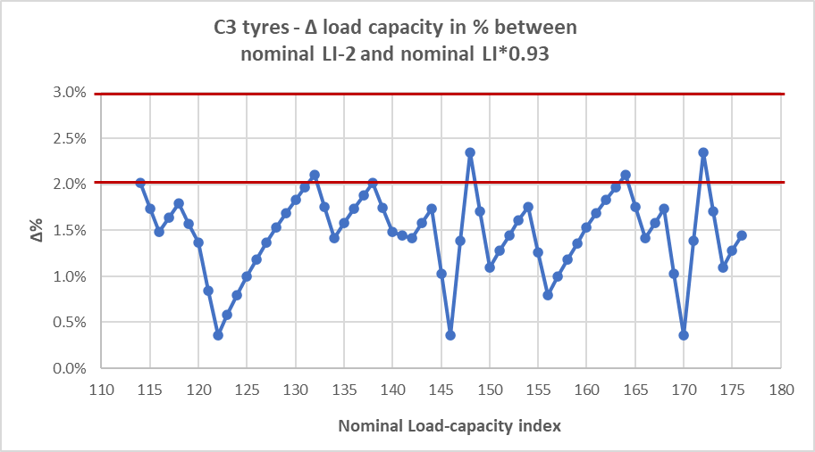

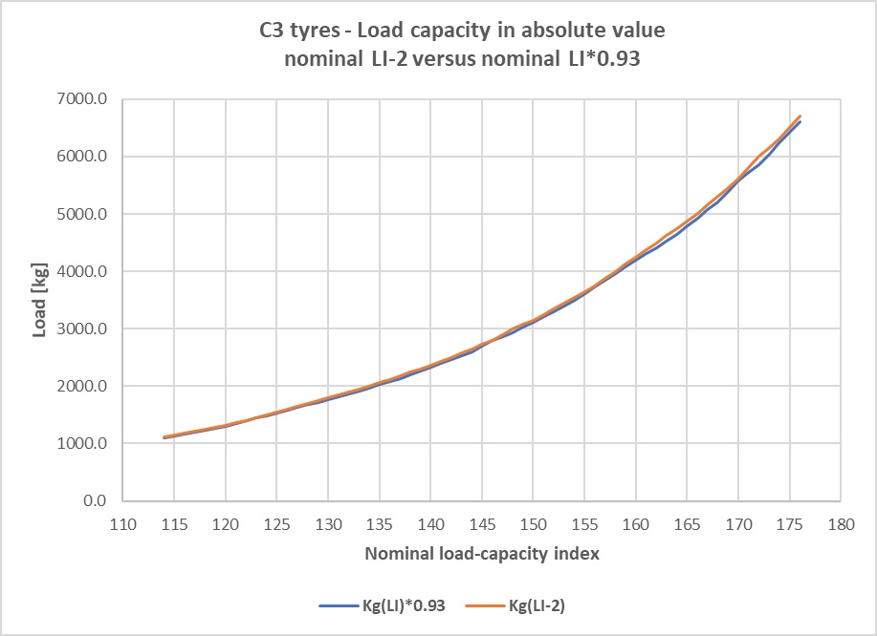

1. Type approval applications for radial tyres with load capacity index greater or equal to 122 and without the additional marking "LT", or "C" have been done in the past for the speed category symbol N for which the load/speed endurance test procedure is not described in Annex 7, Appendix 1. To type approve such tyres the test speed was separately defined by the different involved Type Approval Authorities. In order to harmonize the test procedure to be used for the type approval of such tyres, it is proposed to amend the Annex 7, Appendix 1 by introducing testing conditions in line with the rule applied for defining the test speed of radial tyres with load capacity index greater or equal to 122 (i.e. starting from 32 km/h set for F speed category symbol, the test speed is increased by 8 km/h respect to the one set for the previous speed category symbol).
2. The definition of "snow tyre" is amended to clarify that "snow tyres" are not only suitable for the use in snow conditions but also on mud and by replacing the term "maintain vehicle motion" (i.e. keeping the vehicle speed and direction of movement constant) by a more general concept of "controlling vehicle motion" (i.e. also being able to change the vehicle speed and direction of movement as intended).
3. It is proposed to explicitly allow other technical measurement solutions of the tyre overall width by removing the words “*by caliper*” which fix a technical limitation. The removal of this technical limitation would be advisable following the principle of not stopping the technical innovations.
4. ~~Editorial corrections are introduced~~ ~~to ensure that the terms "load-capacity" and "speed category symbol" are used consistently throughout the text and to remove some typing mistakes present in the current text.~~

1. As defined in the Consolidated Resolution on the Construction of Vehicles (R.E.3.), document ECE/TRANS/WP.29/78/Rev.6.
2. This Regulation defines requirements for tyres as a component. It does not limit their installation on any categories of vehicles.

   * For the purpose of this Regulation, "tyres" means "pneumatic tyres".
3. For consistency, the symbols and speeds shown in this table are the same as those for passenger cars (as in UN Regulation No. 30). They should not be taken to indicate the speeds at which commercial vehicles fitted with such tyres may be operated on the roads.