Economic Commission for Europe
Inland Transport Committee
Working Party on the Transport of Dangerous Goods
Joint Meeting of the RID Committee of Experts and the
Working Party on the Transport of Dangerous Goods 21 February 2023
Bern, 20-24 March 2023
Item 4 of the provisional agenda
Interpretation of RID/ADR/ADN
Placarding and orange-coloured plate marking of vehicles and containers for carriage in bulk
Transmitted by the Government of France
Introduction
1. The Government of France has been made aware of an issue related to the provisions in chapter 5.3 concerning carriage in bulk.
2. In accordance with 5.3.1.4, vehicles for carriage in bulk should have a placarding affixed related to dangerous good carried.
3. In RID/ADR/ADN there are no provisions prohibiting the carriage of packages (including IBC and large packages) containing dangerous goods in vehicles/containers built for carriage in bulk, and in some occasion such use can be encountered during road side checks.
4. France believes that there is an ambguity between the provisions in 5.3.1.4 and 5.3.1.5.
5. Indeed, if packages are carried in a vehicle or container intended for bulk transport (see picture below), if the previous provisions are applied taking into account the nature of the vehicle and not the nature of the load this would mean that a vehicle intended for bulk transport carrying packages should have placards affixed. This would be in contradiction with 5.3.1.5
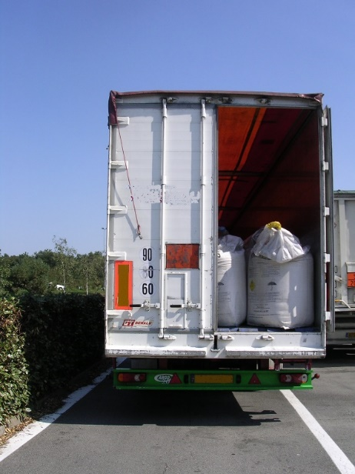

Question
6. France would like to submit the following interpretation questions for consideration by the Joint Meeting:
Question 1: Is it clear enough that the provisions of 5.3.1.4 apply in relation to the nature of the load and not the nature of the means of transport?
Question 2: In principle 5.3.1.5 excludes 5.3.1.4 but is this clear enough or should there be an additionnal explanatory text?

