Proposal for a supplement to UN Regulation No. 152 (Advanced Emergency Braking System for M₁ and N₁)
The text reproduced below is based on discussions during the activities of the eleventh to eighteenth session of the Informal Working Group (IWG) on Advanced Emergency Braking System (AEBS) M₁-N₁. It includes the amendment proposals to the current Regulation marked in bold below.
I. Proposal
Add a new paragraph 6.7., to read:
“6.7. Computer simulation of dynamic tests
6.7.1. A computer simulation model may be used for the tests described in paragraphs 6.4 to 6.6, provided the simulation model and simulation toolchain have been validated according to and are used in accordance with annex 4.
6.7.2. Simulation tools and mathematical models for evaluation of the warning and activation tests may be used in accordance with Schedule 8 of Revision 3 of the 1958 Agreement. Manufacturers shall demonstrate the scope of the simulation tool, its validity for the scenario and concrete vehicle concerned as well as the validation performed for the simulation tool chain (correlation of the outcome with physical tests) in accordance with annex 4.
6.7.3. The technical service shall be able to validate the simulation model using physical validation tests.
6.7.4. In case the computer simulation of dynamic tests is chosen by the manufacturer, a separated report including at least the additional data information specified in annex 4 paragraph 1.4 shall be annexed to the test report.”
Add a new Annex 4, to read:
“Annex 4 – Computer simulation of dynamic tests
0. Introduction (for information only)
This annex describes the processes that can be used to consider simulation results instead of physical results demonstrating compliance with regulatory requirements.
These processes allow both to optimise the reactivity of manufacturers to cover different vehicle definitions and to optimise the economic aspect by limiting the number of physical means involved.
However, this approach is only possible if the framework of the process is clearly defined and if the level of confidence in the results presented is sufficient and based on objective criteria of physical representativeness.
This approach is mainly based on 2 separate axis: the validation of the simulation method & the simulation results for approval process.
The validation of the simulation method is a key stage in the comprehensive digital validation process because it defines the mathematical model’s level of representativeness with respect to the physical test. The quality of the correlation is therefore critical and is assessed via a simulation / test comparison. Once the model has been correlated or, in other words, when the behaviour calculated is similar to the behaviour of the subject in the actual tests, the model can be used to predict the subject’s behaviour within its validity domain.
The simulation results for approval process are the final stage of the whole procedure, namely the type-approval of a vehicle in respect of a regulatory act based solely on a virtual type-approval. Once the digital model’s representativeness has been demonstrated within a scope of validity, this process can be used to assess the performance of the model tested against the requirements of the regulatory text.
This global approach is summarized step by step in the scheme below figure 5. and further detailed in the following chapters.
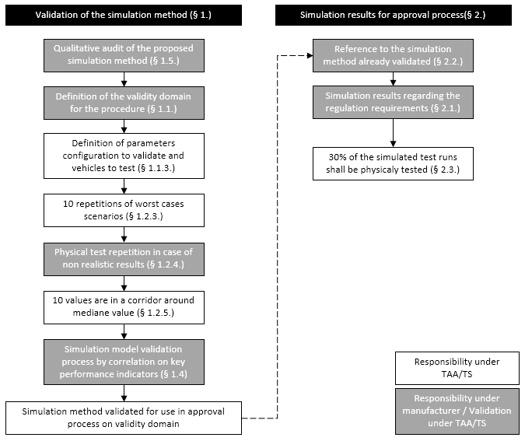
Figure 5. Generic flow chart of the “Computer simulation of dynamic tests as an equivalent approval method”

1. Validation of the simulation method
In order to guarantee that the simulation method used by the manufacturer is able to provide representative results acceptable for approval process, this simulation method shall be evaluated and validated by the technical service.

1.1. Definition of the validity domain
1.1.1 The car manufacturer shall define the boundary conditions for the simulation method. These boundary conditions define the limits within the simulation method can be used.
1.1.2. The validity domain definition shall cover both vehicle characteristics (e.g. mass, equipment, exact sensor type, control algorithm) and scenario characteristics (e.g. speeds, target).
1.1.3. Depending on the validity domain required by the manufacturer, the Technical Service will define the matrix of vehicle and scenarios to be tested in order to cover the entire domain, in accordance with paragraph 1.2.

1.2. Physical validation tests
1.2.1. The technical service shall perform tests to prove the validity of the simulation model.
1.2.2. The number of scenarios to be tested shall be defined by the technical service in order to cover the validity area requested by the manufacturer.
1.2.3. At least 10 repetitions of worst cases scenarios shall be performed and results of the stop relative distance from target or target impact velocity shall be inside a defined interval from the median value. This interval is defined by the technical service.
1.2.3.1. Worst case scenarios are those where model uncertainties are expected to have the greatest impact on the representativeness of the simulation model (e.g. impact with target during full braking would lead to a significant spread in results, lowest possible speed for car-bicycle-scenarios where sensor angle is most relevant).
1.2.4. As mentioned under paragraphs 6.10. of this regulation on the robustness of the system, some physical tests may be repeated in case the system fails to meet the performance requirements. The number of repeated tests shall not exceed:
(a) 10.0 per cent of the performed test runs for the Car to Car tests; and
(b) 10.0 per cent of the performed test runs for the Car to Pedestrian tests.; and
(c) 20.0 per cent of the performed test runs for the Car to Bicycle tests.
1.2.5. The physical tests used for building a physical reference for the numerical model validation shall be repeatable. The repeatability shall be evaluated on the impact speed or remaining distance values of the 10 repetitions which shall be within a corridor defined by the technical service around the median value of the physical tests.

1.3. Simulation model
1.3.1. The simulations (including development of the model) shall be conducted by the manufacturer. It shall reflect the complexity of the architecture of the vehicle, system and components to be tested in relation to the requirements of the current regulation and its boundary conditions.
1.3.2. The model shall be capable of describing the real physical behaviour on the validity domain. 1.3.3. The simulation model shall be constructed, and assumptions prescribed, in such a way that the calculation gives conservative solution, in which the result is independent of the incremental time step.
1.3.4. In addition to the parameters listed in paragraph 1.4. of the current annex, at least the following elements have to be defined in the simulation model:
- Vehicle dynamic model including transmission, power train, etc;
- Sensor model;
- ADAS control model;
- Environment model;
- Scenario model;
- Target model for pedestrians, cyclists and cars;
The technical service shall check the model for correct physical behaviour.

1.4. Simulation model validation process
1.4.1. The simulation model shall be validated in comparison with the physical validation tests performed under paragraph 1.2. and comparability of the test results shall be proven.
1.4.2. The model shall be checked against the repeatability tests and the median value defined as specified in paragraph 1.2.5.
1.4.3. The simulation model shall be considered valid in the requested validity domain if, based on a significance level of 5%, there is no reason to believe that the simulation model results and the test results come from two different distributions for at least the following key performance indicators:
- Time to collision FCW in s
- mean vehicle speed between 4s TTC and before AEB activation in km/h (=initial speed)
- average of absolute Lateral deviation in m
- Brake distance in m (only for test cases with avoidance).
- mean fully developed brake deceleration in m/s².
- Remaining distance to the target after standstill in m (set to zero for non-avoidance).
- Impact speed into target in km/h set to zero for avoidance).
- Brake force build-up time from start of braking to maximum brake deceleration in s.
- time to collision for start of braking in s (align wording with Euro NCAP test procedure).
Standard significance tests shall be used by the manufacturer.
1.4.4. It shall be verified that the measured data describes the correct physical quantities. This means it needs to be checked for plausibility and filtered appropriately. If quantities are not measured directly, an argumentation is required to show that they still can be used.

1.5. Additional data and information
For this application, the following information shall be supplied to the approval authority and technical service in addition to the data, and drawings listed in paragraph 3.2. of this Regulation.
1.5.1. A description of the applied simulation and calculation method which has been used with identification of the model, the analysis software, including at least, its producer, its commercial name, the version and contact details of the developer.
1.5.2. A description of the input parameters encoding the models used including at least systems functionalities characterization, mechanical hypothesis, values for defined masses, centre of gravity, moments of inertia and boundary conditions.
1.5.3. A definition of the validity domain based on vehicle parameters as mass distribution, speed ranges, etc. used in the application of paragraph 1.1. of the current annex.
1.5.4. Each step of the calculation shall be detailed by the manufacturer: pre-processing, processing and post-processing including a justification of the normal termination of the simulation (post processing logfile for example).
1.5.5. The methodology used to generate test correlated data (at least but not limited to: data recording equipment, data processing, calculation of scalar values, statistical calculations, performance indicator values as specified in paragraph 1.4.3., results of the statistical calculations ) shall be documented in the simulation report.
1.5.6. A description of the data archiving system and the updates management process (braking system design, soft updates, regulation amendments) shall be provided by the manufacturer.

2. Simulation results for approval process
2.1. The manufacturer may provide simulation results to meet the requirements specified in paragraphs 6.4. to 6.6. of this Regulation only if the method used to obtain the results have already been evaluated and validated in application of the current annex.
2.2. All simulation results provided by the manufacturer in application of the approval following paragraph 4. of the current regulation shall referred to the method previously evaluated and validated in application of the current annex.
2.3. In addition to the simulation results, at least 30% of the simulated test runs shall be conducted as physical tests as well. The results of simulated test runs and physical test runs shall be checked for differences on an individual basis and using standard statistical tests by the technical service.
2.4. Additional data and information
For this application, the following information shall be supplied to the technical service in addition to the data, and drawings listed in paragraph 3.2. of this Regulation.
2.4.1. A description of the applied simulation and calculation method which has been used with identification of model, the analysis software, including at least, its producer, its commercial name, the version and contact details of the developer.
2.4.2. A description of the input parameters encoding the models used including at least systems functionalities characterization, mechanical hypothesis, values for defined masses, centre of gravity, moments of inertia and boundary conditions.
2.4.3. A reference to the validated simulation method used in application of paragraph 1 of the current annex.
2.4.4. Each step of the calculation shall be detailed by the manufacturer: pre-processing, processing and post-processing including a justification of the normal termination of the simulation.”
II. Justification
1. This proposal targets to let the opportunity to applicant to use virtual testing methodology as alternative methodology to the physical tests. As it is already defined at European Union Whole Vehicle Type Approval system (WVTA), in other regulations or in the current activities on automated driving systems by IWG on Validation Method for Automated Driving Subgroup 2, this approach requires the preliminary assessment of the methodology to be used.
2. This proposal defines a practical approach to preserve safety main principles letting the flexibility to the applicant in the virtual tools to be used.
3. An example of the application is presented in document GRVA-15-20.

