Proposal for a new supplement to UN Regulation No. 85
Submitted by the experts from France.
The text reproduced below was prepared by the expert from France. This document proposes to allow higher tolerance for pressure measurement in paras 4.7 and 4.8 to Annex 5. The difference introduced in revision 1 of the document are in red.

I. Proposal
Annex 5, paragraphs 4.7 and 4.8, amend to read:
4.7. Depression in intake duct (see note 1a to table 1): ± 800 Pa ± 50 Pa.

4.8. Pressure in exhaust duct: ± 800 Pa± 200 Pa.

II. Justification
Context:
Accuracy of pressure measurements for net power determination test is defined in Annex 5 paragraph 4:
4.7. Depression in intake duct (see note 1a to table 1): ± 50 Pa.
4.8. Pressure in exhaust duct: ± 200 Pa.
Intake depression is to calculate the correction factor αd of net power for Diesel internal combustion engines.
5.4.2. Diesel engines - Factor αd
The power correction factor (αd) for diesel engines at constant fuel rate is obtained by applying the formula:
αd = (fa) fm
where
fa is the atmospheric factor
fm is the characteristic parameter for each type of engine and adjustment
[…]
5.4.2.2. Engine factor f m
fm is a function of qc (fuel flow corrected) as follows:
fm = 0.036 qc - 1.14
where: qc = q/r
where:
q is the fuel flow in milligram per cycle per litre of total swept volume (mg/(l.cycle))
r is the pressure ratio of compressor outlet and compressor inlet
(r = 1 for naturally aspirated engines) […]

Exhaust pressure is not used in the power calculation.

Statement
Pressure accuracy is not always compliant to the requirement in § 4 in the engine test benches.
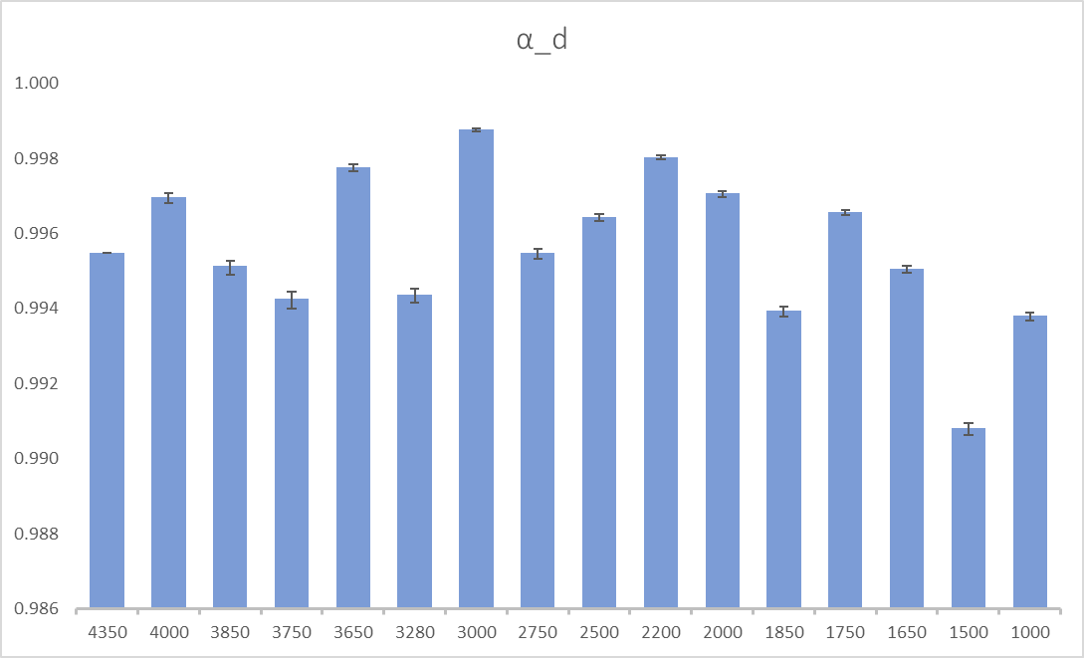
Evaluation of the impact on the pressure sensor accuracy at the intake (fictive engine) with ±800 mbar: Pa

Proposal
Allow higher tolerance for pressure measurement in §4.7 and 4.8 (+ aligned intake and exhaust) in order to avoid refusal of test due to the non-compliance of pressure accuracy and based on the low impact on the αd. Value or approach (linearity?) to be discussed.

