GRBP document for reference

Industry guideline on the anti-tampering provisions
for Non-Original Replacement Exhaust Systems (NORESS)
in UN Regulation No. 92

1 - Introduction
The following content aims at supporting manufacturers, national Type-Approval authorities and enforcement authorities in their understanding of the requirements under section 6.3.1 of UN Regulation No. 92.

The wording expressed in blue below gives guidance on the interpretation of this section with view to provide NORESS manufacturers with regulatory certainty to ensure the implementation of a high level of anti-tampering measures, and to provide national authorities with a set of harmonised best practices for these requirements.

2 - Definitions
In order to ensure clarity, the following definitions are provided:
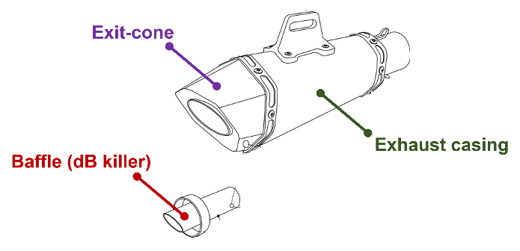
Exit-cone = last part of the exhaust silencer assembly through which exhaust gases exit.
Exhaust casing = shell of the exhaust silencer, main assembly.
Baffle = component or sub-assembly that contributes to the noise attenuation performance of a silencer, e.g. ‘dB killer’.
Fastener = A device used to mechanically join two components
Tamper-proof = an exhaust is considered tamper-proof when grinding, cutting or drilling is required to remove an exit cone, a fastener or a baffle from a silencer.

3 – Best practices and interpretation
[Note: The text of R92.02 is put in italic font; The interpretation is put in blue font]
6.3.1. Tampering protection provisions
The NORESS or its components shall be constructed in a way that does not permit removal of baffles, exit-cones and other parts whose primary function is as part of the silencing/expansion chambers. Where incorporation of such a part is unavoidable, its method of attachment shall be such that removal is not facilitated (e.g. with conventional threaded fixings) and shall also be attached such that removal causes permanent/irrecoverable damage to the assembly.

To facilitate the understanding of section 6.3.1., it is split in 3 parts (a], b] and c]).
a] ensuring tamper-proof characteristics of the product
The NORESS or its components shall be constructed in a way that does not permit removal of baffles, exit-cones and other parts whose primary function is as part of the silencing/expansion chambers. (…)
- Primarily, as per definition, NORESS should be tamper-proof.
- Baffles and exit-cones should not be removable by construction/design. Exhausts manufacturers therefore take the necessary means so that the NORESS integrity would not be easily compromised by users/owners.
- Exit-cones should be tamper-proof. In detail, this means that:
  - Conventional threaded fixing or similar methods used to fasten exit-cones to the rest of the assembly are not considered as tamper-proof
    - Should manufacturers use conventional threaded fixing or similar, exit cones should be also fastened to the exhaust casing by another method such as gluing or welding.
  - However, rivets or break-head bolts may be used to secure exit-cones to the exhaust casing. In such event:
    - Concerning rivets, stainless steel (not aluminum) should be used as a primary option
    - Should manufacturers use non-stainless steel rivets, exit cones should be also fastened to the exhaust casing by another method such as gluing or welding. Alternatively, exist cones fasteners should be filled with epoxy or similar substance;
AND
  - The baffles should be fixed to the exhaust casing or to the exit-cone so as to ensure that removal of the exit-cones should not facilitate the removal of the baffle. The baffle should be tamper-proof: its fixing methods include e.g. sufficient welding or use of threaded fixings covered by epoxy or similar substances.
  - Cosmetic end caps (exit cones) may be attached with conventional fasteners if:
    - removal of the end cap does not facilitate removal of baffles or attenuation devices, and
    - is not a part whose function is as part of the silencing/expansion chambers..
b] methods of attachment
(…) Where incorporation of such a part is unavoidable, its method of attachment shall be such that removal is not facilitated (e.g. with conventional threaded fixings) (…)
- 'such a part’ means above mentioned ‘baffles, exit-cones and other parts whose primary function is as part of the silencing/expansion chambers’;
- Baffles and other parts should be welded to the exhaust (exit cone or exhaust casing) as a primary method of attachment. It is the manufacturer's choice and responsibility to make sure that such welding covers a sufficient perimeter of the outer rim of the baffle to avoid easy removals.
- Screws and other threaded fixings can be used as a secondary way to secure the baffle to the exhaust, (or as an alternative to welding if welding is not technically possible due to different materials being used for the exit cone and the exhaust casing, for example). In such cases, these fixings should be secured by welding, or filled with epoxy or similar substances.
- Baffles should never be attached to the rest of the assembly by use of circlips or similar method of assembly, as this would not be considered a tamper-proof method of attachment.
c] permanent and irrecoverable damages
(…) and shall also be attached such that removal causes permanent/irrecoverable damage to the assembly.
- “removal causing permanent/irrecoverable damage to the assembly” is understood as a being the result (removal) of using other mechanical means than traditional, low cost, easily available tools such as hammer, screwdrivers, or pliers.
- “Irrecoverable/irrecoverable damage” includes damages to the aesthetics of the product or damages which would prevent the reintroduction of the removed part(s).

