**Report of Special Interest Group on Automated Vehicle Regulation Screening (SIG AVRS)**

The text reproduced below has been prepared on request of GRVA & GRBP by experts of the Special Interest Group on Automated Vehicle Regulation Screening (SIG AVRS) in order to identify the impact of automated driving vehicles on the regulations, GRBP is responsible for.

**I. Background**

Under the leadership of GRVA, standards and regulations for Automated Vehicles (AVs) are being developed. The nature of these AVs differ from human driven vehicles to such extend that a screening of the impact of AV on existing regulation are deemed necessary.

On behalf of GRVA, WP29 request GR’s to screen the regulations and GTR’s under their responsibility on the effects of AVs.

**Documentation:**

* Reports of the World Forum for Harmonization of Vehicle Regulations on its [187th session](https://unece.org/sites/default/files/2022-07/ECE-TRANS-WP29-1166e_0.pdf) pg.8/9
* 19. AC.2 received an update on the work of GRVA and automated vehicles related activities:

….

* (e) AC.2 recommended the GRs to consider using the template in [GRVA-13-18](https://unece.org/sites/default/files/2022-05/GRVA-13-18e.pdf) when screening UN GTRs and UN Regulations with regards to ADS.
* <https://unece.org/sites/default/files/2022-07/ECE-TRANS-WP29-1166e_0.pdf>
* <https://unece.org/sites/default/files/2022-05/GRVA-13-18e.pdf>

**II. Procedure of work**

For a structural approach of the screening the below procedure will be followed with some preceding assumptions:

1. Component regulations that need a manual driven vehicle for the component test method might need attention in the future when manual vehicles are less available (components specifically made for Avs). In this assessment the availability of the manual driven vehicles was assumed.
2. Certain components might not be necessary on a AV of a certain category. In that case that regulation could exclude the specific category of AVs.
   1. For now the categorization is not clear and the assessment assumes a worst case.
   2. The SIG requests GRVA to consider to define AV-categories to support the scoping of regulations for different AV-categories
3. Powered 2 Wheelers (P2Ws), motorcycles and mopeds of the vehicle categories L1 and L3 are likely not soon automated. However, there are examples of autonomous P2Ws on exhibitions. Related regulations should have a lower priority if updates would be needed.

The screening of GTR’s and regulations contains the following assessment:

1. Impact on definitions
2. Relevance of regulation for AVs
   1. The subject of the regulation is relevant to the AVs
   2. The test method needs reconsideration for AVs
      1. For driverless AVs (Level 5, shuttles)
         1. With passenger
         2. Without passengers (cargo)
      2. For AVs with driver (Level 3/4, fallback driver/user)
      3. Bi-directional AV’s
3. Requirement to AVs to fulfill the GTR or Regulation that is screened.
4. The template of GRVA will be used for the screening
5. The results are listed in the ANNEX and summarized in section III.

**III. List of UN Regulations for screening for Automated Vehicles**

The secretariat referred to the list of regulations annexed to the 1958 Agreement contained in the ECE/TRANS/WP.29/343/Rev.30. This table is detailed in an EXCEL worksheet. Below is the summary of the list of regulations and the result of the screening.

Table 1  
**Assessment of UN Regulations under the purview of GRBP with regards to AVs**

| *UN Regulations* | *Title* | *Topic* | *Vehicle and/or Component* | *category* | *to be checked* | *changes required* |
| --- | --- | --- | --- | --- | --- | --- |
|
|  |
| **UN R 9** | Noise of three-wheeled vehicles | Noise | Vehicle | L2, L4, L5 | **YES** | **YES** |
| **UN R 28** | Audible warning devices | Noise | Component & Vehicle | M, N, L3, L4, L5 | **YES** | **YES** |
| **UN R 30** | Tyres for passenger cars and their trailers | Tyres | Component | M, O | **No** |  |
| **UN R 41** | Noise emissions of motorcycles | Noise | Vehicle | L3 | **YES** | **??\*\*** |
| **UN R 51** | Noise of M and N categories of vehicles | Noise | Vehicle | M, N | **YES** | **YES** |
| **UN R 54** | Tyres for commercial vehicles and their trailers | Tyres | Component | N, O | **No** |  |
| **UN R 59** | Replacement silencing systems | Noise | Component & Vehicle | M1, N1 | **YES** | **copy  UN R 51** |
| **UN R 63** | Noise emissions of mopeds | Noise | Vehicle | L1 | **YES** | **??\*\*** |
| **UN R64** | Temporary use spare unit, run flat tyres | Tyres | Component & Vehicle | M, N | **YES** | **?\*\*** |
| **UN R 75** | Tyres for motorcycles/mopeds | Tyres | Component | L1, L3 | **No** |  |
| **UN R 92** | Replacement exhaust silencing systems (RESS) for motorcycles | Noise | Component & Vehicle | L | **YES** | **copy  UN R 41\*\*** |
| **UN R 106** | Tyres for agricultural vehicles | Tyres | Component | T, R, S | **No** |  |
| **UN R 108** | Retreaded tyres for passenger cars and their trailers | Tyres | Component | M, O | **No** |  |
| **UN R 109** | Retreaded tyres for commercial vehicles and their trailers | Tyres | Component | N, O | **No** |  |
| **UN R 117** | Tyres, rolling resistance, rolling noise and wet grip | Tyres | Component* | M, N, O | **No** |  |
| **UN R 124** | Replacement wheels for passenger cars | Tyres | Component | M | **YES\*\*** | **YES** |
| **UN R 138** | Quiet Road Transport Vehicles (QRTV) | Noise | Vehicle | M, N | **YES** | **YES** |
| **UN R 141** | Tyre Pressure Monitoring Systems (TPMS) | Tyres | Component & Vehicle | M1, N1 | **YES** | **YES** |
| **UN R 142** | Tyres installation | Tyres | Component & Vehicle | M1 | **YES** | **?** |
| **UN R 164** | Studded tyres with regard to their snow performance | Tyres | Component* |  | **No** |  |
| **UN R 165** | Audible reverse warning devices and audible reverse warning signals | Noise | Component & Vehicle | M2, N2, M3, N3 | **YES** | **?** |
| **GTR No. 16** | Tyres | Tyres | Component* |  | **No** |  |
|  |  |  |  | *Sum of* "YES" | **13** |  |
| * needs any non-fully automated vehicle for testing | | | ** usecase questionable | | |  |

**IV. Standardized wording and concepts**

In the GRVA taskforce FADS, session 1, a further standardization of terminology to be used was proposed. This standardization refers to the concepts mentioned in the table below from GRVA document [FADS-01-06](https://wiki.unece.org/download/attachments/179700733/FADS-01-06%20Relevant%20concepts%20for%20ADS.xlsx?api=v2)

GRVA used an AV-concept approach for the assessment of their own regulations.

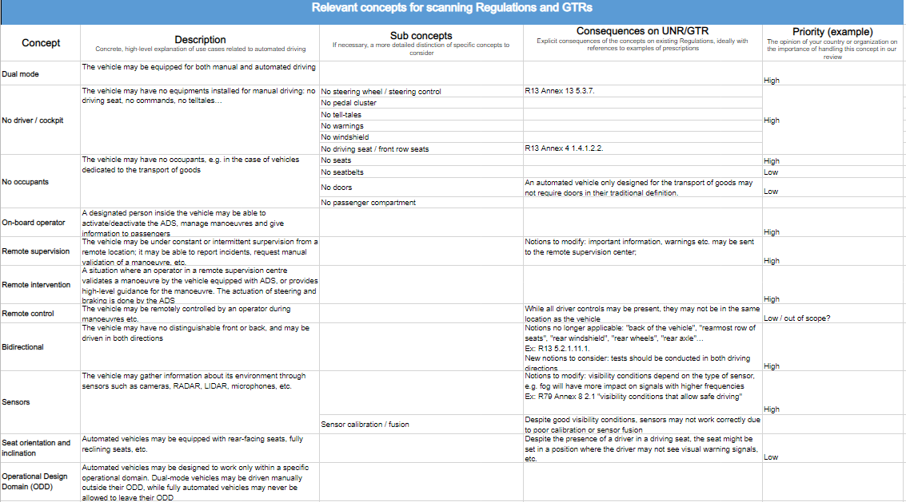

The following AV-concepts are considered for the GRBP regulations:

1. Dual Mode AV’s
2. No driver/cockpit
3. No occupants
4. Bi-directional

Specific wording and concepts should be considered for extending the list of definitions in the regulations.

# **ANNEX I: Template from GRVA-13-18**

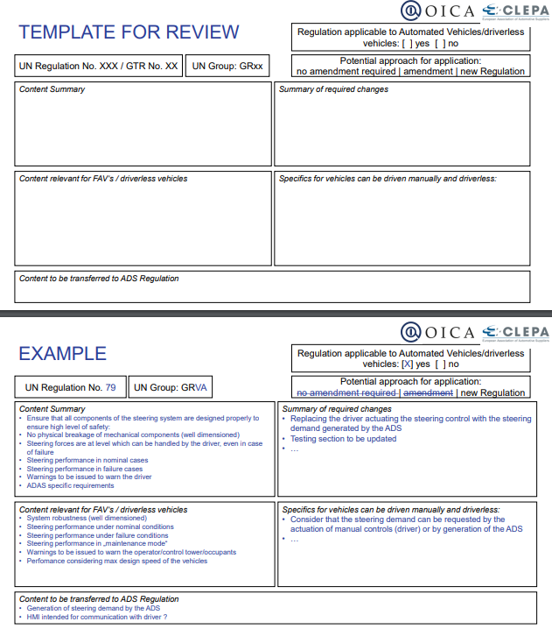

# **ANNEX II: Screening per Regulation and GTR**

|  |  |
| --- | --- |
| GRBP UN/ECE R 009 | Regulation applicable to Automated Vehicles/driverless vehicle : [ X ] YES [ ] NO |
| Sound Emission for L2, L4, L5-cat vehicles |  |
| Content summary | Summary of required changes   * AVs need a test mode to support the test method * Track standard might need adaption to support AV path planning/navigation |
| Content relevant for AV’s/driverless vehicles:   * Driverless vehicles need to have a test mode fitting to the test method and preparations of the test * The test track might need adaptions to support navigation and path planning of the AV. * Vehicles that will not reach the 50km/h (Urban shuttles) need adapted requirements * Bi-direction vehicles to be tested bi-directional * L2 use cases could be Riksja / mini cab * L4 an asymmetric 3-wheel configuration for small goods delivery * L5 like L2 above 50km/h | Specifics for vehicles that can be driven manually and driverless:   * These vehicles can be driven manually in the test, when the manual mode is representative for the automated driving. Else, see driverless remarks. |
| Content to be transferred to ADS regulation: TBD | |

|  |  |
| --- | --- |
| GRBP UN/ECE R 028 | Regulation applicable to Automated Vehicles/driverless vehicle : [ X ] YES [ ] NO |
| Audible warning devices |  |
| Content summary | Summary of required changes |
| Content relevant for AV’s/driverless vehicles:   * Driverless vehicles need to have a test mode fitting to the test method and preparations of the test | Specifics for vehicles that can be driven manually and driverless:   * These vehicles can be operated manually in the test, when the manual mode is representative for the automated driving. Else, see driverless remarks. |
| Content to be transferred to ADS regulation: TBD | |

|  |  |
| --- | --- |
| GRBP UN/ECE R 030 | Regulation applicable to Automated Vehicles/driverless vehicle : [ ] YES [ X ] NO |
| Tyres for Passenger Cars and their trailers |  |
| Content summary | Summary of required changes |
| Content relevant for FAV’s/driverless vehicles:   * … | Specifics for vehicles that can be driven manually and driverless: |
| Content to be transferred to ADS regulation:  … | |

|  |  |
| --- | --- |
| GRBP UN/ECE R 041 | Regulation applicable to Automated Vehicles/driverless vehicle : [ X ] YES [ ] NO |
| Motorcycle Noise (L3-cat) | **Low priority** |
| Content summary  *L3-cat will likely not be automated* | Summary of required changes |
| Content relevant for AV’s/driverless vehicles:   * Driverless vehicles need to have a test mode fitting to the test method and preparations of the test * The test track might need adaptions to support navigation and path planning of the AV. | Specifics for vehicles that can be driven manually and driverless:   * These vehicles can be operated manually in the test, when the manual mode is representative for the automated driving. Else, see driverless remarks. |
| Content to be transferred to ADS regulation: | |

|  |  |
| --- | --- |
| GRBP UN/ECE R 051 | Regulation applicable to Automated Vehicles/driverless vehicle : [ X ] YES [ ] NO |
| Vehicle Sound (M, N) |  |
| Content summary | Summary of required changes |
| Content relevant for FAV’s/driverless vehicles:   * Driverless vehicles need to have a test mode fitting to the test method and preparations of the test * The test track might need adaptions to support navigation and path planning of the AV. * Vehicles that will not reach the 50km/h (Urban shuttles) might need additional requirements * Bi-direction vehicles to be tested bi-directional | Specifics for vehicles that can be driven manually and driverless:   * These vehicles can be operated manually in the test, when the manual mode is representative for the automated driving. Else, see driverless remarks. |
| Content to be transferred to ADS regulation: TBD | |

|  |  |
| --- | --- |
| GRBP UN/ECE R 054 | Regulation applicable to Automated Vehicles/driverless vehicle : [ ] YES [ X ] NO |
| Tyres for Commercial Vehicles and their trailers |  |
| Content summary | Summary of required changes |
| Content relevant for FAV’s/driverless vehicles: | Specifics for vehicles that can be driven manually and driverless: |
| Content to be transferred to ADS regulation: | |

|  |  |
| --- | --- |
| GRBP UN/ECE R 059 | Regulation applicable to Automated Vehicles/driverless vehicle : [ X ] YES [ ] NO |
| Replacement Silencers (M1/N1) |  |
| Content summary  See remarks on R51 | Summary of required changes |
| Content relevant for FAV’s/driverless vehicles: | Specifics for vehicles that can be driven manually and driverless: |
| Content to be transferred to ADS regulation:  … | |

|  |  |
| --- | --- |
| GRBP UN/ECE R 063 | Regulation applicable to Automated Vehicles/driverless vehicle : [ X ] YES [ ] NO |
| Vehicle Sound (L1) | Low priority |
| Content summary | Summary of required changes |
| Check the likelihood of relevance  Content relevant for FAV’s/driverless vehicles:   * Driverless vehicles need to have a test mode fitting to the test method and preparations of the test * The test track might need adaptions to support navigation and path planning of the AV. | Specifics for vehicles that can be driven manually and driverless:   * These vehicles can be operated manually in the test, when the manual mode is representative for the automated driving. Else, see driverless remarks. |
| Content to be transferred to ADS regulation: | |

|  |  |
| --- | --- |
| GRBP UN/ECE R 075 | Regulation applicable to Automated Vehicles/driverless vehicle : [ ] YES [ X ] NO |
| Motorcycle Tyres |  |
| Content summary | Summary of required changes |
| Content relevant for FAV’s/driverless vehicles: | Specifics for vehicles that can be driven manually and driverless: |
| Content to be transferred to ADS regulation: | |

|  |  |
| --- | --- |
| GRBP UN/ECE R 092 | Regulation applicable to Automated Vehicles/driverless vehicle : [ X ] YES [ ] NO |
| Motorcycle Replacement Silencers Systems | **Low priority** |
| Content summary  See remarks on R41  *will likely not be automated* | Summary of required changes |
| Content relevant for FAV’s/driverless vehicles:   * … | Specifics for vehicles that can be driven manually and driverless: |
| Content to be transferred to ADS regulation:  … | |

|  |  |
| --- | --- |
| GRBP UN/ECE R 106 | Regulation applicable to Automated Vehicles/driverless vehicle : [ ] YES [ X ] NO |
| Tyres for Agricultural vehicles |  |
| Content summary | Summary of required changes |
| Content relevant for FAV’s/driverless vehicles: | Specifics for vehicles that can be driven manually and driverless: |
| Content to be transferred to ADS regulation: | |

|  |  |
| --- | --- |
| GRBP UN/ECE R 108 | Regulation applicable to Automated Vehicles/driverless vehicle : [ ] YES [ X ] NO |
| Retreaded Tyres for Passenger Cars and their trailers |  |
| Content summary | Summary of required changes |
| Content relevant for FAV’s/driverless vehicles: | Specifics for vehicles that can be driven manually and driverless: |
| Content to be transferred to ADS regulation: | |

|  |  |
| --- | --- |
| GRBP UN/ECE R 109 | Regulation applicable to Automated Vehicles/driverless vehicle : [ ] YES [ X ] NO |
| Retreaded Tyres for Commercial Vehicles and their trailers |  |
| Content summary | Summary of required changes |
| Content relevant for FAV’s/driverless vehicles: | Specifics for vehicles that can be driven manually and driverless: |
| Content to be transferred to ADS regulation: | |

|  |  |
| --- | --- |
| GRBP UN/ECE R 117 | Regulation applicable to Automated Vehicles/driverless vehicle : [ ] YES [ X ] NO |
| RR, noise, WG and future WGWT |  |
| Content summary | Summary of required changes |
| Content relevant for FAV’s/driverless vehicles: | Specifics for vehicles that can be driven manually and driverless: |
| Content to be transferred to ADS regulation: | |

|  |  |
| --- | --- |
| GRBP UN/ECE R 124 | Regulation applicable to Automated Vehicles/driverless vehicle : [ X ] YES [ ] NO |
| Replacement wheels for passenger cars |  |
| Content summary | Summary of required changes |
| Content relevant for FAV’s/driverless vehicles:   * The potential use of a spare tyre on AV’s should be considered including requirements related to this. | Specifics for vehicles that can be driven manually and driverless:   * Safety of the potential use of a spare tyre needs to be considered for both manual and automated modes. |
| Content to be transferred to ADS regulation: | |

|  |  |
| --- | --- |
| GRBP UN/ECE R 138 | Regulation applicable to Automated Vehicles/driverless vehicle : [ X ] YES [ ] NO |
| Quiet Road Transport Vehicle |  |
| Content summary | Summary of required changes |
| Content relevant for FAV’s/driverless vehicles:   * Driverless vehicles need to have a test mode fitting to the test method and preparations of the test * The test track might need adaptions to support navigation and path planning of the AV. * Bi-direction vehicles to be tested bi-directional | Specifics for vehicles that can be driven manually and driverless:   * These vehicles can be operated manually in the test, when the manual mode is representative for the automated driving. Else, see driverless remarks. |
| Content to be transferred to ADS regulation: | |

|  |  |
| --- | --- |
| GRBP UN/ECE R 141 | Regulation applicable to Automated Vehicles/driverless vehicle : [ X ] YES [ ] NO |
| Tyre Pressure Monitoring Systems |  |
| Content summary | Summary of required changes |
| Content relevant for FAV’s/driverless vehicles:   * One might consider other limits if tyre pressure would be more critical than in manual driving condition due to f.ex. vehicle dynamic change or asymmetric behavior that leads to false adaptive behavior of the automated system. * The response of the ADS to a TPMS warning might need to be considered in this regulation | Specifics for vehicles that can be driven manually and driverless: |
| Content to be transferred to ADS regulation: | |

|  |  |
| --- | --- |
| GRBP UN/ECE R 142 | Regulation applicable to Automated Vehicles/driverless vehicle : [ X ] YES [ ] NO |
| Tyre Installation |  |
| Content summary | Summary of required changes |
| Content relevant for FAV’s/driverless vehicles:   * Vehicle dynamic aspects of tyres might influence the stability of the control systems * One might consider stricter specification than available in the TA-regulation. * Bi-directional use of tyres | Specifics for vehicles that can be driven manually and driverless: |
| Content to be transferred to ADS regulation: | |

|  |  |
| --- | --- |
| GRBP UN/ECE R 164 | Regulation applicable to Automated Vehicles/driverless vehicle : [ ] YES [ X ] NO |
| Studded tyres |  |
| Content summary | Summary of required changes |
| Content relevant for FAV’s/driverless vehicles: | Specifics for vehicles that can be driven manually and driverless: |
| Content to be transferred to ADS regulation: | |

|  |  |
| --- | --- |
| GRBP UN/ECE R 165 | Regulation applicable to Automated Vehicles/driverless vehicle : [ X ] YES [ ] NO |
| Reversed Warning Sound |  |
| Content summary | Summary of required changes |
| Content relevant for FAV’s/driverless vehicles:   * Driverless vehicles need to have a test mode fitting to the test method and preparations of the test * The test track might need adaptions to support navigation and path planning of the AV. * Bi-direction vehicles to be tested bi-directional * Alternative requirements might be needed | Specifics for vehicles that can be driven manually and driverless:   * These vehicles can be operated manually in the test, when the manual mode is representative for the automated driving. Else, see driverless remarks. |
| Content to be transferred to ADS regulation: | |

|  |  |
| --- | --- |
| GRBP UN/ECE GTR 16 | Regulation applicable to Automated Vehicles/driverless vehicle : [ ] YES [ X ] NO |
| Tyres |  |
| Content summary | Summary of required changes |
| Content relevant for FAV’s/driverless vehicles: | Specifics for vehicles that can be driven manually and driverless: |
| Content to be transferred to ADS regulation: | |

# **ANNEX 3: First suggestions for further steps and to reflect the considerations during the screening**

