UN/SCETDG/61/INF.55

Committee of Experts on the Transport of Dangerous Goods
and on the Globally Harmonized System of Classification
and Labelling of Chemicals 1 December 2022
Sub-Committee of Experts on the Transport of Dangerous Goods
Sixty first session
Geneva, 28 November – 6 December 2022
Item 17 (b) of the provisional agenda
Any other business
Progress report on South Africa’s Dangerous Goods Supply Chain Task Group (DGSC-TG), providing a positive impact on implementation of the UN Model Regulations, as well as Dangerous Goods Training & Capacity building
Transmitted by the Responsible Packaging Management Association of Southern Africa (RPMASA)
Introduction and background
- This purpose of this paper is to provide the Sub-Committee with a progress update on the South African initiative for a Task Group of multi-modal and other Regulators, involved in monitoring and enforcing various aspects of the Dangerous Goods Supply Chain. The Task Group was formed as a public-private partnership following the Beirut catastrophe to prevent serious accidents and incidents in South Africa, it includes Industry experts and is co-chaired by the Chief Director Maritime Transport and RPMASA.
2. The initial scope was Class 1 and Class 5.1 with 5 Expert Working Groups -
EWG 1 Data gathering – to map imports, manufacture, warehousing & storage
EWG 2 Legal - to identify and review ALL current regulations which Department’s jurisdictions they fall under and possible gaps
EWG 3 Monitoring and enforcement – to identify which regulators monitor and enforce which regulations, any gaps and /or overlap as well as penalties, in order to better communicate, coordinate and harmonise any discrepancies
EWG 4 Risk Assessments – regulated & voluntary + Emergency response availability
EWG 5 Training and Awareness Raising – mandatory and Industry initiatives
Current status – progress on key issues
3. The scope of the Task Group has now been widened to encompass other Classes of Dangerous Goods.
4. Regulator representation has been expanded to include all 4 National Department of Transport modes and their Agencies, together with representatives from the SA Police Explosives Unit (lead agent for Class 1 explosives & Class 5.1 oxidizers), SA Port Authority, SA Port Terminals, SA Maritime Safety Authority, Road Traffic Management Corporation, Road Traffic Inspectorate, SA Rail Regulator, SA Civil Aviation, National Department of Labour for Major Hazards Installations, National Department of Environment for Environmental Impact approval of new and expanded storage facilities, National Regulator for Compulsory Standards, SA Local Government Association, National Disaster Management & Emergency Response Centre, the Fire Protection Association and the Fertilizer Association.
5. The EWG’s have also formed sub -Work Groups to progress work independently under their Terms of Reference and report back quarterly to the over-arching Task Group.
6. Regulators have recognised the importance of harmonising dangerous goods regulations across the different National, Provincial and Local Departments, to improve safety, and reduce incidents and accidents, as well as the need to improve communication and cooperation between Regulators.
7. Regulations for road and rail were introduced in South Africa through National Standards in the 1990’s and brought into law by reference in the Road Traffic Act. The original intent was that this would simplify keeping up to date and aligned with the UN Transport of Dangerous Goods Model Regulations, and Modal Regulations, however this was not maintained and several of these National Standards are considerably out of date.
8. The National Dept of Transport Civil Aviation Authority participates in the ICAO Dangerous Goods panel and the National Dept of Maritime Transport and the SA Maritime Safety Authority participates at IMO on various Committees including for the IMDG Code, making it essential for Road and Rail to be fully aligned.
9. It has now been agreed that the National Standards for Dangerous Goods shall refer directly to the latest revision of the UN Model Regulations for Transport of Dangerous Goods as well as reference the latest revisions of the IMDG Code and the ICAO Technical dangerous goods regulations. This will ensure future alignment of regulations for all transport modes, and reduce the potential for non-compliance of consignments being sent to the Ports and Airports as well as reduce the DG accidents and incidents.
10. Training – both air and maritime Transport have mandatory Training requirements, but due to misalignment of and incomplete adoption of the requirements of the UN Model Regulations into the National DG Standards, Training was not included or addressed for road and rail transport. This has posed considerable challenges for air and maritime Regulators where, especially for air it results in some consignments being rejected due to non-compliance with various requirements such as packaging, marking and labelling, and documentation! This became worse during covid with the high demand for sanitizers most of which, although flammable, were non- compliant.
11 It has now been agreed to address this by adopting mandatory Training requirements similar to and aligned to those for air and maritime transport, for both Regulators who monitor and enforce as well as for Industry.
12. Training - South Africa has SETA’s Sector Education and Training Authorities which set the Unit Standards, i.e. frameworks for different types of Training for different categories of workers and work, hence the need to review and revise the dangerous goods unit Standards in line with International modal Training requirements.
13. A meeting has been held with the Transport SETA to explain South Africa’s International commitments to the UNTDG, ICAO – Technical and Dangerous Goods Regulations and for the IMO –SOLAS and IMDG Code, thus the urgent need to review and revise the Dangerous Goods Unit Standards to align for multi-modal compliance. The DG related Unit Standards were due for review by June 2023 thus it was agreed to start the process now to be ready for adoption by the expiry of the existing ones.
14. Once the National Dangerous Goods Standards, the DG section of the Road Traffic Act and the DG Unit Standards have been revised mandatory Training will follow.
Additional measures
15. DGSC-TG Participation in the IMO Parallel event for World Maritime day – The Secretary General of the IMO visited South Africa to celebrate World Maritime Day in October 2022 – this had been postponed from 2020 due to covid-19! The event was hosted by the Deputy Minister of Transport with a 3day Conference and Exhibition at the Durban International Conference Centre. The DGSC-TG participated with a stand to Raise Awareness of the global and Modal Dangerous Goods Regulations AND the importance of Training to protect people, property and the environment, and make the world a safer place.
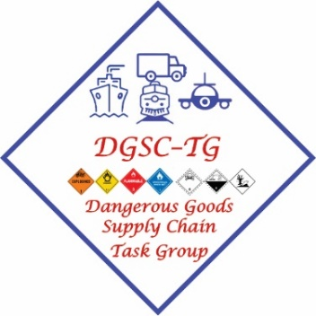
16. The TG first multi-regulator exercise was scheduled for October but had to be moved to 5 November due to unforeseen circumstances.
The Exercise was led by the Head of the SAPS Explosives unit starting with a visit to Port of Durban, then to the Explosives magazine at the Port rail siding, on to a large Dangerous Goods Warehouse and finally to a Weighbridge manned by the Road Traffic Management Corporation. The purpose of the exercise was for representatives from the different regulators to meet and understand each-others’ roles related to these operations and to learn from each other.
17. The exercise was hailed as a resounding success and an excellent learning curve for all. A key outcome being the need for regular exercises to be held in future in different parts of the country, and to address different dangerous goods classes and scenarios with feedback sessions to aid learning as well as facilitate better cooperation and communication, and understanding of the different regulator’s roles in the supply chain. It also highlighted the positive impact of a multi-modal approach to align the National regulations to the Modal Regulations, including Dangerous Goods Training and capacity building.
Note: The Task Group hope in future to
- Share and extend experience and expertise to other countries in our region
(b) Share experiences with other regions in Africa through the African Harbour Masters Forum
18. The Task Group would appreciate information on any similar initiatives in other countries which could assist us, and help guide our efforts, as well as any assistance with awareness raising of hazards and with dangerous goods Training and capacity building.
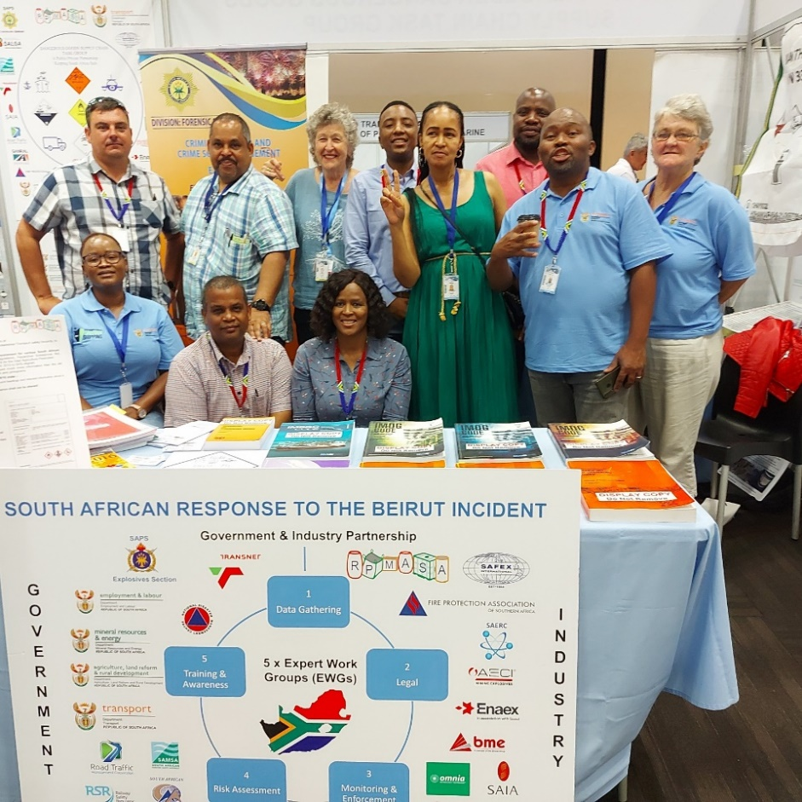

Members of the DGSC - TG Team manning the stand at the IMO Parallel event in Durban

