|  |  |  |  |
| --- | --- | --- | --- |
|  | United Nations | ECE/TRANS/2023/32 | |
| _unlogo | **Economic and Social Council** | | Distr.: General  8 December 2022  Original: English |

**Economic Commission for Europe**

Inland Transport Committee

**Eighty-fifth session**

Geneva, 21-24 February 2023  
Item 7 (v) of the provisional agenda  
**Strategic Questions of a Horizontal and   
Cross-Sectoral Policy or Regulatory Nature:  
Transport Statistics and Data**

Transport Statistics Dissemination: Data Stories

Note by the secretariat

|  |
| --- |
| *Summary* |
| This document highlights the efforts made by the Working Party on Transport Statistics to modernise transport statistics data dissemination, in order to provide the best possible evidence base for transport policy decision makers, through the production of data stories. |
|  |

I. Background

1. The Working Party on Transport Statistics (WP.6) continues its activities in providing key data to inform the Inland Transport Committee (ITC) on developments in the inland transport sector, as well as to facilitate the work of other Working Parties and individual member States through evidence-based policy making. In line with the Inland Transport Committee Strategy to 2030, part of this is to modernize data dissemination activities. Transport Statistics Infocards have, since 2017, provided country profiles containing main transport indicators for each member State. At the last session, the ITC was informed of how this has been modernised into an interactive dashboard. Dashboards are useful to present several top-level transport indicators in one place. However, in some instances there is a need to present several graphs, together with a compelling narrative, to accurately convey a complex issue to non-subject matter specialists. This narrative is a data story. This document describes the data story already produced and potential for further products.

II. What is a Data Story?

2. The way statistics are used in both journalism and research has seen a near constant flux in recent years. Indeed, the very concept of data journalism is relatively new, while research and analysis continue to evolve through the easier processing and wrangling of large and complex datasets. One online resource[[1]](#footnote-2) defines a data story as having three elements: data, visualization, and narrative. While traditional statistics dissemination has normally had some of these, recent advancements in data storytelling have harnessed improved data visualization techniques, typically involving better user interaction. This can include, for example, graphs that allow users to hover over values to see a pop-up box or message, the ability to highlight specific years or countries, or to switch between two complementary series. This more interactive data presentation is complemented by the graphs being animated and text boxes moving dynamically as the user navigates down the page, utilising a ‘scrollytelling’ approach.

III. Secretariat Approach

3. In order to experiment with this format and to fulfil the ITC strategy to 2030[[2]](#footnote-3) in supporting new technologies and innovations, the secretariat of WP.6 together with colleagues from the statistics division has started to produce data stories on transport in order to showcase the potential of this approach and improve data-based transport policy decisions.

4. There are many ways to produce the functionality inherent in data stories, relating to both the production of the graphs and the construction of the web page. The secretariat has made use of open-source data science tools for this task, in order to minimise costs as well as tap into a flourishing open-source community. Thus, the data story is designed in a Python-powered data science environment, allowing the secretariat to produce the data story in a Web 2.0 compliant format. A ‘Mobile First’ approach is followed to enable users to read the data story on mobile devices.

IV. Road Safety Data Story

5. As a prototype data story, progress in the ECE region towards the Sustainable Development Goal target 3.6, relating to halving the number of fatalities from road traffic accidents by 2020. The story can be viewed at <https://w3.unece.org/Stories/2022/06/road_safety/>.

6. The story is titled Road Safety in the UNECE Region. What do the Data Say? Explore the Region’s Progress Towards the 2020 Target and starts with a large photo to accompany introductory text (Figure 1).

# Figure 1

# **Introduction to road safety data story**

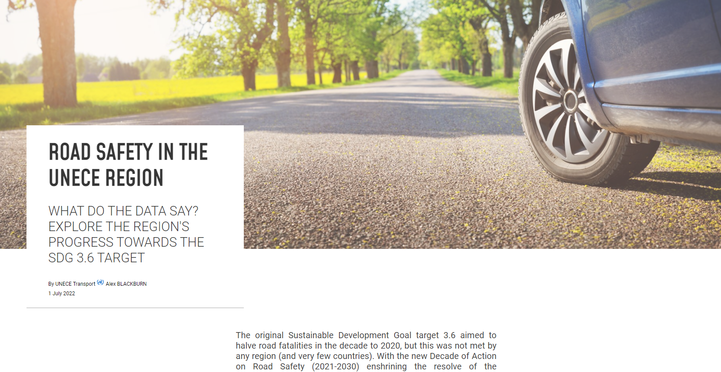

7. From here, the scrollytelling begins when the user scrolls down after some introductory text, and the first message is delivered. The animated interactive graph then starts, and the user is shown the statistics showing the decline in fatalities since 2010 in the ECE region, that is impressive but not enough to meet the 3.6 target (Figure 2). A pop-up box also highlights that due to reductions made since 2010, 72,000 people are alive today.

# Figure 2

# **Line graph of total ECE fatalities from 2010**

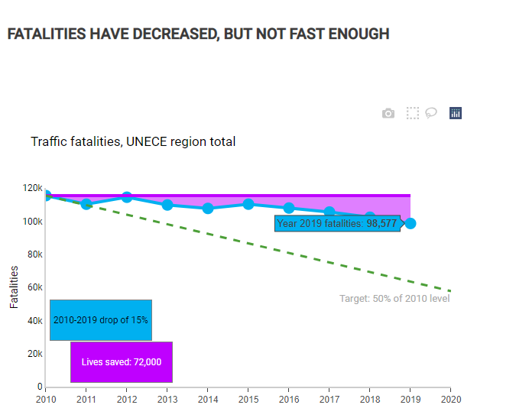

8. Message two of the story is that countries are on very different pathways in terms of progress towards this target. For this graph countries were divided into four categories: those on track; those who are close to achieving the target; those whose progress has stagnated, and those who are going backwards in experiencing increased fatalities (Figure 3). Again, the reader can hover over any bubble to see which country it refers to, with the size of the bubble proportional to population.

# Figure 3

# **Comparison of changes in fatalities since 2010 across ECE countries**

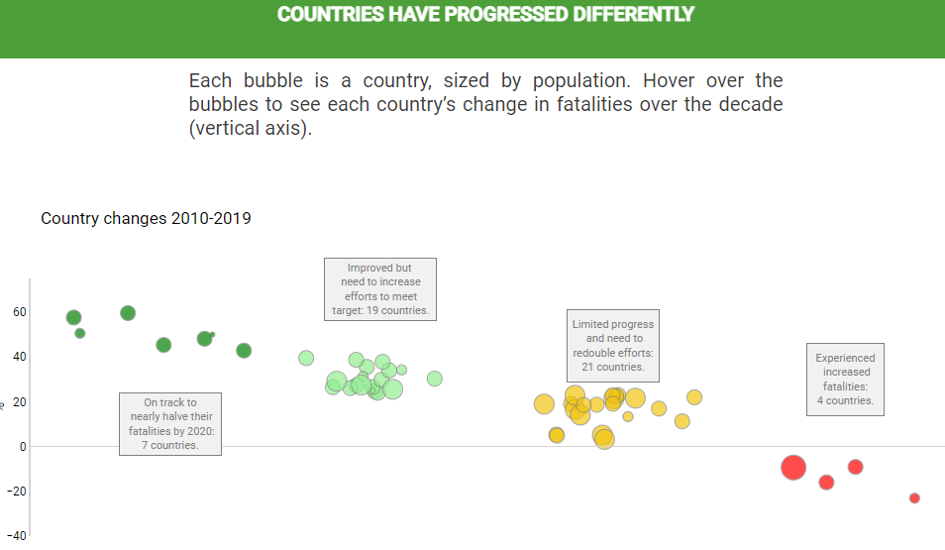

9. After additional explanation in the text of differences between countries, the story continues with its third graph, exploring differences in fatality changes for different types of road user, with available data showing worrying trends in fatalities for pedestrians and cyclists compared to passenger car occupants (Figure 4).

# Figure 4

# **Comparing fatality trends for car occupants and vulnerable road users**

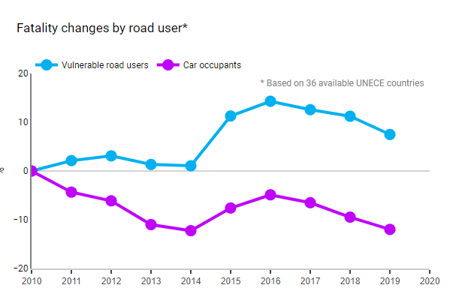

10. After a further graph highlighting the age and sex breakdown of fatalities, the data part of the story concludes with a comparison of ECE fatalities per million inhabitants against the rest of the world. The article concludes by highlighting what solutions ECE and the ITC has available, namely the legal instruments on road safety.

V. Discussion and Concluding remarks

11. It is worth highlighting that the graphs used in the data story are not at all complex. Simple line graphs and bubble graphs, correctly annotated, provide the required information and enabling users to interact with the figures increases the message impact. Similarly, the messages and accompanying text are brief. The goal of the data story is not to be a complex discussion paper, but rather a summary of key messages for policy makers. The full datasets that underpin the story remains available for browsing and download through the ECE statistics site.[[3]](#footnote-4)

12. Following the publication of this first data story, the process has been automated, so that future data stories can be produced much more quickly once the text and graphs are chosen.

13. This first data story did not contain any meaningful geospatial element, but this is a category of data story that can be pursued in the future (in particular when geospatial data on e.g. transport networks is available). The secretariat has already started to develop a story on trends in inland waterway freight tonnage.

14. The secretariat would welcome feedback on this first data story and can produce future ones based on the direct of the ITC and the needs of member States.

1. <https://online.hbs.edu/blog/post/data-storytelling> [↑](#footnote-ref-2)
2. <https://unece.org/transport/publications/itc-strategy-until-2030#:~:text=The%20Strategy%20provides%20strategic%20objectives,to%20new%20technologies%20and%20innovations> [↑](#footnote-ref-3)
3. https://w3.unece.org/PXWeb/en [↑](#footnote-ref-4)