|  |  |  |  |
| --- | --- | --- | --- |
|  | United Nations | ECE/TRANS/WP.29/2023/8 | |
| _unlogo | **Economic and Social Council** | | Distr.: General  19 December 2022  Original: English |

**Economic Commission for Europe**

Inland Transport Committee

**World Forum for Harmonization of Vehicle Regulations**

**189th session**

Geneva, 7-9 March 2023

Item 4.6.7 of the provisional agenda

**1958 Agreement:  
Consideration of draft amendments to existing   
UN Regulations submitted by GRBP**

**Proposal for the 04 series of amendments to UN Regulation No. 117 (Tyre rolling resistance, rolling noise and wet grip)**

**Submitted by the Working Party on Noise and Tyres**[[1]](#footnote-2)\*

The text reproduced below was adopted by the Working Party on Noise and Tyres (GRBP) at its seventy-sixth session (ECE/TRANS/WP.29/GRBP/74, paras. 16, 22, 23 and 26). It is based on ECE/TRANS/WP.29/GRBP/2022/12 as amended by GRBP-76-23 and GRBP-76-32, ECE/TRANS/WP.29/GRBP/2022/23 as amended by GRBP-76-02, GRBP-76-33-Rev.1 and GRBP-76-24-Rev.1, ECE/TRANS/WP.29/GRBP/2022/17 as amended by GRBP-76-31, and ECE/TRANS/WP.29/GRBP/2022/18. It is submitted to the World Forum for Harmonization of Vehicle Regulations (WP.29) and to the Administrative Committee (AC.1) for consideration at their March 2023 sessions.

*Table of Contents, Annexes,* amend to read:

"7 Procedures for snow performance testing relative to snow tyres for use in severe snow conditions

[…]

9 Procedure for determiningthe adhesion on wet surfaces of tyres in worn state

[…]"

*Paragraph 1.1.7.,* replace "1990" by "2000".

*Paragraph 2.1., item (e),* amend to read:

" (e) Whether tyre for use in severe snow conditions or not;"

*Paragraph 2.13.1.,* amend to read:

2.13.1. "*Tyre for use in severe snow conditions*" means a snow tyre or a special use tyre whose tread pattern, tread compound or structure is specifically designed to be used in severe snow conditions and that fulfils the requirements of paragraphs 6.5. and 6.5.1. of this Regulation.

2.13.1.1. "*Ice grip tyre*" means a class C1 snow tyre that is classified as tyre for use in severe snow conditions and additionally designed to be used on road surfaces covered with ice and that fulfils the requirements of paragraph 6.5.2. of this Regulation.

*Paragraph 2.18.*, amend to read:

"2.18. […]

(c) F3611-22 for the size P225/60R16 in worn state and referred to as "moulded SRTT16 worn",

(d) F2872 – 16 for the size 225/75R16C and referred to as "SRTT16C",

(e) F2871 – 16 for the size 245/70R19.5 and referred to as "SRTT19.5",

(f) F2870 – 16 for the size 315/70R22.5 and referred to as "SRTT22.5"."

*Paragraph 3.1.1.,* amend to read:

"3.1.1. The performance characteristics to be assessed for the type of tyre; "rolling sound emissions level" and/or "adhesion performance level on wet surfaces" of a tyre in new state" and/or "adhesion performance level on wet surfaces of a tyre in worn state” and/or "rolling resistance level"; "snow performance level" in case of tyre for use in severe snow conditions and additionally "ice performance level" in case of ice grip tyre;"

*Paragraph 3.1.5.1.,* amend to read:

"3.1.5.1. Whether tyre for use in severe snow conditions or not;"

*Paragraph 4.2.6.,* amend to read:

"4.2.6. The "Alpine Symbol" ("3-peak-mountain with snowflake" conforming to the pictogram described in Annex 7, Appendix 1) if the snow tyre or the special use tyre is classified as tyre for use in severe snow conditions;"

*Paragraph 4.2.6.1.,* amend to read:

"4.2.6.1. The "Ice Grip Symbol" (conforming to the pictogram described in Annex 8, Appendix 1) if the tyre for use in severe snow conditions is additionally classified as ice grip tyre;"

*Add a new paragraph 4.2.6.2.,* to read:

"4.2.6.2. The inscription "M+S" or "M.S" or "M&S" if the special use tyre is classified as tyre for use in severe snow conditions in addition to the "Alpine Symbol";"

*Paragraph 4.3.1.,* amend to read:

"4.3.1. In case the approval of a tyre pursuant to this Regulation has been granted by the same Type Approval Authority than that granting the approval pursuant to Regulation No. 30 or Regulation No. 54, the approval mark pursuant to Regulation No. 30 or Regulation No. 54 can be combined with an indication of the applicable series of amendments to which the tyre was approved pursuant to Regulation No. 117 on the form of 2 digits (example "04" indicating that the Regulation No.117 approval was granted following the 0~~4~~ series of amendments) and the suffixes according to paragraph 5.2.2. using the addition sign "+", as described in Annex 2, Appendix 3 of this Regulation, for example "0236378 + 0~~4~~S2W2R3B"."

*Paragraph 5.2.2.,* amend to read:

"5.2.2. […]

S will be followed by the suffix "2" for compliance to stage 2 while, taking into account that two stages are defined for adhesion on wet surfaces of tyres in new state and rolling resistance specifications in paragraphs 6.2. and 6.3. below, W will be followed either by the suffix "1" for compliance to stage 1 or by the suffix "2" for compliance to stage 2 and R will be followed either by the suffix "2" for compliance to stage 2 or by the suffix "3" for compliance to stage 3."

*Paragraph 5.3.1.2.,* amend to read:

"5.3.1.2. The suffix(es) mentioned in paragraph 5.2.2. above shall be preceded by the two digits identifying the series of amendments of the prescription on tyre performances for Regulation No. 117, e.g. 04S2 to identify the fourth series of amendments on tyre road rolling sound emissions at stage 2 or 04S2W2R3B to identify the fourth series of amendments on tyre road rolling sound emissions at stage 2, adhesion on wet surfaces of a tyre in new state at stage 2, rolling resistance at stage 3 and adhesion on wet surfaces of a tyre in worn state."

*Paragraph 5.4.3.*,amend to read:

"5.4.3. The suffix(es), and the identification to the relevant series of amendments, if any, as specified in the communication form.

One of the suffixes listed below or any combination of them can be used.

|  |  |
| --- | --- |
| S2 | Rolling sound emission level at stage 2 |
| W1 | Wet adhesion level in new state at stage 1 |
| W2 | Wet adhesion level in new state at stage 2 |
| R2 | Rolling resistance level at stage 2 |
| R3 | Rolling resistance level at stage 3 |
| B | Wet adhesion level of tyres in worn state |

[…]"

*Paragraph 6.1.1., footnote below the table of limits for Stage 2,* amend to read:

"The above limits shall be increased by 1 dB(A) for snow tyres that are classified astyre for use in severe snow conditions, extra load tyres or reinforced tyres, or any combination of these classifications."

*Paragraph 6.1.2.,* *table of limits for Stage 2,* amend to read:

"

| *Stage 2* | | | |
| --- | --- | --- | --- |
| *Category of use* | | *Limit dB(A)* | |
| *Other* | *Traction tyres* |
| Normal tyre |  | 72 | 73 |
| Snow tyre |  | 72 | 73 |
| Snow tyre that is classified as tyre for use in severe snow conditions | 73 | 75 |
| Special use tyre |  | 74 | 75 |
|  | Special use tyre that is classified as tyre for use in severe snow conditions | 74 | 75 |

"

*Paragraph 6.1.3., table of limits for Stage 2*, amend to read:

"

| *Stage 2* | | | |
| --- | --- | --- | --- |
| *Category of use* | | *Limit dB(A)* | |
| *Other* | *Traction tyres* |
| Normal tyre |  | 73 | 75 |
| Snow tyre |  | 73 | 75 |
| Snow tyre that is classified as tyre for use in severe snow conditions | 74 | 76 |
| Special use tyre |  | 75 | 77 |
|  | Special use tyre that is classified as tyre for use in severe snow conditions | 75 | 77 |

"

*Paragraph 6.2.1.*, amend to read:

"6.2.1. For Class C1 tyres, tested in accordance with either procedure given in Annex 5, Part (A), to this Regulation, the tyre shall meet the following requirements:

| *Stage 1* | | |
| --- | --- | --- |
| *Category of use* |  | *Wet grip index (G)* |
| Normal tyre | | ≥ 1.1 |
| Snow tyre |  | ≥ 1.1 |
| Snow tyre that is classified as tyre for use in severe snow conditions and with a speed category greater than 160 km/h | ≥ 1.0 |
| Snow tyre that is classified as tyre for use in severe snow conditions and with a speed category not greater than 160 km/h | ≥ 0.9 |
| Special use tyre |  | Not defined |
|  | Special use tyre that is classified as tyre for use in severe snow conditions | Not defined |

| *Stage 2* | | | |
| --- | --- | --- | --- |
| *Category of use* |  | | *Wet grip index (G)* |
| Normal tyre | | | ≥ 1.2 |
| Snow tyre |  | | ≥ 1.2 |
| Snow tyre that is classified as tyre for use in severe snow conditions | Speed category greater than 160 km/h | ≥ 1.1 |
| Speed category not greater than 160 km/h | ≥ 1.0 |
| Ice grip tyres | ≥ 1.0 |
| Special use tyre | | | ≥ 1.1 |
|  | Special use tyre that is classified as tyre for use in severe snow conditions | | ≥ 1.0 |

"

*Paragraph 6.2.2.*, amend to read:

"6.2.2. For Class C2 tyres, tested in accordance with either procedure given in Annex 5, Part (B), to this Regulation, the tyre shall meet the following requirements:

|  |  |  |  |
| --- | --- | --- | --- |
| *Stage 1* | | | |
| *Category of use* | | *Wet grip index (G)* | |
| *Other* | *Traction tyres* |
| Normal tyre | | ≥ 0.95 | ≥ 0.85 |
| Snow tyre |  | ≥ 0.95 | ≥ 0.85 |
| Snow tyre that is classified as tyre for use in severe snow conditions | ≥ 0.85 | ≥ 0.85 |
| Special use tyre |  | ≥ 0.85 | ≥ 0.85 |
|  | Special use tyre that is classified as tyre for use in severe snow conditions | ≥ 0.85 | ≥ 0.85 |

| *Stage 2* | | | |
| --- | --- | --- | --- |
| *Category of use* |  | *Wet grip index (G)* | |
| *Other* | *Traction tyres* |
| Normal tyre | | ≥ 1.10 | ≥ 1.00 |
| Snow tyre |  | ≥ 1.10 | ≥ 1.00 |
| Snow tyre that is classified as tyre for use in severe snow conditions | ≥ 1.00 | ≥ 1.00 |
| Special use tyre | | ≥ 1.00 | ≥ 1.00 |
|  | Special use tyre that is classified as tyre for use in severe snow conditions | ≥ 1.00 | ≥ 1.00 |

"

*Paragraph 6.2.3.*, amend to read:

"6.2.3. For Class C3 tyres, tested in accordance with either procedure given in Annex 5, Part (B), to this Regulation, the tyre shall meet the following requirements:

|  |  |  |  |
| --- | --- | --- | --- |
| *Stage 1* | | | |
| *Category of use* |  | *Wet grip index (G)* | |
| Other | Traction tyres |
| Normal tyre | | ≥ 0.80 | ≥ 0.65 |
| Snow tyre |  | ≥ 0.65 | ≥ 0.65 |
| Snow tyre that is classified as tyre for use in severe snow conditions | ≥ 0.65 | ≥ 0.65 |
| Special use tyre |  | ≥ 0.65 | ≥ 0.65 |
|  | Special use tyre that is classified as tyre for use in severe snow conditions | ≥ 0.65 | ≥ 0.65 |

|  |  |  |  |
| --- | --- | --- | --- |
| *Stage 2* | | | |
| *Category of use* |  | *Wet grip index (G)* | |
| Other | Traction tyres |
| Normal tyre | | ≥ 0.95 | ≥ 0.80 |
| Snow tyre |  | ≥ 0.80 | ≥ 0.80 |
| Snow tyre that is classified as tyre for use in severe snow conditions | ≥ 0.80 | ≥ 0.80 |
| Special use tyre | | ≥ 0.80 | ≥ 0.80 |
|  | Special use tyre that is classified as tyre for use in severe snow conditions | ≥ 0.80 | ≥ 0.80 |

"

*Paragraph 6.3.*, amend to read:

"6.3.Rolling resistance coefficient (Cr) limits, as measured by the method described in Annex 6 to this Regulation.

The maximum value ofthe rolling resistance coefficient shall not exceed the values given below(value in N/kN is equivalent to value in kg/tonne):

| *Stage 2* | |
| --- | --- |
| *Tyre class* | *Max value of Cr (N/kN)* |
| C1 | 10.5 |
| C2 | 9.0 |
| C3 | 6.5 |
| For snow tyre that is classified as tyre for use in severe snow conditions, the limits shall be increased by 1 N/kN. | |

|  |  |  |  |  |
| --- | --- | --- | --- | --- |
| *Stage 3* | | | | |
| *Tyre class* | | | | *Max value of Cr (N/kN)* |
| C1 | load capacity index < 87 | | | 10.0 |
| load capacity index ≥ 87 | Tyres other than Run Flat Tyres or Extended Mobility Tyres |  | 9.0 |
| Tyres with a nominal aspect ratio ≤ 40 and suitable for speeds ≥ 300 km/h | 10.0 |
| Run Flat Tyres or Extended Mobility Tyres | | 10.0 |
| Special use tyres | | | 10.0 |
| C2 | Tyres other than Traction tyres | | | 8.5 |
| Traction tyres | | | 9.0 |
| C3 | Tyres other than tyres marked with “C”, “CP” or “LT” | | | 6.0 |
| Tyres marked with “C” or “CP” as suffix to the tyre-size designation or with “LT” either as prefix or suffix to the tyre-size designation or with “LT” placed after the service description | | | 6.5 |
| For snow tyre that is classified as tyre for use in severe snow conditions, the limits shall be increased by 1 N/kN. | | | | |

"

*Paragraph 6.4.1.*, amend to read:

"6.4.1. For class C1 tyres, tested in accordance with either procedure given in Annex 9 to this Regulation, the tyre shall meet the following requirements:

| *Category of use* |  | | *Wet grip index (GB)* |
| --- | --- | --- | --- |
| Normal tyre |  | | ≥ 0.88 |
|  | Tyre with a nominal aspect ratio equal to or less than 40, a section width equal to or higher than 235 mm and suitable for speeds equal to or greater than 300 km/h | | ≥ 0.80 |
| Snow tyre |  | | ≥ 0.88 |
| Snow tyre that is classified as tyre for use in severe snow conditions suitable for speeds greater than 160 km/h |  | ≥ 0.80 |
| Ice grip tyre | ≥ 0.70 |
| Snow tyre that is classified as tyre for use in severe snow conditions suitable for speeds equal to or less than 160 km/h |  | ≥ 0.70 |
| Ice grip tyre | ≥ 0.70 |
| Special use tyre | | | ≥ 0.80 |
|  | Special use tyre that is classified as tyre for use in severe snow conditions | | ≥ 0.80 |

"

*Add a new paragraph 6.4.2.,* to read:

"6.4.2. For class C2 tyres, evaluated in accordance with the procedure given in paragraph 3. of Annex 9 to this Regulation, the tyre shall meet the following requirements:

|  |  |  |  |
| --- | --- | --- | --- |
| *Category of use* | | *Wet grip index (GB)* | |
| *Other* | *Traction tyres* |
| Normal tyre | | ≥ 0.82 | ≥ 0.74 |
| Snow tyre | | ≥ 0.82 | ≥ 0.74 |
|  | Snow tyre that is classified as tyre for use in severe snow conditions | ≥ 0.74 | ≥ 0.74 |
| Special use tyre | | ≥ 0.74 | ≥ 0.74 |
|  | Special use tyre that is classified as tyre for use in severe snow conditions | ≥ 0.74 | ≥ 0.74 |

"

*Add a new paragraph 6.4.3.,* to read:

"6.4.3. For class C3 tyres, evaluated in accordance with the procedure given in paragraph 3. of Annex 9 to this Regulation, the tyre shall meet the following requirements:

|  |  |  |  |
| --- | --- | --- | --- |
| *Category of use* | | *Wet grip index (GB)* | |
| *Other* | *Traction tyres* |
| Normal tyre | | ≥ 0.66 | ≥ 0.54 |
| Snow tyre | | ≥ 0.54 | ≥ 0.54 |
|  | Snow tyre that is classified as tyre for use in severe snow conditions | ≥ 0.54 | ≥ 0.54 |
| Special use tyre | | ≥ 0.54 | ≥ 0.54 |
|  | Special use tyre that is classified as tyre for use in severe snow conditions | ≥ 0.54 | ≥ 0.54 |

"

*Paragraph 6.5.*, amend to read:

"6.5. In order to be classified as a tyre for use in severe snow conditions the tyre shall meet the performance requirements of paragraph 6.5.1. below. The tyre shall meet these requirements based on a test method of Annex 7 by which:

[…]"

*Paragraph 6.5.2.*, amend to read:

"6.5.2. Ice performance requirements for class C1 tyres classified as ice grip tyre

In order to be classified as ice grip tyre, a tyre for use in severe snow conditions shall meet the minimum ice grip index value, as calculated in the procedure described in Annex 8 and compared with the respective Standard Reference Test Tyre (SRTT) shall be as follows:

[…]"

*Paragraphs 6.6. and 6.6.1.,* amend to read:

"6.6. In order to be classified as a "traction tyre", a tyre is required to meet at least one of the below reported conditions of paragraph 6.6.1. or 6.6.2.

6.6.1. The tyre shall have a tread pattern with minimum two circumferential ribs, each containing a minimum of 30 block-like elements, separated by grooves and/or sipe elements the depth of which has to be minimum of one half of the tread depth."

*Add new paragraphs 6.6.2., 6.6.2.1., 6.6.2.2. and 6.6.2.3.*, to read:

"6.6.2. The tyre shall have a total number (*n*TE) of traction elements of its tread pattern is equal to or greater than a limit that is calculated based on the deformation potential (*P*def) of its tread pattern pursuant to paragraph 6.6.2.3.

6.6.2.1. Calculation of the deformation potential of the tread pattern

The "deformation potential" (*P*def) is calculated as follows:

$P_{\text{def}}=R_{\text{void}}∙{d_{\text{tr}}}^{3}$

where:

*R*void is a dimensionless figure between 0 and 1 representing the void to fill ratio of the tread pattern according to the definition in paragraph 2.17.;

*d*tris the maximum of the tread depths as defined in paragraph 2.16. of this Regulation expressed in millimetres.

The deformation potential *P*def is expressed in mm3.

6.6.2.2. Calculation of the number of traction elements

"Traction elements" (TE) are elements of the tread pattern which are completely separated from each other by grooves and/or sipes, on all their edges, at tread surface.

The total number *n*TE of traction elements is calculated as follows

$n_{\text{TE}}=\frac{1}{2}∙\left(n_{\text{TE,50}}+n_{\text{TE,70}}\right)$

where:

*n*TE,50is the number of traction elements separated by grooves/sipes with a depth equal to or greater than 50% of the maximum tread depth;

*n*TE,70is the number of traction elements separated by grooves/sipes with a depth equal to or greater than 70% of the maximum tread depth.

For the avoidance of doubt, each traction element counted within *n*TE,70 is also counted within *n*TE,50.

6.6.2.3. In order to be classified as a traction tyre, the total number of traction elements in the tread pattern of a tyre shall, depending on tyre class and, for class C3 tyres, nominal rim diameter, fulfil the respective condition:

For class C2 tyres: $n_{\text{TE}}≥-\frac{2}{25 {mm}^{3}}∙P_{\text{def}}+100$

For class C3 tyres with nominal rim diameter code less than 20:

$n_{\text{TE}}≥-\frac{1}{10{ \text{mm}}^{3}}∙P_{\text{def}}+200$

For class C3 tyres with nominal rim diameter code equal to or greater than 20:

If *P*def < 1400 mm3:

If *P*def ≥ 1400 mm3:  **"**

*Paragraph 6.7.,* amend to read:

"6.7. […]

For class C1 tyres: a tread depth ≥ 9 mm and void to fill ratio ≥ 30 per cent

[…]"

*Paragraph 12. and its subparagraphs,* amend to read:

"**12. Transitional provisions**

12.1. As from the official date of entry into force of the 04 series of amendments, no Contracting Party applying this Regulation shall refuse to grant or refuse to accept type approvals under this Regulation as amended by the 04 series of amendments.

12.2. As from 7 July 2024, Contracting Parties applying this Regulation shall not be obliged to accept type approvals issued according to any preceding series of amendments, first issued after 7 July 2024.

12.3. As from 7 July 2024, Contracting Parties applying this Regulation shall not be obliged to accept type approvals issued according to the 04 series of amendments to this Regulation, first issued after 7 July 2024, if the stage 2 requirements for wet adhesion in new state set out in paragraph 6.2. and the stage 3 requirements for rolling resistance set out in paragraph 6.3. are not complied with.

12.4. Until 6 July 2026, Contracting Parties applying this Regulation shall accept type approvals issued according to the 02 or the 03 series of amendments, first issued before 7 July 2024.

12.5. As from 7 July 2026, Contracting Parties applying this Regulation shall not be obliged to accept type approvals issued according to any preceding series of amendments to this Regulation.

12.6. Until the dates given below, Contracting Parties applying this Regulation shall accept type approvals issued according to the 04 series of amendments to this Regulation, first issued before 7 July 2024, if the stage 2 requirements for wet adhesion in new state set out in paragraph 6.2. and the stage 3 requirements for rolling resistance set out in paragraph 6.3. are not complied with.

| *Tyre class* | *Date* |
| --- | --- |
| C1 | 6 July 2026 |
| C2 and C3 | 31 August 2028 |

12.7. As from the dates given below, Contracting Parties applying this Regulation shall not be obliged to accept type approval issued according to the 04 series of amendments to this Regulation, if the stage 2 requirements for wet adhesion in new state set out in paragraph 6.2. and the stage 3 requirements for rolling resistance set out in paragraph 6.3. are not complied with.

| *Tyre class* | *Date* |
| --- | --- |
| C1 | 7 July 2026 |
| C2 and C3 | 1 September 2028 |

12.8. Contracting Parties applying this Regulation may grant type approvals according to any preceding series of amendments to this Regulation.

12.8.1. Contracting Parties applying this Regulation shall continue to grant extensions of existing approvals to any preceding series of amendments to this Regulation.

12.9. Until 1 September 2024, Contracting Parties applying this Regulation may continue to grant type approvals according to the 04 series of amendments to this Regulation, based on snow performance test described in Annex 7 to this Regulation using SRTT14 as reference tyre. [[2]](#footnote-3)(a)

12.10. Until 1 September 2024, Contracting Parties applying this Regulation may continue to grant type approvals according to the 04 series of amendments to this Regulation, based on the test procedures for measuring the wet adhesion of tyres in new state as described in Annex 5 of this Regulation, without taking into account the provisions introduced after Supplement 12 to the 02 series of amendments.

12.11. Until 6 July 2024, Contracting Parties applying this Regulation may continue to grant type approvals of class C1 tyres according to the 04 series of amendments to this Regulation, based on the test procedures for measuring the wet adhesion of tyres in worn state as described in Annex 9 to this Regulation using buffed SRTT16 in worn state as reference tyre.

12.12. Notwithstanding paragraph 12.11., Contracting Parties applying this Regulation shall continue to grant extensions to existing type approvals of class C1 tyres according to the 04 series of amendments to this Regulation first granted before 7 July 2024, based on the test procedures for measuring the wet adhesion of tyres in worn state as described in Annex 9 to this Regulation using buffed SRTT16 in worn state as reference tyre. In case a new test has to be performed on a different representative tyre size for an extension to be granted after 7 July 2024, the moulded SRTT16 worn shall be used.

12.13. Until 60 months from the entry into force of Supplement 15 to the 02 series of amendments, Contracting Parties applying this Regulation shall continue to grant type approvals and extension to existing type approvals according to the 04 series of amendments to this Regulation, based on tyre-rolling sound emissions tests performed on test sites the surface and the dimensions of which is in accordance with ISO 10844:2014.

12.14. As from 7 July 2024, Contracting Parties applying this Regulation shall not be obliged to accept type approvals issued according to the 04 series of amendments to this Regulation, first issued after 7 July 2024, if, in the case of classes C2 and C3 traction tyre, the requirements for traction classification set out in paragraph 6.6.2. are not complied with.

12.15. Until 31 August 2030, Contracting Parties applying this Regulation shall accept type approvals and grant extension to type approvals issued according to the 04 series of amendments to this Regulation, first issued before 7 July 2024, if, in the case of classes C2 and C3 traction tyre, the requirements for traction classification set out in paragraph 6.6.2. are not complied with.

12.16. As from 1 September 2030, Contracting Parties applying this Regulation shall not be obliged to accept type approvals of tyres issued according to the 04 series of amendments to this Regulation if, in the case of classes C2 and C3 traction tyre, the requirements for traction classification set out in paragraph 6.6.2. are not complied with."

*Annex 1,*

*Item 4.1,* amend to read:

"4.1. Tyre for use in severe snow conditions (Yes/No)2"

*Item 8.*, amend to read:

"8. Performance(s) approved: rolling sound emission level at stage 2, wet adhesion level of tyres in new state at (stage 1/stage 2)2, rolling resistance level at (stage 2/stage 3)2, wet adhesion level of tyres in worn state."

*Item 8.3.,* amend to read:

"8.3. Wet adhesion level of tyres in worn state of representative size, see paragraph 2.7. of this Regulation, as per the test report in the appendix to Annex 9 in the case of class C1 tyres or as per evaluation performed according to paragraph 3. of Annex 9 in the case of classes C2 and C3 tyres2: ……………………… (GB) using the vehicle or trailer method2"

*Footnote 6*, amend to read:

"6 In the case of tyre for use in severe snow conditions a test report according to Appendix 2 or Appendix 3, as applicable, to Annex 7 shall be submitted. Additionally in the case of ice grip tyre a test report according to Appendix 2 to Annex 8 shall be submitted."

*Annex 2*,

*Appendix 1,* amend to read:

**"****Annex 2 ‑ Appendix 1**

**Examples of separate Regulation No. 117 approval marks**

Example 1

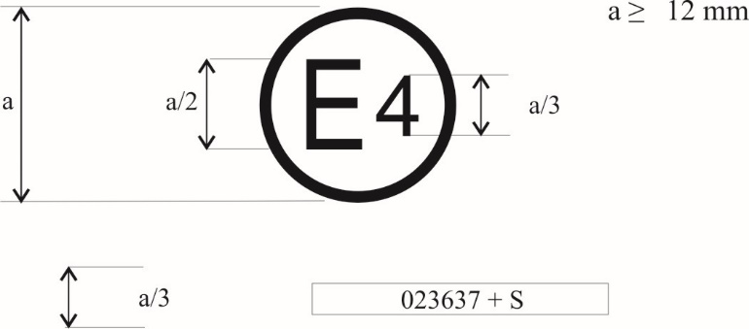

**0412345 S2**

The above approval mark, affixed to a pneumatic tyre shows that a tyre concerned has been approved in the Netherlands (E 4) pursuant to Regulation No. 117 (marked by S2 (rolling sound at stage 2) only), under approval number 0412345. The first two digits of the approval number (04) indicate that the approval was granted according to the requirements 04 series of amendments to this Regulation.

Example 2

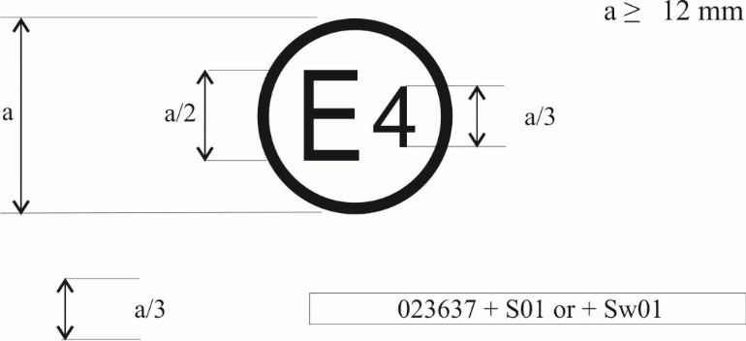

**0412345 S2W2R3B**

The above approval mark shows that the tyre concerned has been approved in the Netherlands (E 4) pursuant to Regulation No. 117 (marked by S2 (rolling sound at stage 2) W2 (wet adhesion of tyres in new state at stage 2), R3 (Rolling resistance at stage 3) and B (wet adhesion of tyres in worn state)) under approval number 0412345. The first two digits of the approval number (04) indicate that the approval was granted according to the requirements of the 04 series of amendments to this Regulation."

*Appendix 2,* amend to read:

**"Annex 2 ‑ Appendix 2**

**Approval according to Regulation No. 117 coincident with approval of Regulation No. 30 or 54[[3]](#footnote-4)**

Example 1

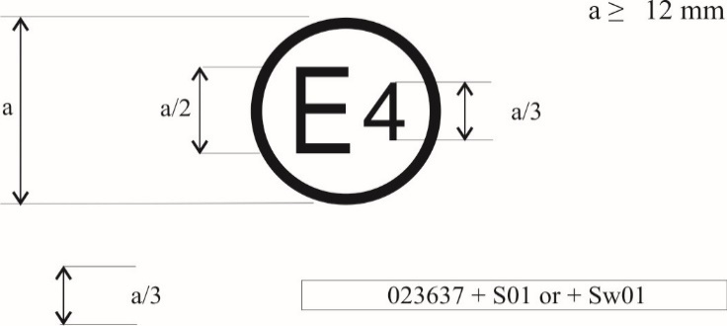

**a/3** **0412345 S2 0236378**

The above approval mark shows that the tyre concerned has been approved in the Netherlands (E 4) pursuant to UN Regulation No. 117 (marked by "S2" (rolling sound at stage 2)), under approval number 0412345 and UN Regulation No. 30, under approval number 0236378. The first two digits of the approval number ("04" and "02") indicate that the approval was granted according to the 04 series of amendments and the approval pursuant to UN Regulation No. 30 according to the 02 series of amendments.

Example 2

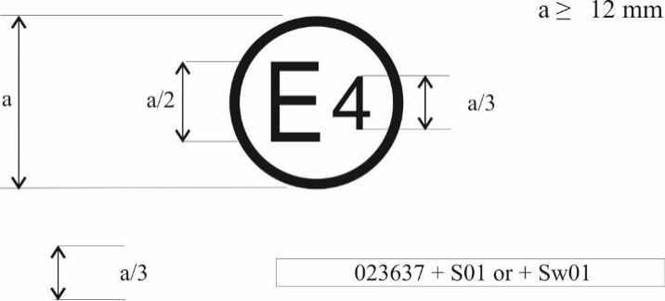

**0412345 S2W2R3B 0236378**

**or**

**0412345 S2W2R3B**

**0236378**

The above approval mark shows that the tyre concerned has been approved in the Netherlands (E 4) pursuant to Regulation No. 117 (marked by "S2W2R3B" (rolling sound emission at stage 2, wet adhesion of tyres in new state at stage 2, rolling resistance at stage 3 and wet adhesion of tyres in worn state)), under approval number 0312345 and UN Regulation No. 30 under approval number 0236378. The first two digits of the approval numbers ("04" and "02") indicate that the approval pursuant to UN Regulation No. 117 was granted according to the 04 series of amendments and the approval pursuant to UN Regulation No. 30 according to the 02 series of amendments."

Example 3

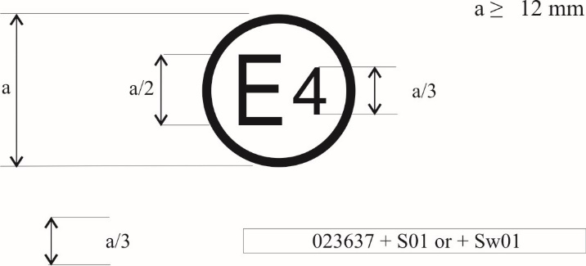

**a/3** **0412345 S2W2R3 0065432**

The above approval mark shows that the tyre concerned has been approved in the Netherlands (E4) pursuant to UN Regulation No. 117 (marked by "S2W2R3" (rolling sound emission at stage 2, wet adhesion of tyres in new state at stage 2 and rolling resistance at stage 3)), under approval number 0412345 and UN Regulation No. 54 under approval number 0065432. The first two digits of the approval numbers ("04" and "00") indicate that the approval pursuant to UN Regulation No. 117 was granted according to the 04 series of amendments and the approval pursuant to UN Regulation No. 54 according to its original form."

*Appendix 3,* amend to read:

**"Annex 2 ‑ Appendix 3**

**Combinations of markings of approvals issued in accordance with Regulations Nos. 117, 30 or 54[[4]](#footnote-5)**

Example 1

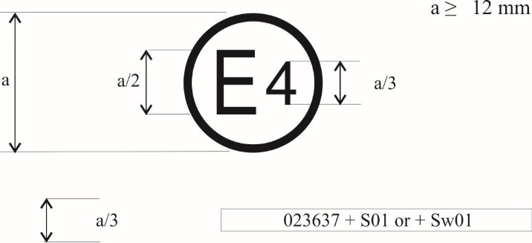

**a/3** **0236378 + 04S2**

The above approval mark shows that the tyre concerned has been approved in the Netherlands (E4) pursuant to UN Regulation No. 30 according to its 02 series of amendments (indicated by the first two digits of the approval number, "02") under approval number 0236378. It is also marked by "+ 04S2" which indicates that the tyre was also approved pursuant to UN Regulation No. 117 (04 series of amendments) for S (rolling sound emission at stage 2).

Example 2

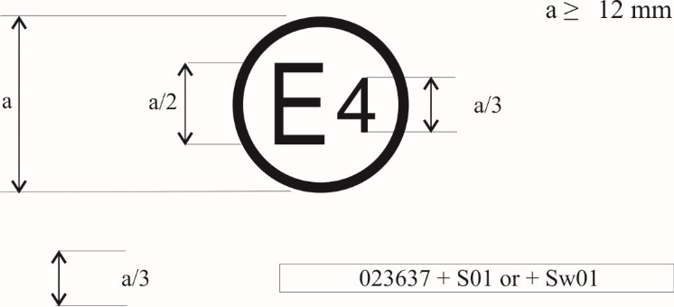

|  |  |  |
| --- | --- | --- |
|  | **0236378 + 04S2W2R3B** |  |

The above approval mark shows that the tyre concerned has been approved in the Netherlands (E4) pursuant to UN Regulation No. 30 according to its 02 series of amendments (indicated by the first two digits of the approval number, "02") under approval number 0236378. It is also marked by "+ 04S2W2R3B" which indicates that the tyre was also approved pursuant to UN Regulation No. 117 (04 series of amendments) for S (rolling sound emission at stage 2) W (wet adhesion of tyres in new state at stage 2), R (rolling resistance at stage 3) and B (wet adhesion of tyres in worn state)."

*Appendix 4,* amend to read:

**"Annex 2 ‑ Appendix 4**

**Extensions to combine approvals issued in accordance with Regulation No. 117**

Example 1

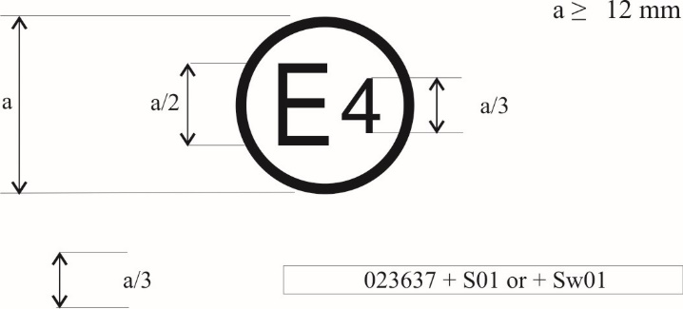

**a/3** **0212345 S2WR2 + 04B**

The above approval mark shows that the tyre concerned has been initially approved in the Netherlands (E4) pursuant to UN Regulation No. 117 and the 02 series of amendments under approval number 0212345. The marking is complemented by S2WR2 (rolling sound emission at stage 2) W (wet adhesion of tyres in new state) and R (rolling resistance at stage 2). The "04B" preceded by "+" indicates that it has had its approval extended under UN Regulation No. 117 and 04 series of amendments to wet adhesion of tyres in worn state based on separate certificate."

*Annex 3, paragraph 2.1.,* replace "ISO 10844:2014" by "ISO 10844:2021".

*Annex 3, Appendix 1, item 6.1,* amend to read:

"6.1. Tyre for use in severe snow conditions (Yes/No)1"

*Annex 5, Part (A),*

*Table in paragraph 3.3*, amend to read:

"

| *Category of use* | | *Wetted surface temperature* | *Ambient temperature* |
| --- | --- | --- | --- |
| Normal tyre | | 12 °C – 35 °C | 12 °C – 40 °C |
| Snow tyre | | 5 °C – 35 °C | 5 °C – 40 °C |
|  | Snow tyre that is classified as tyre for use in severe snow conditions | 5 °C – 20 °C | 5 °C – 20 °C |
| Special use tyre | | 5 °C – 35 °C | 5 °C – 40 °C |
|  | Special use tyre that is classified as tyre for use in severe snow conditions | 5 °C – 20 °C | 5 °C – 20 °C |

"

*Paragraph 4.1.6.4., table 2,* amend to read:

" Table 2

| *Category of use* | | *ϑ0*  *(°C)* | *a* | *b*  *(°C−1)* | *c*  *(°C−2)* | *d*  *(mm−1)* |
| --- | --- | --- | --- | --- | --- | --- |
| Normal tyre | | 20 | +0.99382 | +0.00269 | −0.00028 | −0.02472 |
| Snow tyre | | 15 | +0.92654 | −0.00121 | −0.00007 | −0.04279 |
|  | Snow tyre that is classified as tyre for use in severe snow conditions | 10 | +0.72029 | −0.00539 | +0.00022 | −0.03037 |
| Special use tyre | | 15 | +0.92654 | −0.00121 | −0.00007 | −0.04279 |
|  | Special use tyre that is classified as tyre for use in severe snow conditions | 10 | +0.72029 | −0.00539 | +0.00022 | −0.03037 |

"

*Paragraph 4.2.8.4., table 4,* amend to read:

" Table 4

| *Category of use* | | *ϑ0*  *(°C)* | *a* | *b*  *(°C−1)* | *c*  *(°C−2)* | *d*  *(mm−1)* |
| --- | --- | --- | --- | --- | --- | --- |
| Normal tyre | | 20 | +0.99757 | +0.00251 | −0.00028 | +0.07759 |
| Snow tyre | | 15 | +0.87084 | −0.00025 | +0.00004 | −0.01635 |
|  | Snow tyre that is classified as tyre for use in severe snow conditions | 10 | +0.67929 | +0.00115 | −0.00005 | +0.03963 |
| Special use tyre | | 15 | +0.87084 | −0.00025 | +0.00004 | −0.01635 |
|  | Special use tyre that is classified as tyre for use in severe snow conditions | 10 | +0.67929 | +0.00115 | −0.00005 | +0.03963 |

"

*Annex 5,* *Part (B), paragraph 2.1.2.1.,* amend to read:

"2.1.2.1. […]

$$P_{t}=P_{r}{∙\left(\frac{Q_{t}}{Q_{r}}\right)}^{1.25}$$

Where:

*Pr* = Inflation pressure corresponding to the indication of the inflation pressure marked on the sidewall as required by paragraph 4.1. of this Regulation.

*Qt* = The static test load of the tyre

*Qr*= The maximum mass associated with the load capacity index of the tyre"

*Annex 6, Appendix 3, item 6.1.,* amend to read:

"6.1. for use in severe snow conditions (Yes/No)2"

*Annex 7,*

*Title,* amend to read:

**"Procedures for snow performance testing relative to tyres for use in severe snow conditions"**

*Paragraph 3.1.4.2.,* amend to read:

"3.1.4.2. For class C2 tyres, the vehicle load shall be such that the resulting loads on the tyres are between 60 per cent and 100 per cent of the load corresponding to the tyre load capacity index.

The static tyre load on the same axle should not differ by more than 10 per cent.

The inflation pressure is calculated to run at constant deflection:

For a vertical load higher or equal to 75 per cent of the load capacity of the tyre, a constant deflection is applied, hence the test inflation pressure *Pt* shall be calculated as follows:

$$P_{t}=P_{r}{∙\left(\frac{Q_{t}}{Q_{r}}\right)}^{1.25}$$

*Qr* is the maximum load associated to the load capacity index of the tyre written on the sidewall

*Pr* is the inflation pressure corresponding to the indication of the inflation pressure marked on the sidewall as required by paragraph 4.1. of this Regulation.

*Qt* is the static test load of the tyre

For a vertical load lower than 75 per cent of the load capacity of the tyre, a constant inflation pressure is applied, hence the test inflation pressure *Pt* shall be calculated as follows:

$P_{t}=P_{r}×{\left(0.75\right)}^{1.25}=0.7 P_{r}$

*Pr* is the inflation pressure corresponding to the indication of the inflation pressure marked on the sidewall as requiredby paragraph 4.1. of this Regulation.

Check the tyre pressure just prior to testing at ambient temperature."

*Annex 8,*

*Title,* amend to read:

**"Procedures for ice performance testing relative to ice grip tyres of class C1"**

*Paragraph 2.4.2.2., Table 3*, amend to read:

"Table 3

Calculation of the adjusted mean fully developed deceleration *d*m,adj(R) of the reference tyre

|  |  |  |
| --- | --- | --- |
| *If the number and the sequence of candidate tyres within one braking test cycle is* | *and the candidate tyre to be qualified is* | *the corresponding adjusted mean fully developed deceleration dm,adj(R) of the reference tyre is calculated as follows* |
| 1 Ri – T1 – Rf | T1 |  |
| 2 Ri –T1 – T2 – Rf | T1 |  |
| T2 |  |

"

*Second occurrence of paragraph 2.4.2.2.,* renumber as 2.4.2.3.

*Second occurrence of paragraph 2.4.4.4.*, renumber as 2.4.4.5.

*Paragraph 2.4.4.5. (former),* renumberas 2.4.4.6.

*Paragraph 2.4.5.2.1.,* replace "2.4.4.5." by "2.4.4.6."

*Annex 9,*

*Title,* amend to read

**"Procedure for determining the adhesion on wet surfaces of tyres in worn state"**

*Paragraph 2.,* amend to read

"2. Test procedure for tyres of classC1

[…]"

*Paragraph 2.1.1.*, amend to read:

"2.1.1. "*Tyre in worn state*" or "*worn tyre*"means, for the purpose of this Regulation, a new tyre artificially worn by reducing the tread depth or, with respect to the reference tyre in worn state,  moulded at the height defined in paragraph 2.2.1.2.4.1. of this Annex."

*Paragraph 2.1.13.*, amend to read:

"2.1.13. "*Reference tyre in worn state*"or "*Reference tyre set in worn state*" means a tyre or a tyre set of Standard Reference Test Tyres moulded SRTT16 worn."

*Insert a new paragraph 2.2.1.2.4.1.1.*, to read:

"2.2.1.2.4.1.1.The rim width shall be one specified by a recognized tyre and rim standards organization as listed in Appendix 4 to Annex 6 to this Regulation. The rim width code shall not differ by more than 0.5 from the measuring rim width code."

*Insert a new paragraph 2.2.1.2.4.1.2.*, to read:

"2.2.1.2.4.1.2. The inflation pressure for the tread depth measurement shall be between 180 kPa and 220 kPa."

*Paragraph 2.3.1.5.*, replace "SRTT16 in worn state" by "moulded SRTT16 worn".

*Paragraph 2.3.3., table of temperatures,* amend to read:

"

|  |  |  |  |
| --- | --- | --- | --- |
| *Category of use* | | *Wetted surface temperature* | *Ambient temperature* |
| Normal tyre | | 12 °C – 35 °C | 12 °C – 40 °C |
| Snow tyre | | 5 °C – 35 °C | 5 °C – 40 °C |
|  | Snow tyre that is classified as tyre for use in severe snow conditions | 5 °C – 20 °C | 5 °C – 20 °C |
| Special use tyre | | 5 °C – 35 °C | 5 °C – 40 °C |
|  | Special use tyre that is classified as tyre for use in severe snow conditions | 5 °C – 20 °C | 5 °C – 20 °C |

"

*Paragraph 2.4.1.1.4.*, amend to read:

" 2.4.1.1.4. Calculation of the wet grip index of the candidate tyre

[…]

*BFC*adj(R) is the adjusted average braking force coefficient in accordance with Table 1 of Annex 5;

[…]

*K*vehicle = 1.95 is a factor to grant consistency between previous calculation of the wet grip index and this one, and to ensure convergence between vehicle and trailer method and

coefficients *a*, *b*, *c* and *d* are given in Table 2.

Table 2

| *Category of use* | | *ϑ0*  *(°C)* | *a* | *b*  *(°C−1)* | *c*  *(°C−2)* | *d*  *(mm−1)* |
| --- | --- | --- | --- | --- | --- | --- |
| Normal tyre | | 20 | +0.90996 | −0.00179 | −0.00013 | −0.10313 |
| Snow tyre | | 15 | +0.81045 | −0.00004 | −0.00019 | −0.05093 |
|  | Snow tyre that is classified as tyre for use in severe snow conditions | 10 | +0.71094 | +0.00172 | −0.00025 | +0.00127 |
| Special use tyre | | 15 | +0.81045 | −0.00004 | −0.00019 | −0.05093 |
|  | Special use tyre that is classified as tyre for use in severe snow conditions | 10 | +0.71094 | +0.00172 | −0.00025 | +0.00127 |

"

*Paragraph 2.4.2.1.4.*, amend to read:

"2.4.2.1.4. Calculation of the wet grip index of the candidate tyre

[…]

*µ*peak,adj(R) is the adjusted peak braking force coefficient in accordance with Table 3 of Annex 5;

[…]

*K*trailer = 1.50 is a factor to grant consistency between previous calculation of the wet grip index and this one, and to ensure convergence between vehicle and trailer method and

coefficients *a*, *b*, *c* and *d* are given in Table 4.

Table 4

| *Category of use* | | *ϑ0*  *(°C)* | *a* | *b*  *(°C−1)* | *c*  *(°C−2)* | *d*  *(mm−1)* |
| --- | --- | --- | --- | --- | --- | --- |
| Normal tyre | | 20 | +0.99655 | −0.00124 | +0.00041 | +0.06876 |
| Snow tyre | | 15 | +0.94572 | −0.00032 | −0.00020 | +0.08047 |
|  | Snow tyre that is classified as tyre for use in severe snow conditions | 10 | +0.89488 | +0.00061 | −0.00080 | +0.09217 |
| Special use tyre | | 15 | +0.94572 | −0.00032 | −0.00020 | +0.08047 |
|  | Special use tyre that is classified as tyre for use in severe snow conditions | 10 | +0.89488 | +0.00061 | −0.00080 | +0.09217 |

"

*Add a new paragraph 3.*, to read

"3. Evaluation of the adhesion of tyres of classes C2 and C3

Wet grip index evaluation of the tyre in worn state

Principle

Two steps:

1. The wet grip index *G* of the tyre in new state is evaluated following the provisions specified in Annex 5, Part (B), "Classes C2 and C3 tyres" and its subparagraphs.
2. The wet grip index *GB* in worn state of tyres of classes C2 and C3 is evaluated using the following formulae:

$$G_{B}\left(\text{C2}\right)=K_{\text{worn}}\left(\text{C2}\right)∙G\left(\text{C2}\right)$$

$$G_{B}\left(\text{C3}\right)=K_{\text{worn}}\left(\text{C3}\right)∙G\left(\text{C3}\right)$$

Kworn is the performance drop factor between the wet grip in new state and in worn state:

Kworn (C2) = 0.87

Kworn (C3) = 0.83"

1. \* In accordance with the programme of work of the Inland Transport Committee for 2023 as outlined in proposed programme budget for 2023 (A/77/6 (Sect. 20), table 20.6), the World Forum will develop, harmonize and update UN Regulations in order to enhance the performance of vehicles. The present document is submitted in conformity with that mandate. [↑](#footnote-ref-2)
2. (a) SRTT14 will be available from the supplier until end of October 2021. [↑](#footnote-ref-3)
3. Approvals in accordance with UN Regulation No. 117 for tyres within the scope of UN Regulation No. 54 currently do not include the requirement on adhesion of tyres in worn state on wet surfaces. [↑](#footnote-ref-4)
4. Approvals in accordance with UN Regulation No. 117 for tyres within the scope of UN Regulation No. 54 currently do not include the requirement on adhesion of tyres in worn state on wet surfaces. [↑](#footnote-ref-5)