|  |
| --- |
| **UN/SCETDG/61/INF.16** |
| **Committee of Experts on the Transport of Dangerous Goods and on the Globally Harmonized System of Classification and Labelling of Chemicals**  **Sub-Committee of Experts on the Transport of Dangerous Goods 10 November 2022**  **Sixty-first session**  Geneva, 28 November-6 December 2022  Item 3 of the provisional agenda  **Listing, classification and packing** |

Comment on document ST/SG/AC.10/C.3/2022/51 (Germany)

Submitted by the experts from the European Aerosol Federation (FEA) and the Household and Commercial Products Association (HCPA)

Introduction

1. Below comments are submitted by FEA and HCPA, supported by other regional associations.

Key principles

1. In document ST/SG/AC.10/C.3/2022/51 (Germany), the lack of a clear distinction between UN 1950 Aerosols and UN 2037 Receptacles, small, containing gas (gas cartridges) is identified as a problem.
2. However, there are two areas where there are clear differences in the requirements for UN 1950 and UN 2037:

* Special Provision 191 states that ‘Receptacles, small, containing gas are not fitted with a release device’.
* New 6.2.4.1 states that ‘the internal pressure of aerosol dispensers at 50 ºC shall not exceed 1.2 MPa (12 bar) when using flammable liquefied gases, 1.32 MPa (13.2 bar) when using non-flammable liquefied gases and 1.5 MPa (15 bar) when using non-flammable compressed gases or dissolved gases. In case of a mixture of several gases, the stricter limit shall apply.’

1. The aerosol industry commonly understands that the ‘release device’, specified in the definition of an aerosol dispenser, is the self-closing valve which must be protected from inadvertent discharge during transport (Special Provision 190). An actuator or another packaging element is a separate device that may or not be attached during transport that opens (actuates) the release devise or self-closing valve to dispense the content in the desired form.
2. In principle a small number of niche products may be classified in UN 1950 and UN 2037, and the manufacturer might decide which one is used as long as they comply with the different requirements. They have done so for many years without causing any safety problems.
3. In the last ten years over 150 billion aerosols have been transported to market across the world and the aerosol industry is not aware of any safety problems in transport resulting from the use of UN 1950.
4. Document ST/SG/AC.10/C.3/2022/51 does not identify any safety gaps or concerns caused by the overlapping of UN 1950 and UN 2037, and the proposal defining the ‘release device’ does not improve safety but may have other unintended consequences.
5. There are a number of more detailed comments on Figures 1, 2 and 4 in document ST/SG/AC.10/C.3/2022/51 included at the end of this paper.

Concerns

1. The proposal defines a ‘release device’ as:

*“Release device means a device that is part of a non-refillable receptacle design and fitted to its valve to open the valve and release the contents.*

*Note: For UN 1950 aerosols, the release device is typically an actuator or a spray cap.”*

does not address the main difference between UN 1950 and UN 2037 which is that UN 1950 limits the internal pressure of the container.

1. The proposed definition would therefore create new legal uncertainties for a significant number of aerosol dispensers currently compliant with the requirements of UN 1950 and which would face arbitrary re-classification. Here are examples:

Aerosol air fresheners or insecticides: Certain aerosols are sold without actuators, to be used in dispensing devices

Figure 1: Aerosol air fresheners or insecticides used with dispensing devices.

Asthma inhalers: Inhaler refills can be sold without actuators, to be used in ‘rescue inhaler

Figure 2: Inhaler refills

Aerosol paints: certain aerosol paint actuators are sold separately so that they may be used several times or to allow different spraying applications.

Figure 3: Set of aerosol paint actuators

Aerosol sealants: Applicators for sealants which are reusable and sold separately.

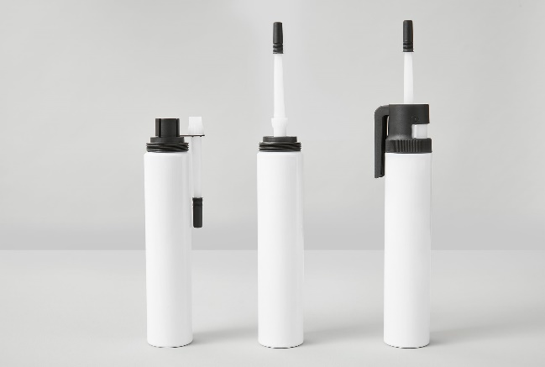

Figure 4: Reusable applicators for sealants, sold separately.

Maintenance: Aerosol products designed for connection to boilers/heating systems. Boiler connectors are sold separately.

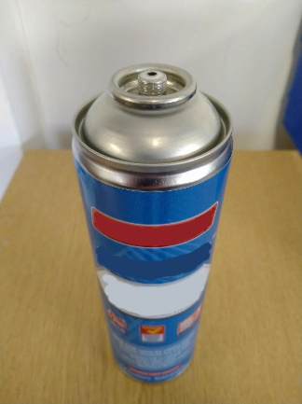

Figure 5: Maintenance product for boilers/heating systems

Cleaning Spray: Anti-virus aerosol spray, the actuator is removable and reusable with a new pack which is sold without actuator to reduced materials consumption.

Figure 6: Cleaning spray with refill pack

1. Under the proposal to define the release devise, the example aerosols above not having an actuator would not be classified as UN 1950 Aerosols for transport, so the unintended consequence will be that all aerosols will be shipped with an ‘actuator or spray cap’ whether they need them or not for their application.
2. The deletion of the reference “meeting the requirements of 6.2.4” in paragraph 9 of the proposal should not be adopted as it might lead to uncertainties/confusion.

Conclusion

1. FEA and HCPA are firmly convinced that the definition of “aerosol” should remain unchanged without further clarification:

“*Aerosol or aerosol dispenser* means an article consisting of a non-refillable receptacle meeting the requirements of 6.2.4, made of metal, glass or plastics and containing a gas, compressed, liquefied or dissolved under pressure, with or without a liquid, paste or powder, and fitted with a release device allowing the contents to be ejected as solid or liquid particles in suspension in a gas, as a foam, paste or powder or in a liquid state or in a gaseous state.”

Comments on Figures 1, 2 and 4 of document ST/SG/AC.10/C.3/2022/51

1. On Figure 1, the container is labelled with the old (pre-GHS) flame symbol, which suggests that the labelling is incorrect, or it is an outdated picture. “UN 1950” is additionally labelled on the product, which is not required. No conformity mark is visible. This outdated example should not be used to demonstrate the described problem.
2. On Figure 2, the container is marked with both the reversed epsilon ‘3’ claiming compliance with the requirements of the EU Aerosol Dispenser Directive, and the Pi “П” conformity mark for “UN 2037”. The marking with the UN number might be required in the conformity assessment. In this case the container is claiming conformity with both requirements: It is however our understanding that in a more recent version of this product the marking has been changed by the manufacturer with the deletion of the reversed epsilon (see figure 7 below).

Figure 7: Updated version of the product presented in document ST/SG/AC.10/C.3/2022/51

1. On Figure 4 in document ST/SG/AC.10/C.3/2022/51, the blue container on the right has a release device, a self-closing valve.

Figure 8: Blue container from Figure 4 fitted with a release device.