E/ECE/TRANS/505/Rev.3/Add.147/Amend.4
25 November 2022
Agreement
Concerning the Adoption of Harmonized Technical United Nations Regulations for Wheeled Vehicles, Equipment and Parts which can be Fitted and/or be Used on Wheeled Vehicles and the Conditions for Reciprocal Recognition of Approvals Granted on the Basis of these United Nations Regulations*
(Revision 3, including the amendments which entered into force on 14 September 2017)
_________
Addendum 147 – UN Regulation No. 148
Amendment 4
Supplement 4 to the original version of the Regulation – Date of entry into force:
8 October 2022
Uniform provisions concerning the approval of light-signalling devices (lamps) for power-driven vehicles and their trailers
This document is meant purely as documentation tool. The authentic and legal binding text is: ECE/TRANS/WP.29/2022/37.
_________
UNITED NATIONS

Paragraph 5.4.4.2., amend to read:
"5.4.4.2. In case of failure of any one light source in a single lamp containing more than one light source, one of the following provisions shall apply:
(a) The light intensity at the points of standard light distribution defined in paragraph 2.2. of Annex 3 shall be at least 80 per cent of the minimum intensity required; or
(b) The light intensity in the axis of reference shall be at least 50 per cent of the minimum intensity required, provided that a note in the communication form states that the lamp is only for use on a vehicle fitted with a tell-tale indicating failure."
Paragraph 5.10.2., amend to read:
"5.10.2. The lamp must be so designed that the light emitted directly towards the side, the front or the rear of the vehicle does not exceed 0.5 cd within the angular field as defined below.
(a) The vertical minimum angle φ_{min} (in degrees) is:
φ_{min} = arctan ((1-h)/10); where h is mounting height in m
(b) The vertical maximum angle φ_{max} (in degrees) is: φ_{max} = φ_{min} + 11.3
The measurement shall be limited to a horizontal angle ranging from +90° to -90° with respect to the line which cuts the reference axis and which is perpendicular to the vertical longitudinal plane of the vehicle.
The measurement distance shall be 3.0 m minimum."
Paragraph 5.11.3., amend to read:
"5.11.3. Photometric characteristics
For the approval of this device, the illumination of the space to be occupied by the plate is determined. The illuminated areas are grouped in the following categories:
Category 1a: illuminated area of at least 340 x 240 mm (Figure A3-IX).
Category 1b: illuminated area of at least 520 x 120 mm (Figure A3-X).
Category 1c: illuminated area of at least 255 x 165 mm, for use on agricultural or forestry tractors, (Figure A3-XI).
Category 2a: illuminated area of at least 330 x 165 mm (Figure A3-XII).
Category 2b: illuminated area of at least 440 x 220 mm (Figure A3-XIII).
Category 1: illuminated area of at least 130 x 240 mm for use on a vehicle of category L (Figure A3-XIV).
Category 2: illuminated area of at least 200 x 280 mm for use on a vehicle of category L (Figure A3-XV).
At each of the points of measurement shown in paragraph 3. of Annex 3, the luminance B shall be at least
(a) For categories 1a, 1b, 1c, 2a and 2b equal to 2.5 cd/m²;
(b) For categories 1 and 2 equal to 2.0 cd/m².
The gradient of the luminance between the values B₁ and B₂, measured at any two points 1 and 2 selected from among those mentioned above, shall not exceed 2 x Bo/cm, Bo being the minimum luminance measured at the various points, i.e.:
"

Figure A7-III and the text below, amend to read:
"Figure A7-III
Marking example 3
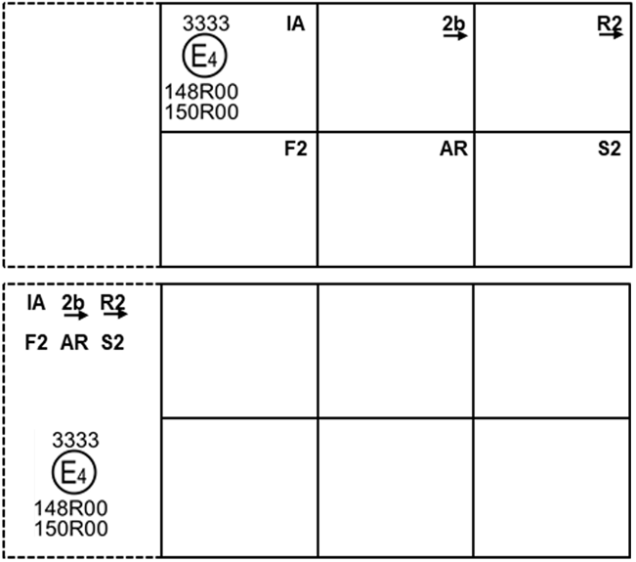
These examples of approval marks represent two possible solutions for the marking of a light signalling lamp where two or more lamps are part of the same assembly of grouped, combined or reciprocally incorporated lamps
They indicate that the lamp was approved in the Netherlands (E4) under approval number 3333 and comprises:
(a) A retro-reflector of class IA;
(b) A rear direction indicator lamp with variable luminous intensity (category 2b). The horizontal arrow shows in what position this device, which cannot be mounted on either side of the vehicle indiscriminately, is to be mounted;
(c) A rear position lamp with variable luminous intensity (R2). The horizontal arrow indicates the side on which the required photometric specifications are met up to an angle of 80° H;
(d) A rear fog lamp with variable luminous intensity (F2);
(e) A reversing lamp (AR);
(f) A stop lamp with variable luminous intensity (S2).
All these lamps (functions) are approved in accordance with the original series of amendments to this Regulation (148R) and to UN Regulation No. 150 (150R) as indicated by the number (00) mentioned after 148R and 150R respectively."

Figure A7-IV, amend to read:
"Figure A7-IV
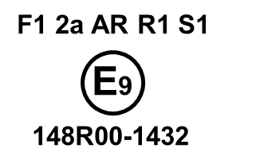
This example corresponds to the marking of a lens intended to be used in different types of light signalling lamps. The approval marks indicate that the lamp was approved in Spain (E9) under approval number 1432 and may comprise all listed different functions.
The main body of the lamp shall bear the only valid approval mark."

* Former titles of the Agreement: Agreement concerning the Adoption of Uniform Conditions of Approval and Reciprocal Recognition of Approval for Motor Vehicle Equipment and Parts, done at Geneva on 20 March 1958 (original version); Agreement concerning the Adoption of Uniform Technical Prescriptions for Wheeled Vehicles, Equipment and Parts which can be Fitted and/or be Used on Wheeled Vehicles and the Conditions for Reciprocal Recognition of Approvals Granted on the Basis of these Prescriptions, done at Geneva on 5 October 1995 (Revision 2).

