Proposal for Supplement [9] to the 03 series of amendments to UN Regulation No. 129 (Enhanced Child Restraint Systems)
Submitted by the expert from the European Association for the Co-ordination of Consumer Representation in Standardisation on behalf of Consumers International *
The text reproduced below was prepared by the expert from the European Association for the Co-ordination of Consumer Representation in Standardization (ANEC) on behalf of Consumers International (CI). It introduces an amendment to UN Regulation No. 129 (Enhanced Child Restraint System (CRS)). The modifications to the existing text of the UN Regulation are marked in bold for new or strikethrough for deleted characters.
I. Proposal

Insert new paragraph 4.6.4, to read:
"4.6.4. Only type-approved belt routings shall be indicated on the ECRS. The type-approved belt routings shall be green and no other colour. No other belt routings shall be indicated.
II. Justification
1. This additional clause prevents that green indicators suggest a belt route outside the remit of the type approval.
2. For instance an integral ECRS is type approved for statures up to 105cm and is encouraging (unauthorised) non-integral use by its green belt route indicators
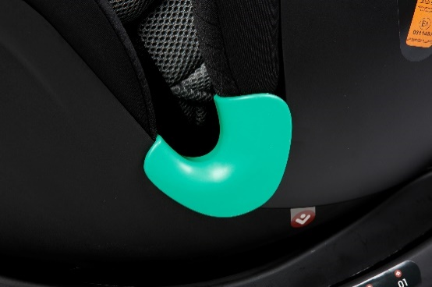

* In accordance with the programme of work of the Inland Transport Committee for 2014–2018 (ECE/TRANS/240, para. 105 and ECE/TRANS/2014/26, programme activity 02.4), the World Forum will develop, harmonize and update UN Regulations in order to enhance the performance of vehicles. The present document is submitted in conformity with that mandate.

