|  |
| --- |
| **UN/SCETDG/61/INF.8** |
| **Committee of Experts on the Transport of Dangerous Goods and on the Globally Harmonized System of Classification and Labelling of Chemicals**  **Sub-Committee of Experts on the Transport of Dangerous Goods 18 October 2022**  **Sixty-first session**  Geneva, 28 November-6 December 2022  Item 2 (b) (ix) of the provisional agenda  **Recommendations made by the Sub-Committee at its fifty-eighth,  fifty-ninth and sixtieth sessions and pending issues: explosives and related matters** |

Classification of nitrocellulose membrane filters for diagnostic and other life science applications

Submitted by the European Chemical Industry Council (Cefic) on behalf of the World Nitrocellulose Producers Association (WONIPA)

Introduction

1. Nitrocellulose (NC) membrane filters are used for diagnostic and other life science applications since several decades. Applications of these nitrocellulose membrane filters are rapid test devices for Covid 19 infections, pregnancy tests, infectious diseases like influenza, hepatitis and also Malaria, Borreliose and other diseases. In addition NC membranes are used as substrates for bioanalytical test platforms for analysis of proteins and biomarkers and microorganisms: bacterial load of water, food and beverages, medical diagnostics for identification and separation of target proteins in human blood serum (HIV, BSE etc.) via electrophoresis.

2. Nitrocellulose membrane filters UN 3270 with not more than 12.6 % nitrogen by dry mass, are classified in the division 4.1 of the UN Model Regulations for the Transport of dangerous goods. For getting this classification, special provision 237 requests, that the Nitrocellulose membrane filters, including paper separators, coatings or backing materials etc., that are present in transport, shall not be liable to propagate a detonation as tested by one of the tests described in the *Manual of Tests and Criteria* Part I, test series 1(a). In addition, the competent authority may determine on the basis of the results of suitable burning rate tests taking account of the standard tests in the *Manual of Tests and Criteria* Part III, subsection 33.2 that Nitrocellulose membrane filters in the form in which they are to be transported are not subject to the provisions of these Regulations applicable to flammable solids in division 4.1.

3. Cefic, on behalf of WONIPA, which represents in this case a group of manufacturers of NC membrane filters, which accounts for 80 % of the worldwide production of NC membrane filters for diagnostic and life science applications, presented in informal document INF.16 (sixtieth session of the Sub-Committee) a complete set of test results with UN 1(a) and UN N.1 tests for a group of NC membrane filters. These test results showed that NC-membrane filters with a NC-content of up to 53 g/m² and a paper separator of minimum 80 g/m² can be excluded from division 4.1 of the Model Regulations by using the provisions of special provision 237.

4. The informal document INF.16 (sixtieth session) was discussed in the Working Group on Explosives (EWG) and the proposal was amended by the EWG. The Working Group on Explosives unanimously recommended to accept the proposal as amended (paragraph 11 and amendment 2 of the report of the EWG in informal document INF.44 (sixtieth session). The TDG Sub-Committee requested that Cefic should submit the proposal in amendment 2 of the EWG report in an official document (paragraph 32 in ST/SG/AC.10/C.3/120), which was done in document ST/SG/AC.10/C.3/2022/59 in paragraph 6. The EWG requested that additional single package testing should be made by Cefic using inner packaging configurations subjected to a burner that is used for airbags. The TDG Sub-Committee invited Cefic to provide an electronic copy of standard ISO 15105. The electronic copy of the standard ISO 15105 was sent to the secretariat together with document ST/SG/AC.10/C.3/2022/59.

5. Due to the short time before the deadline for the submission of a working document and the summer holiday season it was not possible to finalize the additional single packaging tests before the deadline for working papers for the November/December 2022 Sub-Committee session. Cefic now provides the comprehensive test results in this additional INF paper to document ST/SG/AC.10/C.3/2022/59. The airbag burner tests showed that all packaging configurations described in the proposal for the special provision in document ST/SG/AC.10/C.3/2022/59 show a very slow burning and very low burning rates of max. 0.13 kg/min and confirm the test results of the UN N.1-tests. CEFIC, WONIPA and the producers of NC-membrane filters would therefore highly appreciate, if the Sub-Committee would adopt the special provision in ST/SG/AC.10/C.3/2022/59 at its November/December 2022 session and help by this adoption to improve the availability of Covid-19 rapid test devices worldwide. This will save a lot of work for the competent authorities worldwide, as they do not have to create competent authority decisions for each NC membrane filter type and will additionally improve the availability of the NC-membrane filters (incl. rapid test devices for Covid-19 infections) worldwide, as the transport of these filters is facilitated. A detailed description of the NC membrane filter packaging configurations, a compilation of the test results now available and the detailed test descriptions and results can be found in annexes I through III.

Test description and test results.

6. All tests were performed by the German Competent Authority BAM according to the method for airbag burner tests according to ISO 14451 part 2. An electronic copy of ISO 14451 part 2 is sent to the Sub-Committee secretariat together with this INF paper. A heat rate in the order of 80 K/min was chosen to achieve the same heating conditions as with a wood fire.

7. NC membrane filters are delivered in different product packaging configurations. Please find an overview of the NC membrane filter packaging configurations in Annex I. They are produced from a master roll of NC membrane filter, from which the different forms (round filters, sheets and small rolls) are achieved by cutting the master roll into round filters, sheets and rolls.

8. The working group on explosives requested that additional single package testing should be made by Cefic/WONIPA using inner packaging configurations subjected to a burner that is used for airbags. Cefic/WONIPA present in this informal document the test results for single package testing for all inner packaging configurations described in the special provision: for NC-membrane filter products in roll form, in sheet form, for NC-membrane round filters and single packed NC membrane filters in pouches of paper and plastic (Leporello-) packaging. The NC-membrane filters are always packed in an additional carton packaging for transport to avoid a damage of the NC-membrane filters. If damaged, they can no longer be used. The smallest inner packaging transport units packed in carton were used for the airbag burner test therefore.

9. All NC membrane filters are packed for transport in a inner packaging, e.g. plastic bags or cardboard boxes or in aluminium pouches. The NC-membrane filters are wrapped for transport in this inner packaging (cardboard or plastic film or aluminium pouch). It is important, that the sequence of NC-membrane filters and paper separators is fixed and that it is ensured that the layers lie closely upon the other. This is achieved by tightly wrapping the NC-membrane filters and the paper separators with the primary packaging.

Test results

10. Annex II shows the detailed test results for all inner packaging configurations in the special provision: for NC-membrane filter products in roll form, in sheet form, for NC-membrane round filters and single packed in pouches of paper and plastic (Leporello-) packaging. The burning time was measured and the burning rate in kg/min was calculated. As the weights of the packages are all different, only the burning rates can be used for comparison. The packaging weights, the burning time and the burning rate are given in the tables of Annex II. In addition photos of the tested inner transport packaging configuration are provided in Annex II. All samples showed a very slow burning and burning rates of max. 0.13 kg/min. These test results confirm the results of the UN N.1 tests already described in the informal document INF.16 (sixtieth session) and give an additional proof that the group of NC-membrane filters described in the special provision made in document ST/SG/AC.10/C.3/2022/59 can be excluded from the transport division 4.1.

11. In Annex III a compilation of the product descriptions and the test results of the airbag burner tests is given. The upper limit of 53 g NC/m² is covered by three tests. Also these trials with the upper limit of 53 g NC/m² show a very slow burning and vey low burning rates. Also these tests confirm the test results of the UN N.1 tests.

Proposal

12. CEFIC proposes to add the text of the special provision as contained in document ST/SG/AC.10/C.3/2022/59 to the Model Regulations, based on the complete set of test results and to add the new special provision SPXXX to the dangerous goods list in chapter 3.2 of the UN Model Regulations in Column 6 of the UN No. 3270 NITROCELLULOSE MEMBRANE FILTERS, with not more than 12.6 % Nitrogen, by dry mass.

13. If there are any questions concerning this INF paper, please contact Werner Lange at: [dr.werner.lange@icloud.com](mailto:dr.werner.lange@icloud.com). I would highly appreciate, if we could have an email discussion of the INF paper before the Sub-Committee November / December 2022 session, so that as many questions as possible can be clarified before the session.

Justification

14. Billions of Covid 19 rapid test devices are needed worldwide to control the spread of the Covid 19 pandemic. For the billions of Covid 19 rapid test devices, billions of NC membrane filters are needed as substrate. CEFIC, respectively WONIPA presents a packaging concept of the manufacturers of NC membrane filters which will simplify the transport of NC membrane filters. The simplification of the transport of NC membrane filters will improve the availability of the NC membrane filter for Covid 19 rapid test devices worldwide and by this improve the control of the Covid 19 pandemic. CEFIC presents in this INF paper a complete set of test results for NC membrane filters timely before the Sub-Committee session in November December 2022. The test results in this INF-paper fully support the exclusion of a group of NC-membrane filters clearly described in the proposal for a special provision made in document ST/SG/AC.10/C.3/2022/59.

Annex I

Overview of NC membrane filter product packaging configurations

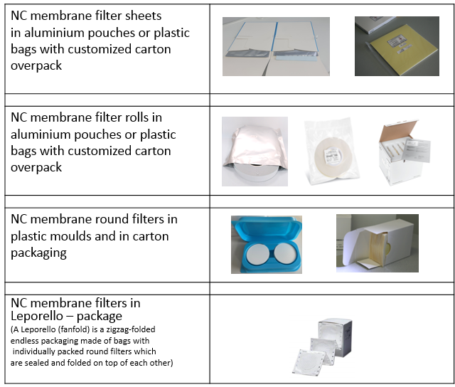

**Annex II**

Description of product configurations tested and test results of airbag burner tests

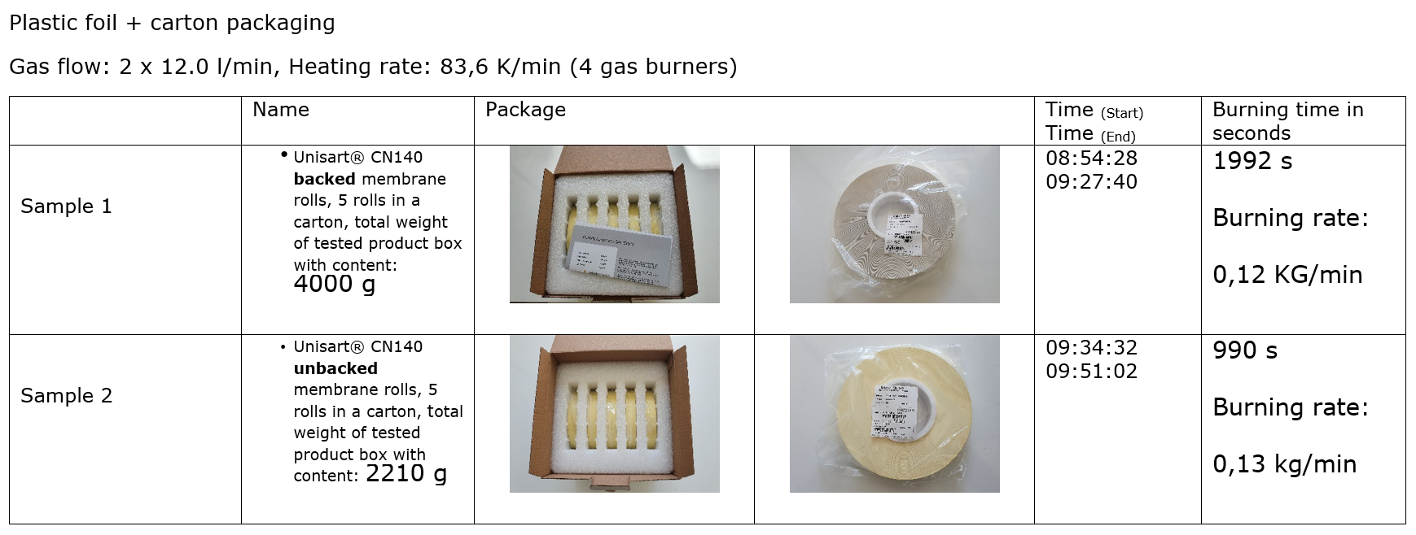

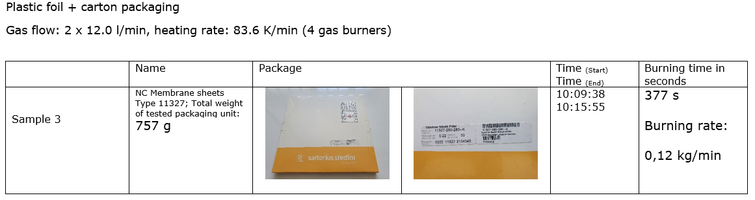

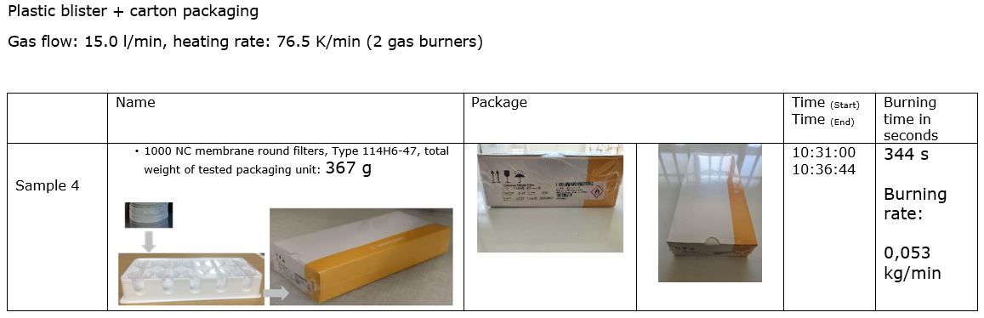

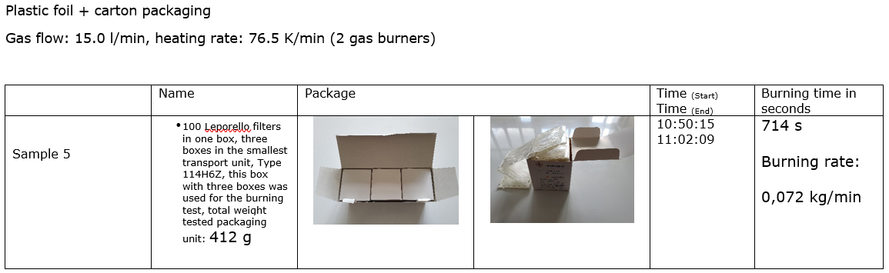

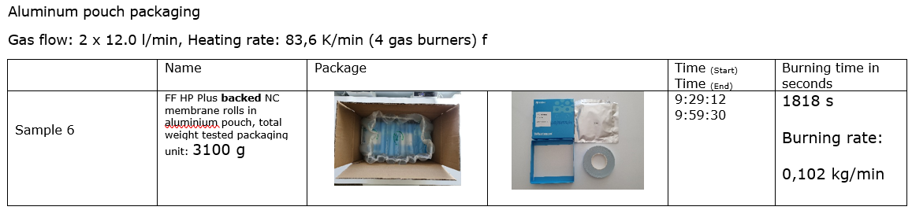

Annex III

Compilation of product descriptions and test results of airbag burner tests for NC-membrane filters



________________