E/ECE/324/Rev.1/Add.66/Rev.6/Amend.2−E/ECE/TRANS/505/Rev.1/Add.66/Rev.6/Amend.2
14 September 2022
Agreement
Concerning the Adoption of Harmonized Technical United Nations Regulations for Wheeled Vehicles, Equipment and Parts which can be Fitted and/or be Used on Wheeled Vehicles and the Conditions for Reciprocal Recognition of Approvals Granted on the Basis of these United Nations Regulations*
(Revision 3, including the amendments which entered into force on 14 September 2017)
_________
Addendum 66 – UN Regulation No. 67
Revision 6 - Amendment 2
04 series of amendments – Date of entry into force: 22 June 2022
Uniform provisions concerning the approval of:
I. Specific equipment of vehicles of category M and N using liquefied petroleum gases in their propulsion system
II. Vehicles of category M and N fitted with specific equipment for the use of liquefied petroleum gases in their propulsion system with regard to the installation of such equipment
This document is meant purely as documentation tool. The authentic and legal binding text is: ECE/TRANS/WP.29/2021/97.
_________
UNITED NATIONS
Paragraph 5.2., amend to read:
"5.2. An approval number shall be assigned to each type of equipment approved in accordance with Schedule 4 of the Agreement (E/ECE/TRANS/505/Rev.3)."
Paragraph 16.2., amend to read:
"16.2. An approval number shall be assigned to each type of vehicle approved in accordance with Schedule 4 of the Agreement (E/ECE/TRANS/505/Rev.3)."
Paragraphs 17.1.8. to 17.1.8.2., amend to read:
"17.1.8. Identification of LPG-fuelled vehicles
17.1.8.1. Vehicles of categories M₂/N₂ and M₃/N₃ shall be labelled as specified in Annex 17.
17.1.8.2. These labels shall be placed on the front of the vehicle and on the left side as well as on the right side of the vehicle; for the side if available in vicinity of a front door. If there is no front door available, the label has to be placed on the first third of the vehicle length. In addition, for vehicles of category M₂ and M₃, a label shall be fixed to the rear of the vehicle."
Insert new paragraphs 22.19. to 22.23., to read:
"22.19. As from the official date of entry into force of the 04 series of amendments, no Contracting Party applying this Regulation shall refuse to grant or refuse to accept type approvals under this Regulation as amended by the 03 series of amendments.
22.20. As from 1 September 2023, Contracting Parties applying this Regulation shall not be obliged to accept type approvals to the preceding series of amendments, first issued after 1 September 2023.
22.21. Until 1 September 2025, Contracting Parties applying this Regulation shall accept type approvals to the preceding series of amendments, first issued before 1 September 2023.
22.22. As from 1 September 2025, Contracting Parties applying this Regulation shall not be obliged to accept type approvals issued to the preceding series of amendments to this Regulation.
22.23. Notwithstanding paragraph 22.22. above, Contracting Parties applying the UN Regulation shall continue to accept UN type-approvals issued according to the preceding series of amendments to the UN Regulation, for the vehicles / vehicle systems / vehicle components which are not affected by the changes introduced by the 04 series of amendments."
Annex 17 amend to read:

"Annex 17
Provisions regarding LPG identification marks for vehicles of categories M₂/N₂ and M₃/N_{3.}
(Paragraph 17.1.8. of this Regulation)
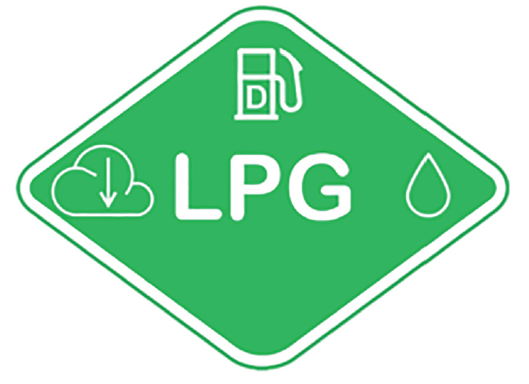
The label shall be weather resistant.
The centre zone indicates the first energy source.
The upper zone indicates the second energy source.
The left zone indicates the gas behaviour due to density.
The right zone indicates the state of aggregation of stored gaseous fuel.
Layout and symbols shall be in accordance with ISO 17840-4:2018.
The colour and dimensions of the label shall fulfil the following requirements:
Colours:
Background: Green, RGB code 0, 176, 80
Border: white reflecting
Letters and symbols: white reflecting
Dimensions:
Sticker width: > 110 mm
Sticker height: > 80 mm "

* Former titles of the Agreement: Agreement concerning the Adoption of Uniform Conditions of Approval and Reciprocal Recognition of Approval for Motor Vehicle Equipment and Parts, done at Geneva on 20 March 1958 (original version); Agreement concerning the Adoption of Uniform Technical Prescriptions for Wheeled Vehicles, Equipment and Parts which can be Fitted and/or be Used on Wheeled Vehicles and the Conditions for Reciprocal Recognition of Approvals Granted on the Basis of these Prescriptions, done at Geneva on 5 October 1995 (Revision 2).

