|  |  |  |  |
| --- | --- | --- | --- |
|  | United Nations | ECE/TRANS/WP.29/2022/131 | |
| _unlogo | **Economic and Social Council** | | Distr.: General  30 August 2022  Original: English |

**Economic Commission for Europe**

Inland Transport Committee

**World Forum for Harmonization of Vehicle Regulations**

**188th session**

Geneva, 14-16 November 2022

Item 4.8.4 of the provisional agenda

**1958 Agreement:  
Consideration of draft amendments to existing UN Regulations submitted by GRSP**

Proposal for Supplement 9 to the 01 series of amendments to UN Regulation No. 129 (Enhanced Child Restraint Systems)

Submitted by the Working Party on Passive Safety [[1]](#footnote-2)\*

The text reproduced below was adopted by the Working Party on Passive Safety (GRSP) at its seventy-first session (ECE/TRANS/WP.29/GRSP/71, para. 25). It is based on ECE/TRANS/WP.29/GRSP/2022/5 not amended. It is submitted to the World Forum for Harmonization of Vehicle Regulations (WP.29) and to the Administrative Committee (AC.1) for consideration at their November 2022 sessions.

.

*Annex 15,* amend to read:

"**Annex 15**

**Description of Conditioning for Adjusters**

Figure 1

**Conditioning for adjusters mounted directly on Enhanced Child Restraint Systems**

**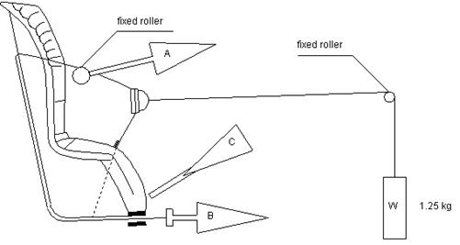**

1. Conditioning for adjusters mounted directly on Enhanced Child Restraint Systems (Figure 1)

1.1. Method

1.1.1. With the webbing set at the reference position described in paragraph 7.2.6.1., withdraw at least 50 mm of webbing from the integral harness by pulling on the free end of the webbing.

1.1.2. Attach the adjusted part of the integral harness to the pulling device A.

1.1.3. Activate the adjuster and pull at least 150 mm of webbing into the integral harness. This represents half of one cycle and puts pulling device A to the maximum webbing extraction position.

1.1.4. Connect free end of webbing to pulling device B.

1.2. The procedure of the cycle is:

1.2.1. Pull B at least 150 mm while A exerts no tension on the integral harness.

1.2.2. Activate the adjusters (C) and pull A while B exerts no tension on the free end of the webbing.

1.2.3. At the end of stroke, de-activate the adjuster.

1.2.4. Repeat cycle as specified in paragraph 6.7.2.7. of this UN Regulation.

Figure 2

**Conditioning for adjusters connected to a strap (not directly mounted on Enhanced Child Restraint Systems)**

Adjuster (rigidly clamped)

Strap

Strap end clamped or fixed to ECRS

2. Conditioning for adjusters connected to a strap (not directly mounted on Enhanced Child Restraint Systems) (Figure 2)

2.1. Method

2.1.1. Rigidly clamp the adjuster

2.1.2. With the strap set at the reference position described in paragraph 7.2.6.2., withdraw at least 50 mm of strap from the adjuster by pulling on the free end of the strap.

2.1.3. Attach the adjuster part of the strap to the pulling device A.

2.1.4. Activate the adjuster (C) and pull at least 150 mm of strap through the adjuster. This represents half of one cycle and puts pulling device A to the maximum strap extraction position.

2.1.5. Connect the free end of the strap to pulling device B.

2.2. The cycle is:

2.2.1. Pull B at least 150 mm while A does not exert tension on the strap.

2.2.2. Activate the adjuster (C) and pull A while B does not exert tension on the free end of the strap.

2.2.3. At the end of the stroke, de-activate the adjuster.

2.2.4. Repeat the cycle as specified in paragraph 6.7.2.7. of this Regulation."

1. \* In accordance with the programme of work of the Inland Transport Committee for 2022 as outlined in proposed programme budget for 2022 (A/76/6 (part V sect. 20) para 20.76), the World Forum will develop, harmonize and update UN Regulations in order to enhance the performance of vehicles. The present document is submitted in conformity with that mandate. [↑](#footnote-ref-2)