|  |  |  |  |
| --- | --- | --- | --- |
|  | United Nations | ECE/TRANS/WP.29/GRSP/2022/25 | |
| _unlogo | **Economic and Social Council** | | Distr.: General  20 September 2022  Original: English |

**Economic Commission for Europe**

Inland Transport Committee

**World Forum for Harmonization of Vehicle Regulations**

**Working Party on Passive Safety**

**Seventy-second session**

Geneva, 5–9 December 2022

Item 10 of the provisional agenda

**UN Regulation No. 129 (Enhanced Child Restraint Systems)**

Proposal for Supplement 9 to the 03 Series of Amendments to UN Regulation No. 129 (Enhanced Child Restraint Systems)

Submitted by the expert from the European Association of Automotive Suppliers [[1]](#footnote-2)\*

The text reproduced below was prepared by the expert from the European Association of Automotive Suppliers (CLEPA) to amend UN Regulation No.129 to correct previous editing mistakes and to harmonize the vertical excursion limit for Q3 and Q6 dummies. The modifications to the current text of the UN Regulation are marked in bold for new or strikethrough for deleted characters.

I. Proposal

*Paragraph 6.6.4.4.1.1.*, amend to read:

"**6.6.4.4.1.1. Forward-facing Enhanced Child Restraint Systems**

**Integral Enhanced Child Restraints: No part of the head of the dummy shall pass beyond the planes BA, DA and DE as defined in Figure 4 below:**

**(a) The value in relation to the BA plane is 500 mm; and**

**(b) The value in relation to the DA plane is 800 mm, except when testing with the Q3 or Q6 dummy where the value is 840 mm; and**

**(c) However, the head of the dummy may pass beyond the DE plane, if the head pad or the backrest part of the child restraint structure, which is behind the head of the dummy, at the point the head, passes the DE plane; and**

**(d) In case of** **dummy contact with a rigid part of the test bench in the rebound phase, the head acceleration criterion during that contact shall not be considered.**

**This shall be judged up to 300 ms or at the moment when the dummy comes to a definitive standstill, whatever occurs first.**

**Non-integral booster seat: No part of the head of the dummy shall pass beyond the planes BA and DA as defined in Figure 4 below.**

**This shall be judged up to 300 ms or the moment that the dummy has come to a definitive standstill, whatever occurs first.**

**When testing with the Q3 or Q6 dummy, the following applies:**

**The value in relation to the DA plane is 840 mm.**

**When testing the Q10 dummy, the following apply:**

**(a) The value in relation to the BA plane is 550 mm; and**

**(b) The value in relation to the DA plane is 840 mm; and**

**(c) The rebound phase is not considered for the assessment of the plane DA.**

**Non-integral booster cushion: No part of the head of the dummy shall pass beyond the planes BA and DA as defined in Figure 4 below.**

**This shall be judged up to 300 ms or the moment that the dummy has come to a definitive standstill, whatever occurs first.**

**When testing with the Q6 dummy, the following applies:**

**The value in relation to the DA plane is 840 mm.**

**When testing using Q10 dummy the following apply:**

**(a) The value in relation to the BA plane is 550 mm; and**

**(b) The value in relation to the DA plane is 840 mm; and**

**(c) The rebound phase is not considered for the assessment of the plane DA; and**

**(d) In case of dummy contact with a rigid part of the test bench in the rebound phase, the head acceleration criterion during that contact shall not be considered.**

**6.6.4.4.1.1.1. Where a test is conducted in accordance with paragraph 6.6.4.1.6.1.1. or paragraph 6.6.4.1.6.1.2. or paragraph 6.6.4.1.8.2. above, a tolerance of +10 per cent shall be applicable to the head excursion value distance between the Cr point and plane AB.**

Figure 4

**Arrangement for Testing a Forward-Facing Device**

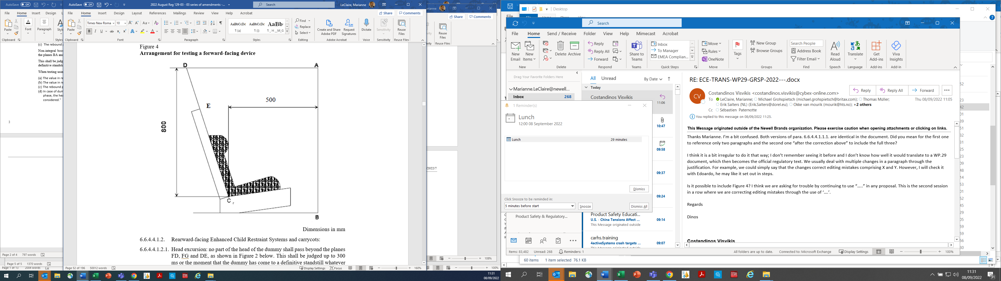"

*Paragraph* 7.1.3.6.4*.*, amend to read:

"7.1.3.6.4. The test specified in paragraph ~~6.6.4.1.6.2.~~ **6.6.4.1.6.1.1.** above is a requirement only for the largest dummy for which the child restraint is designed."

II. Justification

The proposed amendments to paragraph 6.6.4.4.1.1. are firstly to correct mistakes in the Regulation text (see section A) and then secondly to harmonize the vertical excursion limit for Q3 and Q6 dummies (see section B):

The proposed amendments 7.1.3.6.4. are to correct mistakes in the Regulation text (see section A).

A. The Amendments Above Correct Editing Mistakes as Follows:

**1. Error Number One:**

1. There is potential for a mistake in paragraph 6.6.4.4.1.1. if the legal text is strictly followed.

2. When document ECE/TRANS/WP.29/GRSP/2019/35 was adopted, then submitted to WP.29 as document ECE/TRANS/WP.29/2020/58, Supplement 04 to the 03 Series to UN Regulation No. 129, there was an instruction line and some "….." missing from that document. The missing items indicated that new text was to be added after the existing text in paragraph 6.6.4.4.1.1.

3. If the instruction text and "….." remain missing, the legal text in ECE/TRANS/WP.29/2020/58 could be seen as a replacement of text for the entire of paragraph 6.6.4.4.1.1. This would lead to the deletion of requirements for head excursion, for integral Enhanced Child Restraints Systems (ECRS).

There are differences in the way that authorities incorporated the change, which has led to translations containing different versions of the text.

4. The complete text, before amendments should show the requirements for allforward-facing types:

• Integral ECRS

• Non-integral booster seat and

• Non-integral booster cushion.

The complete text should be reinstated as follows:

"6.6.4.4.1.1. "Forward-facing Enhanced Child Restraint Systems

Integral Enhanced Child Restraints: No part of the head of the dummy shall pass beyond the planes BA, DA and DE as defined in Figure 4 below:

(a) The value in relation to the BA plane is 500 mm; and

(b) The value in relation to the DA plane is 800 mm; and

(c) However, the head of the dummy may pass beyond the DE plane, if the head pad or the backrest part of the child restraint structure, which is behind the head of the dummy, at the point the head, passes the DE plane; and

(d) In case of dummy contact with a rigid part of the test bench in the rebound phase, the head acceleration criterion during that contact shall not be considered.

This shall be judged up to 300 ms or the moment that the dummy has come to a definitive standstill, whatever occurs first.

Non-integral booster seat: No part of the head of the dummy shall pass beyond the planes BA and DA as defined in Figure 4 below.

This shall be judged up to 300 ms or the moment that the dummy has come to a definitive standstill, whatever occurs first.

When testing with the Q10 dummy, the following apply:

(a) The value in relation to the BA plane is 550 mm; and

(b) The value in relation to the DA plane is 840 mm; and

(c) The rebound phase is not considered for the assessment of the plane DA.

Non-integral booster cushion: No part of the head of the dummy shall pass beyond the planes BA and DA as defined in Figure 4 below.

This shall be judged up to 300 ms or the moment that the dummy has come to a definitive standstill, whatever occurs first.

When testing using Q10 dummy the following apply:

(a) The value in relation to the BA plane is 550 mm; and

(b) The value in relation to the DA plane is 840 mm; and

(c) The rebound phase is not considered for the assessment of the plane DA.

(d) In case of dummy contact with a rigid part of the test bench in the rebound phase, the head acceleration criterion during that contact shall not be considered.

6.6.4.4.1.1.1. Where a test is conducted in accordance with paragraph 6.6.4.1.6.1.2. or paragraph 6.6.4.1.8.2. above, a tolerance of +10 per cent shall be applicable to the head excursion value distance between Cr point and plane AB.

Figure 4

**Arrangement for testing a forward-facing device**



"

**2. Error Number Two (Raised by TSG):**

5. In paragraph 6.6.4.4.1.1.1., a reference is missing. Current text of the UN Regulation, after amending the text to address error one above reads as follows:

"6.6.4.4.1.1.1. Where a test is conducted in accordance with paragraph 6.6.4.1.6.1.2. or paragraph 6.6.4.1.8.2. above, a tolerance of +10 per cent shall be applicable to the head excursion value distance between Cr point and plane AB."

6. The paragraph should read:

"6.6.4.4.1.1.1. Where a test is conducted with paragraph 6.6.4.1.6.1.1. or paragraph 6.6.4.1.6.1.2. or paragraph 6.6.4.1.8.2. above, a tolerance of +10 per cent shall be applicable to the head excursion value distance between Cr point and plane AB."

**3. Error Number Three (Raised by TSG):**

7. There is a reference to a paragraph that does not exist in the Regulation. Current text of the UN Regulation:

"7.1.3.6.4. The test specified in paragraph 6.6.4.1.6.2. above is a requirement only for the largest dummy for which the child restraint is designed."

Paragraph 6.6.4.1.6.2. does not exist.

Paragraph 7.1.3.6.4. should reference paragraph 6.6.4.1.6.1.1., the misuse test without the anti-rotation device in use, as follows:

"7.1.3.6.4. The test specified in paragraph 6.6.4.1.6.1.1. above is a requirement only for the largest dummy for which the child restraint is designed."

B. The Proposed Amendments to Paragraph 6.6.4.4.1.1 Harmonize the Vertical Excursion Limit for Q3 and Q6 Dummies

8. The 03 Series of amendments to UN Regulation No. 129 were a combination of documents ECE/TRANS/WP29/2018/42 and ECE/TRANS/WP.29/2018/45.

9. Document ECE/TRANS/WP.29/2018/45, amended paragraph 6.6.4.4.1.2. for rearward-facing ECRS and carrycots:

6.6.4.4.1.2.1. was amended to read as follows:

"6.6.4.4.1.2.1. Head excursion: no part of the head of the dummy shall pass beyond the planes FD, FG and DE, as shown in figure 2 below. This shall be judged up to 300 ms or the moment that the dummy has come to a definitive standstill whatever occurs first.

Except when testing using Q6 or Q3 dummy where the value in relation to the FD plane is 840 mm.

Where a test is conducted with paragraph 6.6.4.1.6.1.1. or paragraph 6.6.4.1.6.1.2. or paragraph 6.6.4.1.8.2. above, only the second test results without 100 mm diameter bar will be considered.

Figure 2

**Arrangement for Testing a Rearward-Facing Device, Not Supported by the Dashboard**

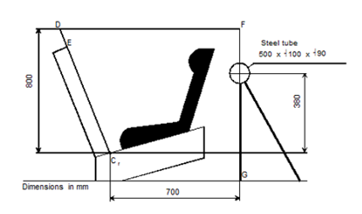

10. In paragraph 6.6.4.4.1.1. for forward-facing Enhanced Child Restraint Systems there was an existing allowance for vertical excursion up to 840mm:

"Head excursion: No part of the head of the dummy shall pass beyond the planes BA, DA and DE as defined in Figure 1 below. This shall be judged up to 300 ms or the moment that the dummy has come to a definitive standstill whatever occurs first. Except for booster seats when testing using Q10 dummy where:

(a) The value in relation to the DA plane is 840 mm; and

(b) The value in relation to the BA plane is 550 mm; and

(c) The rebound phase is not considered for the assessment of the plane DA and DE."

Since the vertical excursion of 840 mm is already well established for the Q10 in the forward-facing direction and Q3 and Q6 in the rearward-facing direction, itis very natural to also accept the vertical excursion of 840 mm for the Q3 and Q6 dummies in the forward-facing direction. This would harmonize the vertical excursion requirements to be consistent in all circumstances for the Q3, Q6 and Q10 dummies.

11. This amendment is not seen to have any negative consequences for the safety level of children, since the vertical excursion has existed at 840 mm in the Regulation for the relevant dummies.

12. Measurements of the space available in a sample of vehicles, show that the minimum vertical distance available from the Cr point in the vehicles was in most vehicles between 880 mm and 960 mm and in all cases more than 840 mm. Therefore, the space for the vertical excursion of 840mm is available in vehicles.

1. \* In accordance with the programme of work of the Inland Transport Committee for 2022 as outlined in the proposed programme budget for 2022 (A/76/6, part V, sect. 20, para. 20.76), the World Forum will develop, harmonize and update UN Regulations in order to enhance the performance of vehicles. The present document is submitted in conformity with that mandate. [↑](#footnote-ref-2)