E/ECE/324/Rev.1/Add.53/Rev.3/Amend.6−E/ECE/TRANS/505/Rev.1/Add.53/Rev.3/Amend.6
3 December 2021
Agreement
Concerning the Adoption of Harmonized Technical United Nations Regulations for Wheeled Vehicles, Equipment and Parts which can be Fitted and/or be Used on Wheeled Vehicles and the Conditions for Reciprocal Recognition of Approvals Granted on the Basis of these United Nations Regulations*
(Revision 3, including the amendments which entered into force on 14 September 2017)
_________
Addendum 53 – UN Regulation No. 54
Revision 3 - Amendment 6
Supplement 24 to the original version of the Regulation – Date of entry into force:
30 September 2021
Uniform provisions concerning the approval of pneumatic tyres for commercial vehicles and their trailers
This document is meant purely as documentation tool. The authentic and legal binding texts is: ECE/TRANS/WP.29/2021/5
_________

UNITED NATIONS
Title of the Regulation, amend to read:
"Uniform provisions concerning the approval of pneumatic tyres for commercial vehicles and their trailers"
Paragraph 2.6.2., amend to read:
"2.6.2. "Radial" or "radial-ply" describes a tyre structure in which the ply cords extend to the beads and are laid substantially at 90° to the centreline of the tread, the carcass being stabilized by an essentially inextensible circumferential belt;"
Paragraph 2.20., amend to read:
"2.20. "Tyre-size designation" means, except in the case of types of tyre for which the tyre-size designation is shown in the first column of the tables in Annex 5 to this Regulation, a designation showing:"
Paragraph 2.20.1., delete.
Paragraph 2.20.1.1., renumber as 2.20.1. and amend to read:
"2.20.1. The nominal section width (S₁);"
Paragraph 2.20.1.2., renumber as 2.20.2. and amend to read:
"2.20.2. The nominal aspect ratio or, depending on the tyre design type, the nominal outer diameter expressed in mm;"
Insert new paragraphs 2.20.3. to 2.20.3.2., to read:
"2.20.3. An indication of the structure placed in front of the rim diameter marking as follows:
2.20.3.1. On diagonal (bias-ply) tyres, a dash "-" or the letter "D";
2.20.3.2. On radial-ply tyres, the letter "R";"
Paragraphs 2.20.1.3. and 2.20.1.3.1., renumber as 2.20.4. and 2.20.4.1., respectively.
Paragraph 2.20.1.4., renumber as 2.20.5. and amend to read:
"2.20.5. An indication of the tyre to rim fitment configuration when it differs from the standard configuration and is not already expressed by the symbol "d" denoting the nominal rim diameter code; in the case of tyres first approved after 1 March 2004 this identification shall be placed only immediately after the rim diameter marking;"
Insert a new paragraph 2.20.6., to read:
"2.20.6. The prefix "LT" before the nominal section width, or the suffix "C" or "LT" after the rim diameter marking or, if applicable, after the tyre to rim fitment configuration; notwithstanding the foregoing, instead of a prefix or a suffix to the tyre-size designation "LT" may be placed after the service description;"
Insert new paragraphs 2.20.8. and 2.20.9., to read:
"2.20.8. The suffix "MPT" after the rim diameter marking for tyres specifically designed for the equipment of multi-purpose commercial vehicles;
2.20.9. The prefix "ST" before the nominal section width for tyres specifically designed for the equipment of special trailers."
Insert a new paragraph 2.35., to read:
"2.35. "Service description" means the association of the load index or indices with a speed category symbol (for example, 164M or 121/119S); the service description may include either one or two load indices which indicate the load the tyre can carry in single or in single and dual operation."
Paragraph 3.1.4., amend to read:
"3.1.4. (Omitted)"
Paragraphs 3.1.4.1. and 3.1.4.2., delete.
Paragraph 3.1.12., amend to read:
"3.1.12. (Omitted)"
Paragraph 3.1.14., amend to read:
"3.1.14. The inscription "LT" after the service description, if it is not marked as part of the tyre size designation; tyres whose tyre-size designation includes the suffix "C" or "CP" may be marked with the additional inscription "LT" away from the tyre-size designation;"
Paragraph 3.1.14.1., renumber as 2.20.6.1.
Paragraph 3.1.14.2., renumber as 2.20.6.2.
Paragraph 3.1.15., renumber as 2.20.7. and amend to read:
"2.20.7. The suffix "CP" after the rim diameter marking or, if applicable, after the tyre to rim fitment configuration; this marking is mandatory in the case of tyres fitted on 5° drop centre rims, having a load capacity index in single lower or equal to 121 and specifically designed for the equipment of motor caravans;"
Paragraph 3.1.16., renumber as 3.1.15.
Paragraph 3.4., amend to read:
"3.4. The markings referred to in paragraph 3.1 and the approval mark prescribed in paragraph 5.4. of this Regulation shall be clearly legible, indelible and raised above or sunk below the tyre surface."
Paragraph 3.4.1., amend to read:
"3.4.1. The markings shall be situated in the lower area of the tyre on at least one of its sidewalls, except for the inscriptions mentioned in paragraphs 3.1.1. and 3.1.2.
However, for tyres identified by the "tyre to rim fitment configuration" (see paragraph 2.20.1.4) symbol "A", the markings may be placed anywhere on the sidewall of the tyre."
Insert a new paragraph 3.4.2. to read:
"3.4.2. In the case that the date of manufacture is not moulded, it shall be applied not later than 24 hours after the tyre is removed from the mould."
Paragraph 4.1.13, amend to read:
"4.1.13. The additional load/speed combinations and, if different from the inflation pressure specified according to paragraph 4.1.12, the applicable inflation pressure in cases where paragraph 6.2.5. below is applied."
Paragraph 6.1.2.1., amend to read:
"6.1.2.1. …
d is the conventional number defined in paragraph 2.20.4. above, expressed in millimetres;
…"
Paragraph 6.2.3., amend to read:
"6.2.3. Except for tyres with radial structure, the outer diameter of the tyre, measured six hours after the load/speed endurance test, must not differ by more than ±3.5 per cent from the outer diameter as measured before the test."
Paragraph 6.2.5., amend to read:
"6.2.5. Where application is made for the approval of a type of tyre which has a load/speed combination in addition to the one that is subject to the variation of load with speed given in the table in Annex 8, the endurance test prescribed in paragraph 6.2.1. above shall also be carried out on a second tyre of the same type at the additional load/speed combination and the applicable inflation pressure. At the option of the tyre manufacturer, one test at the highest load index, the highest speed symbol and the lowest test inflation pressure indicated may be submitted."
Insert a new paragraph 12., to read:
"12. Transitional provisions
12.1. Until 3 months after the date of entry into force of Supplement 24 to the original version of this Regulation, Contracting Parties applying this Regulation may continue to grant and/or extend type approvals according to the original version of this Regulation, without taking into account the provisions of Supplement 24.
12.2. For tyres first approved before the entry into force of Supplement 24 the markings "MPT" and "ST" do not need to be placed as a prefix or a suffix to the tyre size designation."
Annex 1
Item 4.1., amend to read
"4.1. Tyre-size designation "
Annex 3
Figure, amend to read:
"Example 1:
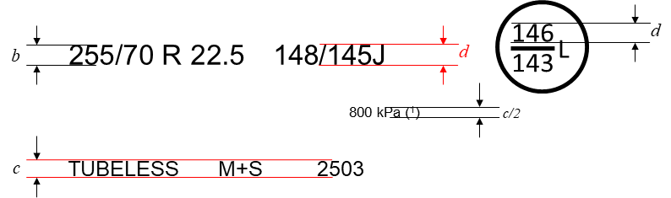
(¹) PSI marking instead of kPa is allowed for tyres first type approved before 1 January 2018. The kPa marking may be preceded by "TEST AT :" or, alternatively, by "TEST INFL :" or the symbol "@".

Example 2:
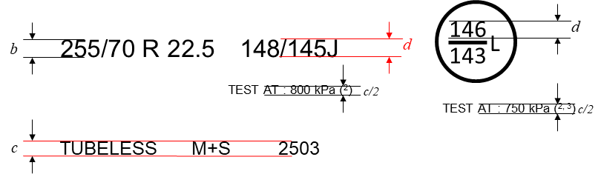

(²) "TEST AT :" may be replaced by "TEST INFL :" or the symbol "@" or be omitted.
(³) The indication of a second inflation pressure for the additional service description is optional. If there is no indication, the same test inflation applies to both load/speed combinations.
Dimensional requirements for further markings (⁴):
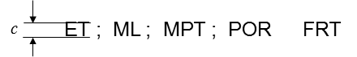
(⁴) For "ML" and "MPT" being part of the tyre size designation marking the minimum dimension b applies."
Paragraph 1., last indent, amend to read:
"…
Requiring to be inflated to 800 kPa for both load/speed endurance tests in Example 1 and 800 kPa for the load/speed endurance test according to the main load/speed combination and 750 kPa for the test according to the additional load/speed combination in Example 2."
Insert a new subparagraph 3. (e) to read:
"(e) If there are two indications for the test inflation pressure, they must be placed in such a way that it is clear which pressure indication belongs to which load/speed combination."
Annex 5
Part II, Table B,
Note 4, delete the quotation marks at the end of the text and amend to read:
"⁴ In case of tyre-size designations …
…
The outer diameter (D) is calculated as follows:
(a) Highway Tread D (mm) = (overall diameter (expressed by code) – 0.48) · 25.4 rounded to the nearest mm.
(b) Traction Tread D (mm) = (overall diameter (expressed by code) – 0.24) · 25.4 rounded to the nearest mm. "
Note 5, amend to read:
"⁵ Traction tread tyres are those bearing at least one of the following inscriptions:
- Inscription(s) defined in section 3.1.13. of this Regulation.
- Alpine symbol as defined in UN Regulation No. 117.
- "TRACTION" inscription as defined in UN Regulation No. 117."
Annex 9, item 5.3., delete the quotation marks at the end of the text.

* Former titles of the Agreement: Agreement concerning the Adoption of Uniform Conditions of Approval and Reciprocal Recognition of Approval for Motor Vehicle Equipment and Parts, done at Geneva on 20 March 1958 (original version); Agreement concerning the Adoption of Uniform Technical Prescriptions for Wheeled Vehicles, Equipment and Parts which can be Fitted and/or be Used on Wheeled Vehicles and the Conditions for Reciprocal Recognition of Approvals Granted on the Basis of these Prescriptions, done at Geneva on 5 October 1995 (Revision 2).

