|  |  |  |  |
| --- | --- | --- | --- |
|  | United Nations | ECE/TRANS/WP.29/GRBP/2022/12 | |
| _unlogo | **Economic and Social Council** | | Distr.: General  15 June 2022  Original: English |

**Economic Commission for Europe**

Inland Transport Committee

**World Forum for Harmonization of Vehicle Regulations**

**Working Party on Noise and Tyres**

**Seventy-sixth session**

Geneva, 5–7 September 2022

Item 4 (c) of the provisional agenda

**Tyres: UN Regulation No. 117 (Tyre rolling resistance, rolling noise and wet grip)**

**Proposal for the 04 series of amendments to UN Regulation No. 117**

**Submitted by the experts from the European Commission[[1]](#footnote-2)\***

The text reproduced below was prepared by the experts from the European Commission. The modifications to the existing text of the UN Regulation are marked in bold for new or strikethrough for deleted characters and are indicated in relation to ECE/TRANS/WP.29/2022/83 – a proposal for the 03 series of amendments to UN Regulation No. 117 that is anticipated to be adopted at the June 2022 session of the World Forum for Harmonization of Vehicle Regulations (WP.29).

**I. Proposal**

*Paragraph 1.1.7.,* amend to read:

"1.1.7. Tyres designed only to be fitted to vehicles registered for the first time before 1 October ~~1990~~**2000**."

*Paragraph 4.3.1.,* amend to read:

"4.3.1. In case the approval of a tyre pursuant to this Regulation has been granted by the same Type Approval Authority than that granting the approval pursuant to Regulation No. 30 or Regulation No. 54, the approval mark pursuant to Regulation No. 30 or Regulation No. 54 can be combined with an indication of the applicable series of amendments to which the tyre was approved pursuant to Regulation No. 117 on the form of 2 digits (example "0~~3~~**4**" indicating that the Regulation No.117 approval was granted following the 0~~3~~**~~4~~** series of amendments) and the suffixes according to paragraph 5.2.2. using the addition sign "+", as described in Annex 2, Appendix 3 of this Regulation, for example "0236378 + 0~~3~~**~~4~~**S2W**2**R~~2~~**3**B"

*Paragraph 5.2.2.,* amend to read:

"5.2.2. The communication form mentioned in paragraph 5.3. below shall identify specific performance parameters of Regulation No. 117 by the following suffixes:

S To identify additional conformity to the requirements on tyre rolling sound emissions;

W To identify additional conformity to the requirements on adhesion on wet surfaces of tyres in new state;

R To identify additional conformity to the requirements on tyre rolling resistance;

B To identify additional conformity to the requirements on adhesion on wet surfaces of tyres in worn state.

S ~~and R~~ will be followed by the suffix "2" for compliance to stage 2 **while, taking into account that two stages are defined for adhesion on wet surfaces of tyres in new state and rolling resistance specifications in paragraphs 6.2. and 6.3. below, W will be followed either by the suffix "1" for compliance to stage 1 or by the suffix "2" for compliance to stage 2 and R will be followed either by the suffix "2" for compliance to stage 2 or by the suffix "3" for compliance to stage 3.**"

*Paragraph 5.3.1.2.,* amend to read:

"5.3.1.2. The suffix(es) mentioned in paragraph 5.2.2. above shall be preceded by the two digits identifying the series of amendments of the prescription on tyre performances for Regulation No. 117, e.g. 0~~3~~**4**S2to identify the ~~third~~ **fourth** series of amendments on tyre road rolling sound emissions at stage 2 or 0~~3~~**4**S2W**2**R~~2~~**3B** to identify the ~~third~~ **fourth** series of amendments on tyre road rolling sound emissions at stage 2, adhesion on wet surfaces of a tyre in new state **at stage 2** ~~and~~ **,** rolling resistance at stage ~~2~~**3** **and adhesion on wet surfaces of a tyre in worn state**."

*Paragraph 5.4.3.*,amend to read:

"5.4.3. The suffix(es), and the identification to the relevant series of amendments, if any, as specified in the communication form.

One of the suffixes listed below or any combination of them can be used.

|  |  |
| --- | --- |
| S2 | Rolling sound emission level at stage 2 |
| W**1** | Wet adhesion levelin new state **at stage 1** |
| **W2** | **Wet adhesion level in new state at stage 2** |
| R2 | Rolling resistance level at stage 2 |
| **R3** | **Rolling resistance level at stage 3** |
| B | Wet adhesion level of tyres in worn state |

These suffixes shall be placed to the right or below the approval number, if part of the original approval.

If the approval is extended subsequent to Regulation No. 30 or 54 approvals, the addition sign "+" and the series of amendment to Regulation No. 117 shall be placed in front of the suffix or any combination of suffixes to denote an extension to the approval.

If the approval is extended subsequent to the original approval under Regulation No. 117, the addition sign "+" shall be placed between the suffix or any combination of suffixes of the original approval and the suffix or any combination of suffixes added to denote an extension to the approval."

*Paragraph 6.2.1.*, amend to read:

"6.2.1. For Class C1 tyres, , tested in accordance with either procedure given in Annex 5, Part (A), to this Regulation, the tyre shall meet the following requirements:

|  |  |  |
| --- | --- | --- |
| ***Stage 1*** | | |
| *Category of use* |  | *Wet grip index (G)* |
| Normal tyre | | ≥ 1.1 |
| Snow tyre |  | ≥ 1.1 |
| "Snow tyre for use in severe snow conditions" and with a speed symbol ("R" and above, including "H") indicating a maximum permissible speed greater than 160 km/h | ≥ 1.0 |
| "Snow tyre for use in severe snow conditions" and with a speed symbol ("Q" or below excluding "H") indicating a maximum permissible speed not greater than 160 km/h | ≥ 0.9 |
| Special use tyre | | Not defined |

| ***Stage 2*** | | | |
| --- | --- | --- | --- |
| ***Category of use*** |  | | ***Wet grip index (G)*** |
| **Normal tyre** | | | **≥ 1.2** |
| **Snow tyre** |  | | **≥ 1.2** |
| **Snow tyre for use in severe snow conditions** | **Speed symbol ("R" and above, including "H") indicating a maximum permissible speed greater than 160 km/h** | **≥ 1.1** |
| **Speed symbol ("Q" or below excluding "H") indicating a maximum permissible speed not greater than 160 km/h** | **≥ 1.0** |
| **Ice grip tyres** | **≥ 1.0** |
| **Special use tyre** | | | **≥ 1.1** |

"

*Paragraph 6.2.2.*, amend to read:

"6.2.2. For Class C2 tyres, tested in accordance with either procedure given in Annex 5, Part (B), to this Regulation, the tyre shall meet the following requirements:

|  |  |  |  |
| --- | --- | --- | --- |
| ***Stage 1*** | | | |
| *Category of use* |  | *Wet grip index (G)* | |
| *Other* | *Traction tyres* |
| Normal tyre | | ≥ 0.95 | ≥ 0.85 |
| Snow tyre |  | ≥ 0.95 | ≥ 0.85 |
| Snow tyre for use in severe snow conditions | ≥ 0.85 | ≥ 0.85 |
| Special use tyre | | ≥ 0.85 | ≥ 0.85 |

|  |  |  |  |
| --- | --- | --- | --- |
| ***Stage 2*** | | | |
| ***Category of use*** |  | ***Wet grip index (G)*** | |
| ***Other*** | ***Traction tyres*** |
| **Normal tyre** | | **≥ 1.10** | **≥ 1.00** |
| **Snow tyre** |  | **≥ 1.10** | **≥ 1.00** |
| **Snow tyre for use in severe snow conditions** | **≥ 1.00** | **≥ 1.00** |
| **Special use tyre** | | **≥ 1.00** | **≥ 1.00** |

"

*Paragraph 6.2.3.*, amend to read:

"6.2.3. For Class C3 tyres, tested in accordance with either procedure given in Annex 5, Part (B), to this Regulation, the tyre shall meet the following requirements:

|  |  |  |  |
| --- | --- | --- | --- |
| ***Stage 1*** | | | |
| *Category of use* |  | *Wet grip index (G)* | |
| Other | Traction tyres |
| Normal tyre | | ≥ 0.80 | ≥ 0.65 |
| Snow tyre |  | ≥ 0.65 | ≥ 0.65 |
| Snow tyre for use in severe snow conditions | ≥ 0.65 | ≥ 0.65 |
| Special use tyre | | ≥ 0.65 | ≥ 0.65 |

|  |  |  |  |
| --- | --- | --- | --- |
| ***Stage 2*** | | | |
| ***Category of use*** |  | ***Wet grip index (G)*** | |
| **Other** | **Traction tyres** |
| **Normal tyre** | | **≥ 0.95** | **≥ 0.80** |
| **Snow tyre** |  | **≥ 0.80** | **≥ 0.80** |
| **Snow tyre for use in severe snow conditions** | **≥ 0.80** | **≥ 0.80** |
| **Special use tyre** | | **≥ 0.80** | **≥ 0.80** |

"

*Paragraph 6.3.*, amend to read:

"6.3.Rolling resistance coefficient **(Cr)** limits, as measured by the method described in Annex 6 to this Regulation.

The maximum ~~values for stage 2~~~~for~~ **value of** the rolling resistance coefficient shall not exceed the ~~following~~ **values given below** (value in N/kN is equivalent to value in kg/tonne):

| ***Stage 2*** | |
| --- | --- |
| *Tyre class* | *Max value* ***of Cr*** *(N/kN)* |
| C1 | 10.5 |
| C2 | 9.0 |
| C3 | 6.5 |
| For "snow tyre for use in severe snow conditions”, the limits shall be increased by 1 N/kN. | |

|  |  |  |  |  |
| --- | --- | --- | --- | --- |
| ***Stage 3*** | | | | |
| ***Tyre class*** | | | | ***Max value of Cr******(N/kN)*** |
| **C1** | **load capacity index < 87** | | | **10.0** |
| **load capacity index ≥ 87** | **Tyres other than Run Flat Tyres or Extended Mobility Tyres** |  | **9.0** |
| **Tyres with a nominal aspect ratio ≤ 40 and suitable for speeds ≥ 300 km/h** | **10.0** |
| **Run Flat Tyres or Extended Mobility Tyres** | | **10.0** |
| **Special use tyres** | | | **10.0** |
| **C2** | **Tyres other than Traction tyres** | | | **8.5** |
| **Traction tyres** | | | **9.0** |
| **C3** | **Tyres other than tyres marked with “C”, “CP” or “LT”** | | | **6.0** |
| **Tyres marked with “C” or “CP” as suffix to the tyre-size designation or with “LT” either as prefix or suffix to the tyre-size designation or with “LT” placed after the service description** | | | **6.5** |
| **For "snow tyre for use in severe snow conditions”, the limits shall be increased by 1 N/kN.** | | | | |

"

*Paragraph 6.5.*, amend to read:

"6.5. In order to be classified as a "snow tyre for use in severe snow conditions" the tyre shall meet the performance requirements of paragraph ~~6.4.1.~~**6.5.1.** below. The tyre shall meet these requirements based on a test method of Annex 7 by which:

(a) The mean fully developed deceleration ("mfdd") in a braking test,

(b) Or alternatively an average traction force in a traction test,

(c) Or alternatively the average acceleration in an acceleration test

of the candidate tyre is compared to that of a Standard Reference Test Tyre (SRTT).

The relative performance shall be indicated by a snow grip index."

*Paragraph 6.7.,* amend to read:

"6.7. In order to be classified as a "special use tyre" a tyre shall have a block tread pattern in which the blocks are larger and more widely spaced than for normal tyres and have the following characteristics:

For class C1 tyres: a tread depth ≥ ~~11~~ **9** mm and void to fill ratio ≥ ~~35~~ **30** per cent

For class C2 tyres: a tread depth ≥ 11 mm and void to fill ratio ≥ 35 per cent

For class C3 tyres: a tread depth ≥ 16 mm and void to fill ratio ≥ 35 per cent"

*Paragraph 12. and its subparagraphs,* amend to read:

"**12. Transitional provisions**

12.1. As from the official date of entry into force of the 0~~3~~**4** series of amendments, no Contracting Party applying this Regulation shall refuse to grant or refuse to accept type approvals under this Regulation as amended by the 0~~3~~**4** series of amendments.

~~12.2. Contracting Parties applying this Regulation shall continue to accept type approvals of and to grant extensions of approvals to, the classes C2 and C3 tyres, which are not affected by the changes of the technical requirements concerning the adhesion on wet surfaces of class C1 tyres in worn state introduced by the 03 series of amendments, to the 02 series of amendments to this Regulation.~~

12.~~3~~**2**. As from 7 July 2024, Contracting Parties applying this Regulation shall not be obliged to accept type approvals ~~of class C1 tyres to the 02~~ **issued according to any preceding** series of amendments, first issued after 7 July 2024.

**12.3. As from 7 July 2024, Contracting Parties applying this Regulation shall not be obliged to accept type approvals issued according to the 04 series of amendments to this Regulation, first issued after 7 July 2024, if the stage 2 requirements for wet adhesion in new state set out in paragraph 6.2. and the stage 3 requirements for rolling resistance set out in paragraph 6.3. are not complied with.**

12.4. Until ~~7~~ **6** July 2026, Contracting Parties applying this Regulation shall accept type approvals ~~of class C1 tyres to the 02~~ **issued according to any preceding** series of amendments, first issued before 7 July 2024.

12.5. As from 7 July 2026, Contracting Parties applying this Regulation shall not be obliged to accept type approvals ~~of class C1 tyres~~ issued **according to any preceding** ~~to the 02~~ series of amendments to this Regulation.

**12.6. Until the dates given below, Contracting Parties applying this Regulation shall accept type approvals issued according to the 04 series of amendments to this Regulation, first issued before 7 July 2024, if the stage 2 requirements for wet adhesion in new state set out in paragraph 6.2. and the stage 3 requirements for rolling resistance set out in paragraph 6.3. are not complied with.**

| ***Tyre class*** | ***Date*** |
| --- | --- |
| **C1** | **6 July 2026** |
| **C2 and C3** | **31 August 2028** |

**12.7. As from the dates given below, Contracting Parties applying this Regulation shall not be obliged to accept type approval issued to the 04 series of amendments to this Regulation, if the stage 2 requirements for wet adhesion in new state set out in paragraph 6.2. and the stage 3 requirements for rolling resistance set out in paragraph 6.3. are not complied with.**

| ***Tyre class*** | ***Date*** |
| --- | --- |
| **C1** | **7 July 2026** |
| **C2 and C3** | **1 September 2028** |

12.~~6~~**8**. Contracting Parties applying this Regulation may grant type approvals according to any preceding series of amendments to this Regulation.

12.~~6~~**8**.1. Contracting Parties applying this Regulation shall continue to grant extensions of existing approvals to any preceding series of amendments to this Regulation.

12.~~7~~**9**. Until 1 September 2024, Contracting Parties applying this Regulation may continue to grant type approvals according to the 0~~3~~**4** series of amendments to this Regulation, based on snow performance test described in Annex 7 to this Regulation using SRTT14 as reference tyre. [[2]](#footnote-3)(a)

12.~~8~~**10**. Until 1 September 2024, Contracting Parties applying this Regulation may continue to grant type approvals according to the 0~~3~~**4** series of amendments to this Regulation, based on the test procedures for measuring the wet adhesion of tyres in new state as described in Annex 5 of this Regulation, without taking into account the provisions introduced after Supplement12 to the 02 series of amendments."

*Annex 1*, *~~Paragraph~~ item 8.*, amend to read:

*“*8. Performance(s) approved: rolling sound emission level at stage 2, wet adhesion level of tyres in new state **at (stage 1/stage 2)2**, rolling resistance level at (stage 2**/stage 3)2**, wet adhesion level of tyres in worn state.”

*Annex 2*, amend to read:

**"****Annex 2 ‑ Appendix 1**

**Examples of separate Regulation No. 117 approval marks**

Example 1

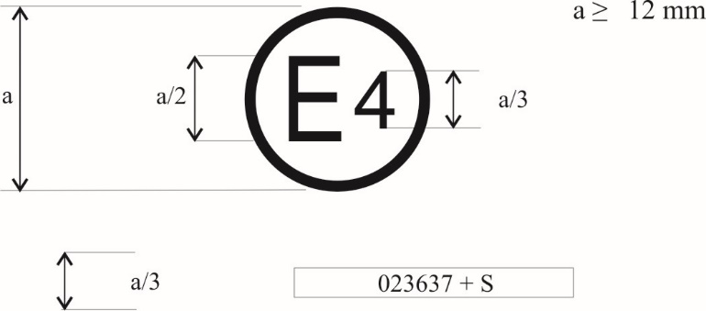

**0~~3~~412345 S2**

The above approval mark, affixed to a pneumatic tyre shows that a tyre concerned has been approved in the Netherlands (E 4) pursuant to Regulation No. 117 (marked by S2 (rolling sound at stage 2) only), under approval number 0~~3~~**4**12345. The first two digits of the approval number (0~~3~~**4**) indicate that the approval was granted according to the requirements 0~~3~~**4** series of amendments to this Regulation.

Example 2

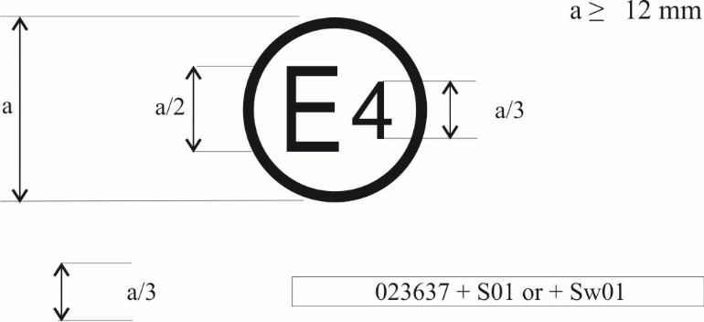

**0~~3~~412345 S2W2R3B**

The above approval mark shows that the tyre concerned has been approved in the Netherlands (E 4) pursuant to Regulation No. 117 (marked by S2 (rolling sound at stage 2) W**2** (wet adhesionof tyres in new state **at stage 2**), ~~and~~ R~~2~~**3** (Rolling resistance at stage ~~2~~**3**) and B (wet adhesion of tyres in worn state)) under approval number 0~~3~~**4**12345. The first two digits of the approval number (0~~3~~**4**) indicate that the approval was granted according to the requirements of the 0~~3~~**4** series of amendments to this Regulation.

**Annex 2 ‑ Appendix 2**

**Approval according to Regulation No. 117 coincident with approval of Regulation No. 30 or 54[[3]](#footnote-4)**

Example 1

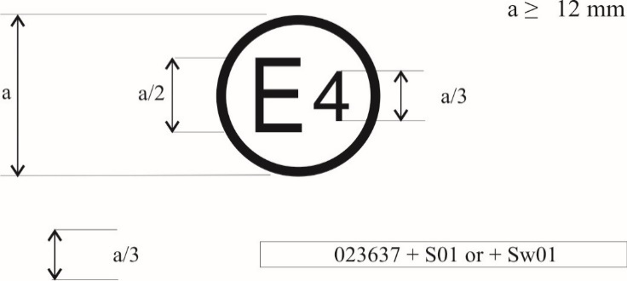

**a/3** **0~~3~~412345 S2 0236378**

The above approval mark shows that the tyre concerned has been approved in the Netherlands (E 4) pursuant to Regulation No. 117 (marked by "S2" (rolling sound at stage 2)), under approval number 0~~3~~**4**12345 and Regulation No. 30, under approval number 0236378. The first two digits of the approval number ("0~~3~~**4**" and "02") indicate that the approval was granted according to the 0~~3~~**4** series of amendments and the approval pursuant to UN Regulation No. 30 according to the 02 series of amendments.

Example 2

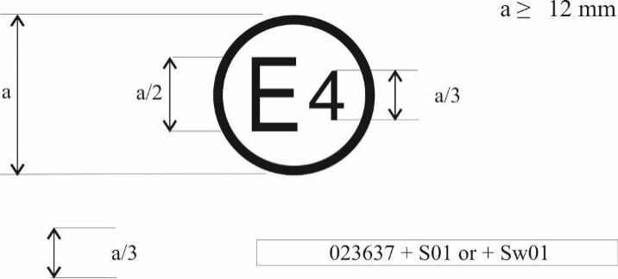

**0~~3~~412345 S2W2R~~2~~3B 0236378**

**or**

**0~~3~~412345 S2W2R~~2~~3B**

**0236378**

The above approval mark shows that the tyre concerned has been approved in the Netherlands (E 4) pursuant to Regulation No. 117 (marked by "S2W**2**R~~2~~**3**B" (rolling sound emission at stage 2, wet adhesion of tyres in new state **at stage 2**, rolling resistance at stage ~~2~~**3** and wet adhesion of tyres in worn state)), under approval number 0312345 and UN Regulation No. 30 under approval number 0236378. The first two digits of the approval numbers ("0~~3~~**4**" and "02") indicate that the approval pursuant to UN Regulation No. 117 was granted according to the 0~~3~~**4** series of amendments and the approval pursuant to UN Regulation No. 30 according to the 02 series of amendments.

Example 3

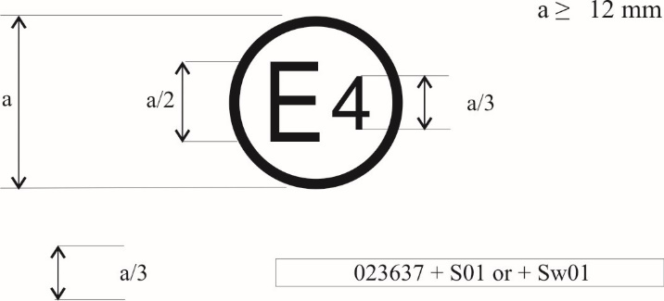

**a/3** **0~~3~~412345 S2W2R~~2~~3 0065432**

The above approval mark shows that the tyre concerned has been approved in the Netherlands (E4) pursuant to UN Regulation No. 117 (marked by "S2W**2**R~~2~~**3**" (rolling sound emission at stage 2, wet adhesion of tyres in new state **at stage 2** and rolling resistance at stage ~~2~~**3**)), under approval number 0~~3~~**4**12345 and UN Regulation No. 54 under approval number 0065432. The first two digits of the approval numbers ("0~~3~~**4**" and "00") indicate that the approval pursuant to UN Regulation No. 117 was granted according to the 0~~3~~**4** series of amendments and the approval pursuant to UN Regulation No. 54 according to its original form.

**Annex 2 ‑ Appendix 3**

**Combinations of markings of approvals issued in accordance with Regulations Nos. 117, 30 or 54[[4]](#footnote-5)**

Example 1

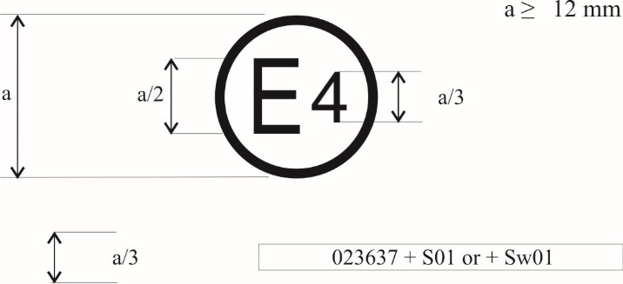

**a/3** **0236378 + 0~~3~~4S2**

The above approval mark shows that the tyre concerned has been approved in the Netherlands (E4) pursuant to UN Regulation No. 30 according to its 02 series of amendments (indicated by the first two digits of the approval number, "02") under approval number 0236378. It is also marked by "+ 0~~3~~**4**S2" which indicates that the tyre was also approved pursuant to UN Regulation No. 117 (0~~3~~**4** series of amendments) for S (rolling sound emission at stage 2).

Example 2

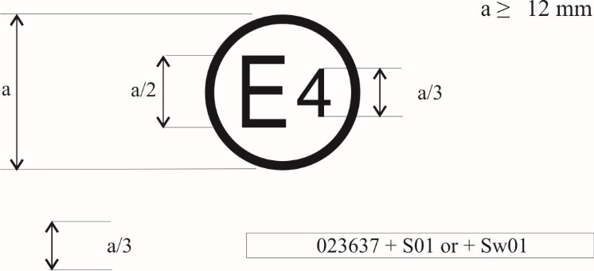

|  |  |  |
| --- | --- | --- |
|  | **0236378 + 0~~3~~4S2W2R3B** |  |

The above approval mark shows that the tyre concerned has been approved in the Netherlands (E4) pursuant to UN Regulation No. 30 according to its 02 series of amendments (indicated by the first two digits of the approval number, "02") under approval number 0236378. It is also marked by "+ 0~~3~~**4**S2W**2**R~~2~~**3**B" which indicates that the tyre was also approved pursuant to UN Regulation No. 117 (0~~3~~**4** series of amendments) for S (rolling sound emission at stage 2) W (wet adhesion of tyres in new state **at stage 2**), R (rolling resistance at stage ~~2~~**3**) and B (wet adhesion of tyres in worn state).

**Annex 2 ‑ Appendix 4**

**Extensions to combine approvals issued in accordance with Regulation No. 117**

Example 1

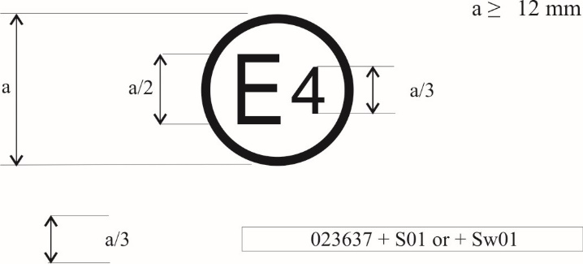

**a/3** **0212345 S2WR2 + 0~~3~~4B**

The above approval mark shows that the tyre concerned has been initially approved in the Netherlands (E4) pursuant to UN Regulation No. 117 and the 02 series of amendments under approval number 0212345. The marking is complemented by S2WR2 (rolling sound emission at stage 2) W (wet adhesion of tyres in new state) and R (rolling resistance at stage 2). The "0~~3~~**4**B" preceded by "+" indicates that it has had its approval extended under UN Regulation No. 117 and 0~~3~~**4** series of amendments to wet adhesion of tyres in worn state based on separate certificate."

*Annex 5, Part (A), paragraph 3.3.*, amend to read:

"3.3. Atmospheric conditions

The wind conditions shall not interfere with wetting of the surface (wind-shields are allowed).

The wetted surface temperature and the ambient temperature shall be between:

|  |  |  |  |
| --- | --- | --- | --- |
| *Category of use* | | *Wetted surface temperature* | *Ambient temperature* |
| Normal tyre | | 12 °C – 35 °C | 12 °C – 40 °C |
| Snow tyre | | 5 °C – 35 °C | 5 °C – 40 °C |
|  | Snow tyre for use in severe snow conditions | 5 °C – 20 °C | 5 °C – 20 °C |
| Special use tyre | | ~~not applicable~~  **5 °C – 35 °C** | ~~not applicable~~  **5 °C – 40 °C** |

Moreover, the wetted surface temperature shall not vary during the test by more than 10 °C.

The ambient temperature shall remain close to the wetted surface temperature; the difference between the ambient and the wetted surface temperatures shall be less than 10 °C."

*Annex 5, Part (A), Table 2*, amend to read:

"Table 2

| *Category of use* | | *ϑ0*  *(°C)* | *a* | *b*  *(°C−1)* | *c*  *(°C−2)* | | *d*  *(mm−1)* |
| --- | --- | --- | --- | --- | --- | --- | --- |
| Normal tyre | | 20 | +0.99382 | +0.00269 | −0.00028 | | −0.02472 |
| Snow tyre | | 15 | +0.92654 | −0.00121 | −0.00007 | | −0.04279 |
|  | Snow tyre for use in severe snow conditions | 10 | +0.72029 | −0.00539 | +0.00022 | | −0.03037 |
| **Special-use tyre** | | ~~not defined~~ | | | | | |
|  | | **15** | **+0.92654** | **−0.00121** | | **−0.00007** | **−0.04279** |

"

*Annex 5, Part (A), Table 4*, amend to read:

"Table 4

| *Category of use* | | | *ϑ0*  *(°C)* | *a* | *b*  *(°C−1)* | *c*  *(°C−2)* | | *d*  *(mm−1)* |
| --- | --- | --- | --- | --- | --- | --- | --- | --- |
| Normal tyre | | | 20 | +0.99757 | +0.00251 | −0.00028 | | +0.07759 |
| Snow tyre | | | 15 | +0.87084 | −0.00025 | +0.00004 | | −0.01635 |
|  | Snow tyre for use in severe snow conditions | | 10 | +0.67929 | +0.00115 | −0.00005 | | +0.03963 |
| **Special-use tyre** | | | ~~not defined~~ | | | | | |
|  | |  | **15** | **+0.87084** | **−0.00025** | **+0.00004** | **−0.01635** | |

"

II. Justification

1. To keep delivering on the global climate action, in line with the United Nations Sustainable Development Goals[[5]](#footnote-6) and with specific reference to Goal 13 on Climate Action, as well as to keep pursuing concerted action to facilitate international transport while improving its safety and environmental performance, the European Commission calls for an improved regulatory framework for fuel efficiency and safety performances of tyres.

2. For rolling resistance, tighter limits can contribute to the further reduction of CO2 emissions and/or increase the range of battery electric vehicles. This can contribute to the fight against climate change in line with the objectives of the Paris Agreement. According to studies for car tyres (84 per cent of tyre sales) limits could be strengthened by up to 15 per cent. For vans (9 per cent of tyre sales) limits could be strengthened by up to 5 per cent and for trucks (7 per cent of tyre sales) limits could be strengthened by up to 8 per cent (see Informal document GRBP-73-22).

3. For wet grip, tighter limits at new stage can help reducing road accidents. This is important to achieve the Vision Zero objective in a context where the average mass of vehicles tend to increase (battery electric vehicles, sport utility vehicles - SUVs). According to studies, existing limits for new tyres could be strengthened by 10 per cent for cars, 15 per cent for vans and up to 23 per cent for trucks (see Informal document GRBP-73-22).

4. The expected impacts are below described.

(a) Raising wet grip performance limits for tyres in new state by 10-20% depending on the tyre category:

• contributing to UN zero-road fatalities goal

• supporting maximization of tyre-life usage.

(b) Improving tyre rolling resistance performances by 5-15 per cent, depending on the tyre category:

• would apply to the whole vehicle fleet in a shorter timeframe vs any provisions on new vehicles would lead gradually to removing from the market worst performing tyres for rolling resistance. For example, in the case of EU27, CO2 savings equivalent to taking about 1 million vehicles off the roads in the fairly short time associated with tyre replacement.

5. The date in paragraph 1.1.7. is proposed to be adjusted to 1 October 2000, to address tyres to be fitted on vintage cars, considering the previous adjustments that took place in the past as following:

(a) 1 October 1990 was considered for the 02 series of Amendments adopted in June 2010 and entered into force in January 2011.

(b) 1 October 1980 was considered for the Directive 2001/43/EC which introduced the stage 1 noise limits in the EU Member States and entered into force in August 2001.

6. Considering Informal document GRBP-75-30, the Informal Working Group for Wet Grip on Worn Tyres (IWG WGWT) prepared a revised definition for C1 special use tyre and considered it to respond to the need for a specific cluster for wet grip on worn tyres. As no wet grip in new state requirements were defined for this revised C1 special use tyres, it is proposed to address wet grip requirements in new state to be consistent with the wet grip requirements in worn state. The C1 tyres following the proposed new definition for special use tyres are estimated to account for about 0.6 per cent of the market.

1. \* In accordance with the programme of work of the Inland Transport Committee for 2022 as outlined in proposed programme budget for 2022 (A/76/6 (Sect.20), para 20.76), the World Forum will develop, harmonize and update UN Regulations in order to enhance the performance of vehicles. The present document is submitted in conformity with that mandate. [↑](#footnote-ref-2)
2. (a) SRTT14 will be available from the supplier until end of October 2021. [↑](#footnote-ref-3)
3. Approvals in accordance with Regulation No. 117 for tyres within the scope of Regulation No. 54 currently do not include the requirement on adhesion of tyres in worn state on wet surfaces. [↑](#footnote-ref-4)
4. Approvals in accordance with Regulation No. 117 for tyres within the scope of Regulation No. 54 currently do not include the requirement on adhesion of tyres in worn state on wet surfaces. [↑](#footnote-ref-5)
5. Reference to the “UN Sustainable Development Goals and the UN Transport Conventions under the purview of the UNECE Inland Transport Committee”, 26.07.2016 (https://unece.org/transport-7). [↑](#footnote-ref-6)