Transmitted by the  Co-Chairs of the Informal Working  Group on Periodical Technical Inspections | Informal document WP.29-187-22  187th WP.29, 21-24 June 2022  Provisional agenda item 7.6

Proposal for a Framework Document on Vehicle Whole-Life Compliance (updated)
A. Introduction
At it’s the 184th session WP.29 requested the draft Framework document on vehicle whole-life compliance as revised in session (WP.29-184-10/Rev.1) to be issued as an official document, circulated among all GRs for their comments and contributions and submitted for further consideration.
The text reproduced below was prepared by the Informal Working Group on Periodical Technical Inspections on the basis of document ECE/TRANS/WP.29/2021/148. It incorporates all the comments and contributions submitted by all GRs. The strikethrough text in the document is supposed to be deleted. The text highlighted with bold inclined font is to be added.
B. Proposal
I. Purpose
1. This framework document’s primary purpose is to provide guidance for the World Forum for Harmonization of Vehicle Regulations (WP.29) and its subsidiary Working Parties (GRs) to coordinate the different stages of the legal life of vehicles, equipment and parts. The whole of the various aspects related to the requirements to vehicles is called whole-life compliance. The level of safety and environmental performance may vary at different stages of whole life compliance.
II. Definition
2. For the purposes of this Framework document, unless specified otherwise therein:
(a) The "Conformity of Production" procedure aims to ensure that each produced wheeled vehicle, equipment or part is in conformity with the approved type.
[The procedure for demonstrating that every vehicle, equipment or part approved pursuant to a UN Regulation is manufactured as to conform to the type approved by meeting the requirements of the said UN Regulation.]
(b) "In-service Conformity" is the procedure for demonstrating the compliance of vehicles on the road operated over their normal driving patterns, conditions and payloads to the relevant UN Regulations.
(c) "Road-side inspection" means an unexpected technical inspection of the roadworthiness of a vehicle carried out by the competent authorities of a Member State Contracting Party or under their direct supervision.
(d) "Stage of whole-life compliance" means each one of the arrangements to demonstrate that vehicles fulfil some requirements in a given moment of their life. The current stages of whole-life compliance defined in the 1958 and 1998 Geneva Agreements and the 1997 Vienna Agreement are Type Approval, Conformity of Production, In-Service Conformity, Periodical Technical Inspection and Road-Side Inspection.
(e) "Technical Inspection" includes means the periodical uniform inspection of any equipment and parts which are used on wheeled vehicles and whose characteristics have a bearing on road safety, protection of the environment and energy saving.
(f) "Type approval" means an administrative procedure by which the approval authorities of one Contracting Party declare, after carrying out the required verifications that a type of vehicle, equipment or part submitted by the manufacturer conforms to the requirements of the given UN Regulation. Afterwards the manufacturer certifies that each vehicle, equipment or parts put on the market were produced to be identical with the approved product.
(g) "Whole-life compliance" means the ensemble of stages in which vehicles shall fulfil certain requirements.
III. Safety and Environmental Vision
3. Vehicles degrade over the time as is the case for any product, and it is necessary to assess the impact of degradations, breakdowns, tampering, wear and other events that may impact vehicle’s performances. Those performances have been traditionally related to road safety and environmental protection and energy saving; new technologies oblige to have an open approach to incorporate new aspects like cybersecurity or personal data protection.
4. The Type Approval shall, as one of the stages of whole-life compliance, facilitate those performances are reasonably preserved during vehicles’ life and hence shall consider other stages of whole-life compliance.
5. The whole-life compliance vision, altogether, is necessary to define the appropriate provisions to ensure that the performance of vehicles, throughout their use, fulfils the legal requirements applicable at each stage and can be impartially assessed.
6. Stakeholders’ responsibility: The assurance of whole-life vehicle compliance is made up by different approach with different level of responsibility depending on each of the stakeholders.
7. The main goal: in-use Vehicles in use technical conditions shall not cause any traffic accidents resulting in injury or death that are reasonably foreseeable and preventable, shall resist cyberattacks and shall be environmentally consistent with their Type Approvals.
IV. Working principles
8. The coordination of technical provisions and/or guidance and resolutions for whole-life compliance of the vehicles shall be conducted by WP.29 within the context of the 1958 and 1998 Geneva Agreements and the 1997 Vienna Agreement.
9. The technical provisions and guidance resolutions for whole-life compliance of the vehicles will be performance-based and not-design restrictive, founded on the current state-of-the-art while keeping an open framework to include future innovation.
10. They shall take into account existing legislation, standards and guidelines of the Contracting Parties and standardization bodies as well as previous work and reference documents agreed in UNECE.
11. Implementation of the technical provisions through the identified work priorities at the level of Informal Working Group on Periodical Technical Inspection (IWG on PTI) and other GRs will aim at developing technical requirements which may take the form of regulatory or non-regulatory instruments (e.g., guidelines, recommendations, UN Resolutions, UN Regulations, UN Global Technical Regulations, UN Rules) as agreed and accepted by the Contracting Parties.
12. This document shall be approved and managed by WP.29 as specific work items are expected to be prepared in multiple GRs and the IWG on PTI with extensive cross-coordination between them.
V. Whole-life compliance principles
13. The following list of topics is intended to guide discussions and activities on whole-life compliance assessment within WP.29 and each of its relevant subsidiary bodies. The aim is to capture the shared interests and concerns of regulatory authorities, provide the general parameters for the work, and assist with common definitions and guidance within WP.29 and interested stakeholders.
14. This document seeks to create the framework to help deliver safe, clean and secure vehicles and promote collaboration and communication amongst those involved in their development and oversight.
15. The following is a list of whole-life compliance principles, having in mind the statement of item 3.5 of this document. It is expected these would form the basis for further development within the WP.29 and subsidiary bodies:
(a) The relevant aspects of vehicle use need to be considered, including safety, the environment and security;
(b) In a realistic scenario, and even more with the most evolved technologies, it appears necessary to define provisions for the different stages to ensure whole-life compliance in coordination with the type approval process;
(c) The opportunities created by new technologies need to be considered to increase the efficiency and reduce the cost of whole-life compliance;
(d) The whole-life compliance framework shall provide the necessary transparency to facilitate the acceptance of new technologies by the users;
(e) The stages of whole-life compliance shall be coordinated, whereas their scopes, methods, thresholds and other parameters may differ;
(f) When necessary, relevant requirements to check the performance of vehicles, systems and components shall be developed according to the corresponding stages of whole-life compliance;
(g) Contracting Parties shall have the appropriate [and free of cost] access to the technical specifications of each individual vehicle and the data needed for objective verification of the performances at any of the stages of the whole-life compliance;
(h) Whole-life compliance shall take advantage of existing and new technologies; and,
(i) Vehicle design shall allow impartial assessment of whole-life compliance stages.
VI. The whole-life compliance approach
16. The whole-life compliance approach shows the necessary stages to better ensure the vehicles’ performance, reasonably, during their whole life. Figure 1 below shows various stages of whole-life compliance.
Development & Production
Vehicle in Use
Type
Approval
Conformity of Production
In Service Conformity
Periodical Technical Inspections
Road Side Inspection
Market Surveillance
OEM, Approval Authorities (1958 Agreement)
OEM, Approval Authorities (1958 Agreement)
Competent Authorities (1997 Agreement)
Competent Authorities (UN R.E.6)
National Market Surveillance Competent Authorities (not included in the 1958/97 agreement)
WHOLE-LIFE COMPLIANCE
Fig. 1. Stages of whole-life compliance

The main tool to assess the convenience of stages of whole-life compliance, like the addition of market surveillance, geofencing, retrofit or recall campaigns, is the risk analysis described later in the document. The risk analysis approach is also a valid framework to liaise the different stages of whole-life compliance.
17. The risk analysis, which needs to be considered for each system of the vehicle, consists of assessing the possibilities of noncompliance and their impacts. In essence, the figure 2 below shows the rationale.
18. Once followed the path described, a better rationale will be available to consider if the necessity:
(a) Is it reasonable to check that system/performance of vehicle, its parts and equipment during the life of the vehicle;
(b) Would it be convenient to foresee any kind of provision required during the Type Approval;
(c) Would it be convenient to provide Contracting Parties Competent Authorities with data and system access for an impartial assessment.
19. The requirements to fulfil at each stage of whole-life compliance shall be coordinated with those of the Type Approval.
20. The stages of whole-life compliance and their relationships shall be designed in such a way as to reasonably facilitate each other’s objectives and provide information and data when appropriate.
21. Performances may be verified by methods different from those prescribed in the relevant UN Regulations, Global Technical Regulations, Rules and other relevant UN ECE documents.
22. The stages of whole-life compliance may include legal requirements different than those defined in the scope of vehicle approval.

Approach
What could go wrong?
• Breakdown
• Wear and tear
• Modification
• Tampering
• …
Which may be the consequences?
• Increase of emissions
• Crash
• Increase of crash severity
• (Cyber) security breach
• Loss of comfort
• …
How can it be detected?
• Manual/visual inspection and by operation
• Data analysis
• Operational check
• Electronic interface
• Remote sensing
• On-board monitoring
• Regulated self-diagnosis
• Nonregulated self-diagnosis
• …
Fig.2. The approach for assessing the possibilities of noncompliance and their impacts.
Annex to be deleted
Whole life compliance and vehicle degradation
Figure 1
Visual representation of the Whole-life compliance
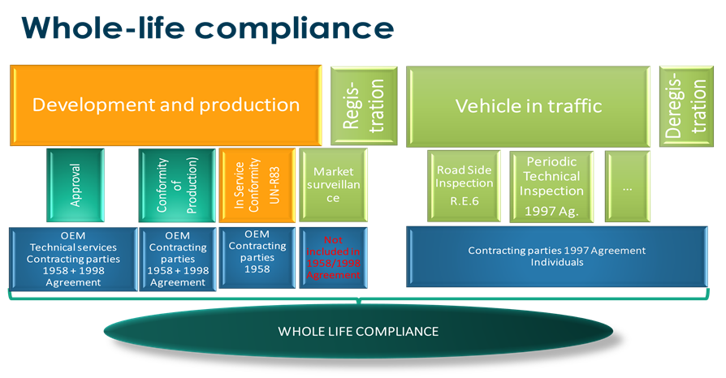
Figure 2
Schematical vehicle degradation over time
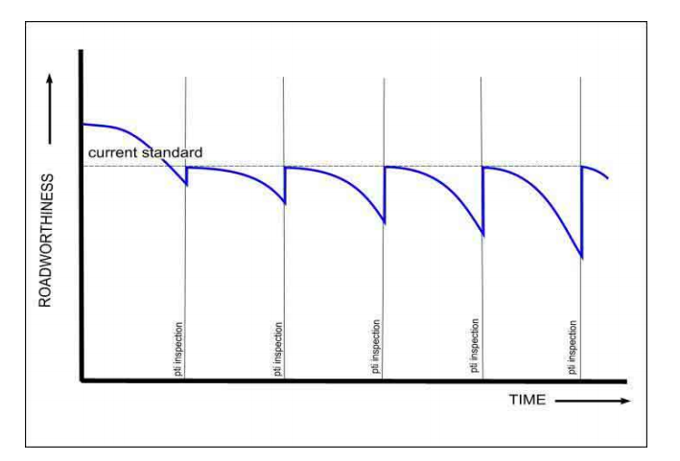

ECE/TRANS/505/Rev.3
ECE/TRANS/WP.29/2020/38
ECE/TRANS/505/Rev.3
AUTOFORE, https://citainsp.org/wp-content/uploads/2016/01/Autofore_Final_report_without_links.pdf

