UN/SCETDG/60/INF.26
Committee of Experts on the Transport of Dangerous Goods
and on the Globally Harmonized System of Classification
and Labelling of Chemicals
Sub-Committee of Experts on the Transport of Dangerous Goods 20 June 2022

Sixtieth session
Geneva, 27 June-6 July 2022
Item 4 (c) of the provisional agenda
Electric storage systems: transport provisions
Reuse, repair and re-purposing lithium ion cells and batteries and implications on safety and UN 38.3 testing requirements
Submitted by RECHARGE the Advanced Rechargeable & Lithium Batteries Association and PRBA – The Rechargeable Battery Association
Introduction
1. As many countries governments and non-governmental organizations (NGOs) promote concepts associated with a “circular economy,” lithium ion cells and batteries are often identified as products that should be “reused” (i.e., remanufactured or repaired) and “repurposed” before being shipped for final disposal and recycling at end-of-life. The following links provide examples of such activities:
- The European Commission’s “roadmap” for Batteries promotes the need for battery designs that provide for “maximum longevity”, “refurbishing” and “second life”; See https://battery2030.eu/digitalAssets/860/c_860904-l_1-k_roadmap-27-march.pdf.
- The US State of California’s Lithium-ion Car Battery Recycling Advisory Group has had extensive discussions over the past 18 months on the collection, recycling, and reuse of lithium ion electric vehicle batteries; See https://calepa.ca.gov/lithium-ion-car-battery-recycling-advisory-group/.
- The United States’ Department of Energy’s “National Blueprint for Lithium Batteries” includes extensive references to reuse lithium ion batteries and how “a resilient market should be developed for the reuse of battery cells from retired electric vehicles for secondary applications, including grid storage”; See https://www.energy.gov/sites/default/files/2021-06/FCAB%20National%20Blueprint%20Lithium%20Batteries%200621_0.pdf.
2. While RECHARGE and PRBA support the principles associated with a circular economy, we nonetheless have significant concerns with how companies may be reusing, repairing or repurposing lithium ion cells and batteries and at the same time complying with all applicable technical, regulatory, and safety requirements found in the UN 38.3 lithium battery tests and Model Regulations that are associated with the safe transport of these dangerous goods.
3. Our paper therefore provides the Sub-Committee with a general overview of how lithium ion cells and batteries are currently being reused and repurposed. It also includes several questions for the Sub-Committee’s consideration on how this new issue should be considered.
Remanufacturing, reuse, repair, secondary use, and repurposing of lithium ion cells and batteries
4. It is important to recognize the difference between “reuse”, “repair” and “repurposing” and the similar terms used to describe them.
5. When a battery is “repurposed,” it typically results in the whole battery or part of it being used in a different application than it was originally designed. (The term “secondary use” is often equated with the term repurposed.) For example, it is generally recognized that used lithium ion electric vehicle (EV) batteries can often be repurposed as stationary energy storage systems (ESS) for storing energy generated by renewable sources such as solar and wind at a significantly lower cost than new, fresh-off-the-production-line batteries.
6. When a battery is “reused”, the whole battery is used in the same application it was originally designed. (The term “refurbished” is often equated with the term “reused”.)
7. RECHARGE and PRBA therefore offer the following definitions for the Sub-Committee’s consideration to better understand the issues addressed in this paper:
- Repurpose: A scenario by which a lithium ion battery, or components of a battery (e.g., battery management system) are used for a different purpose/application/function than initially designed and placed on the market for the first time. Other terms used to describe such a scenario include “secondary use” and “second life.”
- Reuse: A scenario by which a lithium ion battery, or components of a battery (e.g., battery management system) are used again for the same purpose/application/function it was initially designed and placed on the market for the first time. Other terms used to describe such a scenario include “remanufacturing” and “refurbishing”.
8. Standardisation organisations are also working on this topic, and the following table from IEC is presented as an example of proposed definitions for these multiple operations.
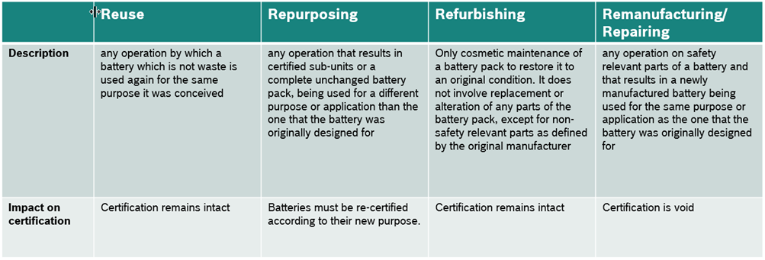

Electric vehicle battery packs repurposed for stationary Energy Storage Systems (ESS)
9. A lithium ion battery pack designed for an electric vehicle is typically comprised of multiple battery “modules” as shown in the photograph and schematic drawing below. Each module is comprised of individual lithium ion cylindrical, pouch, or prismatic cells.
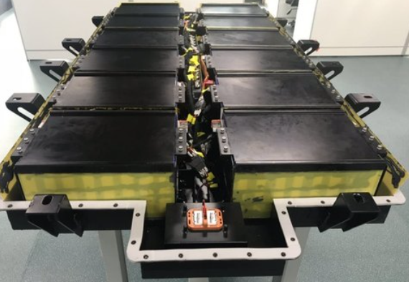
Lithium ion Battery “Modules” in an Electric Vehicle Lithium ion Battery Pack

_______________________________
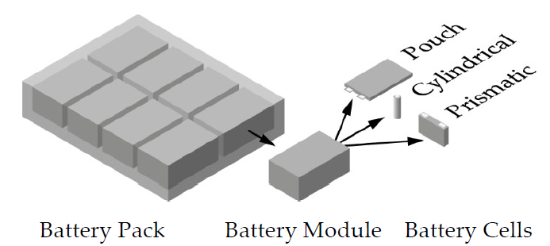
Schematic drawing courtesy of Bernhard Faessler from April 2021 article in Energies: Stationary, Second Use Battery Energy Storage Systems and Their Applications:
A Research Review
_______________________________

10. If a lithium ion EV battery pack or module no longer meets the necessary performance requirements for the vehicle it was designed to power, the pack or modules may often be repurposed and used in less demanding applications such as an ESS instead of being shipped directly to a lithium ion battery recycling facility. This is the most common example of how lithium ion batteries are being repurposed today due to their high value, demand for stationary ESS for renewable sources such as wind and solar energy, and support of the circular economy being promoted by governmental agencies and NGOs.
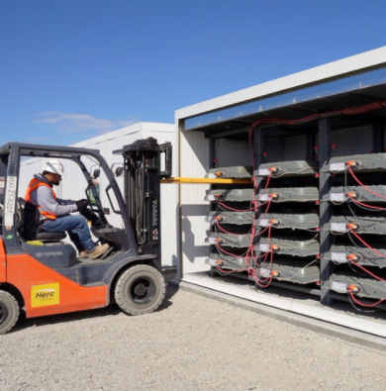
11. In one repurposing scenario, UN 38.3 tested battery modules like those in the EV battery pack photograph above are often removed and then reassembled and repurposed as a new stationary ESS. In such a scenario, there often is no change in the tested type EV battery module design and thus retesting to UN 38.3 would not be required. It is necessary, however, for the manufacturer of the ESS to have a quality management programme in place in accordance with section 2.9.4 (e) of the Model Regulations.
12. In a second repurposing scenario, complete EV battery packs can be connected in series and parallel strings with no change in the pack design. The photograph to the right shows an ESS using complete lithium ion EV battery packs installed in cabinets in the original battery pack casing in which they were mounted in the vehicle. In such a scenario, there often is no change in the tested type EV battery design, and thus retesting to UN 38.3 would not be required; See https://www.b2uco.com/. And, as noted above, the manufacturer of the ESS should have a quality management programme in place in accordance with section 2.9.4 (e) of the Model Regulations.
13. In other repurposing scenarios, battery components (the modules) or even single cells are separated and rebuilt into a product with a different design and application than the original battery. This is the case for example of automotive batteries dismantled and rebuilt into bicycle batteries.
Implication for compliance with UN 38.3 testing requirements for repurposed lithium ion cells and batteries
14. Below is section 38.3.2.2 of the UN Manual of Tests and Criteria that lists in paragraphs (a), (b), and (c) very specific examples of when a cell or battery differs from a tested type and thus requires retesting. The “NOTE” in 38.3.2.2 provides examples of when a cell or battery “might” be considered to differ from a tested type and thus require retesting.
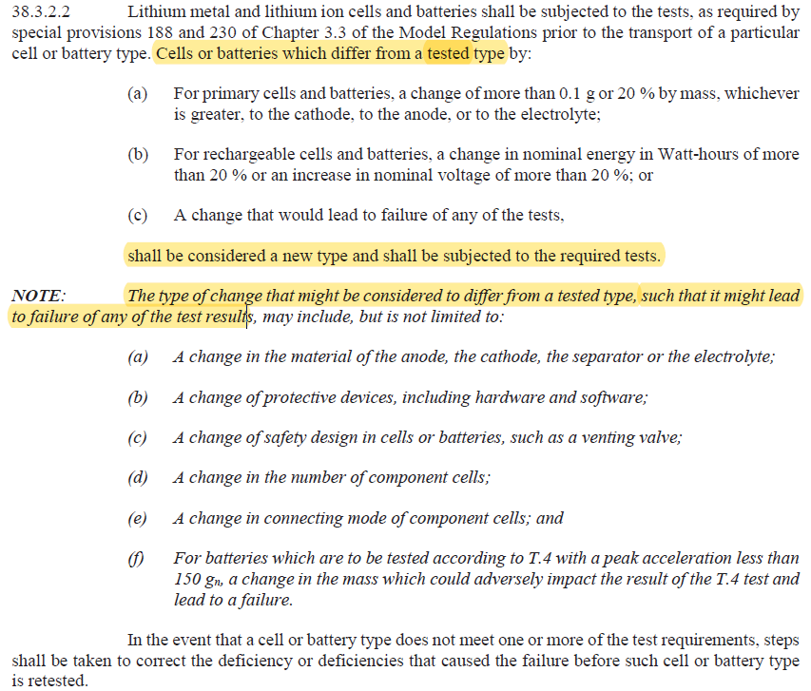
15. The case of reuse or refurbishing of a battery was never anticipated when section 38.3.2.2 was last amended. Nevertheless, several questions can be raised on the way this regulation is applicable to batteries after reuse and repurposing.
16. One issue that requires immediate resolution is how a new battery design from reused or repurposed cells or batteries can meet the cycling requirement (i.e., charged and discharged) found throughout the UN 38.3 tests. Because cells and batteries have already met the UN 38.3 testing requirements and been cycled hundreds of times in most cases while in use, it should not be necessary to require these new designs to meet any additional cycling requirements.
17. RECHARGE and PRBA are therefore providing below a list of issues and questions regarding reuse and repurposing of lithium ion cells and batteries and compliance with the UN 38.3 lithium ion battery tests and Model Regulations for the Sub-Committee’s consideration, recognizing of course we fully expect other issues and questions to arise:
(a) Definitions. To better align with other standards and regulations, new definitions for reused and repurposed lithium ion cells and batteries should be considered.
(b) Quality Control. To demonstrate the UN 38.3 tested products are representative of a stable production with all quality controls in place in accordance with 2.9.4 (e) of the Model Regulations using well defined and characterized parts, new text is needed to clarify this issue.
(c) Cycling (conditioning) Cells and Batteries. When it has been determined that UN 38.3 testing of reused and repurposed cells and batteries is necessary, the elimination of the cycling requirements for new battery designs should be considered since it provides no practical safety benefit, and the practical interpretation of “new cells” should be clarified.
18. Based on responses from members of the Sub-Committee, RECHARGE and PRBA propose to host a series of virtual meetings over the next several months with the goal of developing new texts for the UN 38.3 lithium battery tests and the Model Regulations to clarify the issues and questions addressed in this document to avoid uncontrolled interpretations of the present regulations and ensure the safe transport of reused and repurposed lithium cells and batteries.
__________________

