Proposal for amendments to document ECE/TRANS/WP29/GRVA/2022/14
Electronic Stability Control
(OICA proposal with purple text)

- Proposal

Paragraph 5.2.1.32., amend to read:
“5.2.1.32. Subject to the provisions of paragraph 12.3. of this Regulation, all vehicles of the following categories shall be equipped with a vehicle stability function:
(a) M₂, M₃, N₂ ¹²;
(b) N₃ ¹² having no more than 3 axles;
(c) N₃ ¹² with 4 axles, either with a maximum mass not exceeding 25t and a maximum wheel diameter code not exceeding 19.5 or maintaining transported material’s state through continuous movement (concrete mixer truck for example).;
(d) N₃ ¹² with 4 axles, with two power-driven rear axles
The vehicle stability function shall include roll-over control and directional control and meet the technical requirements of Annex 21 to this Regulation.”

Paragraph 12., insert new paragraphs:
“12.8. Transitional Provisions applicable to the 13 series of amendments
12.8.1. As from the official date of entry into force of the 13 series of amendments, no Contracting Party applying this Regulation shall refuse to grant or refuse to accept type approvals under this Regulation as amended by the 13 series of amendments.
12.8.2. As from 1 September 2026, Contracting Parties applying this Regulation shall not be obliged to accept type approvals to the preceding series of amendments, first issued after 1 September 2026.
12.8.3. Until 1 September 2028, Contracting Parties applying this Regulation shall accept type approvals to the preceding series of amendments, first issued before 1 September 2026.
12.8.4. As from 1 September 2028, Contracting Parties applying this Regulation shall not be obliged to accept type approvals issued to the preceding series of amendments to this Regulation.
12.8.5. Notwithstanding paragraph 12.8.4., Contracting Parties applying this Regulation shall continue to accept type approvals issued according to the preceding series of amendments to this Regulation, for the vehicles which are not affected by the changes introduced by the 13 series of amendments.
12.8.6. Contracting Parties applying this Regulation may grant type approvals according to any preceding series of amendments to this Regulation.
12.8.7. Contracting Parties applying this Regulation shall continue to grant extensions of existing approvals to any preceding series of amendments to this Regulation.”

- Justification
- Given the difficulty to identify concrete mixers in the regulation, the proposal is to include all 4 axles with two power-driven rear axles in the scope of the mandatory installation, should they be concrete mixers or not.
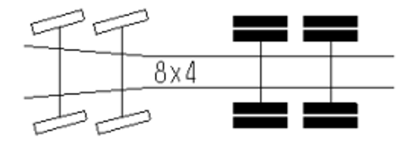
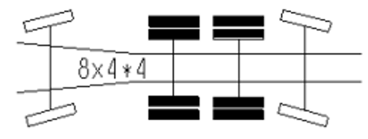

- This proposal achieves in a fairly good way the objectives of France, since most of the concrete mixers are 8x4 or 8x4/4, and only very few are 8x2.
- It should be noted that this proposal is actually addressing higher volumes than only the concrete mixers, which is only a small fraction of 8x4 and 8x4*4 vehicles, while excluding off road vehicles from the scope (footnote 12).
- Given the change in the technical specification of the vehicles, a new series of amendments is needed, with sufficient lead-time to update the production.

_______________________

