Proposal for Supplement 1 to the 03 series of amendments to UN Regulation No. 127 (Pedestrian Safety)
Submitted by the experts from France and OICA*
The text reproduced below was prepared by the experts from France and OICA. The proposed test makes a few minor adaptations and clarifications to the existing requirements. The modifications to the current text of the UN Regulation are marked in bold for new or strikethrough for deleted characters.

I. Proposal
Paragraph 2.44., amend to read and insert Figures 12 and 13:
"2.44. "Windscreen test area" is an area on the outer surface of the windscreen. It is bound (see Figure 12):
(a) In the front, by a line 100 mm rearward to the opaque obscuration of the windscreen. In case of absence of the opaque obscuration, the line is measured from the front visible edge of the windscreen material.
(b) In the rear, by a WAD 2,500 or a line 130 mm forward to the rear visible edge of the windscreen material, whichever is more forward at a given lateral position.
(c) At each side, by a line 100 mm inside the opaque obscuration of the windscreen. In case of absence of the opaque obscuration, the line is measured from the side visible edge of the windscreen material.
For (a) and (c): the distances of 100 mm are to be measured with a flexible tape held tautly along the outer surface of the vehicle at an angle of 90° to the tangent line to the opaque obscuration limit or in case of absence of the opaque obscuration, from the visible edge respectively.
For (b): the distances of 130 mm is to be measured with a flexible tape held tautly along the outer surface of the vehicle at an angle of 90 ° to the tangent line to the rear visible edge of the windscreen.

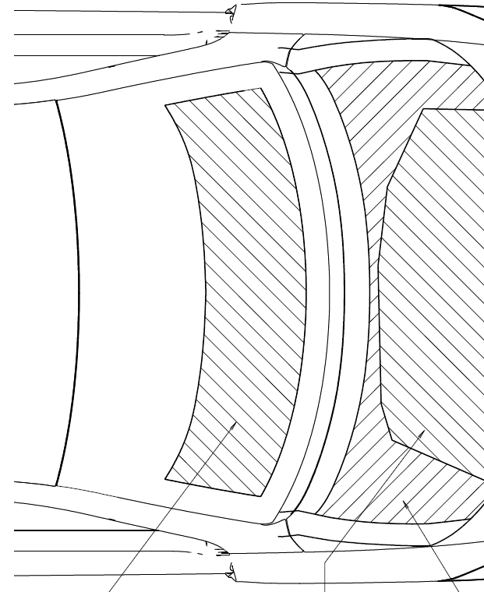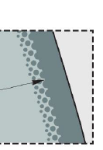
100
100
Visible edge of windscreen -130mm or
WAD 2500, whichever is more forward.
130
Opaque obscuration (e.g. black print) or, in absence of obscuration, visible edge of windscreen material.
Opaque obscuration e.g. black print (solid strip)
Measure perpendicular
Figure 12 : windscreen test area
Windscreen test area

Where the lines defined in (b) and (c) do not intersect, they should be extended and/or modified using the semi-circular template defined in 2.8., as shown in Figure 13.
Figure 13: Upper corner definition with template
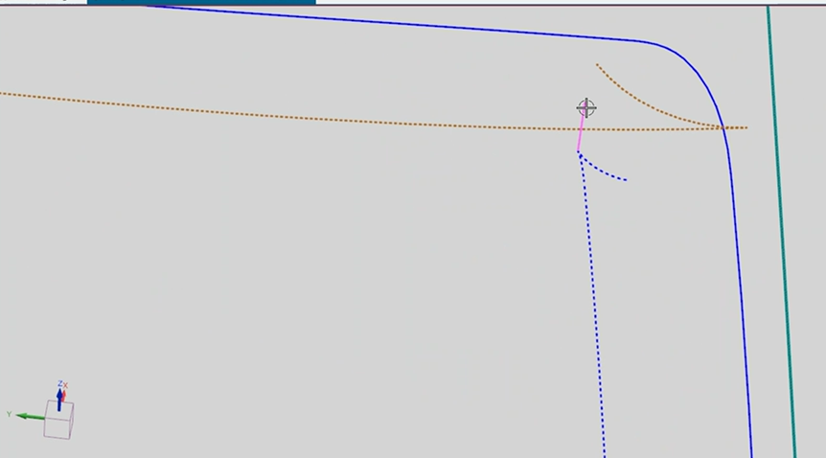
(c)
(b)
R100 mm
Corner ‘A’
Corner ‘B’
45°

Point ‘C’
Point ‘D’
45°

The template should be placed on the vehicle with corners “A” and “B” turned to the front of the vehicle, and Points “C” and “D” to the rear and with line AB parallel to the median transversal plane of the vehicle. The template should be slid progressively rearwards transversally until the arc of the template makes first contact with the line defined in (b).
Ensuring line AB remains parallel to the median transversal plane and first contact of the template with line defined ins (b) is maintained, the template should be slid progressively transversally rearwards until the arc of the template makes first contact with the line defined in (c). Throughout the process, the template should be curved to follow, as closely as possible, the outer contour of the vehicle's windscreen, without wrinkling or folding of the template. Then the contour of windscreen test area is extended and/or modified to follow the circumferential arc of the template to meet the line defined in (c), as shown in Figure 13.
If the template cannot make simultaneous contact with lines defined in (b) and (c), then additional templates should be used where the radii are increased progressively in increments of 20 mm, until simultaneous contact with lines defined in (b) and (c) are achieved.

Tests assigned to any measuring points located in the windscreen area forward of and including WAD 1,700 are performed with the child headform impactor. Tests assigned to any measuring points located in the windscreen area rearward of WAD 1,700 are performed with the adult headform impactor.

Paragraph 2.45., amend to read and Figures 14 and 15 to insert:
2.45. "Cowl monitoring area" is generally located near the rear of the bonnet test area and the front of the windscreen test area.
For the adult head tests, if any, this area is bound:
(a) In the front, by the forward most boundary of the adult headform bonnet top test area as defined in paragraph 2.1 or a line 82.5 mm forward of the bonnet rear reference line, whichever is most rearward at a given lateral position; and
(b) At the rear, by a WAD 2,500 or the front of the windscreen test area, whichever is most forward at a given lateral position.
For the child head tests, this area is bound:
(a) In the front, by the forward most boundary of the child headform bonnet top test area as defined in paragraph 2.16 or a line 82.5 mm forward of the bonnet rear reference line, whichever is most rearward at a given lateral position; and
(b) At the rear, by a WAD 1,700 or the front of the windscreen test area, whichever is most forward at a given lateral position.
In order to generate the lateral boundary of the cowl monitoring area (see Figure 14), at each side:
- the “P corner point” will be projected forward to the rear edge of the bonnet top and create Q point;
- the Q point will be connected to the “T point” (rear corner of the bonnet top test area);
using a flexible tape held tautly from point P to Q and on the outer surface of the vehicle from point Q to T.

Figure 14:
lateral limits of the cowl monitoring area
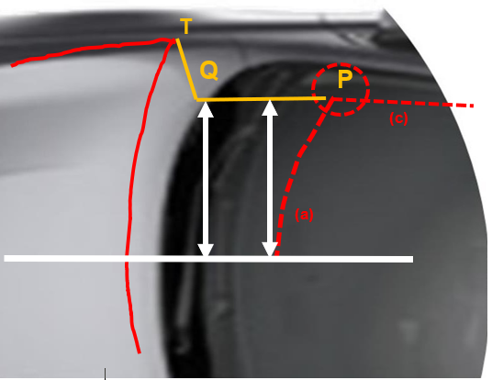
If there is no unique “P point” where the lines defined in 2.44 (a) and (c) intersect, then the “P point” is defined by the first contact made by a 45° line, as shown in Figure 15.

Figure 15: Particular case, if no unique “P point” corner

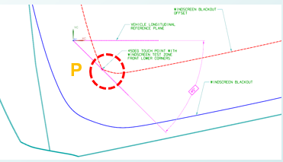

Tests assigned to any monitoring point located in the cowl monitoring area forward of and including WAD 1,700 are performed with the child headform impactor. Tests assigned to any monitoring point located in the cowl monitoring area rearward of WAD 1,700 are performed with the adult headform impactor.

Paragraph 2.48., amend to read and insert Figures 16:

2.48. "Atypical windscreen fracture behaviour" is where the headform to windscreen impact results in at least one of the following cases:
- The absolute value of the minimum value of the derivation of the headform acceleration versus time is below 180 g/ms for the first 4 ms after the initial contact of the headform to the windscreen, as shown in Figure 16 ; or
Figure 16: Jerk criteria graph and formula
│min ($\frac{da}{dt}$) │< 180g/ms, for 0 < t < 4ms
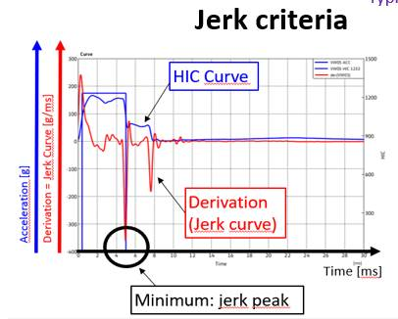
(b) The minimum value of the acceleration below 300 m/s² between the initial peak and 10 milliseconds is reached later than 4 ms in the time/acceleration plot, or glass breaking which expands to whole windshield is not visibly observed."

Insert new paragraphs 2.49. and 2.50., to read:

2.49. "Third of the windscreen test area" means the geometric trace of the area between the lateral boundaries of the windscreen test area as defined in §2.44.(c), measured with a flexible tape following the outer contour of the windscreen on any transverse section, divided in three equal parts.

2.50. "Third of Cowl monitoring area" means the distance between the lateral boundaries of the cowl monitoring area as defined in §2.45, measured on any transverse section, divided in three equal parts.

II. Justification
- The proposal makes minor adaptations and clarifications to the existing provisions.
- Clarification of the definition of the cowl monitoring area:
  - Definition of the lateral limits has been added to be able to define the third of the area.
  - Regarding the impactor to be used, the same WAD 1700 limit as in 2.44 Windscreen test area definition applies between the child and adult cowl monitoring areas.
- Clarification of the definition of the windscreen test area:
  - Determination of the upper corners in some special cases and
  - definition of the third of the area.
- Clarification of the jerk criteria: addition of the formula and exemple of the graph of an atypical test.

________________

* In accordance with the programme of work of the Inland Transport Committee for 2021 as outlined in proposed programme budget for 2021 (A/75/6 (Sect.20), para 20.51), the World Forum will develop, harmonize and update UN Regulations in order to enhance the performance of vehicles. The present document is submitted in conformity with that mandate.
from WAD 2,100 boundary, if applicable, in accordance with paragraphs 11.9 to 11.11.

