Proposal for a Document for Reference:
A general approach how to handle measurement uncertainty
Submitted by the Informal Working Group on Measurement Uncertainties
The text below was developed by the Informal Working Group on Measurement Uncertainties (IWG MU) as a document for reference. According to the mandate of the Working Party on Noise and Tyres (GRBP) at its seventy-first session (ECE/TRANS/WP.29/GRBP/69), IWG MU was given the first task to amend UN Regulations Nos. 51 and No.117 to reduce measurement uncertainties. In addition, the Terms of Reference of IWG MU included developing a general approach how to handle measurement uncertainties in UN Regulations.

Document for Reference:
A general approach how to handle measurement uncertainty
Contents
Page
1. Background 3
2. General considerations 3
3. How to handle measurement uncertainty 5
4. Stages of uncertainty evaluation 6
5. ISO/IEC 98-3 (GUM) approach 7
6. ISO 5725 approach 10
7. Example of estimation of expanded uncertainty –
UN Regulation No. 51 and ISO 362-1. 11
8. References 14

1. Background
In all kind of testing of objects according to standards, there is a certain measurement uncertainty. This is also the case of the measurement of sound levels of vehicles and tyres, for example during type approval of these objects. In standards used for such measurements (ISO, ANSI, CEN, etc.) a separate chapter on measurement uncertainty is mandatory. However, this is not the case in UN Regulations.
The focus on in-use compliance checking of vehicles is increasing, as the introduction of European Union (EU) Regulation 2018/8581 (Marked surveillance) is showing. In the United States of America, such testing has been in place for decades for emissions and safety (not noise).
These kinds of tests will then be performed by institutions not involved in the original type- approval test ("third party"). Therefore, uncertainties connected to such market surveillance tests will be of uttermost importance, as upon a failure they could withdraw any previously given type approval to the vehicle/object.
Such third-party testing is not within the scope of the United Nations, however measurement uncertainties have also an important role in general for Conformity of Production (CoP), which is part of UN Regulations for vehicles and tyres.
GRBP has therefore been asked to establish an Informal Working Group on measurement uncertainties to work on the following topics:
(a) Improvements of test methods
(b) Compensation, if possible (systematic errors)
(c) Remaining uncertainties (random errors)
This document outlines the general approach to measurement uncertainty, based on both the ISO 5725 standard and the International Organization for Standardization (ISO)/International Electrotechnical Commission (IEC) Guide to the Expression of Uncertainty in Measurement (GUM) 98-3. However, the steps of defining the uncertainty of a measurement based on ISO 5725 do not differ significantly from GUM. Therefore, the statistical method described in this report will mainly focus on GUM.
2. General considerations
Measurement procedures are always affected by factors causing disturbances leading to variation in the results observed by the same subject. The source and nature of these perturbations are not completely known and can sometimes affect the end-result in a non-predictable way.
A measured result shall be understood as an approximation to the true result, which by itself is unknown.
Two measurements are deemed to provide the same result if their test results are within a given uncertainty.
Thus, the knowledge of the measurement uncertainty is important as it provides information about the precision and repeatability of measurements.
It is important to minimize the uncertainties, e.g. by narrowing ambient and test conditions or by corrections. Any residual uncertainty shall be covered by tolerances.
Sources of errors in measurements come from limitations in the sensitivity of the instruments or from imperfections in experimental design or measurement techniques. Errors are classified as random or systematic.
2.1. Random errors, which cannot be compensated for
They are always present and are from operator approximating a reading and changes in the experimental conditions. There is equal probability that the reading will be too high or too low. To minimize random error, repeated measurements are taken, and the average or mean is calculated. If the same operator gets the same results, the results are said to be reproducible, see figure 2.1. Recording the precision or uncertainty is one way of representing random error:
measurement ± random error
2.2. Systematic errors, which can be compensated for
These are typically present and are from limitations in instruments, technology and operator skill. To minimize systematic errors, carefully calibration of the instruments can be done, and the operator uses the best techniques. Systematic errors lead to bias, moving the measurements away from the true value in one direction or the other, see Figure 2.1. Recording the bias can be represented as:
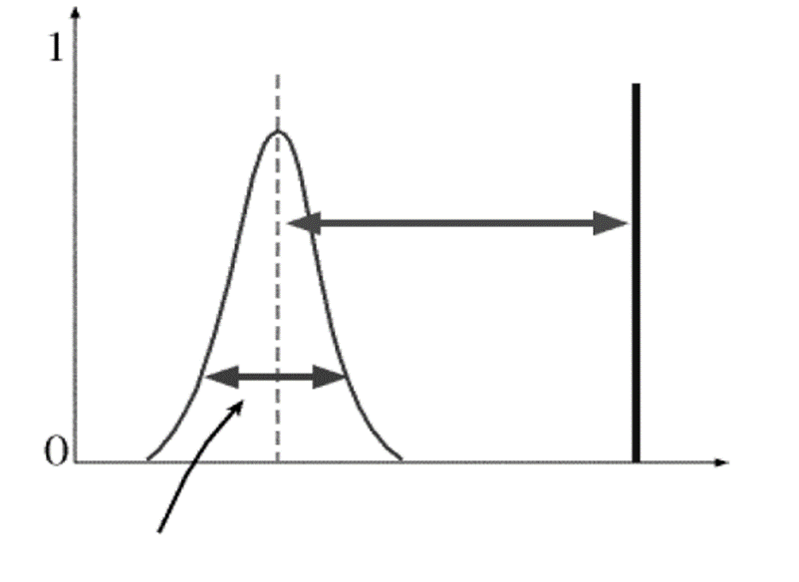
measurement + systematic error or measurement – systematic error
mean
truth
bias
(system error)
precision (uncertainty), also referred to as random error
measured value
frequency
Figure 2.1
Graphical representation of random and systematic error.¹
In Figure 2.1, the bias is measurement – systematic error. Normally, only the uncertainty is reported. Systematic errors are dealt with only if the true value is known and then the error in per cent can be calculated and discussed.
2.3. Precision and accuracy in measurements
Precision reflects how reproducible the measurements are while accuracy reflects how close the measurements are to the true value. Ideally, we aim for both precision (smaller random errors) and accuracy (systematic error). The target analogy works well, as shown in Figure 2.2.
A graphical representation is shown in Figure 2.3.
It should be noted that the approach to define the uncertainty contribution as given by GUM does not distinguish between random or systematic errors.

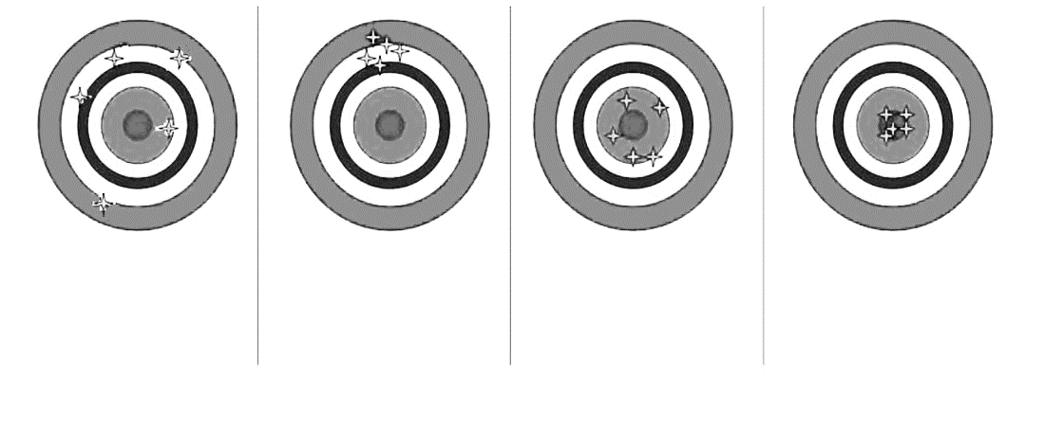
Figure 2.2
Low Accuracy
Low Precision

Random Error large
Systematic Error large
Low Accuracy
High Precision

Random Error small
Systematic Error large
High Accuracy
Low Precision

Random Error large
Systematic Error small
High Accuracy
High Precision

Random Error small
Systematic Error small

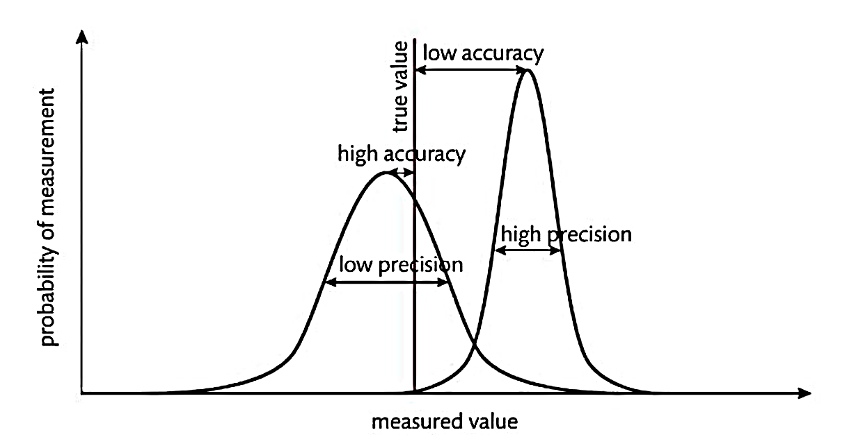
Precision and accuracy. Notice that random error is related to precision while systematic errors are related to accuracy.²
measured value
Low Precision
High Accuracy
Low Accuracy
High Precision
probality of measurement
true value

Figure 2.3

Graphical representation for precision and accuracy. Note that the set of readings to the left represent high accuracy and low precision. Those on the right indicate the values have high precision and low accuracy.³
3. How to handle measurement uncertainty
To reduce measurement uncertainty, the following approach is recommended:⁴
3.1. Avoidance of uncertainties
Normally, a regulation/measuring method defines certain tolerances within which the measurements can be performed. It is important to understand the possibilities to reduce uncertainty by limiting boundary conditions.
As an example, measurements according to UN Regulation No. 117 on rolling sound can be performed within a test track surface temperature between +5 to + 50 °C. The measured sound level at a certain surface temperature shall then be corrected to a reference temperature of + 20 °C, based on a defined correlation correction between road surface temperature and sound level in this Regulation. If the measurements can be made as close as possible to this reference temperature, the measurement uncertainty related to the influence of temperature can be reduced.
3.2. Use of compensations (reducing systematic errors)
Staying with the UN Regulation No. 117 example, the measured sound level at a certain surface temperature shall then be corrected to a reference temperature of + 20 °C, based on a defined correction between road surface temperature and measured sound level. The correction does not eliminate measurement uncertainty, but it does reduce the measurement uncertainty. The lowest possible uncertainty is if all measurements are performed at + 20 °C.
3.3. Use of an uncertainty model
As there is never a "true" value for the final result, there is a need to use an uncertainty model to define the tolerances (as expected variance) of the measured value. Such uncertainty models are defined in ISO 5725 and in the ISO/IEC Guide 98-3.
3.4. Repetition of measurements
In a regulation/measuring method, a certain number of repetitions of a test condition can be defined, as a means to reduce uncertainties. Therefore, by repeating measurements under equal boundary conditions, using the mathematical mean of the measurements minimizes the uncertainty, as the influence of random errors will be reduced. An example of this practice is the use of four measurement runs in UN Regulation No. 51.03 which are then mathematically averaged.
This approach is shown in Figure 3.1:
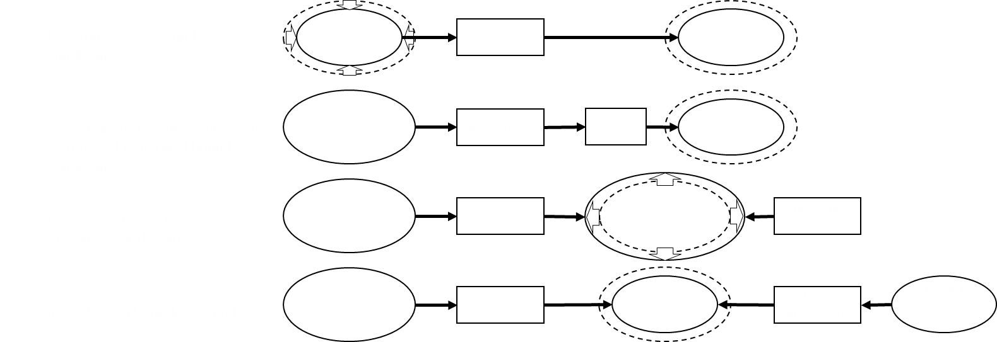
Uncertainty model
Avoidance of uncertainties
by setting closer boundary conditions
Use of compensations,
correction of measurement results with regard to defined boundary conditions
Use of an uncertainty model
for definition of additional tolerances for the limit
Repeat the measurement
under known boundary conditions
1
2
3
4
Usual boundary conditions
Usual boundary conditions
Usual boundary conditions
Closer boundary conditions
Measurement
Measurement
Measurement
Measurement
Repeat Measurement
Final result
Final result
Final result + additional tolerances for the limit
Final result
Known boundary conditions
Corr. by f(x)

Figure 3.1

Approach to reduce measurement uncertainty⁴
4. Stages of uncertainty evaluation
There are in principle two stages to consider:
4.1. The formulation stage:
(a) defining the output quantity Y (the measurand);
(b) identifying the input quantities on which Y depends;
(c) developing a measurement model relating Y to the input quantities;
(d) on the basis of available knowledge, assigning probability distributions – Gaussian, rectangular, etc - to the input quantities (or a joint probability distribution to these quantities that are not independent).
4.2. The calculation stage consists of propagating distributions for the input quantities through the measurement model to obtain the probability distributions for the output quantity Y and summarizing by using distribution to obtain:
(a) the expectation of Y, taken as an estimate y of Y
(b) the standard deviation of Y, taken as the standard uncertainty of µ(y) associated
with y
(c) the coverage interval containing Y with a specific coverage probability.
5. ISO/IEC 98-3 (GUM) approach
The GUM uncertainty framework uses:
(a) the best estimates of x_{i} of the input quantities X_{i}
(b) the standard uncertainties µ(x_{i}) associated with x_{i}
(c) the sensitivity coefficients c_{i}
to form an estimate y of the output quantity Y and the associated standard uncertainty µ(y).
An input quantity to the uncertainty model is never exact, so an assessment must be done.
In most cases, a measurand Y is not measured directly, but is determined from N other quantities X₁, X₂, …, X_{N} through a functional relationship:
Y = ƒ (X₁, X₂, …, X_{N}) (1)
A general expression for a measurement model is:
h(Y,X₁…….X_{N}) = 0 (2)
It is taken that a procedure exists for calculating Y given X₁…..X_{N} in equation (2) and that Y is uniquely defined by this equation.
The input quantities X₁, X₂, …, X_{N} upon where the output quantity Y depends, may themselves be viewed as measurands and may themselves depend on other quantities, including corrections and correction factors for systematic errors.
An estimate of the measurand Y denoted by y, is obtained from equation (1) using input estimates x₁, x₂, ….,x_{N} for the values of N quantities X₁, X₂, …,X_{N}. Thus, the output estimate y, which is the results of the measurements, is given by:
y = ƒ (x₁, x₂, …,x_{N}) (3)
If the input quantity can lie on both sides of the true value and the probability is higher if it is closer to the true value than further away from it, one can assume a normal ("gaussian") distribution as a good approximation. Figure 5.1 show such a normal distribution, where µ is the mean value of the variance V of the quantity and σ is the standard deviation (V = σ²).
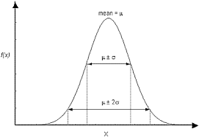

Figure 5.1

Normal ("gaussian") distribution
If all values of the input quantity are equally likely within a given interval, the distribution is rectangular, as shown in figure 5.2.
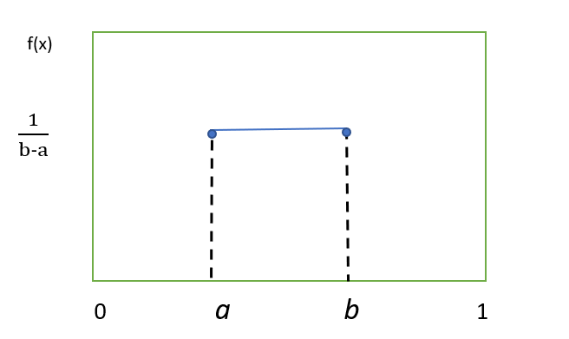

Figure 5.2

Rectangular probability distribution within the interval a to b.
In some cases, the input quantity can only lie above or below a fixed value, and in that case, one has a single-sided distribution. In some cases, a half-normal distribution (single-sided) can also be a good approximation, if for example, the input quantity is more likely to lie close to a limit value, than further away.
Knowledge about an input quantity X_{i} is established from repeated indication values (Type A evaluation of uncertainty) or scientific judgement or other information concerning the possible values of the quantity (Type B evaluation of uncertainty).
In Type A evaluation of measurement uncertainty, the assumption is often made that the distribution best describing an input quantity X given repeated indication values of it (obtained independently) is a Gaussian distribution (figure 4.1). X then has expectation equal to the average indication value and standard deviation equal to the standard deviation of the average.
When the uncertainty is evaluated from a small number of indication values (regarded as instances of an indication quantity characterized by a Gaussian distribution), the corresponding distribution can be taken as a t-distribution. Other considerations apply when the indication values are not obtained independently (see ISO/IEC GUM 98-3, Annex G)
For a Type B evaluation of uncertainty, often the only available information is that X lies in a specified interval [a, b]. In such a case, knowledge of the quantity can be characterized by a rectangular probability distribution with limits a and b (Figure 4.2). If different information were available, a probability distribution consistent with that information would be used.
Estimation of type B uncertainties is often based on calculations, experience, calibration, etc.
The final resulting value consists of the measured value + the input quantity for the uncertainty factor, δ₁ to δ_{i}
Y_{final} = Y_{meas} + δ₁ + δ₂ + δ₃ + δ₄ +··········+ δ_{i} (4)
The uncertainty contribution on the measurand due to the input quantity δ_{i} is c_{i} µ_{i}, where c_{i} is the sensitivity coefficient and µ_{i} the uncertainty.
Sensitivity coefficients c₁……c_{N} describe how the estimate y of Y would be influenced by small changes in the estimates x₁…..x_{N} of the input quantities X₁……X_{N}. For the measurement function (1), c_{i} equals the partial derivative of the first order of f with respect of X_{i}, evaluated at X₁ = x₁, X₂ = x₂, etc. For the linear measurement function
Y = c₁X₁ +……….+c_{N}X_{N} (5)
with X₁……X_{N} independent, a change in x_{i} equal to µ_{i}(x_{i}) would give a change
c_{i} µ_{i}(x_{i}) in y.
This statement would generally be approximate for the models (1) and (2). The relative magnitudes of the terms |c_{i}| µ_{i}(x_{i}) are useful in assessing the respective contributions from the input quantities to the standard uncertainty µ(y) associated with y.
The sensitivity coefficients show how the variables in (3) will influence the magnitude of the result of y,
They function as a multiplier used to convert the uncertainty components to the right units and magnitude for the uncertainty analysis.
If there is no need for a sensitivity coefficient, for example if the input quantities or uncertainty contributors are all reported in the same unit of measure. In such cases, the sensitivity coefficient can be set to 1.
The combined standard uncertainty µ_{c}(y) will then be the positive square roots of the combined variances:
µ_{c}(y) = √∑µ² (6)
The combined standard uncertainty is expressed as the standard deviation of the measurand.
The expanded standard uncertainty, U, is calculated by multiplying the combined standard uncertainty, µ_{c}(y), with a coverage factor, k, for the chosen coverage probability:
U = k· µ_{c}(y) (7)
The coverage factor can be chosen such that the result U can be interpreted as the width of a certain confidence interval (although GUM states that this is statistically not totally true).
Normally, the k factor lies between 2 and 3, which correspond to a level of confidence of approximately 95 % or 99 %. However, in other cases k can also be less than 2.
The result of the measurement is then conveniently expressed as:
Y = y ± U (8)
For practical reasons, a table with an uncertainty budget should be set up, where all relevant quantities are defined. An example of such table is shown, below, taken from an ISO standard to measure the stationary sound pressure level from road vehicles⁵.

Table 5.1

Uncertainty budget for determination of reported sound pressure level⁵
Quantity | Estimate  dB | Standard uncertainty, µ_{i},  dB | Probability distribution | Sensitivity coefficient,  c_{i} | Uncertainty contribution, c_{i} µ_{i},  dB
L_{Ameas, i} | L_{Ameas, i} | - | - | - | -
δ₁ | - | - | - | - | -
δ₂ | - | - | - | - | -
δ₃ | - | - | - | - | -
δ₄ | - | - | - | - | -
δ₅ | - | - | - | - | -
δ₆ | - | - | - | - | -
6. ISO 5725 approach
This ISO-method (ISO 5725 – Accuracy (trueness and precision) of measurement methods and results²) consists of 6 parts:
Part 1: General principles and definitions
Part 2: Basic method for the determination of repeatability and reproducibility of a standard measurement method
Part 3: Intermediate measures of the precision of a standard measurement method
Part 4: Basic methods for the determination of the trueness of a standard measurement method
Part 5: Alternative methods for the determination of the precision of a standard measurement method
Part 6: Use in practice of accuracy values
This standard is primarily suited for inter- or intra-laboratory comparisons of results.
The following is a basic summary of the statistical model given in Part 1 of the standard and from the Union technique de l'automobile, du motocycle et du cycle (UTAC)⁶:
For estimation of the accuracy (trueness and precision) of a measurement method, one can assume that every test result, Y, is the sum of three components:
Y_{ij} = m + L_{i} + ɛ_{ij} (9)
where:
Y_{ij} is the j^{th} test result from laboratory i;
m is the general mean (expectation);
L_{i} is the laboratory effect i, I = 1 to p, with variance σ_{L}²;
ɛ_{ij} is the residue (random error) on the j^{th} result from laboratory I, j to n, with variances:
var(L) = σ_{L}² (10)
var(ɛ) = σ_{ɛ}² (11)
Methods are given in Part 3 for measuring the size of some of the random components of L.
In general, L, can be considered as the sum of both random and systematic errors.
Within a single laboratory, its variance under repeatable conditions is called the within-laboratory variance and is expressed as:
$σ_{L}^{2}=\overline{var\left(ε\right)}=\overline{σ_{W}^{2}}$ (12)
This arithmetic mean is taken over all those laboratories taking part in the accuracy experiment which remain after outliers have been removed.
When this basic model is adopted, the repeatability variance is measured directly as the variance of the error term ɛ, but the reproducibility variance depends on the sum of the repeatability variance and the between-laboratory variance in (10).
For precision evaluations:
• Repeatability standard deviation: σ_{r} = σ_{ɛ}
• Reproducibility standard deviation: σ_{R}² = σ_{L}² + σ_{r}²
Variance component estimation:
• Repeatability: s_{r} = s_{ɛ}
• Reproducibility: s_{R}² = s_{ɛ}² + s_{L}²
For trueness evaluations:
δ = m - μ (13)
where µ is the reference value if it exists
Estimated by:
$\hat{δ}= \hat{m}- μ$ (14)
The combined uncertainty µc(y) comes from the values of precision:
• in conditions of repeatability: µ_{c}(y) = s_{ɛ}
• in conditions of reproducibility: µ_{c}(y) = s_{R}
The expanded uncertainty:
U = k· µ_{c}(y) (15)
where k is the chosen coverage factor.
7. Example of estimation of expanded uncertainty – UN Regulation No. 51 and ISO 362-1.
In UN Regulation No. 51, the test method (Annex 3), for vehicles of categories M₁ and N_{1,} and for vehicles of category M₂ having a maximum authorized mass not exceeding 3,500 kg, is based on two driving conditions; a constant speed test, L_{crs}, and a wide-open throttle acceleration test, L_{wot}, to determine the final type-approval level, L_{urban}.
In table 7.1 below, the impact of the different quantities on these indicators has been estimated for the Run-to-run, Day-to-day, Site-to-site and Vehicle-to-vehicle situations.
Some of the different impacts are based on calculations from tolerances in the regulations, while others are based on experiences. Based on the probability distribution, the variance and the standard deviation is calculated. For each of the quantities, their contribution (in %) has been calculated and the colour scheme makes it easy to understand the influence of the quantity to the total uncertainty. Some of these quantities can be compensated for, like the influence of temperature and test track variations, while other is of random type, like instrumentation accuracy and cannot be compensated. In the example shown below, the estimated total expanded uncertainty has been calculated to ± 3.46 dB for a coverage factor of k = 2 (95 per cent level of confidence).

Table 7.1**

Example of calculation of uncertainties for UN Regulation No. 51:

Measurement uncertainty table for M_{1,} N₁ and M₂ vehicles less than 3600 kg⁷
Situation | Input Quantity | Estimated deviations of the meas. result (peak-peak) |  | Impact on Lurb | Probability  Distribution | Variance | Standard uncertainty | Share | Comb. stand. un-  certainty | Uncertainty Budgets |  |  | 95% uncertainty
 |  | Lwot | Lcrs |  |  |  |  |  |  | Type  Appro-val | CoP | Field  Tests
Run to Run | Microclimate wind effect | 1,60 | 1,50 | 1,57 | gaussian | 015 | 0,392 | 5,6% | 0,53 | 0,53 | 0,53 | 0,53 | 1,1
 | Driver #1:  Deviation from centred driving | 0,50 | 0,50 | 0,50 | rectangular | 0,02 | 0,144 | 0,8%
 | Driver #2: Start of acceleration | 0,60 | 0,00 | 0,40 | rectangular | 0,01 | 0,144 | 0,5%
 | Driver #3:  Speed variations of +/- 1km/h | 0,30 | 0,50 | 0,50 | rectangular | 0,02 | 0,144 | 0,8%
 | Driver #4:  Load variations during cruising | 0,00 | 1,00 | 0,34 | gaussian | 0,01 | 0,085 | 0,3%
 | Varying background noise | 0,40 | 0,40 | 0,40 | rectangular | 0,01 | 0,115 | 0,5%
 | Variation on operating temperature of engine (WOT) and tyres (WOT&CRS) => See ISO 362-1 note | 0,80 | 0,80 | 0,80 | rectangular | 0,05 | 0,231 | 2,0%
Day to Day | Barometric pressure  (Weather +/- 30 hPa) | 0,40 | 0,40 | 0,40 | gaussian | 0,01 | 0,100 | 0,4% | 1,06 | 0,53 | 1,06 | 1,06 | 2,1
 | Air temperature effect on tyre noise  (5-10°C) | 0,00 | 0,00 | 0,00 | rectangular | 0,00 | 0,000 | 0,02%
 | Air temperature effect on tyre noise (10-40°C) | 2,20 | 3,60 | 2,67 | rectangular | 0,60 | 0,772 | 21,9%
 | Varying background noise during measurement | 0,00 | 0,00 | 0,00 | rectangular | 0,00 | 0,000 | 0,0%
 | Air intake temperature variation | 1,60 | 0,00 | 1,06 | rectangular | 0,09 | 0,305 | 3,4%
 | Residual humidity on test track surface | 0,90 | 2,10 | 1,31 | rectangular | 0,14 | 0,377 | 5,2%
Site to Site | Altitude (Location of Track)  -100 hPa/1000m (fr.1015 to 915 hPa) | 0,70 | 0,70 | 0,70 | rectangular | 0,04 | 0,202 | 1,5% | 1,63 |  | 0,82 | 1,63 | 3,3
 | Test Track Surface | 3,40 | 5,50 | 4,11 | rectangular | 1,41 | 1,187 | 51,8%
 | Microphone Class 1 IEC 61672 | 1,00 | 1,00 | 1,00 | gaussian | 0,06 | 0,250 | 2,3%
 | Sound calibrator IEC 60942 | 0,50 | 0,50 | 0,50 | gaussian | 0,02 | 0,125 | 0,6%
 | Speed measuring equipment continuous at PP | 0,10 | 0,10 | 0,10 | rectangular | 0,00 | 0,029 | 0,0%
 | Acceleration calculation from vehicle speed measurement | 0,50 | 0,50 | 0,50 | rectangular | 0,02 | 0,144 | 0,8%
Vehicle to Vehicle | Production Variation on Tyres; Aging of Tyres until delivery to customer (1dB after one year) | 0,80 | 1,50 | 1,04 | gaussian | 0,07 | 0,259 | 2,5% | 1,73 |  | 1,73 | 1,73 | 3,5
 | Tyres at minimum tread depth | 0,40 | 0,40 | 0,40 | gaussian | 0,04 | 0,209 | 1,8%
 | Variation on Tyre Size and Brand  (non-OEM) | 0,00 | 0,00 | 0,00 | gaussian | 0,00 | 0,000 | 0,0%
 | Production Variation in Power, incl. proper break-in of a brand-new engine | 0,40 | 0,40 | 0,40 | rectangular | 0,01 | 0,115 | 0,5%
 | Battery state of charge for HEVs  (3 dB(A)) | 0,00 | 0,00 | 0,00 | rectangular | 0,00 | 0,000 | 0,0%
 | Production Variability of Sound Reduction Components | 1,10 | 0,00 | 0,73 | gaussian | 0,03 | 0,182 | 1,2%
 | Impact of variation of vehicle mass | 1,60 | 1,60 | 1,60 | rectangular | 0,21 | 0,462 | 7,8%
 |  |  |  |  |  |  | 1,552 | 100 %
 |  | Overall Combined Uncertainty +/- | Expanded uncertainty (95%)  +/- |  | Type Approval | CoP | Field Test
Coverage Factor
k=2 (95%) |  | 1,73 | 3,46 |  | 1,5 | 4,5 | 5,3
In ISO 362-1, the appendix dealing with the measurement uncertainty has recently been updated in the ongoing revision and is now in line with the uncertainty budget as shown in table 7.1.
8. References
¹ Regulation (EU) 2018/858 on the approval and market surveillance of motor vehicles and their trailers, and of systems, components and separate technical units intended for such vehicles.
² ISO 5725:1994. Accuracy (trueness and precision) of measurement methods and results – Part 1 to Part 6.
³ ISO/IEC Guide 98-3:2008. Uncertainty of measurements. Part 3 – Guide to the expression of uncertainty in measurements (GUM:1995).
⁴ Informal document TFMU-02-04. How to handle measurement uncertainties. November 2019.
⁵ ISO 5130:2019. Acoustics – Measurements of sound pressure level emitted by stationary road vehicles.
⁶ Informal document TFMU-01-05. Experimental approach for evaluating uncertainties associated to stationary vehicle noise according to ISO 5725. May 2019.
7 Informal document IWGMU-17-02. MU table according to IWGMU-06-02. ISO. March 2022.

** The acronyms and designations in table 7.1 follow the 03 series of amendments to UN Regulation No. .51

