Economic Commission for Europe
Inland Transport Committee
Working Party on the Transport of Dangerous Goods
111th session
Geneva, 9–13 May 2022
Item 4 of the provisional agenda 3 May 2022
Work of the RID/ADR/ADN Joint Meeting
Correction of text adopted by the Joint Meeting: Note in the new clause 6.8.3.2.9.1
Transmitted by Liquid Gas Europe
Introduction
1. Liquid Gas Europe believes there is an error in the « note » that was added to the new clause 6.8.3.2.9.1.
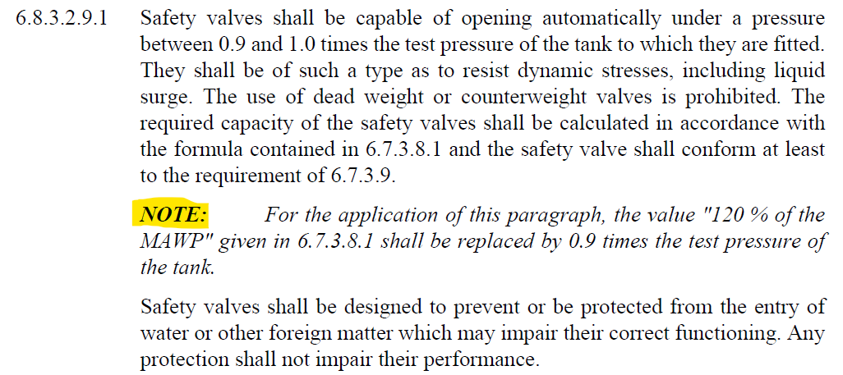

The requirements of 6.7.3.8.1 are
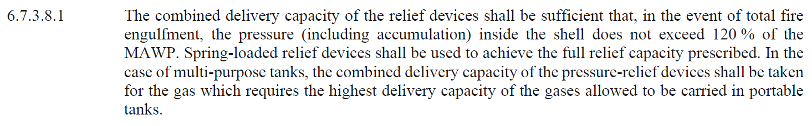

2. With the changes required by the wording of the current note in 6.8.3.2.9.1 the first sentence of 6.7.3.8.1 will read
“The combined delivery capacity of the relief devices shall be sufficient that, in the event of total fire engulfment, the pressure (including accumulation) inside the shell does not exceed 0.9 times the test pressure of the tank”
3. That means that the safety valve shall open at 0.9 times the test pressure of the tank, however the first requirement of 6.8.3.2.9.1 is that the safety valve shall open between 0.9 and 1.0 times the test pressure of the tank!
No pressure rise is permitted above the opening pressure, so the safety valve shall be fully open at its set pressure, that is not possible with a spring-loaded safety valve, which is required by 6.7.3.8.1!
4. Liquid Gas Europe believes that the intention was to replace « the MAWP » by « 0.9 times the test pressure of the tank ».
5. With this wording the first sentence of 6.7.3.8.1 would read –
“The combined delivery capacity of the relief devices shall be sufficient that, in the event of total fire engulfment, the pressure (including accumulation) inside the shell does not exceed 120% of 0.9 times the test pressure of the tank”
Proposal
6. Liquid Gas Europe suggests that the note in 6.8.3.2.9.1 should be changed to read:
“NOTE: For the application of this paragraph, the MAWP given in 6.7.3.8.1 shall be replaced by “0.9 times the test pressure of the tank”.”

