Proposal for amendments to ECE/TRANS/WP.29/GRE/2022/3
(Proposal for a new 04 series of amendments to UN Regulation No. 53)
The text reproduced below is based on German proposal to introduce amendments to improve road safety for motorcycles by deleting of Class A headlamps from UN Regulation No. 53. Additional amendments to the original proposal are identified in blue characters.
The modifications to the existing text are marked in bold for new and strikethrough for deleted characters.
I. Proposal
Paragraph 6.1.1., amend to read:
"6.1.1. Number:
6.1.1.1. For motorcycles having a cylinder capacity ≤ 125 cm3 or 11 kW
One or two of approved type according to:
(a) Class C, D or E of Regulation No. 113;
(b) [Class B of] UN Regulation No. 112;
[(c) Regulation No. 1;]
(d) Regulation No. 8;
(e) Regulation No. 20;
(f) Regulation No. 57;
[(f) Regulation No. 72;]
(g) Regulation No. 98;
(h) Class [ A,] B, D, CS, DS or ES of UN Regulation No. 149.
6.1.1.2. For motorcycles having a cylinder capacity > 125 cm3 or 11 kW
One or two of approved type according to:
(a) Class D or E of Regulation No. 113;
(b) Class B of UN Regulation No. 112
(c) Regulation No. 1;
(c) Regulation No. 8;
(d) Regulation No. 20;
(f) Regulation No. 72;
(e) Regulation No. 98;
(f) Class A, B, D, DS or ES of UN Regulation No. 149.
Two of approved type according to:
(g) Class C of UN Regulation No. 113;
(h) Class CS of UN Regulation No. 149."

Paragraph 6.2.1., amend to read:
"6.2.1. Number:
6.2.1.1. For motorcycles having a cylinder capacity ≤ 125 cm3 or 11 kW
One or two of approved type according to:
(a) Class C, D or E of Regulation No. 113;
(b) [Class B of] UN Regulation No. 112;
[(c) Regulation No. 1;]
(d) Regulation No. 8;
(e) Regulation No. 20;
(f) Regulation No. 57;
[(f) Regulation No. 72;]
(g) Regulation No. 98;
(h) Class [ A,] B, D, CS, DS or ES of UN Regulation No. 149;
(i) Class C or V of the 01 and subsequent series of amendments to UN Regulation No. 149.
6.2.1.2. For motorcycles having a cylinder capacity > 125 cm3 or 11 kW
One or two of approved type according to:
(a) Class D or E of Regulation No. 113;
(b) Class B of UN Regulation No. 112
(c) Regulation No. 1;
(c) Regulation No. 8;
(d) Regulation No. 20;
(f) Regulation No. 72;
(e) Regulation No. 98;
(f) Class A, B, D, DS or ES of UN Regulation No. 149;
(g) Class C or V of the 01 and subsequent series of amendments to UN Regulation No. 149.
Two of approved type according to:
(h) Class C of UN Regulation No. 113;
(i) Class CS of UN Regulation No. 149."

Insert a new paragraph 11.12. to read:
"11.12. Transitional provisions applicable to the 04 series of amendments
11.12.1. As from the official date of entry into force of the 04 series of amendments, no Contracting Party applying this UN Regulation shall refuse to grant or refuse to accept UN type approvals under this UN Regulation as amended by the 04 series of amendments.
11.12.2. As from [1 September 2026], Contracting Parties applying this UN Regulation shall not be obliged to accept UN type approvals to the preceding series of amendments, first issued after [1 September 2026].
11.12.3. Until [1 September 2027], Contracting Parties applying this Regulation shall accept type approvals to the preceding series of amendments, first issued before [1 September 2026].
11.12.4. As from [1 September 2027], Contracting Parties applying this Regulation shall not be obliged to accept type approvals issued to the preceding series of amendments to this Regulation.
11.12.5. Notwithstanding the transitional provisions above, Contracting Parties who start to apply this UN Regulation after the date of entry into force of the most recent series of amendments are not obliged to accept UN type-approvals which were granted in accordance with any of the preceding series of amendments to this UN Regulation.
11.12.6. Notwithstanding paragraph 11.12.2., Contracting Parties applying this UN Regulation shall continue to accept UN type approvals to the preceding series of amendments to this UN Regulation and extension thereof, for the vehicles which are not affected by the changes introduced by the 04 series of amendments.
11.12.7. Contracting Parties applying this Regulation may grant type approvals according to any preceding series of amendments to this Regulation.
11.12.8. Contracting Parties applying this Regulation shall continue to grant extensions of existing approvals to any preceding series of amendments to this Regulation."

II. Justification
1. Irrespectively to original proposal WP.29/GRE/2022/3 there are included changes for passing-beam as well as for driving-beam headlamp.
For better consistency of the changes the proposal updates conditions for mounting of relevant headlamps Class A approved according to Regulation No. 112 and headlamps approved according to Regulations 1, 57 and 72 as well.
2. Parameters of headlamps approved according to Regulations No. 1 and 72 are similar to parameters of Class A of Regulations No. 112 or 149, therefore the proposal remove these Regulations with the same intention as Class A.
3. Class BS was removed completely from the proposal because Class BS of Regulation No. 149 resp. Class B of Regulation No. 113 is not allowed in 02 and 03 series of amendments to Regulation 53 already.
Parameters of headlamps approved according to Regulation No. 57 are similar to parameters of Class B of Regulation No. 112 or Class BS of Regulation 149, therefore the proposal removes this Regulations completely.
4. The original proposal WP.29/GRE/2022/3 was modified with respect to comparation of parameters of Class A and CS, see tables below. Symmetrical headlamps of Class CS (resp. C of Regulation No. 113) are allowed for motorbikes having a cylinder capacity below the 125 cm³ and asymmetrical headlamps of Class A with similar parameters should be kept for such L3 vehicles having a cylinder capacity below the 125 cm³ as well.
However, with respect to original proposal submitted by experts from Germany removal of the Class A of Regulations No. 112 and 149, Regulations 1 and 72 in paragraphs 6.1.1.1 and 6.2.1.1 is in square brackets for additional discussion. But in case the GRE will find the differences between the motorbikes having a cylinder capacity below the 125 cm³ and above the 125 cm³ as useless the proposal should be improved, and the requirements should be consistent for any cylinder capacity of the engine without any differences of the classes of the headlamps.
5. If the differences of cylinder capacity of the engine in category L3 will be kept and find as useful still, we additionally propose to take in account different classification for electric (or alternative propulsion) vehicles. The additional classification is based on the power of the propulsion system and the power 11 kW was selected based on classification of the same subcategory as for motorbikes having a cylinder capacity below the 125 cm³ as prescribes EU Regulation.
6. Transitional provisions for new series of amendment are not modified in this document.

- Regulation No. 149.00, Table for driving-beam headlamps
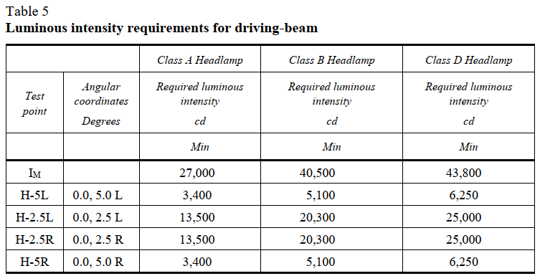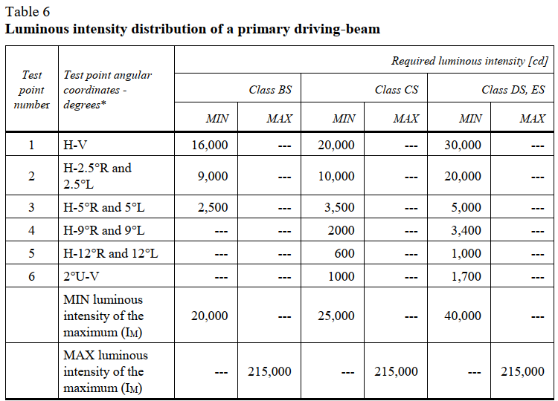

- Regulation No. 149.00, Table for passing-beam headlamps
