Transmitted by the experts of IWG WGWT | Informal document GRBP-75-25-Rev.1  (75th GRBP, 8-11 February 2022,  agenda item 4 (d))

- Proposal to amend document ECE/TRANS/WP.29/2022/11

The changes compared to document ECE/TRANS/WP.29/2022/11 are marked in bold for added text and strike through for deleted text, all in red font

I. Proposal
Table of contents, Annexes, at the end add a reference to a new Annex 9 to read:
"9 Test procedure for measuring the adhesion on wet surfaces of tyres in worn state
Appendix 1 Worn tyre preparation report example
Appendix 2 Test reports examples of wet grip index for tyres in worn state "
Paragraph 1.1., amend to read:
"1.1. This Regulation applies to new pneumatic tyres* of classes C1, C2 and C3 in new state with regard to their sound emissions, rolling resistance and to adhesion performance on wet surfaces (wet adhesion) and for class C1 tyres in worn state with regard to adhesion performance on wet surfaces (wet adhesion). It does not, however, apply to:

* For the purpose of this Regulation "tyres" means "pneumatic tyres"
Paragraph 1.2., amend to read:
"1.2. Contracting Parties shall issue or accept approvals to rolling sound and/or adhesion of tyres in new state on wet surfaces and/or adhesion of tyres in worn state on wet surfaces and/or rolling resistance."
Paragraph 2.7., amend to read:
"2.7. "Representative tyre size" means the tyre size which is submitted to the test described in Annex 3 to this Regulation with regard to rolling sound emissions, or Annex 5 for adhesion on wet surfaces or Annex 6 for rolling resistance to assess the conformity for the type approval of the type of tyre, or Annex 7 for measuring snow performance, or Annex 8 for measuring ice performance, or Annex 9 for adhesion on wet surfaces of class C1 tyres in worn state."
Paragraph 2.13.1., amend to read:
"2.13.1. "Snow tyre for use in severe snow conditions" means a snow tyre whose tread pattern, tread compound or structure is specifically designed to be used in severe snow conditions and that fulfils the requirements of paragraphs 6.5. and 6.5.1. of this Regulation."
Insert new paragraphs 2.19.17. and 2.19.18., to read:
"2.19.17. "Tyre in worn state" or "worn tyre" means the tyre in a state as defined in Annex 9 to this Regulation.
2.19.18. "Tyre in new state" means the tyre in a state as defined in Annex 9 to this Regulation."
Paragraph 3.1.1., amend to read:
"3.1.1. The performance characteristics to be assessed for the type of tyre; "rolling sound emissions level" and/or "adhesion performance level on wet surfaces of a tyre in new state" and/or "adhesion performance level on wet surfaces of a tyre in worn state” and/or "rolling resistance level"; "snow performance level" in case of "snow tyre for use in severe snow conditions" and additionally "ice performance level" in case of ice grip tyre;"
Paragraph 4.3.1., amend to read:
"4.3.1. In case the approval of a tyre pursuant to this Regulation has been granted by the same Type Approval Authority than that granting the approval pursuant to UN Regulations Nos. 30 or 54, the approval mark pursuant to UN Regulations Nos. 30 or 54 can be combined with an indication of the applicable series of amendments to which the tyre was approved pursuant to UN Regulation No. 117 on the form of 2 digits (example "03" indicating that the UN Regulation No. 117 approval was granted following the 03 series of amendments) and the suffixes according to paragraph 5.2.2. using the addition sign "+", as described in Annex 2, Appendix 3 of this Regulation, for example "0236378 + 03S2WR2B"."
Paragraph 5.2.2., amend to read:
"5.2.2. The communication form mentioned in paragraph 5.3. below shall identify specific performance parameters of UN Regulation No. 117 by the following suffixes:
S To identify additional conformity to the requirements on tyre rolling sound emissions;
W To identify additional conformity to the requirements on adhesion on wet surfaces of tyres in new state;
R To identify additional conformity to the requirements on tyre rolling resistance;
B To identify additional conformity to the requirements on adhesion on wet surfaces of tyres in worn state.
S and R will be followed by the suffix "2" for compliance to stage 2."
Paragraph 5.3.1.2., amend to read:
"5.3.1.2. The suffix(es) mentioned in paragraph 5.2.2. above shall be preceded by the two digits identifying the series of amendments of the prescription on tyre performances for UN Regulation No. 117, e.g. 03S2 to identify the third series of amendments on tyre road rolling sound emissions at stage 2 or 03S2WR2 to identify the third series of amendments on tyre road rolling sound emissions at stage 2, adhesion on wet surfaces of a tyre in new state and rolling resistance at stage 2."
Paragraph 5.4.3., amend to read:
"5.4.3. The suffix(es), and the identification to the relevant series of amendments, if any, as specified in the communication form.
One of the suffixes listed below or any combination of them can be used.
S2 | Rolling sound emission level at stage 2
W | Wet adhesion level of tyres in new state
R2 | Rolling resistance level at stage 2
B | Wet adhesion level of tyres in worn state
These suffixes shall be placed to the right or below the approval number, if part of the original approval.
If the approval is extended subsequent to UN Regulations Nos. 30 or 54 approvals, the addition sign "+" and the series of amendment to UN Regulation No. 117 shall be placed in front of the suffix or any combination of suffixes to denote an extension to the approval.
If the approval is extended subsequent to the original approval under UN Regulation No. 117, the addition sign "+" shall be placed between the suffix or any combination of suffixes of the original approval and the suffix or any combination of suffixes added to denote an extension to the approval."
Paragraph 6.1.1., amend to read:
"6.1.1. For class C1 tyres, the rolling sound emission value shall not exceed the values given below. These values refer to the nominal section width as defined in UN Regulation No. 30:
Stage 2
Nominal section width | Limit dB(A)
185 and lower | 70
Over 185 up to 245 | 71
Over 245 up to 275 | 72
Over 275 | 74
The above limits shall be increased by 1 dB(A) for "snow tyre for use in severe snow conditions", extra load tyres or reinforced tyres, or any combination of these classifications.
"
Paragraph 6.1.2., amend to read:
"6.1.2. For class C2 tyres, the rolling sound emission value with reference to its category of use (see paragraph 2.1., subparagraph (d) above) shall not exceed the values given below:
Stage 2
Category of use |  | Limit dB(A)
 |  | Other | Traction tyres
Normal tyre |  | 72 | 73
Snow tyre |  | 72 | 73
 | Snow tyre for use in severe snow conditions | 73 | 75
Special use tyre |  | 74 | 75
"
Paragraph 6.1.3., amend to read:
"6.1.3. For class C3 tyres, the rolling sound emission value with reference to its category of use (see paragraph 2.1., subparagraph (d) above) shall not exceed the values given below:
Stage 2
Category of use |  | Limit dB(A)
 |  | Other | Traction tyres
Normal tyre |  | 73 | 75
Snow tyre |  | 73 | 75
 | Snow tyre for use in severe snow conditions | 74 | 76
Special use tyre |  | 75 | 77
"
Paragraph 6.2., amend to read:
"6.2. The wet adhesion of tyres in new state will be based on a procedure that compares either peak brake force coefficient ("pbfc") or mean fully developed deceleration ("mfdd") against values achieved by a Standard Reference Test Tyre (SRTT). The relative performance shall be indicated by a wet grip index (G)."
Paragraph 6.3., amend to read:
"6.3. Rolling resistance coefficient limits, as measured by the method described in Annex 6 to this Regulation.
The maximum values for stage 2 for the rolling resistance coefficient shall not exceed the following (value in N/kN is equivalent to value in kg/tonne):
Tyre class | Max value (N/kN)
C1 | 10.5
C2 | 9.0
C3 | 6.5
For "snow tyre for use in severe snow conditions”, the limits shall be increased by 1 N/kN.
"
Insert a new paragraph 6.4., to read:
"6.4. The wet adhesion of tyres in worn state shall be based on a procedure defined in Annex 9 to this Regulation.
6.4.1. For class C1 tyres, tested in accordance with either procedure given in Annex 9 to this Regulation, the tyre shall meet the following requirements:
[
Category of use |  |  | Wet grip index (G_{B})
Normal tyre |  |  | ≥ 0.88
Snow tyre |  |  | ≥ 0.80
 | "Snow tyre for use in severe snow conditions" and with a speed category symbol ("R" and above, including "H") indicating a maximum permissible speed greater than 160 km/h |  | ≥ 0.80
 |  | Ice grip tyre | ≥ 0.70
 | "Snow tyre for use in severe snow conditions" and with a speed category symbol ("Q" or below excluding "H") indicating a maximum permissible speed not greater than 160 km/h |  | ≥ 0.70
 |  | Ice grip tyre | ≥ 0.70
Special use tyre |  |  | Not defined
For normal tyres with speed category symbol indicating a maximum permissible speed equal to or greater than 300 km/h and aspect ratio equal to or lower than 40, the limit shall be decreased by 0.08.
]"
Paragraph 6.4. (former) and its subparagraphs, renumber as 6.5. and its respective subparagraphs.
Paragraph 6.5., (former), renumber as 6.6. and amend to read:
"6.6. In order to be classified as a "traction tyre", a tyre is required to meet the conditions of paragraph 6.6.1. below."
Paragraphs 6.5.1. (former), 6.6. (former) and 6.7., renumber as 6.6.1., 6.7. and 6.8., respectively.
Insert a new paragraph 8.3.3., to read:
"8.3.3. In the case of verification tests with regard to approvals in accordance with paragraph 6.4. of this Regulation, these shall be carried out using the same testing method (see Annex 9 to this Regulation) as that adopted for the original approval."
Paragraph 12., amend to read:
"12. Transitional provisions
12.1. As from the official date of entry into force of the 03 series of amendments, no Contracting Party applying this Regulation shall refuse to grant or refuse to accept type approvals under this Regulation as amended by the 03 series of amendments.
12.2. Contracting Parties applying this Regulation shall continue to accept type approvals of and to grant extensions of approvals to, the classes C2 and C3 tyres, which are not affected by the changes of the technical requirements concerning the adhesion on wet surfaces of class C1 tyres in worn state introduced by the 03 series of amendments, to the 02 series of amendments to this Regulation.
12.3. As from 7 July 2024, Contracting Parties applying this Regulation shall not be obliged to accept type approvals of class C1 tyres to the 02 series of amendments, first issued after 7 July 2024.
12.4. Until 7 July 2026, Contracting Parties applying this Regulation shall accept type approvals of class C1 tyres to the 02 series of amendments, first issued before 7 July 2024.
12.5. As from 7 July 2026, Contracting Parties applying this Regulation shall not be obliged to accept type approvals of class C1 tyres issued to the 02 series of amendments to this Regulation.
12.6. Contracting Parties applying this Regulation may grant type approvals according to any preceding series of amendments to this Regulation.
12.6.1. Contracting Parties applying this Regulation shall continue to grant extensions of existing approvals to any preceding series of amendments to this Regulation.
12.7. Until 1 September 2024, Contracting Parties applying this Regulation may continue to grant type approvals according to the 0203 series of amendments to this Regulation, based on snow performance test described in Annex 7 to this Regulation using SRTT14 as reference tyre. ^{(a)}
12.8. Until 1 September 2024, Contracting Parties applying this Regulation may continue to grant type approvals according to the 03 series of amendments to this Regulation, based on the test procedures for measuring the wet adhesion of tyres in new state as described in Annex 5 of this Regulation, without taking into account the provisions introduced after Supplement 12 to the 02 series of amendments.
^{(a)} SRTT14 will be available from the supplier until end of October 2021."
Annex 1
Paragraph 8., amend to read:
"8. Performance(s) approved: rolling sound emission level at stage 2, wet adhesion level of tyres in new state, rolling resistance level at stage 2, wet adhesion level of tyres in worn state"
Paragraph 8.2., amend to read:
"8.2. Wet adhesion level of tyres in new state of representative size, see paragraph 2.7. of this Regulation, as per the test report examples shown in the appendix to Annex 5: ……………………… (G) using the vehicle or trailer method²"
Insert a new paragraph 8.3., to read:
"8.3. Wet adhesion level of tyres in worn state of representative size, see paragraph 2.7. of this Regulation, as per item Y. of the test report in the appendix to Annex 9: ……………………… (G_{B}) using the vehicle or trailer method²"
Paragraphs 8.3. (former), 8.4. and 8.4.1., renumber as 8.4., 8.5. and 8.5.1., respectively.
Annex 2, Appendix 1, amend to read:
"Annex 2 - Appendix 1
Examples of separate UN Regulation No. 117 approval marks

Example 1
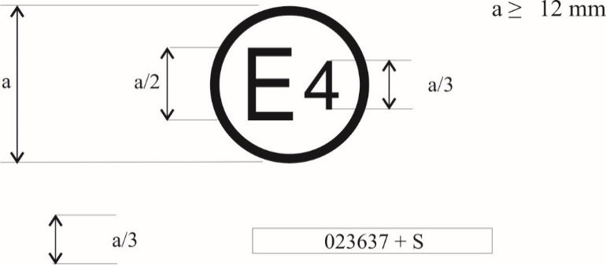
0312345 S2
The above approval mark, affixed to a tyre shows that the tyre concerned has been approved in the Netherlands (E4) pursuant to UN Regulation No. 117 (marked by S2 (rolling sound emission at stage 2)), under approval number 0312345. The first two digits of the approval number (03) indicate that the approval was granted according to the requirements of the 03 series of amendments to this Regulation.

Example 2

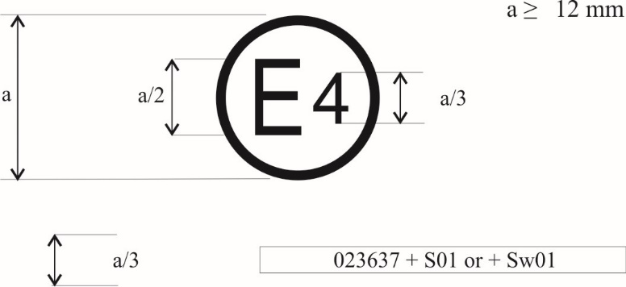
0312345 S2WR2B
The above approval mark shows that the tyre concerned has been approved in the Netherlands (E4) pursuant to UN Regulation No. 117 (marked by S2 (rolling sound emission at stage 2), W (wet adhesion of tyres in new state), R2 (rolling resistance at stage 2) and B (wet adhesion of tyres in worn state)) under approval number 0312345. The first two digits of the approval number (03) indicate that the approval was granted according to the requirements of the 03 series of amendments to this Regulation."
Annex 2, Appendix 2, amend to read:
"Annex 2 - Appendix 2
Approval according to UN Regulation No. 117 coincident with approval of UN Regulations Nos. 30 or 54

Example 1
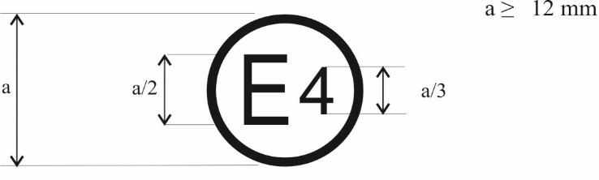
a/3 0312345 S2 0236378
The above approval mark shows that the tyre concerned has been approved in the Netherlands (E4) pursuant to UN Regulation No. 117 (marked by "S2" (rolling sound emission at stage 2)), under approval number 0312345 and UN Regulation No. 30, under approval number 0236378. The first two digits of the approval numbers ("03" and "02") indicate that the approval pursuant to UN Regulation No. 117 was granted according to the 03 series of amendments and the approval pursuant to UN Regulation No. 30 according to the 02 series of amendments.

Example 2
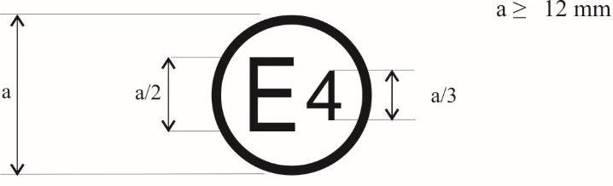
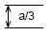0312345 S2WR2B 0236378
or
0312345 S2WR2B
0236378
The above approval mark shows that the tyre concerned has been approved in the Netherlands (E4) pursuant to UN Regulation No. 117 (marked by "S2WR2B" (rolling sound emission at stage 2, wet adhesion of tyres in new state, rolling resistance at stage 2 and wet adhesion of tyres in worn state)), under approval number 0312345 and UN Regulation No. 30 under approval number 0236378. The first two digits of the approval numbers ("03" and "02") indicate that the approval pursuant to UN Regulation No. 117 was granted according to the 03 series of amendments and the approval pursuant to UN Regulation No. 30 according to the 02 series of amendments.

Example 3
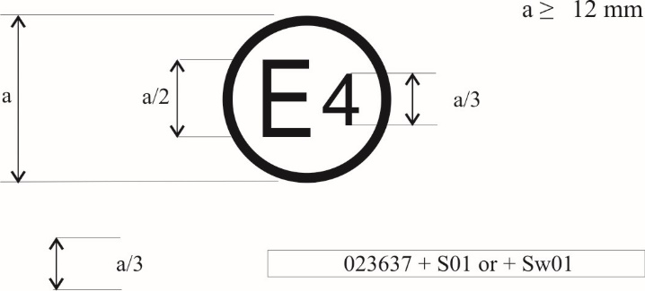
a/3 0312345 S2WR2 0065432
The above approval mark shows that the tyre concerned has been approved in the Netherlands (E4) pursuant to UN Regulation No. 117 (marked by "S2WR2" (rolling sound emission at stage 2, wet adhesion of tyres in new state and rolling resistance at stage 2)), under approval number 0312345 and UN Regulation No. 54 under approval number 0065432. The first two digits of the approval numbers ("03" and "00") indicate that the approval pursuant to UN Regulation No. 117 was granted according to the 03 series of amendments and the approval pursuant to UN Regulation No. 54 according to its original form."
Annex 2, Appendix 3, amend to read:
"Annex 2 - Appendix 3
Combinations of markings of approvals issued in accordance with Regulations Nos. 117, 30 or 54

Example 1
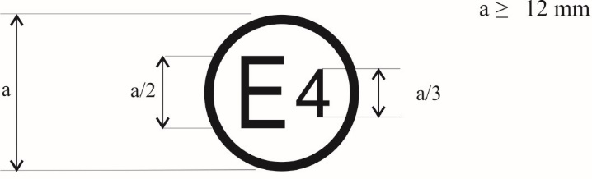
a/3 0236378 + 03S2
The above approval mark shows that the tyre concerned has been approved in the Netherlands (E4) pursuant to UN Regulation No. 30 according to its 02 series of amendments (indicated by the first two digits of the approval number, "02") under approval number 0236378. It is also marked by "+ 03S2" which indicates that the tyre was also approved pursuant to UN Regulation No. 117 (03 series of amendments) for S (rolling sound emission at stage 2).

Example 2

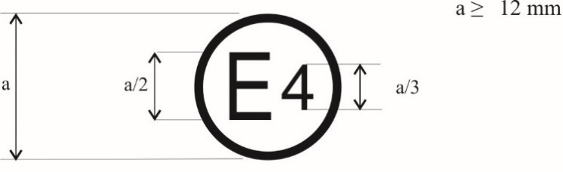
a/3 0236378 + 03S2WR2B
The above approval mark shows that the tyre concerned has been approved in the Netherlands (E4) pursuant to UN Regulation No. 30 according to its 02 series of amendments (indicated by the first two digits of the approval number, "02") under approval number 0236378. It is also marked by "+ 03S2WR2B" which indicates that the tyre was also approved pursuant to UN Regulation No. 117 (03 series of amendments) for S (rolling sound emission at stage 2) W (wet adhesion of tyres in new state), R (rolling resistance at stage 2) and B (wet adhesion of tyres in worn state)."
Annex 2, Appendix 4, amend to read:
"Annex 2 - Appendix 4
Extensions to combine approvals issued in accordance with Regulation No. 117

Example 1

a/3 0212345 S2WR2 + 03B
The above approval mark shows that the tyre concerned has been initially approved in the Netherlands (E4) pursuant to UN Regulation No. 117 and the 02 series of amendments under approval number 0212345. The marking is complemented by S2WR2 (rolling sound emission at stage 2) W (wet adhesion of tyres in new state) and R (rolling resistance at stage 2) The "03B" preceded by "+" indicates that it has had its approval extended under UN Regulation No. 117 and 03 series of amendments to wet adhesion of tyres in worn state based on separate certificate."
Annex 5, title, amend to read:
"Test procedures for measuring the adhesion on wet surfaces of tyres in new state"
Annex 5 – Appendix, amend to read:
"Test reports examples of wet grip index for tyres in new state

Example 1: Test report of wet grip index for tyres in new state using trailer or tyre test vehicle method

…

Example 2: Test report of wet grip index for tyres in new state using vehicle method

…"
Annex 7,
Appendix 3, Part I, paragraph 7., amend to read:
"7. Snow grip index relative to SRTT according to paragraph 6.5.1.1."
Insert a new Annex 9, to read:
"Annex 9
Test procedure for measuring the adhesion on wet surfaces of tyres in worn state
1. General part (reserved)
2. Tyres of class C1
Principle
Two steps:
1) Preparation of the tyre in worn state
2) Wet grip index evaluation of the tyre in worn state
2.1. Definitions
For the purpose of this Annex, the "Candidate tyre" or "Candidate tyre set" and the "Reference tyre" or "Reference tyre set” mentioned in paragraphs 2.19.2. and 2.19.3. shall be read respectively as "Candidate tyre in worn state" or "Candidate tyre set in worn state" and the "Reference tyre in worn state" or "Reference tyre set in worn state".
2.1.1. "Tyre in worn state" or "worn tyre" means, for the purpose of this Regulation, a new tyre artificially worn by reducing the tread depth at the height of the tread-wear indicator as defined in the UN Regulation No. 30 (1.6 +0.6 / −0.0 $1,6 +0,6 / -0,00$mm).
2.1.2. "Tyre in new state" means a new tyre before starting to be artificially worn.
2.1.3. "Groove" means the space between two adjacent ribs or blocks in the tread pattern.
2.1.4. "Groove depth" means the perpendicular distance from a real or calculated reference plane defined by edges of two adjacent ribs to the lowest point in the groove.
2.1.5. "Reference tread width" (C) is calculated as follows:
$$C=\left(1.075-0.005∙Ra\right)∙S_{1}^{1.001}$$
Where:
Ra is the nominal aspect ratio as defined as part of tyre size designation in UN Regulation No. 30 except for the sizes listed in Annex 5 of UN Regulation No. 30 where it is taken as 90 and
S₁ is the nominal section width according to UN Regulation No. 30 except for the sizes listed in Annex 5 of UN Regulation No. 30 where it is the tyre section width listed therein.
2.1.6. "Tread-wear indicators": see definition in UN Regulation No.30.
2.1.7. "Centre line" means the line dividing the overall width of the tyre in two equal parts.
2.1.8. "Central zone" means the area on the tread width defined by the ¾ (75%) of the reference tread width (C) symmetrically measured from the centre line.
2.1.9. "Shoulder zone" means the area on both sides of the tread outside of the central zone.
2.1.10. "Mould parting line" means the border circumference in which mould tread pattern segments connects with mould sidewall plates. If no mould parting line is visible on the tyre, a virtual mould parting line shall be considered as the circumferential line in the equivalent position at the end of the shoulder grooves.
2.1.11. "Tread pattern limit points Li and Le" means the points located on the tyre profile between mould parting line and hypothetical point up to 15 mm on the tyre profile towards centre line (see Figure 1).
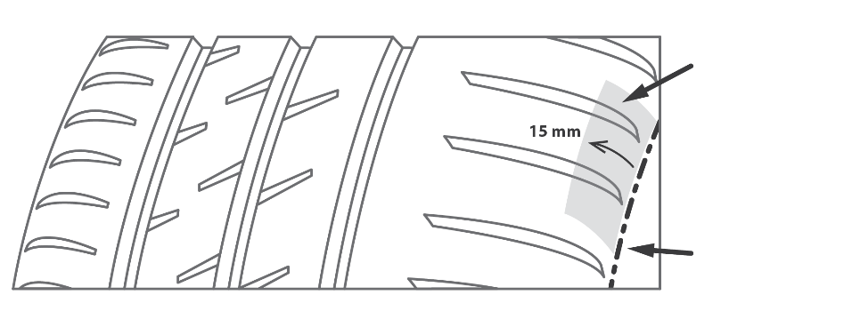
Li (Le) zone
Mould parting line
Figure 1
2.1.12. "Buffing" is all the processes of removing material from the tread to prepare the tyre in worn state for following the procedure in paragraph 2.2.1.
2.1.13. "Reference tyre in worn state" or "Reference tyre set in worn state" means a tyre or a tyre set of Standard Reference Test Tyres SRTT16 in worn state.
2.2. Theoretical target profile of a tyre at worn state
The theoretical target profile is the profile curve of the tyre in worn state, as described in paragraph 2.2.1.2.2.
2.2.1. Preparation of class C1 tyres in worn state
The following paragraphs outline the preparation of worn tyres of class C1 by removal of a predetermined amount of tread rubber (for example cutting, grinding, surface finish) for subsequent wet grip index testing.
2.2.1.1. Apparatus
2.2.1.1.1. Tread Depth Gauge.
Any mechanical, optical, or electronic device capable of measuring groove (void) depth can be used. The resolution of the gauge shall be at least 0.02 mm. The accuracy of the gauge shall be to within ±0.04 mm.
2.2.1.1.2. Tyre Tread Removal Machine, with equipment to remove tread rubber in a predetermined manner. Specifically, the equipment shall ensure a buffing accuracy and precision on the final groove depth as required in the paragraph 2.2.1.2.4.1.
2.2.1.2. Procedure
Choose 4 positions approximately equally spaced around the circumference.
Figure 2
At each of the four positions, choose measurement points in the transversal direction:
- In the central zone pursuant to the procedure described in paragraph 2.2.1.2.1. and
- In each shoulder zone at least one measurement point.
2.2.1.2.1. Choice of the control measurement points of the central zone
To control the conformity of the preparation process (see paragraph 2.2.1.2.3., choose n measurement points in the central zone, in the transversal direction (see Figure 2)
- The number of measurement points n shall be greater than or equal to 4; */
- 1 measurement point in each principal groove;
- The other measurement points shall be located in non-principal grooves:
      - At the maximum groove depth in the corresponding groove/zone;
      - In order to have the most regular distribution of the n points.
*/ In case a tyre tread pattern does not allow the measurement at 4 points in the central zone, the groove depth may be measured at 3 measurement points. In case that 3 measurement points in transversal direction are not available, the number and position of the measurement points shall be agreed with the Type Approval Authority.
Measurement points in the principal grooves shall be positioned at locations with full groove depth, for example, avoiding rubber ridges, tie bars, treadwear indicators and other elevated elements.
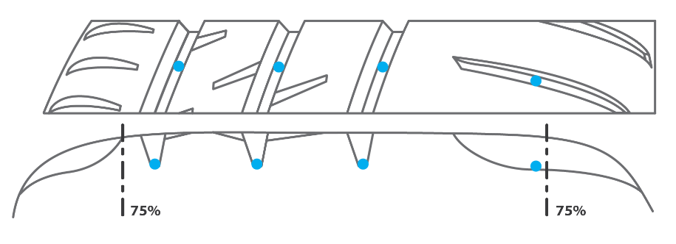
Figure 3
2.2.1.2.2. Description of theoretical worn target profile
Central zone: curve built on a circle with its centre located on the radial axle passing through the centre line and its radius built on a fit on all the points located at 2 mm height on all the control points as described in paragraph 2.2.1.2.1.. Alternatively, depending of the specificity of the tread pattern geometry, the fitting curve can be the offset of the original tyre profile.
Shoulder zone: edges of the artificial worn profile in the central part of the tread are connected with Le and Li points. Regularity of the whole artificial worn tyre profile (on the of the central zone to the shoulders) shall be assured (for example by an arc of circumference or another curve).
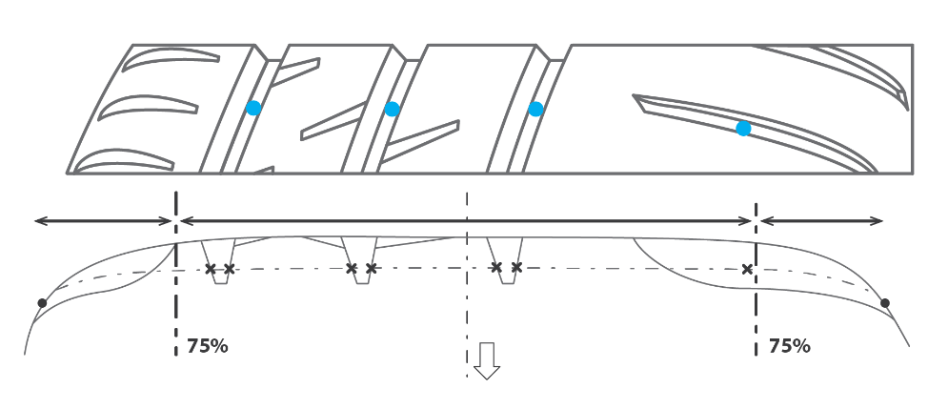
Centre of
the circle
Centre line
Li
Le
Shoulder zone
Central zone
Shoulder zone
Figure 4
2.2.1.2.3. Preparation of the worn tyre.
Inspect the tyre to determine that there are no tread defects that would affect the finished tyre. If such conditions are noted, do not use the tyre for this procedure.
Depending on the worn tyre preparation processing technique, the removing of the rubber can be managed by directly targeting the worn tyre target profile, or by a manual regular controlling of the rubber removal, or other means.
2.2.1.2.4. Validation of the prepared tyre
2.2.1.2.4.1. Validation of tread depths
At the end of the preparation process, measure the groove depth at the measurement points defined in paragraph 2.2.1.2.1.
For all the measurement points defined in the central zone:
- The final groove depth at each individual measurement point of the central zone shall be 2 mm ± 0.4 mm
- The average groove depth over all measurement points in the central zone shall be 2 mm ± 0.2 mm
For each measurement point defined in the shoulder zone:
- The final groove depth in the shoulder zone shall not be greater than 2 mm.

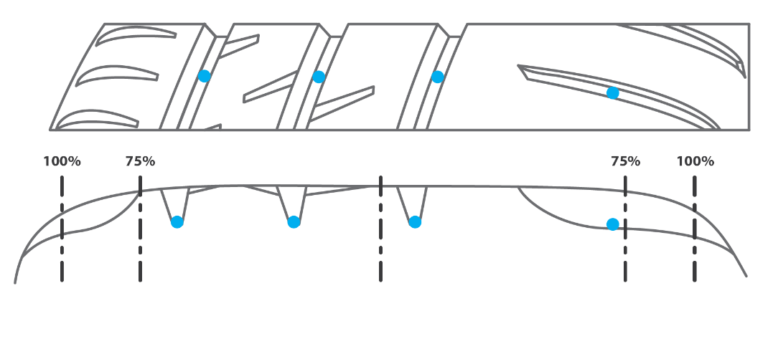
2 mm ± 0.4 mm
2 mm ± 0.2 in average $\left(4∙n\right)$
≤ 2 mm

Figure 5
If one of the above conditions is not met, another candidate tyre shall be prepared.
2.2.1.2.4.2. Validation of the surface of the worn tyre
The arithmetic mean deviation arithmetical mean height of the absolute values of the roughness profile, as defined in [ISO 4287:1997ISO 21920-2:2021], of the final surface shall be determined at 3 measurement points in the transversal direction approximately equally spaced on the prepared surface, at 4 circumferential positions equally spaced.
The average of the 3 arithmetic mean deviation arithmetical mean height of the absolute values of the roughness profile of the final surface shall not exceed 20 µm.
If the above condition is not met, another candidate tyre shall be prepared.
2.3. General test conditions
All the provisions specified in Annex 5, Part (A), paragraph 3. "General test conditions" and its subparagraphs apply except for paragraph 3.4. "Replacement of reference tyres". The paragraph 2.3.1. of this Annex applies instead.
2.3.1. Replacement of reference tyres
When irregular wear or damage results from tests, or when wear or aging influences the test results, the use of the reference tyre shall be discontinued.
2.3.1. Track characteristics
The test track shall have the following characteristics:
2.3.1.1. The surface shall have a dense asphalt surface with a uniform gradient of not more than 2 per cent in both longitudinal and lateral directions and shall not deviate more than 6 mm when tested with a 3 m straight edge.
2.3.1.2. The surface shall have a pavement of uniform age, composition, and wear. The test surface shall be free of loose material and foreign deposits.
2.3.1.3. The maximum chipping size shall be 10 mm (tolerances permitted from 8 mm to 13 mm).
2.3.1.4. The average macro texture depth as measured in accordance with ASTM E965-96 (Reapproved 2006) by a sand patch shall be (0.7 ± 0.3) mm. In case the vehicle method is used, the average macro texture depth shall be determined in both lanes where the tyres are going to brake.
2.3.1.5. The wetted frictional properties of the surface shall be measured using the Worn Standard Reference Test Tyre SRTT16 in worn state either with the method described in paragraph 2.3.2.1 of this Annex in case the vehicle method (according to paragraph 2.4.1. below) is used, or with the method described in paragraph 2.3.2.2 in this Annex in case the trailer (or tyre test vehicle) method is used.
2.3.2. Methods to measure the wetted frictional properties of the surface
2.3.2.1. Using the procedure described in paragraph 2.4.1. of this Annex, perform two braking tests of the reference tyre, each consisting of at least six (6) valid test runs in the same direction on aligned segments of the track. The braking tests shall cover the entire potential braking area, including where the texture depth was measured.
Evaluate the braking tests as described in paragraphs 2.4.1.1.1. and 2.4.1.1.2. of this Annex. If the coefficient of variation of one braking test CV_{BFC} exceeds 4 per cent, dismiss the results and repeat the braking tests.
For each braking test, the arithmetic mean $\overline{{BFC}_{\text{ave}}}$ of the average Braking Force Coefficients shall be corrected for effects of temperature as follows:
$${BFC}_{\text{ave,corr}}=\overline{{BFC}_{\text{ave}}}+a∙\left(ϑ-ϑ_{0}\right)$$
where
ϑ is the wetted surface temperature in degrees Celsius,
$a= 0.002{ ℃ }^{-1}$ and $ϑ_{0}=20 ℃$.
For each braking test, the temperature-corrected average Braking Force Coefficient (BFC_{ave,corr}) shall be not less than 0.4 and not greater than.0.65
The arithmetic means of the temperature-corrected average Braking Force Coefficients of the two braking tests shall not differ by more than 10 per cent of the average of the two values:
$$CVal\left({BFC}_{\text{ave,corr}}\right)=2∙\left|\frac{{BFC}_{\text{ave,corr,1}}-{BFC}_{\text{ave,corr,2}}}{{BFC}_{\text{ave,corr,1}}+{BFC}_{\text{ave,corr,2}}}\right|≤10 \%$$
2.3.2.2. Using the procedure described in paragraph 2.4.2. of this Annex, perform in the same area where the average macro texture depth was measured one braking test of the reference tyre, consisting of at least six (6) test runs in the same direction.
Evaluate the braking test as described in paragraphs 2.4.2.1.1. and 2.4.2.1.2. of this Annex. If the coefficient of variation CV_{µ} exceeds 4 per cent, dismiss the results and repeat the braking test.
The arithmetic mean ($\overline{μ_{\text{peak}}}$) of the measured peak braking force coefficients shall be corrected for effects of temperature as follows:
$$μ_{\text{peak,corr}}=\overline{μ_{\text{peak}}}+a∙\left(ϑ-ϑ_{0}\right)$$
Where
ϑ is the wetted road surface temperature in degrees Celsius
$a= 0.002{ ℃ }^{-1}$ and $ϑ_{0}=20 ℃$.
The temperature corrected average peak braking force coefficient (µ_{peak,corr}) shall be not less than 0.45 and not greater than 0.80.
2.3.3. Atmospheric conditions
The wind conditions shall not interfere with wetting of the surface (wind-shields are allowed).
The wetted surface temperature and the ambient temperature shall be between:
Category of use |  | Wetted surface temperature | Ambient temperature
Normal tyres |  | 12 °C – 35 °C | 12 °C – 40 °C
Snow tyres |  | 5 °C – 35 °C | 5 °C – 40 °C
 | Snow tyres for use in severe snow conditions | 5 °C – 20 °C | 5 °C – 20 °C
Special use tyres |  | not applicable | not applicable

Moreover, the wetted surface temperature shall not vary during the test by more than 10 °C.
The ambient temperature shall remain close to the wetted surface temperature; the difference between the ambient and the wetted surface temperatures shall be less than 10 °C.
2.3.4. Replacement of reference tyres
When irregular wear or damage results from tests, or when wear or aging influences the test results, the use of the reference tyre shall be discontinued.
2.4. Testing methods for measuring the adhesion on wet surfaces
For the calculation of the wet grip index (G_{B}) of a candidate tyre in worn state, the wet grip braking performance of the candidate tyre is compared to the wet grip braking performance of the reference tyre on a vehicle travelling straight ahead on a wet, paved surface. It is measured with one of the following methods:
(a) Vehicle method consisting of testing a set of tyres mounted on an instrumented passenger car;
(b) Testing method using a trailer towed by a vehicle or a tyre test vehicle, equipped with the test tyre(s).
2.4.1. Testing method (a) using an instrumented passenger car
All the provisions specified in Annex 5, Part (A), paragraph 4.1. "Testing method (a) using an instrumented passenger car" and its subparagraphs apply with the exception of paragraph 4.1.6. "Processing of measurement results". The paragraph 2.4.1.1. of this Annex applies instead.
2.4.1.1. Processing of measurement results
2.4.1.1.1. Calculation of the average braking force coefficient
All the provisions specified in Annex 5, Part (A), paragraph 4.1.6.1. apply.
2.4.1.1.2. Validation of results
The coefficient of variation CV_{BFC} is calculated as follows:
$${CV}_{BFC}=100\%∙\frac{σ_{BFC}}{\overline{{BFC}_{ave}}}$$
where
$σ_{BFC}=\sqrt{\frac{1}{N-1}\sum_{j=1}^{N}{{\left({BFC}_{ave,j}-\overline{{BFC}_{ave}}\right)}^{2}}}$ denotes the corrected sample standard deviation and
$\overline{{BFC}_{ave}}$ the arithmetic mean of the average braking force coefficients BFC_{ave,j} of N test runs.
For the reference tyre:
(a) The coefficient of variation CV_{BFC} of the initial and the final braking test of the reference tyre within one test cycle shall be less than or equal to [4] per cent.
(b) The arithmetic means of the average braking force coefficients of the initial and the final braking test shall not differ by more than [5] per cent of the average of the two values:
$$CVal\left({BFC}_{ave}\right)=100\%∙ 2∙\left|\frac{\overline{{BFC}_{ave}}\left({\text{R}}_{\text{i}}\right)-\overline{{BFC}_{ave}}\left({\text{R}}_{\text{f}}\right)}{\overline{{BFC}_{ave}}\left({\text{R}}_{\text{i}}\right)+\overline{{BFC}_{ave}}\left({\text{R}}_{\text{f}}\right)}\right|≤[5]\%$$
where
$\overline{{BFC}_{ave}}\left({\text{R}}_{\text{i}}\right)$ and $\overline{{BFC}_{ave}}\left({\text{R}}_{\text{f}}\right)$ are the arithmetic means of the average braking force coefficients respectively in the initial and final braking tests of the reference tyre within a test cycle.
(c) The temperature-corrected average braking force coefficients (BFC_{ave,corr}, see paragraph 3.2.1.2.3.2.1. of this Annex) as calculated from the initial and from the final braking tests of the reference tyre within a test cycle shall be not less than [0.570.40] and not greater than [0.790.65].
If one or more of the above conditions is not met, the complete test cycle shall be performed again.
For the candidate tyres (T):
The coefficient of variation CV_{BFC} is calculated for each candidate tyre set. If one coefficient of variation is higher than [4] per cent, the data shall be discarded and the braking test repeated for that candidate tyre set.
2.4.1.1.3. Calculation of adjusted average braking force coefficient
All the provisions specified in Annex 5, Part (A), paragraph 4.1.6.3. apply.
2.4.1.1.4. Calculation of the wet grip index of the candidate tyre
[The wet grip index G_{B}(T_{n}) of the candidate tyre T_{n} (n = 1, 2 or 3) is calculated as follows:
$G_{B}\left({\text{T}}_{n}\right)=K_{\text{vehicle}}∙\left\{\overline{{BFC}_{ave}}({\text{T}}_{n})-\left[a∙∆BFC\left(\text{R}\right)+b∙∆ϑ+c∙{\left(∆ϑ\right)}^{2}+d∙∆MTD\right]\right\}$
where:
$\overline{{BFC}_{ave}}\left({\text{T}}_{n}\right)$ is the arithmetic mean of the average braking force coefficients of the candidate tyre T_{n} within a braking test;
$$∆BFC(R)={BFC}_{adj}(R)-BFC(R_{0})$$
BFC_{adj}(R) is the adjusted average braking force coefficient in accordance with Table 1;
BFC(R₀) = 0.680.52 is fixed as the braking force coefficient for the reference tyre in the reference conditions;
$$∆ϑ=ϑ-ϑ_{0}$$
ϑ is the measured wet surface temperature in degrees Celsius when the candidate tyre T_{n} is tested;
ϑ₀ is the wetted surface reference temperature for the candidate tyre according to its category of use as listed in Table 2;
$$∆MTD=MTD-{MTD}_{0}$$
MTD is the measured macro texture depth in mm of the track (see paragraph 3.1.4. of this Annex);
MTD₀ = 0.8 mm is the macro texture depth of the reference track;
K_{vehicle} = 1.871.95 is a factor to grant consistency between previous calculation of the wet grip index and this one, and to ensure convergence between vehicle and trailer method and
coefficients a, b, c and d are given in Table 2.
Table 2
Category of use |  | ϑ₀  (°C) | a | b  (°C⁻¹) | c  (°C⁻²) | d  (mm⁻¹)
Normal tyre |  | 20 | +0.99382+0.90996 | +0.00269-0.00179 | −0.00028-0.00013 | −0.02472-0.10313
Snow tyre |  | 15 | +0.92654+0.81045 | −0.00121-0.00004 | −0.00007-0.00019 | −0.04279-0.05093
 | Snow tyre for use in severe snow conditions | 10 | +0.72029+0.71094 | −0.00539+0.00172 | +0.00022-0.00025 | −0.03037+0.00127
Special use tyre |  | not defined
]
2.4.2. Testing method (b) using a trailer towed by a vehicle or a tyre test vehicle
All the provisions specified in Annex 5, Part (A), paragraph 4.2. "Testing method (b) using a trailer towed by a vehicle or a tyre test vehicle" and its subparagraphs apply with the exception of paragraph 4.2.8. "Processing of measurement results". The paragraph 2.4.2.1. of this Annex applies instead.
2.4.2.1. Processing of measurement results
2.4.2.1.1. Calculation of the peak braking force coefficient
All the provisions specified in Annex 5, Part (A), paragraph 4.2.8.1. apply.
2.4.2.1.2. Validation of results
The µ_{peak} coefficient of variation CV_{µ} is calculated as follows:
$${CV}_{μ}=100\%∙\frac{σ_{μ}}{\overline{μ_{\text{peak}}}}$$
where
$σ_{µ}=\sqrt{\frac{1}{N-1}\sum_{j=1}^{N}{{\left(μ_{\text{peak},j}-\overline{μ_{\text{peak}}}\right)}^{2}}}$ denotes the corrected sample standard deviation and
$\overline{μ_{\text{peak}}}$ the arithmetic mean of the peak braking force coefficients ($μ_{\text{peak},j}$) of N test runs.
For the reference tyre (R):
(a) The coefficients of variation CV_{μ} of the initial and the final braking tests of the reference tyre within one test cycle shall be less than or equal to [4] per cent;
(b) The arithmetic mean of the peak braking force coefficients of initial and the final braking test of the reference tyre within one test cycle shall not differ by more than [5] per cent of the average of the two values:
$$CVal\left(µ_{peak}\right)=100\%∙ 2∙\left|\frac{\overline{µ_{peak}}\left({\text{R}}_{\text{i}}\right)-\overline{µ_{peak}}\left({\text{R}}_{\text{f}}\right)}{\overline{µ_{peak}}\left({\text{R}}_{\text{i}}\right)+\overline{µ_{peak}}\left({\text{R}}_{\text{f}}\right)}\right|≤[5]\%$$
where
$\overline{μ_{peak}}\left({\text{R}}_{\text{i}}\right)$ and $\overline{μ_{peak}}\left({\text{R}}_{\text{f}}\right)$ are the arithmetic means of the peak braking force coefficients respectively in the initial and final braking tests of the reference tyre within a test cycle;
(c) The temperature-corrected average peak braking force coefficients (µ_{peak,corr}, see paragraph 3.2.2.2.3.2.2. of this Annex) as calculated from the initial and from the final braking test of the reference tyre within a test cycle shall be not less than [0.650.45] and not greater than [0.900.80].
If one or more of the above conditions is not met, the complete test cycle shall be performed again.
For the candidate tyre(s) (T_{n}):
The coefficient of variation of the peak braking force coefficient CV_{µ} is calculated for each candidate tyre. If one coefficient of variation is greater than [5] per cent, the data shall be discarded and the braking test repeated for this candidate tyre.
2.4.2.1.3. Calculation of the adjusted average peak braking force coefficient of the reference tyre
All the provisions specified in Annex 5, Part (A), paragraph 4.2.8.3. apply.
2.4.2.1.4. Calculation of the wet grip index of the candidate tyre
[The wet grip index G_{B}(T_{n}) of the candidate tyre T_{n} (n = 1, 2, 3) is calculated as follows:
$$G_{B}\left({\text{T}}_{n}\right)=K_{\text{trailer}}∙\left\{\overline{μ_{peak}}({\text{T}}_{n})-\left[a∙∆μ_{peak}\left(\text{R}\right)+b∙∆ϑ+c∙{\left(∆ϑ\right)}^{2}+d∙∆MTD\right]\right\}$$
where:
$\overline{μ_{peak}}({\text{T}}_{n})$ is the arithmetic mean of the peak braking force coefficients of the candidate tyre T_{n} within a braking test;
$$∆μ_{peak}(\text{R})=μ_{peak,adj}(\text{R})-μ_{peak}(R_{0})$$
µ_{peak,adj}(R) is the adjusted peak braking force coefficient in accordance with Table 3;
µ_{peak}(R₀) = 0.850.71 is fixed as the peak braking force coefficient for the reference tyre in the reference conditions;
$$∆ϑ=ϑ-ϑ_{0}$$
ϑ is the measured wet surface temperature in degrees Celsius when the candidate tyre T_{n} is tested;
ϑ₀ is the wetted surface reference temperature for the candidate tyre according to its sidewall marking as listed in Table 4;
$$∆MTD=MTD-{MTD}_{0}$$
MTD is the measured macro texture depth of the track
MTD₀ = 0.8 mm is fixed as the macro texture depth of the reference track;
K_{trailer} = 1.50 is a factor to grant consistency between previous calculation of the wet grip index and this one, and to ensure convergence between vehicle and trailer method and
coefficientcoefficients a, b, c and d are given in Table 4.
Table 4
Category of use |  | ϑ₀  (°C) | a | b  (°C⁻¹) | c  (°C⁻²) | d  (mm⁻¹)
Normal tyre |  | 20 | +0.99757+0.99655 | +0.00251-0.00124 | −0.00028+0.00041 | +0.07759+0.06876
Snow tyre |  | 15 | +0.87084+0.94572 | −0.00025-0.00032 | +0.00004-0.00020 | −0.01635+0.08047
 | Snow tyre for use in severe snow conditions | 10 | +0.67929+0.89488 | +0.00115+0.00061 | −0.00005-0.00080 | +0.03963+0.09217
Special use tyre |  | not defined
]”
Insert a new Annex 9 – Appendix 1, to read:
“Annex 9 – Appendix 1
Worn tyre preparation report example

Date of buffing
Manufacturer
Brand
Trade description/commercial name
Size
Service description
Rim width
Inflation pressure (kPa)
Week of manufacture
Tyre identification code

Groove depth measurement
Groove depth  Central zone: (2.0 ± 0.4) mm  Shoulder zone: ≤ 2 mm |  | in central zone (yes/no) | Circumferential locations
 |  |  | 1 | 2 | 3 | 4
Transversal locations | 1
 | 2
 | 3
 | 4
 | 5
 | 6
 | 7
 | 8

Values

Average groove depth in central zone (mm)
Central zone: (2.0 ± 0.2) mm

Roughness measurement
Arithmetic mean deviation Arithmetical mean height of the absolute values of the roughness profile (µm) |  | Sections
 |  | 1 | 2 | 3 | 4
Trans. Loc. | 1 (right)
 | 2 (center)
 | 3 (left)
Average

Average of the arithmetic mean deviation arithmetical mean height of the absolute values of the roughness profiles (µm)
"
Insert a new Annex 9 – Appendix 2, to read:
"Annex 9 – Appendix 2
Test reports examples of wet grip index for tyres in worn state

Example 1: Test report of wet grip index for tyres in worn state using trailer or tyre test vehicle method
Test report number: |  |  | Test date:
Track: |  |  |  | Minimum: | Maximum:
Texture depth (mm): |  |  | Wetted surface temp. (°C):
µ_{peak,corr}: |  |  | Ambient temp (°C):
Water depth (mm):
Speed (km/h):

No. |  | 1 | 2 | 3 | 4 | 5
Brand
Pattern/trade description |  | SRTT… |  |  |  | SRTT…
Size
Service description
Reference (test) inflation pressure (kPa)
Tyre identification
M+S marking (Y/N)
3PMSF marking (Y/N)
Rim
Load (kg)
Pressure (kPa)
µ_{peak} | 1
 | 2
 | 3
 | 4
 | 5
 | 6
 | 7
 | 8
$\overline{μ_{peak}}$
Standard deviation, σ_{µ}
CV_{µ} ≤ [4] %
CVal(µ_{peak}) ≤ [5] %
µ_{peak,corr}(R)
µ_{peak,adj}(R)
Wet grip index
Wetted surface temp. (°C)
Ambient temp. (°C)
Remarks

Example 2: Test report of wet grip index for tyres in worn state using vehicle method
Test report number: |  |  | Test date:
Track: |  |  |  | Minimum: | Maximum: |  | Vehicle
Texture depth (mm): |  |  | Wetted surface temp. (°C): |  |  |  | Brand:
BFC_{ave,corr,1}: |  |  | Ambient temp (°C): |  |  |  | Model:
BFC_{ave,corr,2}: |  |  |  |  |  |  | Type:
CVal(BFC_{ave,corr}): |  |  |  |  |  |  | Year of registration:
Water depth (mm): |  |  |  |  |  |  | Maximum axle load: | Front | Rear
Initial speed (km/h): |  |  | Final speed (km/h):

No. |  | 1 |  |  | 2 |  |  | 3 |  |  | 4 |  |  | 5
Brand
Pattern/trade description |  | SRTT… |  |  |  |  |  |  |  |  |  |  |  | SRTT…
Size
Service description
Reference (test) inflation pressure (kPa)
Tyre identification
M+S marking (Y/N)
3PMSF marking (Y/N)
Rim
Front axle pressure (kPa) |  | left: |  | right: | left: |  | right: | left: |  | right: | left: |  | right: | left: |  | right:
Rear axle pressure (kPa) |  | left: |  | right: | left: |  | right: | left: |  | right: | left: |  | right: | left: |  | right:
Front axle load (kg) |  | left: |  | right: | left: |  | right: | left: |  | right: | left: |  | right: | left: |  | right:
Rear axle load (kg) |  | left: |  | right: | left: |  | right: | left: |  | right: | left: |  | right: | left: |  | right:
 |  | Braking distance (m) | BFC_{i} |  | Braking distance (m) | BFC_{i} |  | Braking distance (m) | BFC_{i} |  | Braking distance (m) | BFC_{i} |  | Braking distance (m) | BFC_{i}
Measurement | 1
 | 2
 | 3
 | 4
 | 5
 | 6
 | 7
 | 8
 | 9
 | 10
$\overline{{BFC}_{ave}}$
Standard deviation, σ_{BFC}
CV_{BFC} ≤ [4] %
CVal(BFC_{ave}) ≤ [5] %
BFC_{ave,corr}(R)
BFC_{adj}(R)
Wet grip index
Wetted surface temp. (°C)
Ambient temp. (°C)
Remarks
"

Approvals in accordance with UN Regulation No. 117 for tyres within the scope of UN Regulation No. 54 currently do not include the requirement on adhesion of tyres in worn state on wet surfaces.
Approvals in accordance with UN Regulation No. 117 for tyres within the scope of UN Regulation No. 54 currently do not include the requirement on adhesion of tyres in worn state on wet surfaces.

