Amendments to UN Regulation No 117
Submitted by the expert from the European Commission
The text reproduced below was prepared by the expert from the European Commission to strengthen rolling resistance and wet grip performance requirements for tyres.
The modifications are marked in bold for new or strikethrough for deleted characters and are indicated in relation to UN Regulation No 117 02 series of amendments as currently in force.
Any proposed draft amendments as reflected in working document ECE/TRANS/WP.29/2022/11 are not yet incorporated in the below text due to the uncertain status of the adoption of those draft amendments.
As this document serves for the purpose of discussion and deliberation of the various proposals, and these are not yet completely finalized and may diverge from the below approach in certain paragraphs, this informal document should therefore not be transformed into a working document, for consideration, as is.
Hence, further effort will be necessary by the delegates of GRBP in order to correctly consolidate any future adopted changes and the proposal below.
I. Proposal for the 03 series of amendments to UN Regulation No. 117 (Uniform provisions concerning the approval of tyres with regard to rolling sound emissions and/or to adhesion on wet surfaces and/or to rolling resistance)
Paragraph 5.4.3.., amend to read:
"5.4.3. The suffix(es), and …

S1 | Sound level at stage 1
S2 | Sound level at stage 2
W1 | Wet adhesion level at stage 1
W2 | Wet adhesion level at stage 2
R1 | Rolling resistance level at stage 1
R2 | Rolling resistance level at stage 2
R3 | Rolling resistance level at stage 3

… to the approval."

Paragraph 6.2.1., amend to read:
"6.2.1. For Class C1 tyres, …
Stage 1
Category of use |  | Wet grip index (G)
Normal tyre |  | ≥ 1.1
Snow tyre |  | ≥ 1.1
 | "Snow tyre for use in severe snow conditions" and with a speed symbol ("R" and above, including "H") indicating a maximum permissible speed greater than 160 km/h | ≥ 1.0
 | "Snow tyre for use in severe snow conditions" and with a speed symbol ("Q" or below excluding "H") indicating a maximum permissible speed not greater than 160 km/h | ≥ 0.9
Special use tyre |  | Not defined

Stage 2
Category of use |  |  | Wet grip index (G)
Normal tyre |  |  | ≥ 1.2
Snow tyre |  |  | ≥ 1.2
 | Snow tyre for use in severe snow conditions | Speed symbol ("R" and above, including "H") indicating a maximum permissible speed greater than 160 km/h | ≥ 1.1
 |  | Speed symbol ("Q" or below excluding "H") indicating a maximum permissible speed not greater than 160 km/h | ≥ 1.0
 |  | Ice grip tyres | ≥ 1.0
Special use tyre |  |  | Not defined
"
Paragraph 6.2.2., amend to read:
"6.2.2. For Class C2 tyres, …
Stage 1
Category of use |  | Wet grip index (G)
 |  | Other | Traction tyres
Normal tyre |  | ≥ 0.95 | ≥ 0.85
Snow tyre |  | ≥ 0.95 | ≥ 0.85
 | Snow tyre for use in severe snow conditions | ≥ 0.85 | ≥ 0.85
Special use tyre |  | ≥ 0.85 | ≥ 0.85

Stage 2
Category of use |  | Wet grip index (G)
 |  | Other | Traction tyres
Normal tyre |  | ≥ 1.10 | ≥ 1.00
Snow tyre |  | ≥ 1.10 | ≥ 1.00
 | Snow tyre for use in severe snow conditions | ≥ 1.00 | ≥ 1.00
Special use tyre |  | ≥ 1.00 | ≥ 1.00
"
Paragraph 6.2.3., amend to read:
"6.2.3. For Class C3 tyres, …
Stage 1
Category of use |  | Wet grip index (G)
 |  | Other | Traction tyres
Normal tyre |  | ≥ 0.80 | ≥ 0.65
Snow tyre |  | ≥ 0.65 | ≥ 0.65
 | Snow tyre for use in severe snow conditions | ≥ 0.65 | ≥ 0.65
Special use tyre |  | ≥ 0.65 | ≥ 0.65

Stage 2
Category of use |  | Wet grip index (G)
 |  | Other | Traction tyres
Normal tyre |  | ≥ 0.95 | ≥ 0.80
Snow tyre |  | ≥ 0.80 | ≥ 0.80
 | Snow tyre for use in severe snow conditions | ≥ 0.80 | ≥ 0.80
Special use tyre |  | ≥ 0.80 | ≥ 0.80
"

Insert new paragraph 6.3.3., to read:
"6.3.3. The maximum values for stage 3 for the rolling resistance coefficient shall not exceed the following (value in N/kN is equivalent to value in kg/tonne):
Tyre class |  |  |  | Max value (N/kN)
C1 | load capacity index < 87 |  |  | 10.0
 | load capacity index ≥ 87 | Tyres other than Run Flat Tyres or Extended Mobility Tyres |  | 9.0
 |  |  | Tyres with a nominal aspect ratio ≤ 40 and suitable for speeds ≥ 300 km/h | 10.0
 |  | Run Flat Tyres or Extended Mobility Tyres |  | 10.0
 | Special use |  |  | 10.0
C2 | Tyres other than Traction tyres |  |  | 8.5
 | Traction |  |  | 9.0
C3 | Tyres other than tyres marked with “C”, “CP” or “LT” |  |  | 6.0
 | Tyres marked with “C” or “CP” as suffix to the tyre-size designation or with “LT” either as prefix or suffix to the tyre-size designation or with “LT” placed after the service description |  |  | 6.5
For "snow tyre for use in severe snow conditions”, the limits shall be increased by 1 N/kN.
"

Insert new paragraphs 12.9. to 12.12, to read:
"12.9. As from the official date of entry into force of the 03 series of amendments, no Contracting Party applying this Regulation shall refuse to grant or refuse to accept type approval under this Regulation as amended by the 03 series of amendments.
12.10. As from 1 September 2024, Contracting Parties applying this Regulation shall not be obliged to accept type approvals issued according to the preceding series of amendments, first issued after 1 September 2024.
12.11. Until the dates given below, Contracting Parties applying this Regulation shall accept type approvals issued according to the preceding series of amendments, first issued before 1 September 2024

Tyre class | Date
C1 | 1 September 2026
C2 and C3 | 1 September 2028

12.12. As from the dates given below, Contracting Parties applying this Regulation shall not be obliged to accept type approvals issued to the preceding series of amendments to this Regulation.

Tyre class | Date
C1 | 1 September 2026
C2 and C3 | 1 September 2028
"
Annex 2, amend to read:
"Annex 2 - Appendix 1
Example of approval marks
Arrangements of approval marks
(See paragraph 5.4. of this Regulation)
Approval according to Regulation No. 117

Example 1
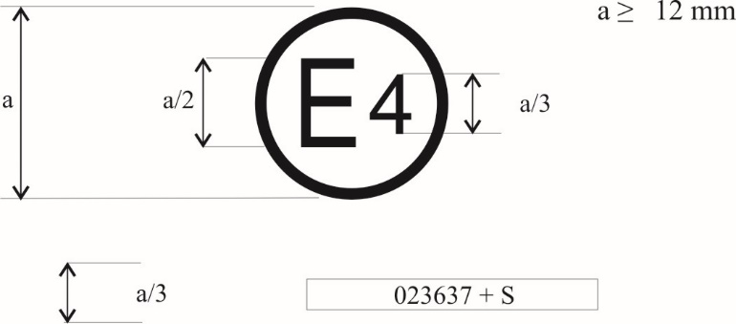
0312345 S2

The above approval mark, affixed to a pneumatic tyre shows that a tyre concerned has been approved in the Netherlands (E 4) pursuant to Regulation No. 117 (marked by S2 (rolling sound at stage 2) only), under approval number 02312345. The first two digits of the approval number (023) indicate that the approval was granted according to the requirements 023 series of amendments to this Regulation.

Example 2
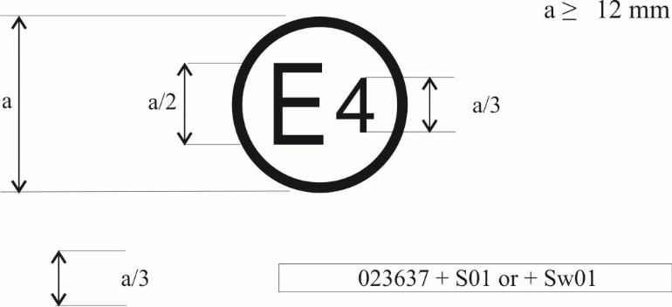
0312345 S2W2R3

The above approval mark shows that the tyre concerned has been approved in the Netherlands (E 4) pursuant to Regulation No. 117 (marked by S12 (rolling sound at stage 12) W2 (wet adhesion at stage 2), and R13 ( Rolling resistance at stage 13 ) under approval number 02312345. This indicates that the approval is for S12W2R13. The first two digits of the approval number (023) indicate that the approval was granted according to the requirements of the 023 series of amendments to this Regulation.

Annex 2 - Appendix 2
Approval according to Regulation No. 117 coincident with approval of Regulation No. 30 or 54

Example 1
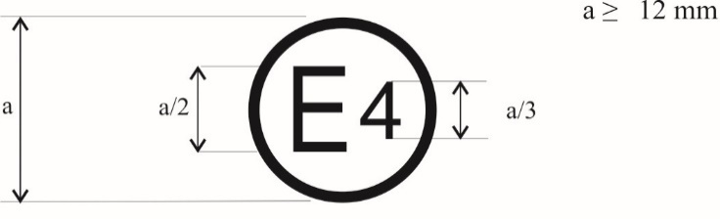
a/3 0312345 S2 0236378

The above approval mark shows that the tyre concerned has been approved in the Netherlands (E 4) pursuant to Regulation No. 117 (marked by S2 (rolling sound at stage 2)), under approval number 02312345 and Regulation No. 30, under approval number 0236378. The first two digits of the approval number (023) indicate that the approval was granted according to the 023 series of amendments and Regulation No. 30 included the 02 series of amendments.

Example 2
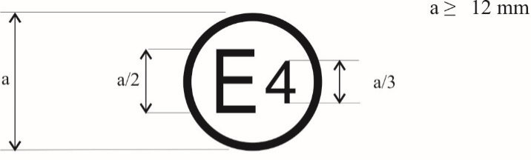

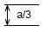 | 0312345 S2W2R3 0236378
 | or
0312345 S2W2R3
0236378

The above approval mark shows that the tyre concerned has been approved in the Netherlands (E 4) pursuant to Regulation No. 117 (marked by S2W2R23 (rolling sound at stage 2 wet adhesion at stage 2 and rolling resistance at stage 23)), under approval number 02312345 and Regulation No. 30 under approval number 0236378. The first two digits of the approval number (023) indicate that the approval was granted according to the 023 series of amendments and Regulation No. 30 included the 02 series of amendments.

Example 3
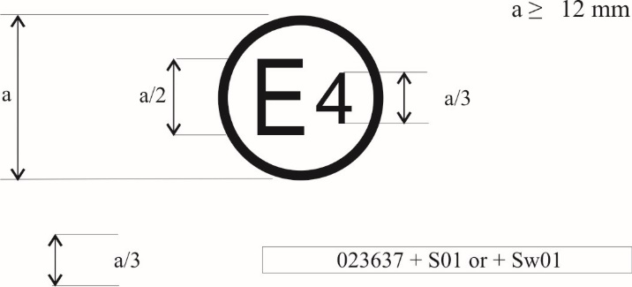
a/3 0312345 S2 0054321
The above approval mark shows that the tyre concerned has been approved in the Netherlands (E 4) pursuant to Regulation No. 117 (marked by S2) and the 02 series of amendments under approval number 02312345 (marked by S2), and Regulation No. 54. This indicates that the approval is for rolling sound stage 2 (S2). The first two digits of the Regulation No. 117 approval number (023) in conjunction with "S2" indicate that the first approval was granted in accordance with Regulation No. 117 which included the 023 series of amendments. The first two digits of Regulation No. 54 (00) indicate that this Regulation was in its original form.

Example 4

a/3 0312345 S2R3 0054321
The above approval mark shows that the tyre concerned has been approved in the Netherlands (E 4) pursuant to Regulation No. 117 (marked by S2R3) and the 02 series of amendments under approval number 02312345 (marked by S2 R2), and Regulation No. 54. This indicates that the approval is for rolling sound stage 2 (S2) and rolling resistance stage 23 (R3). The first two digits of the Regulation No. 117 approval number (023) in conjunction with "S2R23" indicate that the first approval was granted in accordance with Regulation No. 117 which included the 023 series of amendments. The first two digits of Regulation No. 54 (00) indicate that this Regulation was in its original form.

Annex 2 - Appendix 3
Extensions to combine approvals issued in accordance with Regulations Nos. 117, 30 or 54

Example 1
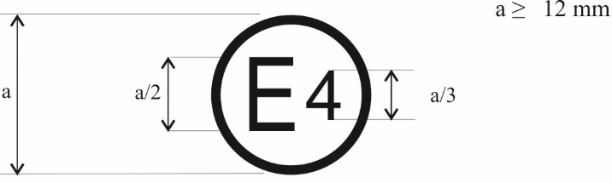
a/3 0236378 + 02S2

The above approval mark shows that the tyre concerned has been initially approved in the Netherlands (E 4) pursuant to Regulation No. 30 and the 02 series of amendments under approval number 0236378. It is also marked by + 02S12 (rolling sound at stage 12) which indicates that its approval is extended under Regulation No. 117 (02 series of amendments). The first two digits of the approval number (02) indicate that the approval was granted according to Regulation No. 30 (02 series of amendments). The addition (+) sign indicates that the first approval was granted in accordance with Regulation No. 30 and has been extended to include the approval(s) granted according to Regulation No. 117 (02 series of amendments) for rolling sound at stage 12.

Example 2
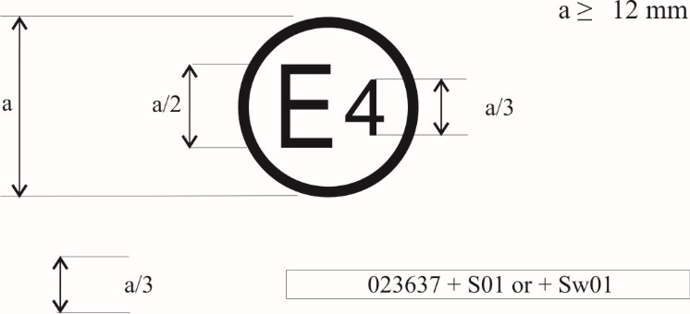
0236378 + 03S2W2R3

The above approval mark shows that the tyre concerned has been initially approved in the Netherlands (E 4) pursuant to Regulation No. 30 and the 02 series of amendments under approval number 0236378. This indicates that the approval is for S12 (rolling sound at stage 12) W2 (wet adhesion at stage 2) and R23 (rolling resistance at stage 23). The S12W2R23 preceded by (023) indicates that it has had its approval extended under Regulation No. 117 which included the 023 series of amendments. The first two digits of the approval number (02) indicate that the approval was granted according to Regulation No. 30 (02 series of amendments). The addition (+) sign indicates that the first approval was granted in accordance with Regulation No. 30 and has been extended to include Regulation No. 117 approval(s) (023 series of amendments).

Annex 2 - Appendix 4
Extensions to combine approvals issued in accordance with Regulation No. 117

Example 1
0312345 W2 + S2R3

The above approval mark shows that the tyre concerned has been initially approved in the Netherlands (E 4) pursuant to Regulation No. 117 and the 023 series of amendments under approval number 02312345. This indicates that the approval is for W2 (wet grip at stage 2). The S2R23 preceded by + indicates that it has had its approval extended under Regulation No. 117 to rolling sound at stage 2 and rolling resistance at stage 23 based on separate certificate(s).

Example 2
0312345 S2W2 + R3

The above approval mark shows that the tyre concerned has been initially approved in the Netherlands (E 4) pursuant to Regulation No. 117 and the 023 series of amendments under approval number 02312345. This indicates that the approval is for S12 (rolling sound at stage 12) and W2 (wet grip at stage 2). The R13 preceded by + indicates that it has had its approval extended under Regulation No. 117 to rolling resistance at stage 13 based on separate certificate(s).

Example 3
0167890 SW + 03R3

The above approval mark shows that the tyre concerned has been initially approved in the Netherlands (E 4) pursuant to Regulation No. 117 and the 01 series of amendments under approval number 0167890. This indicates that the approval is for S (rolling sound at stage 1) and W (wet grip at stage 1). The 023R13 preceded by + indicates that it has had its approval extended under Regulation No. 117 and the 023 series of amendments to rolling resistance at stage 13 based on separate certificate(s)."
II. Justification
1. To keep delivering on the global climate action, in line with UN Sustainable Development Goals and with specific reference to n.13 on Climate Action, as well as to keep pursuing concerted action to facilitate international transport while improving its safety and environmental performance, the European Commission calls for an improved regulatory framework for fuel efficiency and safety performances of tyres.
2. For rolling resistance, tighter limits can contribute to the further reduction of CO₂ emissions and/or increase the range of battery electric vehicles. This can contribute to the fight against climate change in line with the objectives of the Paris Agreement. According to studies for car tyres (84% of tyre sales) limits could be strengthened by up to 15%. For vans limits could be strengthened by up to 5% (9% sales) and for trucks 8% (7% of sales) (see GRBP-73-22).
3. For wet grip, tighter limits at new stage can help reducing road accidents. This is important to achieve the Vision Zero objective in a context where the average mass of vehicles tend to increase (battery electric vehicles, SUVs). According to studies, existing limits for new tyres could be strengthened by 10% for cars, 15% for vans and up to 23% for trucks (see GRBP-73-22).
4. The expected impacts are below described.
Raising wet grip performance limits for tyres in new state by 10-20% depending on the tyre category:
  - contributing to UN zero-road fatalities goal
  - supporting maximization of tyre-life usage.
Improving tyre rolling resistance performances by 5-15%, depending on the tyre category:
- would apply to the whole vehicle park in a shorter timeframe vs any provisions on new vehicles would lead gradually to removing from the market worst performing tyres for rolling resistance. For example, in the case of EU27, CO₂ savings equivalent to taking about 1 million vehicles off the roads in the fairly short time associated with tyre replacement.

Approvals in accordance with Regulation No. 117 for tyres within the scope of Regulation No. 54 currently do not include wet adhesion requirements.
Approvals in accordance with Regulation No. 117 for tyres within the scope of Regulation No. 54 currently do not include wet adhesion requirements.
Approvals in accordance with Regulation No. 117 for tyres within the scope of Regulation No. 54 currently do not include wet adhesion requirements.
refer to “UN Sustainable Development Goals and the UN Transport Conventions under the purview of the UNECE Inland Transport Committee” 26.07.2016 (https://unece.org/transport-7)

