|  |  |  |  |
| --- | --- | --- | --- |
|  | United Nations | ECE/TRANS/WP.29/GRE/2022/2 | |
| Description: _unlogo | **Economic and Social Council** | | Distr.: General  2 February 2022  Original: English |

**Economic Commission for Europe**

Inland Transport Committee

**World Forum for Harmonization of Vehicle Regulations**

**Working Party on Lighting and Light-Signalling**

**Eighty-sixth session**

Geneva, 26–29 April 2022

Item 6 (a) of the provisional agenda

**UN Regulation No. 48 (Installation of lighting and light-signalling devices):**

**Proposals for amendments to the latest series of amendments**

Proposal for a Supplement to the 06, 07 and 08 series of amendments to UN Regulation No. 48

Submitted by the experts from the International Automotive Lighting and Light-Signalling Expert Group[[1]](#footnote-2)\*

This document was prepared by the experts from the International Automotive Lighting and Light-Signalling Expert Group (GTB) with the aim to remove the minimum distance between the left and right front/rear position lamps. The proposed modifications to the current text of the UN Regulation are marked in bold for new or strikethrough for deleted characters.

I. Proposal

*Paragraph 6.9.4.1.,* amend to read:

“6.9.4.1. In width: that point on the apparent surface in the direction of the reference axis which is farthest from the vehicle's median longitudinal plane shall not be more than 400 mm from the extreme outer edge of the vehicle.

In the case of a trailer, that point on the apparent surface in the direction of the reference axis which is farthest from the median longitudinal plane shall not be more than 150 mm from the extreme outer edge of the vehicle.

The distance between the inner edges of the two apparent surfaces in the direction of the reference axes shall:

For ~~M~~~~1~~ ~~and N~~~~1~~ ~~category~~ **motor** vehicles: No special requirement;

For ~~all other categories of vehicles~~ **trailers**: Not less than 600 mm. This distance may be reduced to 400 mm where the overall width of the vehicle is less than 1,300 mm.”

*Paragraph 6.10.4.1.*, amend to read:

“6.10.4.1. In width: That point on the apparent surface in the direction of the reference axis which is farthest from the vehicle's median longitudinal plane shall not be more than 400 mm from the extreme outer edge of the vehicle. This condition shall not apply to the optional rear lamps.

The distance between the inner edges of the two apparent surfaces in the direction of the reference axes shall~~: For M~~~~1~~ ~~and N~~~~1~~ ~~category vehicles:~~ have no special requirement.

~~For all other categories of vehicles: be not less than 600 mm. This distance may be reduced to 400 mm where the overall width of the vehicle is less than 1,300 mm.~~

**In case of two optional position lamps, the distance between the inner edges of the two apparent surfaces in the direction of the reference axes shall not be less than 600 mm. This distance may be reduced to 400 mm where the overall width of the vehicle is less than 1,300 mm.**”

II. Justification

1. The proposal extends the scope of paragraphs 6.9. and 6.10. of UN Regulation No. 48 to allow the installation of position lamps in the shape of a stripe or a band for further vehicles categories additionally.

2. The two optional rear position lamps (see paragraph 6.10.4.1.) are not affected by this proposal.

3. The proposal does not introduce additional lamps, it only allows for a change in shape of the front and rear position lamps.

4. Vehicles of categories M2, M3,N2 andN3 could have a width up to 2,600 mm. The provisions in paragraph 6.9.4.1. “In width: […] apparent surface […] not be more than 400 mm from the extreme outer edge of the vehicle” are not affected by this proposal. The closure of the gap between the left and right lamp, increases the recognition of these vehicles for the upcoming road users, as illustrated on the pictures below.

Figure

**Closing the gap between the left and right lamp**

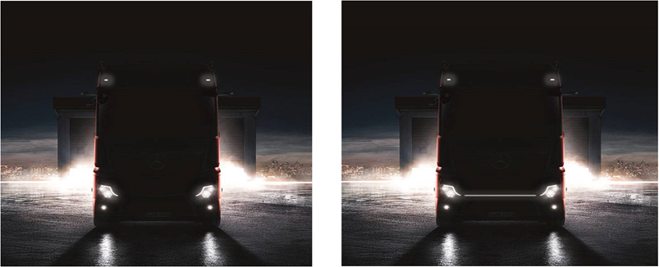

5. The “600 mm” criterion between the left and right front/rear positions light for M1 and N1 categories of vehicles was removed, as a result of the discussions on harmonization with Federal Motor Vehicle Safety Standard (FMVSS) 108, in the 1990s. As of today, such deletion has not generated any known safety-related negative effects.

6. In paragraph 6.10.4.1. a new indent was inserted in order to better describe further requirements for the two optional rear position lamps for vehicles of categories M2, M3, N2, N3, O2, O3 and O4 (see paragraph 6.10.2.1).

7. With this proposal, an unnecessary discrimination among vehicle categories will be eliminated.

1. \* In accordance with the programme of work of the Inland Transport Committee for 2022 as outlined in proposed programme budget for 2022 (A/76/6 (Sect.20), para 20.76), the World Forum will develop, harmonize and update UN Regulations in order to enhance the performance of vehicles. The present document is submitted in conformity with that mandate. [↑](#footnote-ref-2)