|  |  |  |  |
| --- | --- | --- | --- |
|  | United Nations | ECE/TRANS/WP.29/GRSP/2022/2 | |
| _unlogo | **Economic and Social Council** | | Distr.: General  18 February 2022  Original: English |

**Economic Commission for Europe**

Inland Transport Committee

**World Forum for Harmonization of Vehicle Regulations**

**Working Party on Passive Safety**

**Sixty-first session**

Geneva, 9-13 May 2022

Item 2(b) of the provisional agenda

**UN Global Technical Regulation No. 9 (Pedestrian safety):  
Proposal for Amendment 4**

Proposal for Amendment

Submitted by the Chair (Republic of Korea) of the Informal Working Group on the Deployable Pedestrian Protection Systems of UN Global Technical Regulation No. 9. [[1]](#footnote-2)\*

The text reproduced below was prepared by the experts of the Informal Working Group (IWG) of the Deployable Pedestrian Protection Systems (IWG-DPPS) on UN Global Technical Regulation No. 9 and proposes provisions on DPPS. The modifications to the existing text of the UN Global Technical Regulation No. 9 (ECE/TRANS/180/Add.7, Corr.1 and 2, Amend.1 and 2) are marked in bold for new or strikethrough for deleted characters.

I. Proposal

*Part II, Text of the Regulation*,

*Paragraph 3*, amend to read:

"3. Definitions

When performing measurements as described in this Part, the vehicle should be positioned in its normal ride attitude.

**In case of the vehicle equipped with a deployable pedestrian protection system as defined in paragraph 3.17., that area shall be defined with the system deactivated. [Where a deployable pedestrian protection system is fitted, the manufacturer shall state which area is marked up, either the deployed or un-deployed position.]**

If the vehicle is fitted with a badge…

…"

*Paragraph 3.24*. *("Assessment Interval" (AI))*, renumber as paragraph 3.3.

*Paragraphs 3.3 to 3.10.(former),* renumber as paragraphs 3.4. to 3.11.

*Paragraph 3.11. (former)*, renumber as paragraph 3.12. and amend to read:

"3.12. "Bumper test area **(BTA)**" means..."

*Insert new paragraph 3.12.1*., to read:

"**3.12.1.** **"Bumper test area for DPPS detection (BTA)" means either the front vehicle fascia between the left and right corner of bumper as defined in paragraph 3.16., minus the areas covered by the distance of 42 mm inboard of each corner of bumper, as measured horizontally and perpendicular to the longitudinal median plane of the vehicle, [or between the outermost ends of the bumper beam as defined in paragraph 3.10. (see Figure 5D), minus the areas covered by the distance of 42 mm inboard of each end of the bumper beam, as measured horizontally and perpendicular to the longitudinal median plane of the vehicle, whichever area is wider]**."

*Paragraphs 3.12. to 3.14. (former),* renumber as paragraphs 3.14. to 3.16.

*Insert new paragraphs 3.17. to 3.20*., to read:

"**3.17. "Deployable Pedestrian Protection System (DPPS)" means a technical system, providing additional head protection for a pedestrian in the event of a collision with a passenger car. It comprises a deployment module, as defined in paragraph 3.18. below, together with other related components required for its function, such as e.g. bonnet, sensors, or wiring, etc.**

**3.18. "Deployment module" means a unit, comprising components, such as airbags, springs, or pyrotechnic actuators etc., that are used to change the vehicle outer surface from a position of normal use in the vehicle to a deployed position, as defined in paragraph 3.19.1.**

**3.18.1. "Initiation of the deployment module" means, at the option of the manufacturer, either the time when visible movement of the actuator is initially detected, or the switching point of the triggering signal sent from the electronic control unit to the deployment module.**

**3.19. "Deployment time (DT)" means the duration from the initiation of the deployment module, as defined in paragraph 3.18.1. until the DPPS reaches for the first time [initially arrives at] its deployed position, as defined in paragraph 3.19.1.**

Figure XX  
**HIC difference between dynamic and static condition**

Time

Bonnet Lift

**Intended Height**

**TRT**

Lift of actuator

Lift of Bonnet

**Actual HIT for this condition**

**Virtually confirmed timing**

**3.19.1. ["Deployed position" means the position of the vehicle outer surface equipped with a DPPS that can be maintained by the system after its activation. For a static test, the Deployed position shall be specified by the manufacturer.]**

**3.19.2. "Un-deployed position" means the position of the vehicle outer surface equipped with a DPPS when the DPPS is not activated.**

**3.20. "Detection area" is the area designated to detect a pedestrian in order to initiate the activation of the deployable system. The width of the detection area shall be the relevant vehicle width, minus a distance from each side of max of 12,5 per cent of the relevant vehicle width, but not more than 250mm. The detection area must not be smaller than the bumper test area (BTA) as defined in paragraph 3.12.1. [The detection area must not be smaller than the area between the corners of bumper - 42mm.]**

**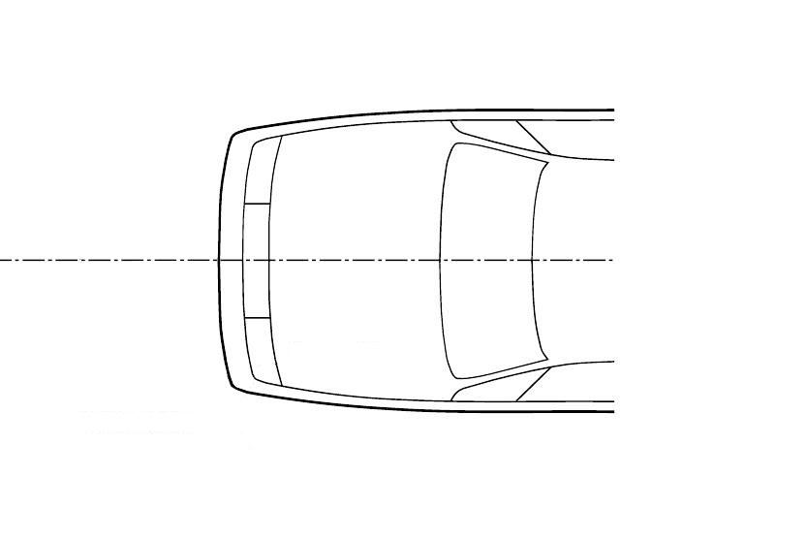**Figure XY   
**Detection Area Width**

Detection Area   
≥ 75 per cent

Relevant Vehicle Width

≤ 12,5 per cent

≤ 12,5 per cent

*Paragraphs 3.15. to 3.18.(former)*, renumber as paragraphs 3.21 to 3.24.

*Insert new paragraph 3.25.*, to read as follows:

"**3.25. "Head impact time (HIT)" means the duration from the time of first contact of a pedestrian with the vehicle front to the time of first contact of a pedestrian head to the outer surface.**

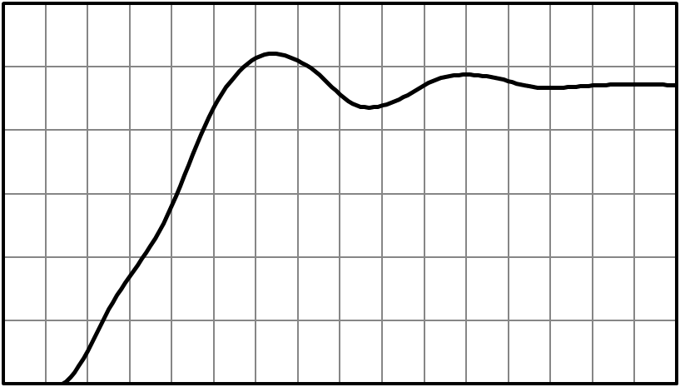

**Total Response Time (TRT)**

**Head Impact Time (HIT)**

**Sensor**

**Time**

**(ST)**

**Deployment**

**Time**

**(DT)**

**Maximum Deployment time**

Deployed position

DPPS position in Z

Time

Time

of contact

Initiation of deployment module

Time of DPPS in deployed position

Maximum

deployment height

*Paragraphs 3.19 to 3.23.(former),* renumber as paragraphs 3.26. to 3.30.

*Insert new paragraphs 3.31. to 3.32.1.*, to read as follows:

"**3.31. "Outer surface" means those components of the vehicle within the headform test areas, which may be contacted by the pedestrian in case of an accident. The outer surface may include the bonnet, the fenders, but also external airbags or other components within the headform test areas.**

**3.32. "Pedestrian sensors"**

**3.32.1. "Pedestrian contact sensors" are sensors that detect a pedestrian contact with the front of the vehicle. These sensors include, but are not limited to, accelerometers, fibre optic sensors, pressure sensors, etc**."

*Paragraphs 3.25. and 3.26.(former)*, renumber as paragraphs 3.33. and 3.34.

*Insert new paragraphs 3.35. and 3.36*., to read:

"**3.35. "Relevant vehicle width" is the maximum width of the vehicle without rear view mirrors or rear-view mirror substitute systems, measured on or in front of a vertical transverse plane passing through the front axle of the vehicle.**

**3.36. "Sensing time (ST)" means the duration from the time of the first contact of a pedestrian with the vehicle front to the initiation of the deployment module for contact sensors.**"

*Paragraphs 3.27. to 3.29. (former)*, renumber as paragraphs 3.37. to 3.39.

*Insert new paragraphs 3.40. to 3.42*., to read:

*"***3.40. "Testing of the DPPS":**

**The headform impact tests on the bonnet can be performed in three ways: statically, dynamically [or combined].**

**3.40.1. "Static testing" means the launch of the headform on a DPPS being in an already deployed position.**

**3.40.2. "Dynamic testing" means the synchronized launch of the headform onto the deploying DPPS to the appropriate HIT.**

**[3.40.3. "Combined testing" means choosing the appropriate testing procedure: static and dynamic testing, using undeployed marking of the bonnet.]**

**3.41. "Testing time" means the timeframe in which the applicable physical headform test to the DPPS is to be performed.**

**3.42. "Total response time (TRT)" means the duration from the time of first contact of a pedestrian with the vehicle front to the time the DPPS reaches the Deployed Position as defined in 3.19.1. It consists of the sensing time (ST) and the deployment time (DT)**."

*Paragraphs 3.30. to 3.32. (former)*, renumber as paragraph 3.43. to 3.45.

*Paragraphs 5.2.1. and 5.2.2*., amend to read:

"5.2.1. Child headform to the front structure:

When tested in accordance with paragraphs 7.2., 7.3. **and Annex 1, if applicable**, the HIC shall comply with paragraph 5.2.3.

5.2.2. Adult headform to the front structure:

When tested in accordance with paragraph 7.2., 7.4. **and Annex 1, if applicable**, the HIC shall comply with paragraph 5.2.3."

*Insert new paragraph 6.2.4.*, to read:

"**6.2.4. A vehicle equipped with a DPPS shall be adjusted as specified in the test procedure defined in Annex 1.**"

*Insert new Annexes 1 to 3*, to read:

"Annex 1

Test procedure for deployable pedestrian protection systems (DPPS)

**1. Pre-requisites**

**For systems to be assessed statically or dynamically as defined in paragraph 3.40., it will be necessary for the vehicle manufacturer to identify detailed information highlighted in this Annex before any testing begins. The vehicle manufacturer shall identify all necessary information regarding detection of pedestrians and the deployment of the system. Based on the evidence identified, activation of the system in the headform test will be determined.**

**1.1. If the pre-requisites are not met, the vehicle will be tested in the un-deployed position.**

**1.2. System specification:**

**As a Contracting Party option, a technical description of the DPPS components shall be identified by the manufacturer. This shall be accompanied by the following information:**

**1.2.1. For Sensing system:**

**(a) Type (pressure, optical, vision…)**

**(b) Sensor locations**

**(c) Operation process (including the lower threshold speed of activation of the DPPS)**

**1.2.2. Deployment information:**

**(a) Type of system (airbag, active hood, …)**

**(b) Mechanism explanation**

**(c) Component description (lifting system (e.g., actuator), hinge, latch, ...)**

**(d) Deployed position [Required height or Intended deployment height] information (not required for dynamic testing)**

**(e) TRT (ST+DT) information (not required for dynamic testing, where only ST is requested)**

**(f) Evolution of system stability (e.g., pressure or force vs. time diagram) (not required for dynamic testing)**

Figure 1  
**Scheme of different test configurations**

**HIT<TRT**

**TRT**

**OR HIT>TRT without stable position of DPPS**

DPPS (Bonnet…) stable

**Dynamic**

**Static time constraint**

DPPS (bonnet, airbag…) unstable

**Testing time aim = LAB tests represent real life**

DPPS (bonnet, airbag…) stable

time

time

time

Timespan for the test

Timespan for the test

HIT<TRT

**Static**

HIT<TRT

**HIT>TRT**

**HIT>TRT**

**With this information (evolution of system stability) and Fig. 1, a decision can be made on how to perform the test. During the static tests it shall be ensured that the resisting force of the DPPS is equivalent to the actual situation at the real HIT.**

**1.3. The marking of the bonnet top impact area specified in 5.2.4.2. shall be done in the [deployed or] undeployed position.**

**1.4.**  **HIT information shall be provided according to Annexes 2 and 3.**

**1.5. Prerequisites for deployed static tests**

**1.5.1. Deployed Position [Required height]**

**The vehicle outer surface with the DPPS capable of maintaining the deployed position shall reach a position equal to or above the deployed position [required height] during the time between the TRT and the HIT that corresponds to the rear end of the respective headform test area. The position shall not go below the [required height] deployed position after the first overshoot phase [exceeding 10 per cent / 10mm tbc below the [required height] deployed position]. If the position does not meet this requirement, then dynamic tests shall be done in accordance with paragraph 5.2. of Annex 1.**

**1.5.2. Verification of the Deployed Position [Required height] in the deployment height time history curve**

**The Deployed Position [Required height] shall be verified by using appropriate tracking means, such as high-speed videos, accelerometer, or laser at the reference points (at the lifting devices).**

**1.6. Sensing System Verification**

**1.6.1. The detection area for the activation tests as specified in paragraph 1.6.4. of Annex 1 is defined in paragraph 3.20. of this Regulation.**

**1.6.2. The detection area will be subdivided into three thirds of identical width, whereas one third is the geometrical trace between the left and right end of the detection area, measured with a flexible tape following the outer contour of the bumper at the upper bumper reference line, equally divided by three. See Figure 2 below.[[2]](#footnote-3)**

Figure 2  
**Scheme of detection area subdivision**

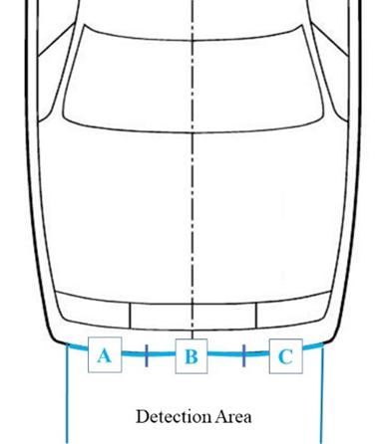

Detection Area

**A**

**B**

**C**

**1.6.3. The vehicle manufacturer shall specify the lowest speed of activation (lower deployment velocity threshold) of the DPPS.**

**1.6.4. For the system deployment verification, sensor activation tests with the flexible lower legform impactor as specified in paragraph 6.3.1.1. of this Regulation shall be performed at the DPPS lower deployment velocity threshold.**

**1.6.5. A minimum of one test per third (A, B and C) shall be performed, maintaining a minimum distance of 50 mm to adjacent tests.1**

**1.6.6. Where a test is performed within the tolerances as specified in paragraph 3 of Annex 1, but below the nominal lower deployment velocity threshold or outside the detection area and the system does not deploy, the test must be repeated.**

**Test Assessment**

**1.6.7. If the system is not activated during the verification test, headform tests shall be conducted in un-deployed position according to paragraphs 7.2. to 7.4. of this Regulation.**

**The flowchart in Figure 3 illustrates the decision process for Contracting Parties that allow both static and dynamic options. For Contracting Parties that allow only dynamic option, this flow chart is also useful, but not all steps will be considered.**

Figure 3

**Flowchart DPPS Assessment**

**OEM information on DPPS**

1: Minimum number of tests specified for Contracting Parties of the 1958 Agreement, only

**no**

**Low speed protection**

3 x headform tests @ 0.9\*LDT speed1

1 test to each third1

HPC 1000 / 1700

**Pass**

**yes**

**Fail**

**HPC criterion**

HPC 1000/1700

**no**

**CP opts to consider static tests**

**Dynamic test @ HIT**

**Static test @ deployed position**

**or**

**dynamic test @ HIT**

**HIT**

(WAD, head impact point)

**> TRT**

**ST Determination**

**no**

**no**

**TRT Determination**

**yes**

**no**

**Pedestrian detection**

Tests in detection area:

3 x FlexPLI @ LDT1

1 x FlexPLI @ 40 km/h1

**yes**

**yes**

**System stability**

DPPS capable of maintaining the deployed position?

**static tests**

**Selection of head impact points**

**HIT vs WAD regression line**

HBM simulations with all relevant pedestrian statures at y0 stowed bonnet, 40 km/h

**Headform tests with DPPS @ undeployed position**

**no**

**Fail**

**Test Assessment**

**Timing of DPPS deployment**

**Pedestrian** **detection**

**Protection at lower vehicle speeds**

**II) Compliance Testing**

**I) Prerequisites**

1: Minimum number of tests specified for Contracting Parties of the 1958 Agreement, only/

**yes**

**Pass**

**2. Verification of TRT and /or ST at nominal velocity**

**2.1. The TRT as defined in paragraph 3.42. shall be confirmed by using the legform impactor at the vehicle speed 11.1 m/s and at the centre line of the vehicle.**

**2.2. For contact sensors as defined in paragraph 3.32.1. of this Regulation, the ST is measured during a TRT measurement test, at the vehicle speed as specified in this Regulation and at the centre of the bonnet.**

**2.2.1. For dynamic testing, only ST shall be verified. If the measured ST exceeds the specified value by more than [3ms], then the measured value shall be used.**

**3. For verification tests of paragraphs 1 and 2 of Annex 1 with the flexible lower legform impactor the following tolerances shall apply:**

**3.1. For tests with a moving vehicle impacting the stationary impactor:   
Target speed: ± 0.6 m/s; impact accuracy: ± 50 mm**

**3.2. For tests with a propulsion system propelling the impactor against the stationary vehicle:**

**Target speed, impact accuracy, angle tolerances are those of the performance tests, as in paragraph 7.1. of the regulation.**

**4. Headform test for protection below the lower threshold speed of activation of the DPPS**

**4.1. The outer surface of the vehicle shall be in un-deployed position.**

**4.2. The test procedures specified in paragraphs 7.2. to 7.4. of this Regulation shall apply with the impact speed specified as 0.9 times lower threshold speed of activation of the DPPS, and the HIC zone splitting may differ between the lower threshold speed of activation and nominal velocity (9.7 m/s) head impact tests.**

**5. Headform Test Procedure at nominal velocity (9.7m/s)**

**Based on a determination by each Contracting Party or regional economic integration organization, either all requirements shall be demonstrated using the dynamic test in paragraph 5.2., or, when the following conditions are fulfilled, all requirements may be demonstrated using the static test in paragraph 5.1., if this technical alternative is offered by the vehicle manufacturer.**

**5.1. Static test option:**

**5.1.1. Determination of headform test method (HIT vs TRT)**

**5.1.1.1. The determination of headform test of the DPPS is based on the comparison of the TRT as defined in paragraph 3.41. of this Regulation with the HIT as defined in paragraph 3.25. of this Regulation.**

**5.1.1.2. If the HIT at the impact point WAD is greater than or equal to the TRT (HIT≥TRT), static headform tests shall be conducted in the deployed position.**

**5.1.2. The outer surface of the vehicle shall represent the deployed position and the resisting force.**

**The outer surface of the vehicle shall be set to that position and its resisting force by appropriate means.**

**5.1.2.1. Static time constraint condition, linked to the resisting force:**

**When there is a constraint on time for the stability of the system and HIT≥TRT, the launching time of the headform test shall ensure that the system remains stable (tolerance ±10 per cent of corresponding resisting force), as identified by the manufacturer (pre-requisite in paragraph 1.2. of Annex 1).**

**5.1.2.2. Appropriate means (e.g., actuator surrogates) that ensure the corresponding resisting force of the DPPS can be used.**

**5.1.3. The test procedures specified in paragraphs 7.2. to 7.4. of this Regulation shall apply.**

**5.2. Dynamic test option:**

**5.2.1. For the systems which cannot maintain their deployed position, Dynamic Headform Test Procedure as defined in paragraph 3.40.2. of this Regulation shall apply.**

**5.2.2. If the HIT at the impact point WAD is less than the TRT (HIT<TRT), dynamic headform tests shall be conducted.**

**5.2.3. The dynamic verification of a DPPS is based on a headform test performed on the DPPS, where the headform launch device and DPPS deployment are synchronized to achieve the correct HIT.**

**The following steps are conducted:**

**5.2.3.1. Test accuracy at impact location**

**As the tolerances described in paragraphs 7.3.3. and 7.4.3. in the Regulation for location and paragraphs 7.3.4. and 7.4.4. in the Regulation for velocity may not be verified accurately in a dynamic test, prior to conducting the dynamic tests at 9.7m/s, one headform test shall be conducted on the undeployed bonnet to confirm that impact velocity and impact location are within tolerances (location at the choice of the Testing Lab).**

**If the velocity and impact location tolerances are met during the undeployed test, there is no requirement to meet these tolerances during dynamic tests, provided test inputs remain the same.**

**5.2.3.2. To enable dynamic testing to be conducted, HIT and sensing time (ST) are required inputs, which shall be established by the following:**

**(a) HIT is obtained from human body model (HIT vs wrap around distance (WAD)) graph, as in Annex 3.**

**(b) ST is determined from manufacturer pre-requisite or sensor verification test as defined in paragraph 3.2. of Annex 1.**

**The test facility shall ensure that the head impact occurs at the correct time relative to the deployment of the DPPS, taking into account the HIT and ST.**

**[5.3. "Combined" test option:**

**If the bonnet top test area consists of sections where the HIT at the impact point WAD is less than TRT (HIT<TRT) as in paragraph 5.2.2. of Annex 1 and sections where the HIT at the impact point WAD is greater or equal than TRT (HIT≥TRT), as in paragraph 5.1.1.1.1. of Annex 1, then all test points forwards of the corresponding wrap around distance WAD (HIT < TRT) shall be tested dynamically. The remaining section of the bonnet top test area may be tested statically. The undeployed marking procedure shall be used for this combined option. (see Figure 4 below).**

Figure 4   
**Scheme of HIT vs WAD for combined testing]**

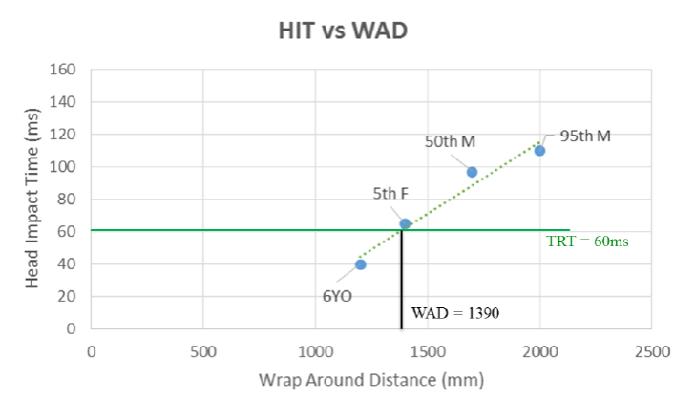

Head Impact Time (ms)

**HIT vs WAD**

Wrap Around Distance (mm)

6YO

5th F

50th M

95th M

WAD= 1390

TRT = 60ms

**5.4. If the vehicle does not meet the pre-requisites as specified in the flowchart in Fig. 1 of Annex 1, all the headform tests shall be conducted in un-deployed position at the impact speed of the headform specified in this Regulation.**

**5.5. The test procedures specified in paragraph 7.2. to 7.4. of this Regulation shall apply.**

**5.5.1. The tolerance shall be determined [at the discretion of Technical Service in case the deviation from measuring points cannot be measured using existing appropriate technologies].**

Annex 2 Human Body Model (HBM) qualification

[To be defined]

Annex 3 Head Impact Time (HIT) determination

[To be defined]"

1. \* In accordance with the programme of work of the Inland Transport Committee for 2022 as outlined in proposed programme budget for 2022 (A/76/6 (part V, sect. 20) para. 20.76), the World Forum will develop, harmonize and update UN Regulations in order to enhance the performance of vehicles. The present document is submitted in conformity with that mandate. [↑](#footnote-ref-2)
2. **Minimum number of tests specified for Contracting Parties of 1958 Agreement, only.** [↑](#footnote-ref-3)