INF.7
Economic Commission for Europe  Inland Transport Committee  Working Party on the Transport of Dangerous Goods  Joint Meeting of Experts on the Regulations annexed to the  European Agreement concerning the International Carriage  of Dangerous Goods by Inland Waterways (ADN)  (ADN Safety Committee)  Thirty-ninth session  Geneva, 24–28 January 2022  Item 4 (b) of the provisional agenda  Special authorizations, derogations and equivalents | 6 January 2022  English
Special authorization concerning UN 1288 SHALE OIL
Submitted by the Government of the Netherlands
Related documents: | ECE/TRANS/WP.15/AC.2/2022/19  Informal document INF.2 of the thirty-ninth session

1. During the thirty-eight session of the ADN Safety Committee, the Special authorization concerning UN 1288 SHALE OIL was considered. The Committee decided to resume the discussion on this subject at its next session on the basis of a formal proposal by the Netherlands.
2. In the meantime the Dutch government has received another request for a Special authorization concerning the transport of UN 1288 SHALE OIL in tank vessels. This request has been submitted by Transafe on behalf of Marpol Services B.V.. The request has been considered and granted.
3. The request for the Special authorization, in English, can be found in annex 1 of this document. The Special authorization (Dutch only), is attachted in annex 2 of this document.

Annex 1
3.2.4.2 Application form for special authorizations under section 1.5.2

For applications for special authorizations, please answer the following questions and points.* Data are used for administrative purposes only and are treated confidentially.
* For questions not relevant to the subject of the application, write “not applicable”.

Applicant

J. van Rijn
(Name)

Marpol Services BV
(Company)

Trawlerkade 51-57, 1976 CB IJmuiden, the Netherlands
(Address)

☐ It concerns several applicants.

Summary of the application
Authorization for transport in tank vessels of

Leisteenolie (Shale Oil)

as a substance of Class
Class 3

Which sailing area does the application apply to?

FARAG (zone 2, 3 & 4)

Annexes
(With brief description)
Annex 1 Applicant

This application concerns the following ships;

Name: Aqua Mosa o.s.n. 02337290
Name: Marpol 19 o.s.n. 02332478
Name: Marpol 18 o.s.n. 02332689

Application made:

At: Hendrik Ido Ambacht

Date: 20-07-2021

By: M. van de Hel (Transafe)

Signature: 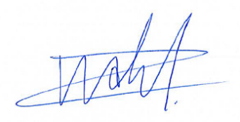
(of the person responsible for the data)

1. General data on the dangerous substance

1.1 Is it a pure substance ☒, a mixture ☒, a solution ☐?
1.2 Technical name (if possible ADN nomenclature or possibly the IBC Code). (International Code for the Construction and Equipment of ships carrying Dangerous Chemicals in Bulk)
Leisteenolie

1.3 Synonym. Schalie olie
1.4 Trade name. Shale oil
1.5 Structure formula and, for mixtures, composition and/or concentration.
Leisteenolie 1-100%, water 0 - 99%

1.6 Hazard class and, where applicable, classification code, packing group.
Klasse 3, classificatiecode F1, VG II en/of III

1.7 UN Number or substance identification number (if known).0
UN 1288

2. Physico-chemical properties
2.1 State during transport (e.g. gas, liquid, molten, ...).
Liquid

2.2 Relative density of liquid at 20ºC or at the transport temperature if the substance is to be heated or refrigerated during transport.

0,917 middle fraction

2.3 Transport temperature (for substances heated or refrigerated during transport).
Ambient

2.4 Melting point or range < -9 ºC.

2.5 Boiling point or range 40 - 645 ºC.

2.5 Vapour pressure at:

- 25ºC 0,06 – 13,5 kPa
- 20ºC ........................................
- 30ºC ........................................
- 37.8ºC .....................................
- 50ºC 10,9 – 26 kPa
- for liquefied gases, vapour pressure at 70ºC : n.v.t.,
- for permanent gases, filling pressure at 15ºC : n.v.t.
2.7 Cubic expansion coefficient 0,000736 – 0.000888 K⁻¹
2.8 Solubility in water at 20 ºC 0,1 - 5,74 g/l
Saturation concentration n.v.t. mg/l, or
Miscibility with water at 15 ºC
☒ Complete ☐ partial ☐ none
(If possible, in the case of solutions and mixtures, indicate concentration)
2.9 Colour. Yellow to dark brown liquid
2.20 Odour. Bitter / irritating
2.11 Viscosity 0,637 – 11,1 mm2/s. at 20°C
2.12 Flow time (ISO 2431-1996) n.v.t. s.
2.13 Solvent separation test n.v.t. .
2.14 pH of the substance or aqueous solution (indicate concentration).
4.8
2.15 Other information.
Not applicable.
3. Technical safety properties

3.1 Auto-ignition temperature in accordance with IEC 60079-20-1:2010, EN 14522:2005, DIN 51 794:2003 in ºC; where applicable, indicate the temperature class in accordance with IEC 60079-20-1:2010.

238 – 395 ºC bij 1013 hPa

3.2 Flash-point
For flash-points up to 175 o C
Closed-cup test methods - non-equilibrium procedure
- Abel method: EN ISO 13736:2008
- Abel-Pensky method: DIN 51755–1:1974 or NF M T60-103:1968
- Pensky-Martens method: EN ISO 2719:2012
- Luchaire apparatus: French standard NF T60-103:1968
- Tag method: ASTM D56-05(2010)

Closed-cup test methods – equilibrium procedure
- Rapid equilibrium procedure: EN ISO 3679:2004; ASTM D3278-96 (2011)
- Closed-cup equilibrium procedure: EN ISO 1523:2002+AC1:2006; ASTM D3941-90 (2007)

For flash-points above 175 ºC
In addition to the above-mentioned methods, the following open-cup test method may be applied:
- Cleveland method: EN ISO 2592:2002; ASTM D92-12.

Flashpoint: 10 - 30 ºC, < 20 ºC for the light (Gasoline) fraction.

3.3 Explosion limits:
Determination of upper and lower explosion limits in accordance with EN 1839:2012.

Non-explosive (100%)

3.4 Maximum safe gap in accordance with IEC 60079-20-1:2010 in mm.
n.v.t. mm.
3.5 Is the substance stabilized during transport? If so, provide data on the stabilizer:
No
3.6 Decomposition products in the event of combustion on contact with air or under the influence of an external fire:
Not applicable

3.7 Is the substance fire intensifying?
Yes
3.8 Abrasion (corrosion)
n.v.t. mm/year.

3.9 Does the substance react with water or moist air by releasing flammable or toxic
gases?

No. Gases released: n.v.t.

3.10 Does the substance react dangerously in any other way?
No

3.11 Does the substance react dangerously when reheated?
No
4. Physiological hazards

4.1 LD50 and/or LC50 value. Necrosis value (where applicable, other toxicity criteria in accordance with 2.2.61.1 of ADN).

LD50 > 2000 mg/kg

CMR properties according to Categories 1A and 1B of chapters 3.5, 3.6 and 3.7 of GHS.

Categorie 1B

4.2 Does decomposition or reaction produce substances posing physiological hazards? (Indicate which substances where known).

No

4.3 Environmental properties (see 2.4.2.1 of ADN)

Acute toxicity:
LC50 96 hr for fish: 5.7 mg/l
EC50 48 hr for crustacea: 9.7 mg/l
ErC50 72 hr for algae: mg/l

Chronic toxicity:
NOEC: 47 mg/l
BCF n.v.t. mg/l or log Kow 2,84 at 23°C
Easily biodegradable .................... no

5. Data on hazard potential

5.1 What specific damage is to be expected if the hazard characteristics produce their effect?

☒ Combustion
☐ Injury
☐ Corrosion
☐ Intoxication in the event of dermal absorption
☐ Intoxication in the event of absorption by inhalation
☐ Mechanical damage
☐ Destruction
☒ Fire
☐ Abrasion (corrosion to metals)
☐ Environmental pollution

6. Data on the transport equipment

6.1 Are particular loading requirements envisaged/necessary (what are they)?
Not applicable
7. Transport of dangerous substances in tanks
7.1 With which materials is the substance to be carried compatible?
Metals

8. Technical safety requirements
8.1 Taking into account the current state of science and technology, what safety measures are necessary in the light of the hazards posed by the substance or liable to arise in the course of the transport process as a whole?

A pair of protective goggles, a pair of protective gloves, a protective suit and a suitable pair of protective shoes (or protective boots if necessary)

8.2 Additional safety measures
- Use of stationary or mobile techniques to measure flammable gases and flammable liquid vapours.

A portable gas detector

- Use of stationary or mobile techniques (toximeters) to measure concentrations of toxic substances.

A Portable H2S detector

What is the benzene percentage? < 0.01 % (1.5 mg/m3)

Annex 1 Applicant:

This application is prepared by Transafe for the transport of UN1288 Shale Oil by transporter (carrier) Marpol Service BV. The intention is to transport this (waste of) Shale Oil.

Annex 2
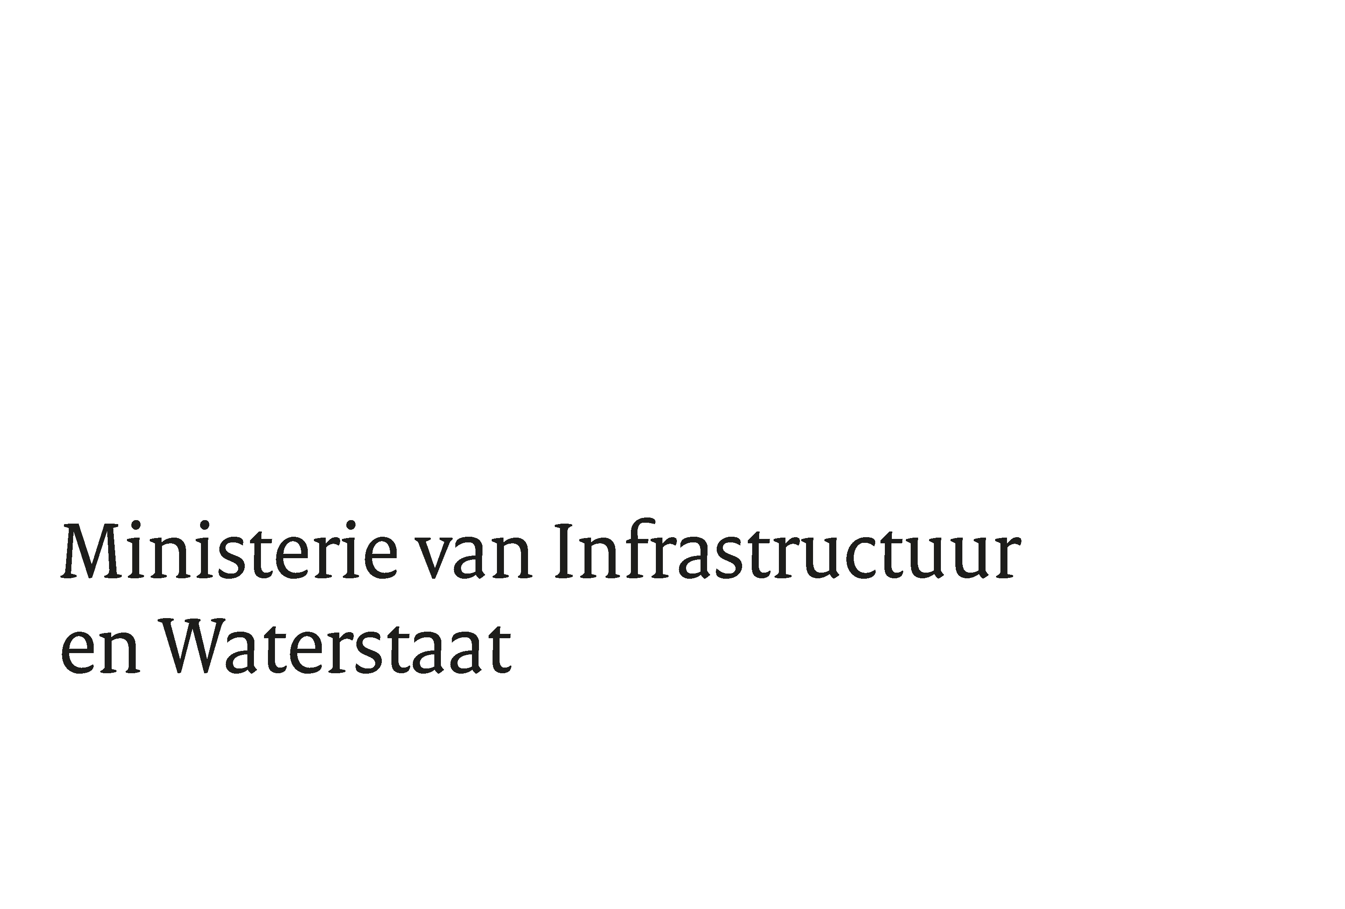

Marpol Services B.V.  T.a.v. J. Van Rijn  Trawlerkade 51-57  1976 CB Ijmuiden | Bestuurskern  Dir Omgevingsveiligheid & Milieurisico's  Cluster B  Den Haag  Postbus 20904  2500 EX Den Haag  Contactpersoon  H.C. Langenberg  Taakveld Vervoer Gevaarlijke Stoffen  T 070-4561566  M +31(0)6-46748893  Henk.LANGENBERG@minienw.nl
Datum 1 december 2021
Betreft Bijzondere machtiging | Ons kenmerk  IENW/BSK-2021/326108

Geachte heer Van Rijn,
Het bedrijf TRANSAFE heeft namens u een bijzondere machtiging op basis van het ADN aangevraagd. Het gaat om transport van UN 1288 Leisteenolie. Uit onderzoek is gebleken dat er geen bezwaren zijn tegen verlening van de machtiging, die ik u dan ook bij deze in de bijlage bij deze brief toe zend.

Met vriendelijke groet,
De Directeur Omgevingsveiligheid en Milieurisico's,

Mr. Judith Elsinghorst

Kenmerk IENW/BSK-2021/325848

Bijzondere machtiging krachtens 1.5.2 van het ADN
Krachtens 1.5.2 van het ADN wordt toegelaten het vervoer in tankschepen van de stof genoemd in onderstaande tabel en onder de voorwaarden die verwijzen naar het ADN zoals daarin vermeld.
De vervoerder is verplicht deze stof door een erkend classificatiebu reau te laten toevoegen aan de lijst waarnaar in 1.16.1.2.5 van het ADN wordt verwezen voordat deze wordt vervoerd.
Deze bijzondere machtiging is geldig voor de volgende schepen:

Aqua Mosa (Scheepsnummer 02337290), Marpol 18 (Scheepsnummer 02332689) en
Marpol 19 (Scheepsnummer 02332478)

van Marpol Services B.V..

Deze bijzondere machtiging is uitsluitend geldig op Nederlandse wateren.

Deze bijzondere machtiging is geldig gedurende twee jaar vanaf de datum van ondertekening, tenzij deze op een eerdere datum wordt ingetrokken.
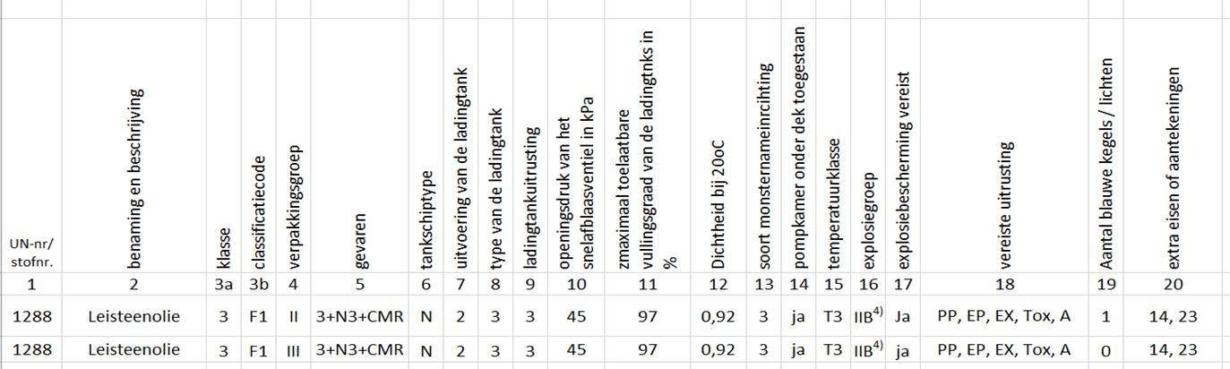

Staat van afgifte:
NEDERLAND

DE BEVOEGDE AUTORITEIT VOOR HET ADN IN NEDERLAND

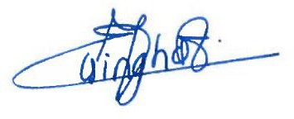

Mr. Judith Elsinghorst

