**Proposal for a new supplement to the 05, 06 and 07 Series of Amendments to UN Regulation No. 83**

This document aims to:

* Equipment conforming to UN Regulation No. 154 may be used for UNR83 / 101 test.

|  |  |  |  |
| --- | --- | --- | --- |
|  | Equipment Requirement | | |
|  | common | UN Regulation No. 154 unique | UNR83 unique |
| UN Regulation No. 154 Tests | ✓ | ✓ | - |
| UNR83 Tests(current) | ✓ | - | ✓ |
| UNR83 Tests(OICA Proposal) | ✓ | ✓ | ✓ |

UNR83 unique can be evolved and replaced with UN Regulation No. 154 unique

The modifications to the current text of the Regulation are marked in bold for new or strikethrough for deleted characters.

1. **Proposal for Regulation No. 83**

*First paragraph of Appendix 1 to 6 of Annex 4a (Type1 test);* amend to read:

Annex 4a - Appendix 1 - Chassis dynamometer system

"1. Specification

1.1. General requirements

**For test and measurement equipment that is compliant with the technical requirements of UN Regulation No. 154 original series or later version, the requirements on the technical equipment described in UN Regulation No. 154 may be followed, in all other cases the following requirements shall apply:**

1.1.1. The dynamometer shall be capable of simulating road load within one of the following classifications: ..."

Annex 4a - Appendix 2 - Exhaust dilution system

"1.2. General requirements

**For test and measurement equipment that is compliant with the technical requirements of UN Regulation No. 154 original series or later version, the requirements on the technical equipment described in UN Regulation No. 154 may be followed, in all other cases the following requirements shall apply:**"

Annex 4a - Appendix 3 - Gaseous emissions measurement equipment

"1. Specification

**For test and measurement equipment that is compliant with the technical requirements of UN Regulation No. 154 original series or later version, the requirements on the technical equipment described in UN Regulation No. 154 may be followed, in all other cases the following requirements shall apply:**"

Annex 4a - Appendix 4 - Particulate mass emissions measurement equipment

"1. Specification

**For test and measurement equipment that is compliant with the technical requirements of UN Regulation No. 154 original series or later version, the requirements on the technical equipment described in UN Regulation No. 154 may be followed, in all other cases the following requirements shall apply:**"

Annex 4a - Appendix 5 - Particulate number emissions measurement equipment

"1. Specification

**For test and measurement equipment that is compliant with the technical requirements of UN Regulation No. 154 original series or later version, the requirements on the technical equipment described in UN Regulation No. 154 may be followed, in all other cases the following requirements shall apply:**"

Annex 4a - Appendix 6 - Verification of simulated inertia

"1. Object

The method described in this appendix makes it possible to check that the simulated total inertia of the dynamometer is carried out satisfactorily in the running phase of the operating cycle. The manufacturer of the dynamometer shall specify a method for verifying the specifications according to paragraph 3. of this appendix.

**In case of the equipment that meets UN Regulation No. 154 requirements, this application may not be required.**"

*Paragraph 4 of Annex 7 (Type4 test);* amend to read:

"4. Test equipment for evaporative test

**For test and measurement equipment that is compliant with the technical requirements of UN Regulation No. 154 original series or later version, the requirements on the technical equipment described in UN Regulation No. 154 may be followed, in all other cases the following requirements shall apply:**

4.1. Chassis dynamometer

The chassis dynamometer shall meet the requirements of Appendix 1 to Annex 4a to this Regulation."

Annex 7 - Appendix 1 - Calibration of equipment for evaporative emission testing

"1. Calibration frequency and methods

**For test and measurement equipment that is compliant with the technical requirements of UN Regulation No. 154 original series or later version, the requirements on the technical equipment described in UN Regulation No. 154 may be followed, in all other cases the following requirements shall apply:**"

**II. Justification**

For OICA as well, we would like to make the following proposals in consideration of further operational efficiency.

In fact, the R154 equipment has been updated and regulated based on the R83 equipment,

an example is shown below,

As reference, no modification on UNR101 is necessary since UNR101 refers UNR83 for

equipment requirement.

**Example 1: particulate sampling system**

ECE R83/05 Annex 4 Appendix 5 → shall be as indicated ….

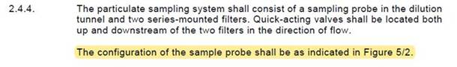

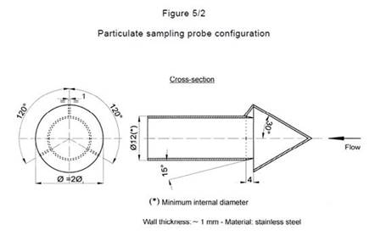

UN R 154 → pre-classifier may be used

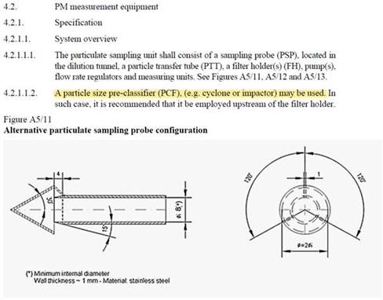

**Example 2: length of pipe**

ECE R83-05 Annex 4 Appendix 5 → max. 3,6 m to dilution tunnel inlet

cid:image008.jpg@01D7E12E.4C0B4070

UN R 154 → max. 3,6 m …or first point of dilution

