Informal document GRBP-75-10
(75th GRBP, 8-11 February 2022
Agenda item 4 (e))

Proposal for Supplement 2 to the 01 series of Amendments to UN Regulation No. 141
Amendments to ECE/TRANS/WP.29/GRBP/2022/2
Submitted by the Task Force on Tyre Pressure Monitoring System and Tyre Installation*
This document has been prepared by the Task Force on Tyre Pressure Monitoring System and Tyre Installation (TF TPMSTI) with the aim to implement the requirements for a Tyre Pressure Refill System (TPRS) and a Central Tyre Inflation System (CTIS) in paragraph 5. of the 01 series of amendments to UN Regulation No. 141. The proposal is based on ECE/TRANS/WP.29/2021/10/Rev.1, Informal document GRBP-74-26 and on the comments that TF TPMSTI has received after the seventy-fourth session of the Working Party on Noise and Tyres (GRBP). New text is shown with bold and deleted text is shown with strikethrough characters in comparison to ECE/TRANS/WP.29/2021/10/Rev.1.
The amendments to the original proposal ECE/TRANS/WP.29/GRBP/2022/2 are marked in bold for new or strikethrough for deleted characters in blue font.

I. Proposal
Table of Contents, Annex 4, amend to read:
"4 Test requirements for Tyre Pressure Refilling Refill Systems (TPRS) and Central Tyre
Inflation Systems (CTIS)……………………. 20"
Paragraph 3.1., amend to read:
“3.1. The application for approval of a vehicle type with regard to its tyre pressure monitoring system Tyre Pressure Monitoring System (TPMS) shall be submitted by the vehicle manufacturer or by his duly accredited representative;”
Paragraph 5.1.1.1., amend to read:
“5.1.1.1. A Tyre Pressure Refill System (TPRS) or a Central Tyre Inflation System (CTIS) shall be deemed to be equivalent for Type Approval to a Tyre Pressure Monitoring System (TPMS) when it fulfils the requirements of paragraph 5.1.2., 5.1.3. and 5.4. to 5.6. and the test criteria of Annex 4 to this Regulation are met. In this case TPMS is not required to be installed.”
Paragraph 5.1.1.2., delete:
“5.1.1.2. A Central Tyre Inflation System (CTIS) shall be deemed to be equivalent to a Tyre Pressure Monitoring System (TPMS) when the test criteria of Annex 4 to this Regulation are met. In this case TPMS is not required to be installed.”
Paragraph 5.1.1.3. (former), renumber as 5.1.1.2. and amend to read:
“5.1.1.32. If more than one system as defined in paragraphs 2.8., 2.14. or 2.15. has been installed, all system the system(s) which communicate(s) warning messages to the driver shall be approved according to the requirements of this Regulation.
If more than one system is installed on the vehicle it has to be ensured that no contradictional information is displayed to the driver, e.g. by priorisation.”
Paragraph 5.1.2., amend to read:
“5.1.2. The effectiveness of the TPMS, TPRS or CTIS tyre pressure monitoring system, the tyre pressure refill system or the central tyre inflation system fitted on a vehicle shall not be adversely affected by magnetic or electrical fields. This shall be demonstrated by fulfilling the technical requirements and respecting the transitional provisions of UN Regulation No. 10 by applying:
(a) The 03 series of amendments for vehicles without a coupling system for charging the Rechargeable Electric Energy Storage System (traction batteries);
(b) The 06 series of amendments for vehicles with a coupling system for charging the Rechargeable Electric Energy Storage System (traction batteries)."
Paragraph 5.1.6., amend to read:
“5.1.6. For vehicles of categories M₁ up to a maximum mass of 3500 kg and N₁
In case of a given warning and if the TPMS tyre pressure monitoring system is equipped with a reset function but does not detect a minimum pressure as defined in paragraphs 5.2. and 5.3. after executing the reset function, the reset control shall be designed and/or located inside the vehicle in such a way that the risk of an inadvertent reset by vehicle occupants or cargo is reduced.
For vehicles where the TPMS tyre pressure monitoring system does not detect if the pressure is above a minimum pressure as defined in paragraphs 5.2. and 5.3. after executing the reset function, the TPMS tyre pressure monitoring system shall include at least measures avoiding a reset if the vehicle did not become stationary after a pressure warning was issued, and either
(a) Measures avoiding inadvertent reset control operation (e.g. shortly touching on the reset control or continuous blocking of the reset control by vehicle occupants or cargo), or
(b) An activation by at least two deliberate actions (e.g. in a menu based system).
The manufacturer shall provide in the vehicle owner's handbook, or by any other communication means in the vehicle, the necessary information.”
Paragraphs 5.4.1., 5.4.2. and 5.4.3., amend to read:
“5.4.1. The TPMS/ TPRS/ CTIS shall illuminate the warning signal described in paragraph 5.5. not more than 10 minutes after the occurrence of a malfunction that affects the generation or transmission of control or response signals in the vehicle's TPMS/ TPRS/ CTIS tyre pressure monitoring system.
5.4.2. The malfunction indication warning signal described in paragraph 5.5. shall be illuminated whenever the towed vehicle TPMS/ TPRS/ CTIS provides a malfunction indication via the communication interface described in paragraph 5.6.
5.4.3. The malfunction indication warning signal described in paragraph 5.5. shall be illuminated whenever no valid TPMS/ TPRS / CTIS information is available from a connected towed vehicle, that is required to have TPMS/ TPRS/ CTIS, via any communication interface described in paragraph 5.6.”
Paragraph 5.5.6., amend to read:
“5.5.6. The malfunction indication may be the same warning signal as the one used to indicate low tyre pressure under-inflation. If the warning signal described in paragraph 5.5.1. is used to indicate both low tyre pressure under-inflation and a malfunction of the TPMS/ TPRS / CTIS, the following shall apply: with the ignition (start) switch in the "on" (run) position the warning signal shall flash to indicate a malfunction. After a short period of time the warning signal shall remain continuously illuminated as long as the malfunction exists and the ignition (start) switch is in the "on" (run) position. The flashing and illumination sequence shall be repeated each time the ignition (start) switch is in the "on" (run) position until the malfunction has been corrected.”
Paragraphs 5.6.1., 5.6.1.1. and 5.6.1.2., amend to read:
“5.6.1. Vehicles of category N₂ or N₃ towing at least one vehicle of category O₃ or O₄ and vehicles of category O₃ and O₄ shall be equipped with a communication interface to exchange TPMS/ TPRS / CTIS data information between towing and towed vehicles. This may be achieved as a wired or a wireless interface, provided that the TPMS/ TPRS/ CTIS equipment in the towing vehicle and in the towed vehicle(s) are compatible.
5.6.1.1. The data communication with wired equipment shall be based on the braking electric control line conforming to ISO 11992-1:2019 and ISO 11992-2:2014 and be a point-to-point type using the seven pin connector according to ISO 7638-1:2018 or ISO 7638-2:2018 or an appropriate automated connector.
Other wired specifications may be used, provided that the TPMS/ TPRS/ CTIS equipment in the towing vehicle and in the towed vehicle(s) are compatible and fulfil the same functional requirements.
5.6.1.2. In the case of a point-to-point link between a towing vehicle ECU and a towed vehicle ECU, there shall be an open standard specification the towed vehicle ECU, which constitutes part of the point-to-point link, shall provide an interface according to an open standard specification to allow an ECU the ECU(s) providing TPMS/ TPRS /CTIS functionality, which does (do) not constitute part of the point-to- point link, to connect, communicate and operate via the towed vehicle ECU which constitutes part of the point-to-point link with ECU of the towing vehicle, i.e. standardised gatewaying. This data communication interface is specified in Part B of Annex 5.”
Insert new paragraphs 5.7. and 5.7.1., amend to read:
“5.7. Alternative procedure for a subject trailer
5.7.1. In the case that a manufacturer chooses to approve a vehicle type of category O₃ or O₄ with regard to TPMS, TPRS or CTIS according to Annex 8 “Alternative procedure for type approval of subject trailer(s)” to this Regulation, then information is utilized from test reports issued in accordance with Annex 7, Appendix 3 and / or Appendix 4 to this Regulation.”

Annex 2, text below, amend to read:
“The above approval mark affixed to a vehicle shows that the vehicle type concerned has, with regard to the equipment of a tyre pressure monitoring system, been approved in the Netherlands (E 4), pursuant to UN Regulation No. 141 under approval number 002439 012439. The first two digits of the approval number indicates that the approval was granted in accordance with the requirements of UN Regulation No. 141 as amended by the 01 series of amendments.”
Annex 4,
Title, amend to read:
“Test requirements for Tyre Pressure Refilling Refill Systems (TPRS) and for Central Tyre Inflation System (CTIS)”
Paragraph 1.2., amend to read:
“1.2. Road test surface
The road shall have a surface affording good adhesion. Testing shall be performed on even ground.”
Paragraph 1.3.1., amend to read:
“1.3.1. Test weight
Any weight condition the vehicle is legally approved for.
The vehicle may be tested at any condition of load, the distribution of the mass among the axles being that stated by the vehicle manufacturer without exceeding any of the maximum permissible mass for each axle.
However, in the case where there is no possibility to set or reset the system, the vehicle shall be unladen. For vehicles of category M₁ up to a maximum mass of 3,500 kg, M₂, M₃, N₁, N₂, and N₃ there may be, in addition to the driver, a second person on the front seat (if fitted) who is responsible for noting the results of the tests.
The load condition shall not be modified during the test.”
Insert a new paragraph 1.3.3. to read:
“1.3.3 Rim position.
The vehicle rims may be positioned at any wheel position, consistent with any related instructions or limitations from the vehicle's manufacturer.”
Paragraph 1.3.3. (former), renumber as 1.3.4. and amend to read:
“1.3.34. Stationary location
When the vehicle is parked, the vehicle's tyres shall be shaded from direct sun. The location shall be shielded from any wind that may affect the results.”
Paragraph 1.5., amend to read:
“1.5. Accuracy of pressure measurement equipment
Pressure measurement equipment to be used for the tests contained in this Annex shall be accurate to at least +/-10 kPa +/-3 kPa.
All pressure measurements shall be carried out using the same test equipment.”
Insert a new paragraph 2.1. to read:
“2.1. If a variant of any vehicle submitted for approval is fitted with twin wheels, that variant shall be used for the test and one of the tyres on a twin wheel (the “test tyre”) must be deflated for the refilling test in paragraph 2.5.”
Insert a new paragraph 2.2. to read:
“2.2. Before inflating the vehicle's tyres, leave the vehicle stationary outside at ambient temperature with the engine off shaded from direct sunlight and not exposed to wind or other heating or chilling influences for at least one hour for vehicles of category M₁ and N₁ and at least 4 hours for vehicles of category M₂, M₃, N₂, N₃, O₃ and O₄. Inflate the vehicle's tyres to the vehicle manufacturer's recommended cold inflation pressure (P_{rec}), in accordance with the vehicle manufacturer's recommendation for the speed and load conditions, and tyre positions. All pressure measurements shall be carried out using the same test equipment.”
Insert a new paragraph 2.3. to read:
“2.3. With the vehicle stationary and the ignition locking system in the "Lock" or "Off" position, activate the ignition locking system to the "On" or "Run" position. The TPRS / CTIS shall perform a check of lamp function for the low tyre pressure tell-tale as specified in paragraph 5.5.2. of this Regulation. This last requirement does not apply to tell-tales shown in a common space.”
Paragraph 2.1. (former), renumber as 2.4. and amend to read:
“2.14. Vehicle conditioning
The pressure reservoir (mounted infrastructure) has to be filled according to UN Regulation No. 13, Series 11, Supplement 16, reservoir pressure limits. Prior to the testing, it has to be ensured that each vehicle wheel has rotated at least ten times. Leave the vehicle stationary outside at ambient temperature with the engine off shaded from direct sunlight and not exposed to wind or other heating or chilling influences for at least one hour. The compressed air supply must be granted during the tests according to paragraph 2.5. and to paragraph 2.6. to this Annex.”
Paragraph 2.2. (former), renumber as 2.5. and amend to read:
“2.25. Check the systems refill functionality
Check the systems refill functionality for incident-related pressure loss and for detection of a tyre pressure level significantly below the recommended pressure for optimum performance including fuel consumption and safety.

Inflate the vehicle's tyres to the vehicle manufacturer's recommended cold inflation pressure (P_{rec}).
Deflate the tyre pressure of one tyre by 20% but not more than 50 kPa below the manufacturers recommended cold inflation pressure (Prec). During the deflation the tyre shall not be connected to the pneumatic circuit.”
Paragraph 2.2.1.(former), renumber as 2.5.1. and amend to read:
“2.25.1. Check refilling according to Figure 1
Check that within 2 minutes the TPRS / CTIS starts refilling and the optical signal for refilling as described by the manufacturer is ON.
Refill process shall be completed within 8 min after the refill process has started and the optical signal for refilling as described by the manufacturer shall be OFF as soon as the refilling process is completed.
Check that within 2 minutes, when the system is operational, the TPRS/ CTIS starts refilling and at least after 2 minutes the low tyre pressure tell-tale, as described in paragraph 5.5. of the Regulation, is “On”.
Refill process shall be completed within 8 min after the refill process has started and the low tyre pressure tell-tale, as described in paragraph 5.5. of the Regulation, is “Off” as soon as the refilling process is completed.
After the refilling process has been completed, check that the tyre pressure is in a range of +/- 5% of manufacturers recommended cold inflation pressure P_{rec}.”
Insert a new paragraph 2.5.2. to read:
“2.5.2. Check refilling according to Figure 2
Check that within 2 minutes when the system is operational the TPRS/ CTIS starts refilling and at least after 2 minutes the low tyre pressure tell-tale, as described in paragraph 5.5. of the regulation, is “On”.
Refill process shall not be completed within 8 min after the refill process has started and the low tyre pressure tell-tale, as described in paragraph 5.5. of the regulation, is “ON” after at least 2 minutes of refilling time.
The deflation rate during the test must be higher than the refilling rate.”

Figure 1, amend to read:
“Figure 1
Refilling check
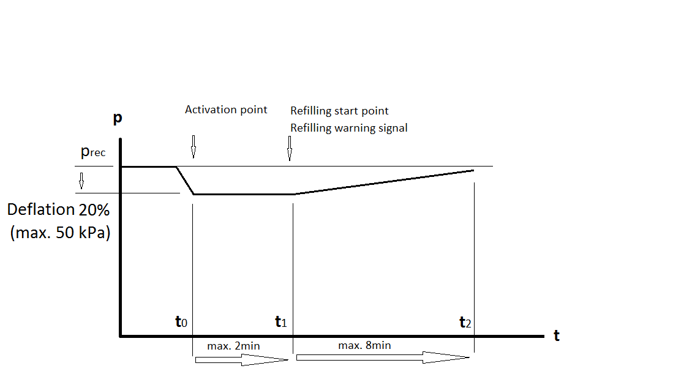
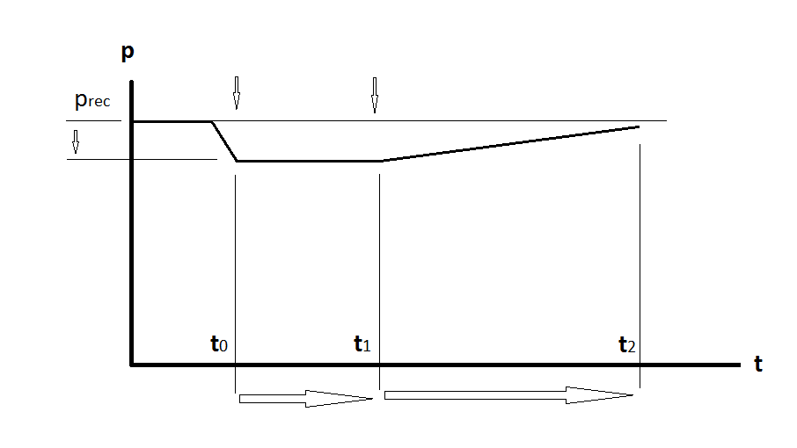”
Deflation 20% (max. 50 kPa)
Activation point
Refilling start point
max. 8min
max. 2min
Paragraph 2.3. (former), delete:
“2.3. Check system malfunction warning functionality according to Figure 2
Inflate the vehicle's tyres to the vehicle manufacturer's recommended cold inflation pressure (Prec).
Constantly deflate the system or the pressure of one tyre by 20% but not more than 50 kPa below the manufacturers recommended cold inflation pressure (Prec).
Within 2 minutes the system shall start refilling and the optical signal as described by the manufacturer for refilling is be ON
Within 8 minutes after the start of the refilling the optical signal for malfunction as described by the manufacturer shall be ON.”
Figure 2, amend to read:
“Figure 2
Checking system malfunction warning functionality.
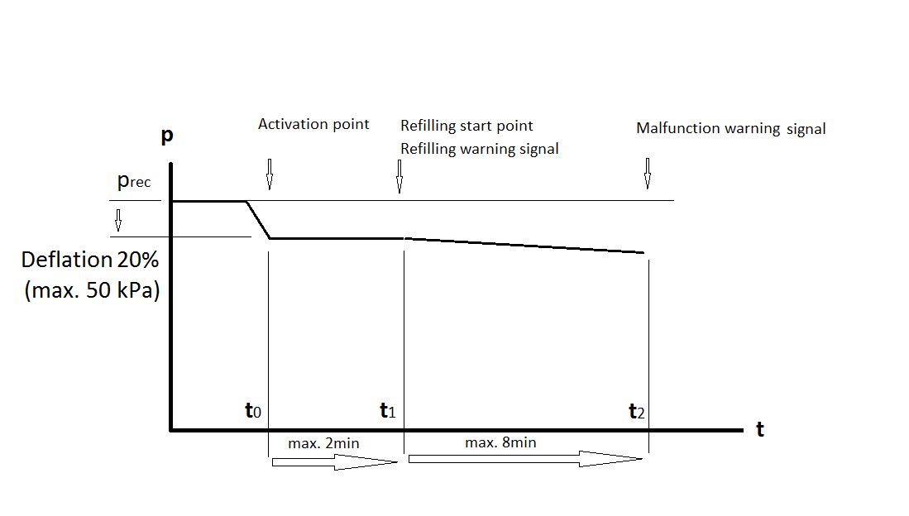
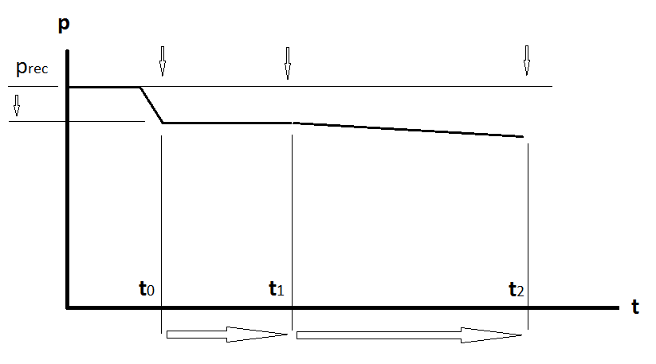
max. 2min
max. 8min
Deflation 20% (max. 50 kPa)
Activation point
Refilling start point
Low tyre pressure tell-tale

”
Insert new paragraphs 2.6., 2.6.1. and 2.6.2. to read:
“2.6. TPRS/ CTIS malfunction detection
2.6.1. Simulate a TPRS/ CTIS malfunction, for example, by disconnecting the energy source (electrical power and / or pneumatic pressure) to any TPRS/ CTIS component, disconnecting any electrical connection between TPRS/ CTIS components. When simulating a TPRS/ CTIS malfunction, the electrical connections for the tell-tale lamps shall not be disconnected.
2.6.2. Restore the TPRS/ CTIS to normal operation. If the warning lamp has not extinguished, discontinue the test.”
Annex 5,
Part A,
Title, amend to read:
“A. TPMS/ TPRS/ CTIS data communication between towing vehicle and towed vehicle(s)”
Paragraph 2.1.1., amend to read:
“2.1.1. Messages transmitted from the towing vehicle to the towed vehicle, if supported:
Function / Parameter | ISO 11992-2: 2014 reference
Reverse gear status | EBS12  Byte 2 Bit 5-6
Braking system wheel-based vehicle speed | EBS12  Byte 7-8
Time/Date – Seconds | SAE J1939 PGN 65254 TD11 Byte 1
Time/Date – Minutes | SAE J1939 PGN 65254 TD11 Byte 2
Time/Date – Hours | SAE J1939 PGN 65254 TD11 Byte 3
Time/Date – Months | SAE J1939 PGN 65254 TD11 Byte 4
Time/Date – Day | SAE J1939 PGN 65254 TD11 Byte 5
Time/Date – Year | SAE J1939 PGN 65254 TD11 Byte 6
Time/Date - Local minute offset | SAE J1939 PGN 65254 TD11 Byte 7
Time/Date - Local hour offset | SAE J1939 PGN 65254 TD11 Byte 8
Identification data index | RGE12 Byte 5
Identification data content | RGE12 Byte 6
Note: Regarding the definition of the parameters of the TD11 Time/Date message, there is a known inconsistency between the SAE J1939 and ISO 11992-2:2014 standards. For the purposes of compliance to this Regulation, the TD11 Time/Date message definition (PGN 65254) provided in the ISO 11992-2:2014 SAE J1939DA 202110 (Publication date 21 October 2021) shall be used.”
Paragraph 2.1.4., amend to read:
“2.1.4. The towed vehicle ECU transmitting the EBS23 and RGE23 messages shall assemble the EBS23 and RGE23 messages from TPMS/ TPRS/ CTIS content received from the ECU ECU(s) providing TPMS/ TPRS/ CTIS functionality and data from other sources not defined in this Regulation.
Signals, other than Tyre Pressure Status (EBS23 Byte 1 Bit 1-2), within messages EBS23 and RGE23 shall be transmitted with the indication “not available” in case the ECU ECU(s) providing TPMS/ TPRS/ CTIS functionality does not provide such data.”
Paragraph 2.2., amend to read:
“2.2. When the towed vehicle transmits the following messages, the towing vehicle shall provide a low tyre pressure warning indication to the driver:”
Paragraph 2.3., amend to read:
“2.3. When the towed vehicle transmits the following messages, the towing vehicle shall provide a TPMS/ TPRS/ CTIS malfunction indication to the driver:
Function / Parameter | ISO 11992-2:2014 reference | Driver warning required
Tyre Pressure Status  (For TPMS/ TPRS/ CTIS Malfunction Indication) | EBS23 Byte 1  Bit 1-2  (10₂ — error indicator) | Reference to paragraph 5.4.1., 5.4.2. and 5.5.2. in this UN Regulation
Tyre/wheel identification (corresponding to Tyre Pressure Status) | EBS23 Byte 2  XXXXXXXX₂ — actual Tyre/Wheel ID)  OR  (00000000₂ — Tyre/Wheel ID not defined or wheel not defined and axle > 15₁₀)  OR  (11111111₂ — Tyre/Wheel ID not available or wheel = 15₁₀ and axle = 15₁₀) | Reference to paragraph 5.4.1., 5.4.2. and 5.5.2. in this UN Regulation
“
Paragraph 2.3.1., amend to read:
“2.3.1. The towed vehicle shall transmit a Tyre Pressure Status value of "error indicator" within 10 minutes of cumulative driving (in accordance with paragraph 5.4.1. of this Regulation) for any scenario where a valid Tyre Pressure Status (i.e. tyre pressure sufficient or insufficient) cannot be transmitted.
Note that before towed vehicles needed to comply with this Regulation, some of them transmitted Tyre Pressure Status “not available” for some of these scenarios, including when the towed vehicle had no function to perform tyre pressure monitoring. Towed vehicles that are required to comply with this Regulation going forward shall instead transmit "error indicator" for these scenarios.
Note that the towing vehicle would not be required to display a towed vehicle TPMS/ TPRS/ CTIS malfunction indication in the case that valid towed vehicle TPMS information is available on an alternative communication interface.”
Paragraph 2.4., amend to read:
“2.4. When a permanent failure is detected in the communication line, the towing vehicle shall illuminate the towed vehicle TPMS/ TPRS/ CTIS malfunction indication signal.
Note that the towing vehicle would not be required to display a towed vehicle TPMS/ TPRS/ CTIS malfunction indication in the case that valid towed vehicle TPMS/ TPRS/ CTIS information is available on an alternative communication interface.”
Paragraph 2.5., amend to read:
“2.5. When a valid Tyre Pressure Status is temporarily not available (i.e. unavailable for less than 10 minutes of cumulative drive time), the towed vehicle shall transmit the following messages:
Function / Parameter | ISO 11992-2:2014 reference | Driver warning required
Tyre Pressure Status  (TPMS/ TPRS/ CTIS data temporarily unavailable) | EBS23 Byte 1  Bit 1-2  (11₂ — not available) | Not applicable
Tyre/wheel identification (corresponding to Tyre Pressure Status) | EBS23 Byte 2  XXXXXXXX₂ — actual Tyre/Wheel ID)  OR  (00000000₂ — Tyre/Wheel ID not defined or wheel not defined and axle > 15₁₀)  OR  (11111111₂ — Tyre/Wheel ID not available or wheel = 15₁₀ and axle = 15₁₀) | Not applicable
Note: paragraph 2.3.1. of part A of this Annex specifies required transmitted values when valid Tyre Pressure Status is unavailable for any longer duration.
”
Annex 5,
Part B,
Title, amend to read:
“B. Data communication between (i) a towed vehicle ECU constituting part of a point-to-point link with the towing vehicle (towed vehicle gateway ECU) and (ii) a towed vehicle ECU ECU(s) providing TPMS/ TPRS/ CTIS functionality”
Paragraph 1.2., amend to read:
“1.2. This annex defines requirements applicable to the towed vehicle gateway ECU and the ECU ECU(s) providing TPMS/ TPRS/ CTIS functionality with respect to the provision of a standard ISO 11898:2015 11898-1:2015 interface and the support of messages defined within ISO 11992-2:2014.”
Paragraphs 2. to 2.2., amend to read:
“2. The towed vehicle gateway ECU that is part of the point-to-point link shall provide an interface with the ECU ECU(s) providing TPMS/ TPRS/ CTIS functionality complying with data link layer and physical layer in accordance with ISO 11898-1:2015 and ISO 11898-2:2016.
2.1. The CAN bit-rate for the ISO 11898-1:2015 interface shall be 250 kbit/s.
2.2. The ISO 11898-2:2015 11898-2:2016 bus termination shall be configured on the vehicle in accordance with the guidelines of the vehicle manufacturer for the given installation.”
Paragraph 2.3., amend to read:
“2.3. A power connection shall be made available to the towed vehicle ECU ECU(s) providing TPMS/ TPRS/ CTIS functionality in accordance with the vehicle manufacturer.”
Paragraph 2.4., amend to read:
“2.4. The towed vehicle gateway ECU shall transmit, towards the towed vehicle ECU ECU(s) providing TPMS/ TPRS/ CTIS functionality, all messages and signals required to realise a reliable TPMS/ TPRS/ CTIS function.”
Paragraph 3.1., amend to read:
“3.1. The following functions and associated messages are those that shall be supported by the towed vehicle gateway ECU or towed vehicle ECU ECU(s) providing TPMS/ TPRS/ CTIS functionality as appropriate:”
Paragraph 3.1.1., amend to read:
“3.1.1. Messages transmitted, if supported, from the towed vehicle gateway ECU to the towed vehicle ECU ECU(s) providing TPMS/ TPRS/ CTIS functionality:
Function / Parameter | ISO 11992-2:2014 reference | Reference to paragraphs in this UN Regulation
Reverse gear status (towing vehicle) | EBS12  Byte 2 Bit 5-6 | Paragraph 5.6.1.2.
Braking system wheel-based vehicle speed (towing vehicle) | EBS12  Byte 7-8 | Paragraph 5.6.1.2.
Identification data index  (towing vehicle) | RGE12 Byte 5 | Paragraph 5.6.1.2.
Identification data content  (towing vehicle) | RGE12 Byte 6 | Paragraph 5.6.1.2.
Time/Date – Seconds (towing vehicle) | SAE J1939 PGN 65254 TD11 Byte 1 | Paragraph 5.6.1.2.
Time/Date – Minutes (towing vehicle) | SAE J1939 PGN 65254 TD11 Byte 2 | Paragraph 5.6.1.2.
Time/Date – Hours (towing vehicle) | SAE J1939 PGN 65254 TD11 Byte 3 | Paragraph 5.6.1.2.
Time/Date – Months (towing vehicle) | SAE J1939 PGN 65254 TD11 Byte 4 | Paragraph 5.6.1.2.
Time/Date – Day (towing vehicle) | SAE J1939 PGN 65254 TD11 Byte 5 | Paragraph 5.6.1.2.
Time/Date – Year (towing vehicle) | SAE J1939 PGN 65254 TD11 Byte 6 | Paragraph 5.6.1.2.
Time/Date - Local minute offset (towing vehicle) | SAE J1939 PGN 65254 TD11 Byte 7 | Paragraph 5.6.1.2.
Time/Date - Local hour offset (towing vehicle) | SAE J1939 PGN 65254 TD11 Byte 8 | Paragraph 5.6.1.2.
Braking system wheel-based vehicle speed (towed vehicle) | EBS21  Byte 3-4 | Paragraph 5.6.1.2.
Lift axle 1 position  (towed vehicle) | RGE21  Byte 2 Bit 1-2 | Paragraph 5.6.1.2.
Lift axle 2 position  (towed vehicle) | RGE21  Byte 2 Bit 3-4 | Paragraph 5.6.1.2.
Note: Regarding the definition of the parameters of the TD11 Time/Date message, there is a known inconsistency between the SAE J1939 and ISO 11992-2:2014 standards. For the purposes of compliance to this Regulation, the TD11 Time/Date message (PGN 65254) definition provided in the ISO 11992-2:2014 SAE J1939DA 202110 (Publication date 21 October 2021) shall be used.”
Paragraph 3.1.2., amend to read:
“3.1.2. Mandatory messages transmitted from the towed vehicle ECU ECU(s) providing TPMS/ TPRS/ CTIS functionality to the towed vehicle gateway ECU:”
Paragraph 3.1.3., amend to read:
“3.1.3. Messages transmitted from the towed vehicle ECU ECU(s) providing TPMS/ TPRS/ CTIS functionality to the towed vehicle gateway ECU, if supported:”
Paragraph 3.1.4., amend to read:
“3.1.4. For messages defined in section 3.1. of Part B of this Annex, signals shall be transmitted with the indication "not available" in case the ECU ECU(s) does (do) not provide such data.”
Paragraph 3.2., amend to read:
“3.2. The support of all other messages defined within ISO 11992-2:2014 is optional for the towed vehicle gateway ECU and the towed vehicle ECU ECU(s) providing TPMS/ TPRS/ CTIS functionality, unless required by other Regulations.”
Paragraph 3.3., amend to read:
“3.3. The towed vehicle gateway ECU and the towed vehicle ECU ECU(s) providing TPMS/ TPRS/ CTIS functionality shall support diagnostics as per ISO 11992-4:2014.”
Paragraph 4., amend to read:
“4. The towed vehicle ECU ECU(s) providing TPMS/ TPRS/ CTIS functionality shall use the source address of "Other Trailer Devices" with respect to its position in the road train as per SAE J1939-71 standard i.e. TPMS/ TPRS/ CTIS of the first towed vehicle shall use source address 207 for "Other Trailer #1 Devices".”
Annex 6,
Paragraph 2.2.1.1., amend to read:
“2.2.1.1. Low Tyre Pressure Warning indication:”
Paragraph 2.2.1.1.1., amend to read:
“2.2.1.1.1. Simulate a towed vehicle low tyre pressure warning and check that the low tyre pressure warning signal specified in paragraph 5.5. of this Regulation is displayed.
The parameters defined in EBS 23 bytes 1 and 2 of ISO 11992-2:2014 shall be transmitted as follows:
Control line signalling | EBS 23 Byte 1  Bits 1 - 2 | EBS 23 Byte 2
Low Tyre Pressure Warning indication for tyre/wheel identification number 1,7 (Axle 1, left inner) | 00₂  (tyre pressure insufficient) | 00010111₂  (Tyre/Wheel “1,7”)
”
Paragraph 2.2.1.1.2., amend to read:
“2.2.1.1.2. Simulate a towed vehicle low tyre pressure warning (without known tyre/wheel ID) and check that the low tyre pressure warning signal specified in paragraphs 5.5 of this Regulation is displayed.
The parameters defined in EBS 23 bytes 1 and 2 of ISO 11992-2:2014 shall be transmitted as follows:
Control line signalling | EBS 23 Byte 1  Bits 1 - 2 | EBS 23 Byte 2
Low Tyre Pressure Warning indication (without known tyre/wheel ID) | 00₂  (tyre pressure insufficient) | 00000000₂  (Tyre/Wheel ID not defined or wheel not defined and axle > 15₁₀)  OR  11111111₂  (Tyre/Wheel ID not available available or wheel = 15₁₀ and axle = 15₁₀)
”
Paragraph 2.2.1.2., amend to read:
“2.2.1.2. TPMS/ TPRS/ CTIS Malfunction Warning:”

Paragraph 2.2.1.2.1., amend to read:
“2.2.1.2.1. Simulate a towed vehicle TPMS/ TPRS/ CTIS malfunction, signalled by the towed vehicle TPMS/ TPRS/ CTIS, and check that the towed vehicle TPMS/ TPRS/ CTIS malfunction indication warning signal specified in paragraph 5.5.6. of this Regulation is displayed.
The parameters defined in EBS 23 bytes 1 and 2 of ISO 11992-2:2014 shall be transmitted as follows:
Control line signalling | EBS 23 Byte 1  Bits 1 - 2 | EBS 23 Byte 2
TPMS/ TPRS/ CTIS Malfunction for tyre/wheel identification number 1,7 (Axle 1, left inner) | 10₂  (Error indicator) | 00010111₂  (Tyre/Wheel “1,7”)
”
Paragraph 2.2.1.2.2., amend to read:
“2.2.1.2.2. Simulate a towed vehicle TPMS/ TPRS/ CTIS malfunction (without known tyre/wheel ID) and check that the towed vehicle TPMS/ TPRS/ CTIS malfunction indication warning signal specified in paragraph 5.5.6. of this Regulation is displayed.
The parameters defined in EBS 23 bytes 1 and 2 of ISO 11992-2:2014 shall be transmitted as follows:
Control line signalling | EBS 23 Byte 1  Bits 1 - 2 | EBS 23 Byte 2
TPMS/ TPRS/ CTIS Malfunction (without known tyre/wheel ID) | 10₂  (Error indicator) | 00000000₂  (Tyre/Wheel ID not defined or wheel not defined and axle > 15₁₀)  OR  11111111₂  (Tyre/Wheel ID not available or wheel = 15₁₀ and axle = 15₁₀)
”
Paragraph 2.2.1.2.3., amend to read:
“2.2.1.2.3. Simulate a permanent failure in the communication line and check that the towed vehicle TPMS/ TPRS/ CTIS malfunction indication warning signal specified in paragraph 5.5.6. of this Regulation is displayed. ”
Paragraph 2.2.1.2.4., amend to read:
“2.2.1.2.4. Note that the towed vehicle TPMS/ TPRS/ CTIS malfunction indication would not be displayed in the case that valid TPMS/ TPRS/ CTIS information is available on an alternative interface.”

Figure 1, amend to read:
“Figure 1
Arrangement of device under test and vehicle simulator where TPMS/ TPRS/ CTIS functionality is provided by ECU connected via ISO 11898-1:2015 and 11898-2:2016 interface
Towed Vehicle
ISO 11992 Towing Vehicle Simulator
ISO 11992-2 Towed Vehicle ECU
ECU providing TPMS/ TPRS/ CTIS functionality
ISO 11898
ISO 11992-2

”
Figure 2, amend to read:
“Figure 2
Arrangement of device under test and vehicle simulator where TPMS/ TPRS/ CTIS functionality is provided by ECU connected to towing vehicle
Towed Vehicle
ISO 11992 Towing Vehicle Simulator
ISO 11992-2 Towed Vehicle
ECU including TPMS/ TPRS/ CTIS functionality
ISO 11992-2

”
Paragraph 3.2.2.2., amend to read:
“3.2.2.2. Follow the test procedure defined in Annex 3 of this Regulation for TPMS or Annex 4 of this Regulation for TPRS/ CTIS and check that the TPMS/ TPRS/ CTIS warning and malfunction signals are transmitted as defined in paragraphs 2.2. and 2.3. of Part A of Annex 5 to this Regulation.”
II. Justification
1. At the seventy-fourth session of GRBP, TF TPMSTI presented Informal document GRBP-74-26 which was based on ECE/TRANS/WP.29/2021/10/Rev.1. GRBP generally supported GRBP-74-26 and invited TF TPMSTI to submit it to the next session in the form of an official document (ECE/TRANS/WP.29/GRBP/72, para. 27).
2. This official document follows the above invitation. It is based on ECE/TRANS/WP.29/2021/10/Rev.1, GRBP-74-26 and on the comments that TF TPMSTI has received after the seventy-fourth session of GRBP.
3. The original 00 series of amendments to UN Regulation No. 141 applies only to vehicles of category M₁ up to a maximum mass of 3,500 kg and N₁, when equipped with a tyre pressure monitoring system (TPMS) only.
4. The 01 series of amendments to UN Regulation No. 141 applies to vehicles of category M₁ up to a maximum mass of 3,500 kg, M₂, M₃, N₁, N₂, N₃, O₃ and O₄, when equipped with TPMS. In addition to TPMS, the tyre pressure refill system (TPRS) and the central tyre inflation system (CTIS) were introduced in the 01 series of amendments to UN Regulation No. 141.
5. Paragraph 5.1.1.1. stated that “Tyre Pressure Refill System (TPRS) shall be deemed to be equivalent to a Tyre Pressure Monitoring System (TPMS) when the test criteria of Annex 4 are met. In this case TPMS is not requested to be installed.”
6. The same was stated in paragraph 5.1.1.2. for a central tyre inflation system: “A Central Tyre Inflation System (CTIS) shall be deemed to be equivalent to a Tyre Pressure Monitoring System (TPMS) when the test criteria of Annex 4 are met. In this case TPMS is not requested to be installed.”
7. All requirements to be fulfilled by TPRS and CTIS were noted in Annex 4 only. TF TPMSTI decided to move these requirements to paragraph 5. of this Regulation. The current proposal follows this approach. Paragraph 5. “Specification and test” is now valid for all three systems: TPMS, TPRS and CTIS. As a consequence, a lot of other paragraphs needed to be revised.
8. Annex 5, Part A, paragraph 2.1.1. and Part B, paragraph 3.1.1. were revised due to the comments received by the International Organization for Standardization (ISO) Working Group ISO/TC22/SC31/WG4 after the seventy-fourth session of GRBP:
• The time/date data were aligned with standard SAE J1939 PGN 65254.
o As was already mentioned in the "Note", there is a known inconsistency between standards SAE J1939 and ISO 11992-2:2014.
o ISO/TC22/SC31/WG4 informed the Task Force that ISO would solve this issue by revising standard ISO 11992-2:2014 in 2022.
o From the new edition of standard ISO 11992-2 (2022) onwards, the time/date message and some of its constituent data identifiers will be listed but the contradictory byte order will no longer be defined directly within the ISO 11992-2 standard. Instead, where applicable, it will make reference to the SAE J1939DA standard.
• Because the publication date of standard SAE J1939DA 202110 was 21 October 2021, the Time/Date Byte 1 to Byte 8 and the “Notes” in paragraph 2.1.1. of Annex 5, Part A, and in paragraph 3.1.1. of Annex 5, Part B were revised.
9. All text, tables and figures in this proposal are produced by TF TPMSTI.
III. Justification (Amendments to ECE/TRANS/WP.29/GRBP/2022/2)
1. References to Annex 7 and to Annex 8 (see ECE/TRANS/WP.29/2022/9) regarding TPMS/ TPRS/ CTIS were introduced in paragraph 5 to this Regulation.

