|  |  |  |  |
| --- | --- | --- | --- |
|  | United Nations | ECE/TRANS/WP.29/2022/37 | |
| _unlogo | **Economic and Social Council** | | Distr.: General  27 December 2021  Original: English |

**Economic Commission for Europe**

Inland Transport Committee

**World Forum for Harmonization of Vehicle Regulations**

**186th session**

Geneva, 8-11 March 2022

Item 4.9.5 of the provisional agenda

**1958 Agreement:  
Consideration of draft amendments to existing   
UN Regulations submitted by GRE**

Proposal for Supplement 4 to the original series of amendments to UN Regulation No. 148 (Light-signalling devices)

Submitted by the Working Party on Lighting and Light-Signalling[[1]](#footnote-2)\*

The text reproduced below was adopted by the Working Party on Lighting and Light-Signalling (GRE) at its eighty-fifth session (ECE/TRANS/WP.29/GRE/85, para. 8). It is based on ECE/TRANS/WP.29/GRE/2021/11 as amended by Informal document GRE-85-11. It is submitted to the World Forum for Harmonization of Vehicle Regulations (WP.29) and to the Administrative Committee (AC.1) for consideration at their March 2022 sessions.

*Paragraph 5.4.4.2.*, amend to read:

“5.4.4.2. In case of failure of any one light source in a single lamp containing more than one light source, one of the following provisions shall apply:

(a) The light intensity at the points of standard light distribution defined in paragraph 2.2. of Annex 3 shall be at least 80 per cent of the minimum intensity required; or

(b) The light intensity in the axis of reference shall be at least 50 per cent of the minimum intensity required, provided that a note in the communication form states that the lamp is only for use on a vehicle fitted with a tell-tale indicating failure.”

*Paragraph* *5.10.2.*, amend to read:

“5.10.2. The lamp must be so designed that the light emitted directly towards the side, the front or the rear of the vehicle does not exceed 0.5 cd within the angular field as defined below.

(a) The vertical minimum angle φmin (in degrees) is:

φmin = arctan ((1-h)/10); where h is mounting height in m

(b) The vertical maximum angle φmax (in degrees) is: φmax = φmin + 11.3

The measurement shall be limited to a horizontal angle ranging from +90° to -90° with respect to the line which cuts the reference axis and which is perpendicular to the vertical longitudinal plane of the vehicle.

The measurement distance shall be 3.0 m minimum.”

*Paragraph 5.11.3.,* amend to read:

“5.11.3. Photometric characteristics

For the approval of this device, the illumination of the space to be occupied by the plate is determined. The illuminated areas are grouped in the following categories:

Category 1a: illuminated area of at least 340 x 240 mm (Figure A3-IX).

Category 1b: illuminated area of at least 520 x 120 mm (Figure A3-X).

Category 1c: illuminated area of at least 255 x 165 mm, for use on agricultural or forestry tractors, (Figure A3-XI).

Category 2a: illuminated area of at least 330 x 165 mm (Figure A3-XII).

Category 2b: illuminated area of at least 440 x 220 mm (Figure A3-XIII).

Category 1: illuminated area of at least 130 x 240 mm for use on a vehicle of category L (Figure A3-XIV).

Category 2: illuminated area of at least 200 x 280 mm for use on a vehicle of category L (Figure A3-XV).

At each of the points of measurement shown in paragraph 3. of Annex 3, the luminance B shall be at least

(a) For categories 1a, 1b, 1c, 2a and 2b equal to 2.5 cd/m2;

(b) For categories 1 and 2 equal to 2.0 cd/m².

The gradient of the luminance between the values B1 and B2, measured at any two points 1 and 2 selected from among those mentioned above, shall not exceed 2 x Bo/cm, Bo being the minimum luminance measured at the various points, i.e.:

 **”**

*Figure A7-III and the text below,* amend to read:

“Figure A7-III

**Marking example 3**

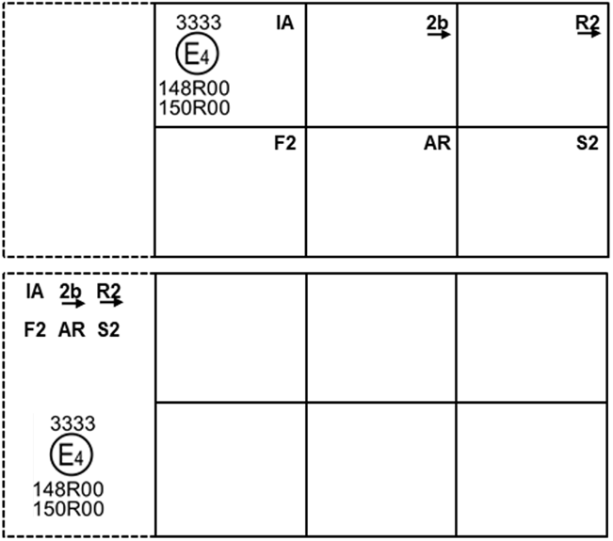

These examples of approval marks represent two possible solutions for the marking of a light signalling lamp where two or more lamps are part of the same assembly of grouped, combined or reciprocally incorporated lamps

They indicate that the lamp was approved in the Netherlands (E4) under approval number 3333 and comprises:

(a) A retro-reflector of class IA;

(b) A rear direction indicator lamp with variable luminous intensity (category 2b). The horizontal arrow shows in what position this device, which cannot be mounted on either side of the vehicle indiscriminately, is to be mounted;

(c) A rear position lamp with variable luminous intensity (R2). The horizontal arrow indicates the side on which the required photometric specifications are met up to an angle of 80° H;

(d) A rear fog lamp with variable luminous intensity (F2);

(e) A reversing lamp (AR);

(f) A stop lamp with variable luminous intensity (S2).

All these lamps (functions) are approved in accordance with the original series of amendments to this Regulation (148R) and to UN Regulation No. 150 (150R) as indicated by the number (00) mentioned after 148R and 150R respectively.”

*Figure A7-IV,* amend to read:

“Figure A7-IV

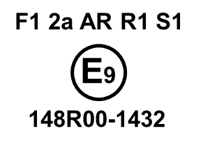

This example corresponds to the marking of a lens intended to be used in different types of light signalling lamps. The approval marks indicate that the lamp was approved in Spain (E9) under approval number 1432 and may comprise all listed different functions.

The main body of the lamp shall bear the only valid approval mark.”

1. \* In accordance with the programme of work of the Inland Transport Committee for 2022 as outlined in proposed programme budget for 2022 (A/76/6 (part V sect. 20) para 20.76), the World Forum will develop, harmonize and update UN Regulations in order to enhance the performance of vehicles. The present document is submitted in conformity with that mandate. [↑](#footnote-ref-2)