E/ECE/324/Rev.2/Add.112/Rev.4/Amend.4−E/ECE/TRANS/505/Rev.2/Add.112/Rev.4/Amend.4
10 December 2021
Agreement
Concerning the Adoption of Harmonized Technical United Nations Regulations for Wheeled Vehicles, Equipment and Parts which can be Fitted and/or be Used on Wheeled Vehicles and the Conditions for Reciprocal Recognition of Approvals Granted on the Basis of these United Nations Regulations*
(Revision 3, including the amendments which entered into force on 14 September 2017)
_________
Addendum 112 – UN Regulation No. 113
Revision 4 – Amendment 4
Supplement 2 to the 03 series of amendments – Date of entry into force: 30 September 2021
Uniform provisions concerning the approval of motor vehicle headlamps emitting a symmetrical passing-beam or a driving-beam or both and equipped with filament, gas-discharge light sources or LED modules
This document is meant purely as documentation tool. The authentic and legal binding text is: ECE/TRANS/WP.29/2021/42
_________
UNITED NATIONS

Annex 3
Figure C, amend to read:

"Figure C
Passing beam test points and zones for Class B headlamp(s):
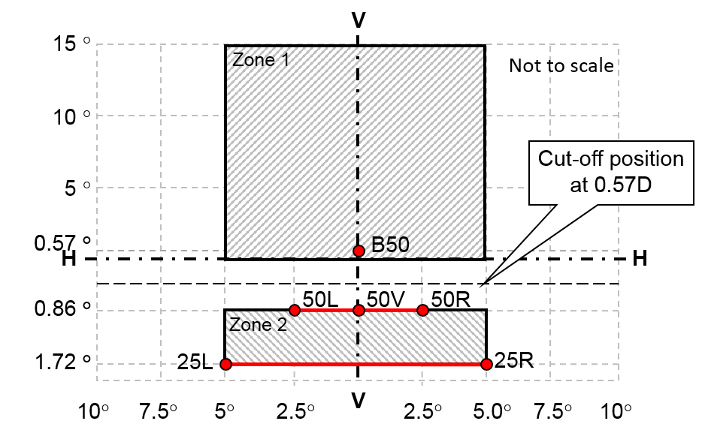
…"

* Former titles of the Agreement: Agreement concerning the Adoption of Uniform Conditions of Approval and Reciprocal Recognition of Approval for Motor Vehicle Equipment and Parts, done at Geneva on 20 March 1958 (original version); Agreement concerning the Adoption of Uniform Technical Prescriptions for Wheeled Vehicles, Equipment and Parts which can be Fitted and/or be Used on Wheeled Vehicles and the Conditions for Reciprocal Recognition of Approvals Granted on the Basis of these Prescriptions, done at Geneva on 5 October 1995 (Revision 2).

