Proposal for the 11 series of amendments to UN Regulation No. 17 (Strength of seats)
Submitted by the expert from the Norway
The modifications related to Annex 9 of the UN Regulation are marked in bold for new characters. The change is adding a paragraph 2.1.1.8 and change in the illustration and text in Figure 1 under the same paragraph.

I. Proposal
Annex 9
Test procedure for devices intended to protect the occupants against displacement of luggage
1. Test blocks
Rigid blocks, with the centre of inertia in the geometric centre.
Type 1
Dimensions: 300 mm x 300 mm x 300 mm
All edges and corners rounded to 20 mm
Mass: 18 kg
Moment of inertia 0.3 ± 0.05 kgm² (around all 3 principal axis of inertia of the luggage blocks)
Type 2
Dimensions: 500 mm x 350 mm x 125 mm
all edges and corners rounded to 20 mm
Mass: 10 kg
2. Test preparation
2.1. Test of seat-backs (see Figure 1)
2.1.1. General requirements
2.1.1.1. At the option of the car manufacturer, parts whose hardness is lower than 50 Shore A can be removed from the tested seat and head restraint for the tests.
2.1.1.2. Two type 1 test blocks shall be placed on the floor of the luggage compartment. In order to determine the location of the test blocks in the longitudinal direction, they shall first be positioned such that their front side contacts that part of the vehicle which constitutes the forward boundary of the luggage compartment and that their lower side rests on the floor of the luggage compartment. They shall then be moved backwards and parallel to the longitudinal median plane of the vehicle until their geometrical centre has traversed a horizontal distance of 200 mm. If the dimensions of the luggage compartment do not allow a distance of 200 mm and if the rear seats are horizontally adjustable, these seats shall be moved forward to the limit of the adjustment range intended for normal occupant use, or to the position resulting in a distance of 200 mm, whichever is less. In other cases, the test blocks shall be placed as far as possible behind the rear seats. The distance between the longitudinal median plane of the vehicle and the inward facing side of each test block shall be 25 mm to obtain a distance of 50 mm between both blocks.
2.1.1.3. During the test, the seats shall be adjusted to ensure that the locking system cannot be released by external factors. If applicable, the seats shall be adjusted as follows:
The longitudinal adjustment shall be secured one notch or 10 mm in front of the rearmost possible position of use specified by the manufacturer (for seats with independent vertical adjustment, the cushion shall be placed to its lowest possible position). The test shall be carried out with the seat-backs in their normal position of use.
2.1.1.4. If the seat-back is fitted with a head restraint, the test shall be carried out with the head restraint placed in the highest position, if adjustable.
2.1.1.5. If the back(s) of the rear seat(s) can be folded down, they shall be secured in their upright normal position by the standard locking mechanism.
2.1.1.6. Seats behind which the type 1 blocks cannot be installed are exempted from this test
2.1.1.7. All seating positions of the seat row under test shall be fitted with all components of its safety-belt providing the restraining function that are part of the seat.
2.1.1.8. For seat(s) with integrated upper seat belt anchorage point, a 50th percentile male dummy shall be placed in rear seat(s) fitted with all components of its safety-belt. The dummy does not have to be instrumented. Other suitable test-manikins with equal mass can be used after agreement between the Technical Service/Type Approval Authorities and the manufacturer. (see Figure 1)

Figure 1

Positions of test blocks and dummies before test of rear seat-backs
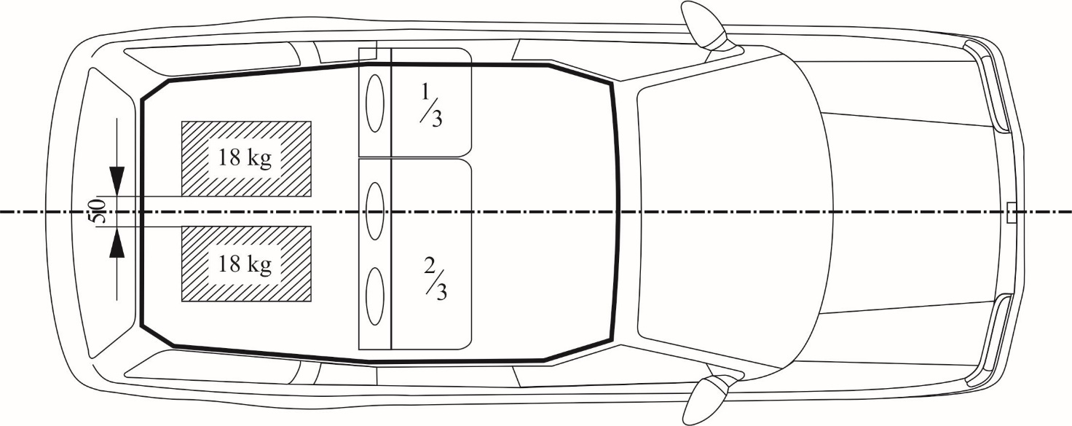
t
t
t
2.1.2. Vehicles with more than two rows of seats
2.1.2.1. If the rearmost row of seats is removable and/or can be folded down by the user according to the manufacturer's instructions in order to increase the luggage compartment area, then the seat row immediately in front of this rearmost row shall also be tested.
2.1.2.2. However, in this case, the Technical Service, after consultation with the manufacturer, may decide not to test one of the two rearmost rows of seats if the seats and their attachments are of similar design and if the test requirement of 200 mm is respected.
2.1.3. When there is a gap, allowing sliding of one type 1 block past the seats, then the test loads (two type 1 blocks) shall be installed behind the seats after agreement between the Technical Service and the manufacturer.
2.1.4. The exact test configuration shall be noted in the test report.
2.2. Test of partitioning systems
For the test of the partitioning systems above the seat-backs, the vehicle shall be fitted with a fixed raised test floor having a load surface that locates the centre of gravity of the test block centrally between the top edge of the bordering seat-back (without taking into account the head restraints) and the bottom edge of the roof lining. A type 2 test block is placed on the raised test floor with its largest surface 500 x 350 mm, centrally in relation to the longitudinal axis of the vehicle and with its surface 500 x 125 mm to the front. Partitioning systems behind which the type 2 test block cannot be installed are exempted from this test. The test block is placed directly in contact with the partitioning system. In addition, two type 1 test blocks are positioned in accordance with paragraph 2.1. in order to perform a simultaneous test on the seat-backs (see Figure 2).

Figure 2

Testing of a partitioning system above the backrest
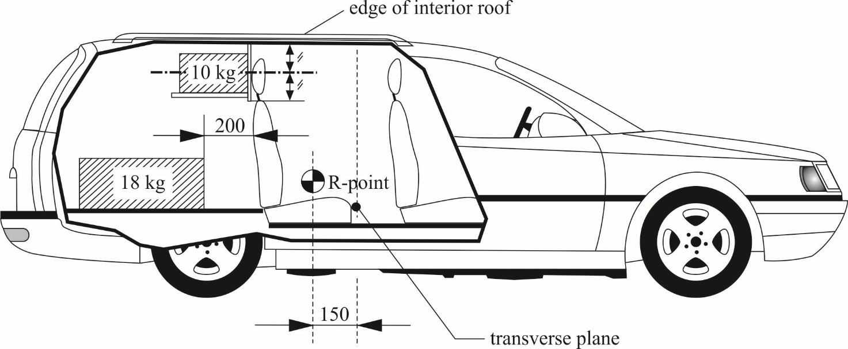
2.2.1. If the seat-back is fitted with a head restraint, the test shall be carried out with the head restraint placed in the highest position, if adjustable.
3. Dynamic testing of seat-backs and partitioning systems used as luggage restraint systems
3.1. The body of the passenger car shall be anchored securely to a test sled, and this anchorage shall not act as reinforcement for seat-backs and the partitioning system. After the installation of the test blocks as described in paragraph 2.1. or 2.2., the passenger car body shall be decelerated or, at the choice of the applicant, accelerated such that the curve remains within the area of the graph in Annex 9, Appendix, and the total velocity change ΔV is 50 +0/-2 km/h. With the agreement of the manufacturer, the above described test pulse corridor can be used alternatively to fulfil the test of the seat strength according to paragraph 6.3.1. of this Regulation.

II. Justification
- Investigations of field collisions have shown that protection of the passenger(s) positioned in the rear seat(s) might be reduced by forces from moving luggage. Especially divided seat-backs with integrated upper seat belt anchorage point indicate some weakness.
- In order to prove that the seat back also will pass the test with occupants placed in the seat, the dynamic test should be up-dated by placing a test-manikin in all rear seats with integrated upper seat belt anchorage point, simulating the load of an occupant in such seats.
- Other test requirements will not be changed.
- We propose the change of the test se-up to be implemented in a new series of amendments with appropriate transitional provisions (TBD)
- Referring to the documents: GRSP-69-02, GRSP-69-06

