Amendments to ECE/TRANS/WP.29/GRSP/2021/28
(UN Regulation No. 127
Submitted by the expert from OICA
The text reproduced below was prepared by the expert from OICA as a revision of informal document GRSP-70-13 from the expert of the European Commission.
The modifications to working document ECE/TRANS/WP.29/GRSP/2021/28 are marked in bold for new or strikethrough for deleted characters.
I. Proposal for the 03 series of amendments to UN Regulation No. 127 (Pedestrian Safety)
Paragraph 2.1., amend to read:
"2.1. …
(b) At the rear, by a WAD [2,500] or a line 82.5 mm forward of the bonnet rear reference line, whichever is most forward at a given lateral position, and
…"
Paragraph 2.43., amend to read:
"2.43. "Wrap Around Distance (WAD)" means … The vehicle is positioned in the normal ride attitude.
This procedure shall be followed, using alternative tapes of appropriate lengths, to describe wrap around distances of 1,000 mm (WAD1000), of 1,700 mm (WAD1700) and of 2,100 mm 2,500 mm (WAD21002500)¹.

Paragraph 2.44., amend to read
"2.44. "Windscreen test area" is an area on the outer surface of the windscreen. It is bound:
(a) In the front, … of the windscreen material.
(b) In the rear, … at a given lateral position.
(c) At each side, … from the side visible edge of the windscreen material.
For (a) and (c): the distances of 100 mm are to be measured with a flexible tape held tautly along the outer surface of the vehicle at an angle of 90° to the tangent line to the opaque obscuration limit or in case of absence of the opaque obscuration, from the visible edge respectively.
For (b): the distances of 130 mm is to be measured with a flexible tape held tautly along the outer surface of the vehicle at an angle of 90 ° to the tangent line to the rear visible edge of the windscreen.
Tests assigned to … with the adult headform impactor.

Paragraph 2.45., amend to read:
"2.45. …
(b) At the rear, by a WAD [2,500] or the front of the windscreen test area, whichever is most forward at a given lateral position.
…"

Paragraph 4.2., amend to read

"4.2. … at present 02 03 corresponding to the 02 03 series of amendments ..."

Insert new paragraphs 11.5 to 11.13., to read:
"11.5 …
…
11.9. Until 1 September 2028, Contracting Parties applying this Regulation shall continue to grant type approvals using the test proceedings related to atypical windscreen fracture behaviour (see Annex 5 paragraphs 4.8. and 5.8.) and specific provisions related to WAD 2,100 boundary (see paragraphs 2.1. and 2.45.).
11.10 Until 1 September 2029, Contracting Parties applying this Regulation shall continue to accept type approvals issued using the specific provisions related to WAD 2,100 boundary (see paragraphs 2.1. and 2.45.)
11.11. As from 1 September 2029, Contracting Parties applying this Regulation shall not be obliged to accept type approvals issued for a vehicle with a WAD 2,100 boundary on the bonnet top (see paragraphs 2.1. and 2.45.)
11.12. Contracting Parties applying this Regulation may grant type approvals according to any preceding series of amendments to this Regulation.
11.13 Contracting Parties applying this Regulation shall continue to grant extensions of existing approvals to any preceding series of amendments to this Regulation"

Annex 1, Part 2, item 16.1., amend to read:
"16.1. Cowl Monitoring area:
point | WAD | Y-coordinate | Impact speed | HIC value
1.
2.
…

WAD 2,100 boundary in accordance with paragraphs 11.9 to 11.11: applicable / not applicable

Annex 2, amend to read:
"Arrangements of approval marks
(See paragraphs 4.4. to 4.4.2. of this Regulation)
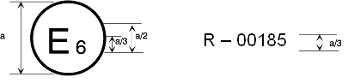
127R - 03185
a = 8 mm min
The above approval mark affixed to a vehicle shows that the vehicle type concerned has been approved in Belgium (E 6) with regard to its pedestrian safety performance pursuant to UN Regulation No. 127. The first two digits of the approval number indicate that the approval was granted in accordance with the requirements of UN Regulation No. 127 as amended by the 02 03 series of amendments."

Annex 5, Figure 5., replace by:
"Figure 5
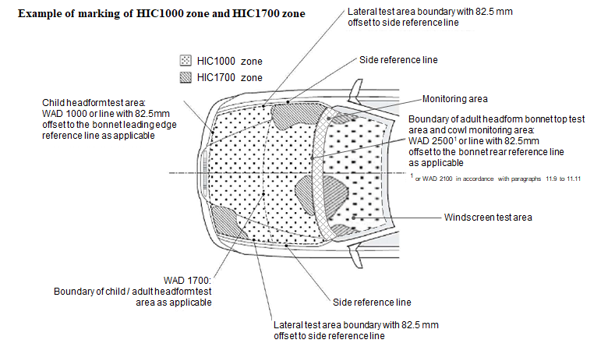

II. Justification
1. The position of the Member States of the European Union has been coordinated in the Member State Expert Group of 18 November 2021. This document reflects the outcome, including some further suggestions proposed by OICA.
2. In paragraph 2.1. the square brackets are removed. The footnote is updated to include 11.9. to 11.11.
3. In paragraph 2.43. WAD 2100 is replaced by WAD 2500
4. In paragraph 2.44. editorial corrections to improve clarity of the definition.
5. In paragraph 2.45. the square brackets are removed. The footnote is updated to include 11.9. to 11.11. and editorial correction
6. In paragraph 4.2. updating 02 series to 03 series.
7. In paragraph 11.9. the square brackets are removed. Some rewording to clarify that until 1 September 2028, type approval procedures shall use the test proceedings and specific provisions foreseen in the requirements (paragraphs 2.1, 2.45 and Annex 5, paragraphs 4.8 and 5.8)
8. Paragraphs 11.10 and 11.11. introduce a sunset clause for existing types, as requested by the Member States, for type approvals issued using the specific provisions related to WAD 2,100 boundary

9. Paragraphs 11.12 and 11.13: these are verbatim the standard provisions contained in the general guidelines ECE/TRANS/WP.29/1044/Rev.3, clarifying the right to grant type approval to any preceding series and the obligation to grant extensions of existing approvals to any preceding series.

or WAD 2,100 in accordance with paragraphs 11.9 to 11.11.
from WAD 2,100 front boundary, if applicable, in accordance with paragraphs 11.9 to 11.11.
Coordinate system as defined by appendix 2 to Annex 1 of the Consolidated Resolution on the Construction of Vehicles (R.E.3).

