This document aims at proposing updated Requirement to Annex 13 (Low Temperature Test Procedure) of Amendment 6 to UN GTR No. 15, as explained in GRPE-85-22.
The modifications to the current text of the UN GTR are marked in track changes.

(...)

5. General requirements
(…)
5.14. Low temperature family definition (if applicable)
Only vehicles that are identical with respect to the technical criteria in paragraph 5.14.1. or 5.14.2. (as applicable) may be part of the same Type 6 family.
5.14.1. Low temperature family for Pure ICE, NOVC-HEVs and OVC-HEVs
5.14.1.1. Powertrain (e.g. ICE, NOVC-HEV, OVC-HEV)
5.14.1.2. Type(s) of fuel(s) (e.g. petrol, diesel, LPG, NG, …). Bi-fuelled or flex-fuelled vehicles may be grouped with other vehicles, with which they have one of the fuels in common.
5.14.1.3. Combustion process (e.g., four stroke)
5.14.1.4. Number of cylinders
5.14.1.5. Configuration of the cylinder block (e.g. in-line, V, radial, horizontally opposed)
5.14.1.6. Engine displacement
The vehicle manufacturer shall specify a value V_{_eng_max} (= maximum engine displacement of all vehicles within the Type 6 family). The engine displacement of vehicles in the Type 6 family shall not deviate more than – 22 % from V_{_eng_max} if V_{_eng_max} ≥ 1 500 ccm and – 32 % from V_{_eng_max} if V_eng_max < 1 500 ccm.
5.14.1.7. Method of engine fuelling (e.g. indirect or direct or combined injection)
5.14.1.8. Type of cooling system (e.g. air, water, oil)
5.14.1.9. Method of aspiration such as naturally aspirated, pressure charged, type of pressure charger (e.g. externally driven, single or multiple turbo, variable geometries)
5.14.1.10. Types and sequence of exhaust after-treatment components (e.g. three- way catalyst, oxidation catalyst, lean NOx trap, SCR, lean NOx catalyst, particulate trap).
5.14.1.11. Exhaust gas recirculation (with or without, internal/external, cooled/non- cooled, low/high combined pressure)
5.14.1.12. An interpolation family may only be included in a Type 6 family where the power to mass ratio of VH and VL are between the value PMRL and PMRH. declared for the Type 6 family according to paragraph 2.6.2.3.2.2. of Annex 13.
5.14.2. Low temperature family for PEVs
Only vehicles which are identical with respect to all the following characteristics are permitted to be part of the same low temperature Family:
(a) Type of traction REESS (type of cell, type of coolant (air, liquid));
(b) Battery management system (BMS);
(c) Pre-heating of the REESS;
(d) Interior heating system;
(e) REESS insulation.
(...)
Annex 13
WLTP Low Temperature Type 6 test (optional annex)
1. Introduction
This annex describes the procedure for undertaking the Type 6 test defined in paragraph 6.2.4. of this UN GTR.
Fuel cell hybrid vehicles are exempted from the Type 6 test.
At the option of the Contracting Party this annex may be omitted.
2. Type 6 test requirements
The Type 6 shall be undertaken according to the definitions, requirements and tests set out in paragraphs 3 to 7 of this UN GTR. Application and amendments to the requirements of Annexes 1 to 8 inclusive of this UN GTR are specified in paragraphs 2.1. to 2.8. of this annex.
2.1. Worldwide light-duty test cycles (WLTC)
The requirements of Annex 1 shall apply for the purposes of this annex.
2.2. Gear selection and shift point determination for vehicles equipped with manual transmissions
The shifting procedures described in Annex 2 shall apply with the following specific provision for Type 6 testing.
It is allowed to set nmin_drive and ASM values which are different than those used for Type 1 testing.
2.3. Reference Fuels
The reference fuels to be used for the Type 6 test shall be those specified in Part II of Annex 3, or Part I if a reference fuel is not provided in Part II. At the option of the manufacturer and approval of the responsible authority a reference fuel as specified in Part I of Annex 3 may be used.
2.3.1. For vehicles powered by NG/biomethane, one of the reference fuels specified in Table A3/9 and Table A3/11 of Part I of Annex 3 shall be selected for Type 6 testing.
2.4. Road load and dynamometer setting
For the vehicle to be tested, the chassis dynamometer load setting determined according to paragraph 8.1.4. or paragraph 8.2.3.3. of Annex 4 using the tyres which are fitted to the Type 6 test vehicle, shall be modified as follows:
2.4.1. The chassis dynamometer setting A*_{d} and B*_{d} shall be the same as those determined for the test at 23 °C, as specified in paragraphs 8.1.4. or 8.2.3.3. of Annex 4. The chassis dynamometer coefficient C*_{d-Tlow} shall be adapted in accordance with the following equation:
C*_{d}-_{Tlow} = C*_{d} + (f₂-_{Tlow} – f₂)
and
f₂-_{TLow} = f₂ * (T₀ + 273)/(T_{low} + 273)
Where:
C*_{d} is the dynamometer coefficient for the vehicle derived at 23 °C
f₂ is the second order road load coefficient, at reference conditions, N/(km/h)²;
T₀ is the road load reference temperature as specified in paragraph 3.2.10. of this UN GTR, C,
T_{low} is the Type 6 temperature, -7 °C.
To perform this adaptation, the same set of tyres shall be fitted to the test vehicle for the setting of the chassis dynamometer at 23 °C as used for the setting of the chassis dynamometer at the temperature -7 °C.
2.4.2. At the request of the manufacturer and approval of the responsible authority the chassis dynamometer coefficient A*_{d}, B*_{d} and C*_{d} from a chassis dynamometer in a different test cell at 23 °C may be used as a basis for the setting of the chassis dynamometer at the temperature of -7 °C, as specified in paragraph 2.4.1.
This shall only be allowed if the manufacturer has demonstrated equivalency between the respective chassis dynamometers and if parasitic losses between the respective chassis dynamometers have been taken into account (e.g. if they are compensated by the dynamometer control system). The equivalency shall be demonstrated on the same vehicle and under the same test conditions within an accuracy of +/-10 N on all reference speed points. This demonstration shall be repeated after major maintenance on either of the chassis dynamometers.
2.4.3. The Type 6 test and its road load setting shall be performed on a 2WD dynamometer in the case that the corresponding Type 1 test was done on a 2WD dynamometer and it shall be performed on a 4WD dynamometer in the case that the corresponding Type 1 test was done on a 4WD dynamometer.
2.4.3.1. Prior to any vehicle operation on a dynamometer in the context of this annex, the tyre pressure shall be adjusted to the same pressure as applied for the setting of the chassis dynamometer at 23 °C.
2.5. Test Equipment
The specifications for test equipment as set out in Annex 5 paragraphs 1. to 3.2.6. and from paragraphs 3.3.3. to 7.4.2.3.1. shall apply for the purposes of this annex. In addition, paragraphs 2.5.1 to 2.5.2.2. of this annex shall apply.
2.5.1. Connection to vehicle exhaust
2.5.1.1. The start of the connecting tube is the exit of the tailpipe. The end of the connecting tube is the sample point, or first point of dilution. For multiple tailpipe configurations where all the tailpipes are combined, the start of the connecting tube shall be taken at the last joint of where all the tailpipes are combined. In this case, the tube between the exit of the tailpipe and the start of the connecting tube may or may not be insulated or heated.
2.5.1.2. The connecting tube between the vehicle and dilution system shall be designed so as to minimize heat loss.
2.5.1.3. The connecting tube shall satisfy the following requirements:
(a) Be less than 6.1 metres long with an internal diameter not exceeding 105 mm and shall be heated to 70 °C or higher.
(b) Not cause the static pressure at the exhaust outlets on the vehicle being tested to differ by more than ± 0.75 kPa at 50 km/h, or more than ± 1.25 kPa for the duration of the test from the static pressures recorded when nothing is connected to the vehicle exhaust pipes. The pressure shall be measured in the exhaust outlet or in an extension having the same diameter and as near as possible to the end of the tailpipe. Sampling systems capable of maintaining the static pressure to within ± 0.25 kPa may be used if a written request from a manufacturer to the responsible authority substantiates the need for the tighter tolerance;
(c) No component of the connecting tube shall be of a material that might affect the gaseous or solid composition of the exhaust gas. To avoid generation of any particles from elastomer connectors, elastomers employed shall be as thermally stable as possible and have minimum exposure to the exhaust gas. It is recommended not to use elastomer connectors to bridge the connection between the vehicle exhaust and the connecting tube.
2.5.2. Dilution air conditioning
2.5.2.1. The dilution air used for the primary dilution of the exhaust in the CVS tunnel shall pass through a medium capable of reducing particles of the most penetrating particle size in the filter material by ≤ 99.95 per cent, or through a filter of at least Class H13 of EN 1822:2009. This represents the specification of High Efficiency Particulate Air (HEPA) filters. The dilution air may optionally be charcoal-scrubbed before being passed to the HEPA filter. It is recommended that an additional coarse particle filter be situated before the HEPA filter and after the charcoal scrubber, if used.
2.5.2.2. At the manufacturer's request, the dilution air may be sampled according to good engineering practice to determine the tunnel contribution to background particulate and, if applicable, particle levels, which can be subsequently subtracted from the values measured in the diluted exhaust (see paragraph 2.1.3. of Annex 6).
In accordance with the principles of CVS sampling and measurement, there shall be no water condensation after the mixing point of the exhaust gas and dilution air within the CVS system and within any systems sampling or measuring from the CVS system. To ensure this, all parts and pipes connecting the mixing device to the CVS when in the cold environment may be insulated and/or heated. This also applies to any part of the CVS which may be in the cold environment.
2.6. Type 6 test procedure and test conditions
The Type 6 test is used to verify the emissions of gaseous compounds, particulate matter, particle number (if applicable), CO₂ mass emission, fuel consumption, electric energy consumption and electric ranges over the applicable WLTP test cycle.
The tests shall be carried out according to the method described in this paragraph and for pure electric and hybrid electric vehicles paragraph 3. of Sub-Annex 1 of this annex. Exhaust gases, particulate matter and particle number (if applicable) shall be sampled and analysed by the prescribed methods.
2.6.1. Description of tests
The test procedures and test conditions specified in paragraphs 1.1.2. to 1.1.2.2.7. of Annex 6 shall apply for the purposes of this annex.
The requirements of paragraphs 1.2. to 1.2.4.2. of Annex 6 shall be replaced with the requirements of paragraphs 2.6.1.1. to 2.6.1.3.2. of this annex.
2.6.1.1. The number of tests shall be determined according to the flowchart in Figure A13/1. The limit value is the maximum allowed value for the respective criteria emission as defined by the Contracting Party.
The flowchart in Figure A13/1 shall be applicable only to the whole applicable WLTP test cycle and not to single phases.
2.6.1.2. The test results shall be the values after the applicable adjustments specified in the post-processing tables in Annex 7, using the steps which are applicable to those adjustments.
2.6.1.3. Determination of total cycle values
2.6.1.3.1. If during any of the tests a criteria emissions limit is exceeded, the vehicle shall be rejected.
2.6.1.3.2. If after the first test all criteria in row 1 of the applicable Table A13/1 are fulfilled, all values shall be accepted as the certification values. If any one of the criteria in row 1 of the applicable Table A13/1 is not fulfilled, a second test shall be performed with the same vehicle.
If after the second test all criteria in row 2 of the applicable Table A13/1 are fulfilled, the arithmetic average results of the two tests shall be calculated and shall be accepted as the certification values.
Table A13/1
Criteria for number of tests
For pure ICE vehicles, NOVC-HEVs and OVC-HEVs charge-sustaining Type 6 test.
 | Test | Judgement parameter | Criteria emission
Row 1 | First test | First test results | ≤ Regulation limit × 0.9
Row 2 | Second test | Arithmetic average of the first and second test results | ≤ Regulation limit × 1.0ª
ª Each test result shall fulfil the regulation limit.
For OVC-HEVs charge-depleting Type 1 test.
 | Test | Judgement parameter | Criteria emissions
Row 1 | First test | First test results | ≤ Regulation limit × 0.9ª
Row 2 | Second test | Arithmetic average of the first and second test results | ≤ Regulation limit × 1.0^{b}
ª "0.9" shall be replaced by “1.0” for charge-depleting Type 1 test for OVC-HEVs, only if the charge-depleting test contains two or more applicable WLTC cycles.
^{b} Each test result shall fulfil the regulation limit.
For PEVs
 | Test | Judgement parameter | Electric energy consumption | PER
Row 1 | First test | First test results | ≤ Declared value × 1.0 | ≥ Declared value × 1.0
Row 2 | Second test | Arithmetic average of the first and second test results | ≤ Declared value × 1.0 | ≥ Declared value × 1.0

Figure A13/1
Flowchart for the number of Type 6 tests
No
First test
Any of criteria emissions > Limit
Yes

All criteria in Table A13/2 within the “first test” row are fulfilled.
No
Yes
Second test
Any of criteria emissions > Limit
Yes

Rejected
Mean of two accepted, depending on judgment result of each value
All emissions accepted
No

2.6.2. Type 6 test
2.6.2.1. Overview
The requirements of paragraph 2.1. of Annex 6 shall apply to the Type 6 test.
2.6.2.2. General test equipment
The requirements of paragraph 2.2. of Annex 6 shall apply to the Type 6 test with the exceptions in the requirements in paragraphs 2.6.2.2.1. to 2.6.2.2.3. of this annex and the addition in paragraph 2.6.2.2.4. of this annex.
2.6.2.2.1. The test cell shall have a temperature set point of -7 °C. The tolerance of the actual value shall be within ± 5 °C. The air temperature shall be measured at the test cell's cooling fan outlet at a minimum frequency of 0.1 Hz.
2.6.2.2.2. Paragraphs 2.2.2.1.2. and 2.2.2.1.3. of Annex 6, shall not apply to the Type 6 test.
2.6.2.2.3. The temperature set point of the soak area, specified in paragraph 2.2.2.2. of Annex 6, shall be -7 °C for the Type 6 test.
2.6.2.2.4. The location of the temperature sensor for the soak area shall be representative to measure the ambient temperature around the vehicle. The sensor shall be at least 10 cm away from the wall of the soak area and shall be shielded from direct air flow. The air flows in the soak area shall be low to avoid unintended forced cooling.
2.6.2.3. Test vehicle
2.6.2.3.1. General
The test vehicle shall conform in all its components with the production series, or, if the vehicle is different from the production series, a full description shall be recorded. In selecting the test vehicle, the manufacturer and the responsible authority shall agree which vehicle model is representative for the Type 6 family.
The vehicle to be tested shall be representative of the family for which the Type 6 data are determined, as described in paragraph 5.14.1. of this UN GTR and paragraph 2.6.3.2.2. of this annex.
2.6.2.3.2. Selection of pure ICE, OVC-HEVs and NOVC-HEVs for Type 6 testing
2.6.2.3.2.1. In the case that a Type 6 family includes bi-fuel or flex-fuel vehicles, at least one of these vehicles shall be selected for Type 6 testing. The selection shall be made in agreement between the manufacturer and the approval authority. The selected vehicle shall be tested on both types of reference fuel.
2.6.2.3.2.2. For every vehicle high (VH) and vehicle low (VL) of the interpolation families in a Type 6 family, the manufacturer shall specify a value PMRH (= highest power-to-mass ratio) and a value PMRL (= lowest power-to-mass ratio).
Here the ‘power-to-mass-ratio’ corresponds to the ratio of the maximum net power of the internal combustion engine as declared by the manufacturer and of the reference mass, where “reference mass” means the mass of the vehicle in running order plus 25 kg.
2.6.2.3.2.2.1. In the case of Type 6 families consisting of ICE or NOVC-HEVs, a vehicle with a power to mass ratio greater than or equal to the highest PMRH and a vehicle with a power to mass ratio less than or equal to the lowest PMRL (if applicable) that are specified according to paragraph 2.6.2.3.2.2. shall be selected for testing and shall be tested with their respective road load settings as applied for the Type 1 test, modified according to the procedure described in paragraph 2.4.2.
2.6.2.3.2.2.2. In the case of a Type 6 family consisting of OVC-HEVs, the manufacturer shall specify at least one vehicle configuration representative for either PMR_{H} or PMR_{L}, whichever is expected to be the worst-case for criteria emissions, and the vehicle configuration with the highest combined energy consumption, i.e. the highest combined cycle energy demand and energy consumption for heating. The selection shall be made in agreement between the manufacturer and the responsible authority.
2.6.2.3.2.3. At least one vehicle for each transmission type (e.g., manual, automatic) installed in vehicles of the Type 6 family shall be selected for testing.
2.6.2.3.2.4. At least one four-wheel drive vehicle (4x4 vehicle) shall be selected for testing if such vehicles are part of the Type 6 family.
2.6.2.3.2.5. For each internal combustion engine displacement of a vehicle within the Type 6 family at least one representative vehicle shall be tested.
2.6.2.3.2.6. Notwithstanding the provisions in paragraphs 2.6.2.3.2.1. to 2.6.2.3.2.5., at least the following number of vehicle emission types of a given Type 6 family shall be selected for testing:
Number of vehicle emission types (N) in a Type 6 family | Minimum number of vehicle emission types (NT) selected for Type 6 testing
1 | 1
from 2 to 4 | 2
from 5 to 7 | 3
from 8 to 10 | 4
from 11 to 49 | NT = 3 + 0.1 x N ⁽¹⁾
more than 49 | NT = 0.15 x N ⁽¹⁾
⁽¹⁾ NT shall be rounded to the next higher integer number.
2.6.2.3.3. Selection of PEVs for Type 6 testing
2.6.2.3.3.1. At least one vehicle which is expected to produce the lowest UBE ratio defined in paragraph 4.4.2.1.3. of sub-annex 1 shall be selected from all vehicle high (VH) of the interpolation families in a low temperature family for PEVs. In order for vehicles to be considered to belong to the same low temperature low temp family for PEVs, the variation in battery capacity shall not exceed 55 per cent of the vehicle with the tested configuration within the family.
The measured UBE ratio of a tested vehicle may be applied without further testing to those different battery capacities of the same low temperature family which fulfil the family criteria defined in paragraph 5.14.2. of this UN GTR.
If the responsible authority determines that the selected vehicle does not fully represent the family, an alternative and/or additional vehicle from other vehicle high (VH) of the interpolation families shall be selected and tested.
2.6.2.3.3.2. At least one vehicle which is expected to produce the lowest ratio (i.e. combination of heater efficiency and cabin volume) for the PER ratio defined in paragraph 4.4.2.1.1. and which is expected to produce the highest EC ratio defined in paragraph 4.3.4.2.1. of sub-annex 1 shall be selected of the interpolation families in a low temperature family for PEVs and tested with road loads of vehicle high (VH) or vehicle low (VL) and dyno settings adjusted as described in paragraph 2.4. of this Annex. The measured EC ratio of a tested vehicle may be extended without further testing to all family members which fulfil the family criteria defined in paragraph 5.14.2. of this UN GTR.
If vehicles within the family include other features which may have a non-negligible influence on the PER and/or EC ratio, these features shall also be identified and considered in the selection of the test vehicle
If the responsible authority determines that the selected vehicle does not fully represent the family, an alternative and/or additional vehicle from other vehicle high (VH) and/or vehicle low (VL) of the interpolation families shall be selected and tested.
2.6.2.3.4. Run-in
The requirements of paragraph 2.3.3. of Annex 6 shall apply to the Type 6 test.
2.6.2.4. Settings
2.6.2.4.1. Dynamometer settings shall be determined according to paragraph 2.4. of this annex.
2.6.2.4.2. Dynamometer operation
2.6.2.4.2.1. The chassis dynamometer shall be warmed up in accordance with the dynamometer manufacturer’s recommendations, or as appropriate, so that the frictional losses of the dynamometer are stabilized. The Type 6 test defined in paragraph 2.6.2.8. shall be started no longer than 30 minutes after:
(a) The completion of dynamometer warm up; or
(b) After an applicable WLTC cycle has been performed by another vehicle on that dynamometer.
2.6.2.4.2.2. If frictional losses of the dynamometer can be stabilized without warming the dynamometer, the test can start following the dynamometer manufacturer’s recommendations. The manufacturer shall provide documentation on the validation of the systems upon request of the responsible authority.
2.6.2.4.3. The requirements of paragraphs 2.6.2.4.3.1. to 2.6.2.4.3.3. inclusive apply to the Type 6 test, all other auxiliary devices shall be switched off or deactivated during dynamometer operation.
2.6.2.4.3.1. Thermal Comfort System setting
The vehicle's interior Thermal Comfort system must be operated by adjusting the comfort setting as indicated in following paragraphs.
From the end of the preconditioning cycle until the end of the Type 6 test defined in paragraph 2.6.2.8. of this annex, the vehicle cabin shall not be heated by any external heating device.
2.6.2.4.3.1.1. The temperature control shall be set to 22 °C within 0-9 seconds after the start of the first applicable WLTC. For vehicles with a thermal comfort system not allowing the selection of 22 °C, maximum heat shall be set within 0-9 seconds after the start of the first applicable WLTC. This setting shall remain unchanged for the whole test procedure.
2.6.2.4.3.1.2. The blower speed control system shall be set to the auto mode within
0-9 seconds after the start of the first applicable WLTC.
If no auto mode is available, the blower speed control system shall be set as follows.
The fan speed control shall be set to the minimum setting, above the setting where the fan is switched off, within 0-9 seconds after the start of the test. After the second 100 and before the second 105 of the test, fan speed shall be set to maximum setting. After the second 987 and before the second 992 of the test, the fan speed shall be reduced to the minimum setting, not being the setting where the fan is switched off.
2.6.2.4.3.1.3. The airflow direction control shall be set to the auto mode within 0-9 seconds after the start of the first applicable WLTC. If no auto mode is available, the airflow direction control shall be set to the feet compartment and to the front windscreen. If that setting is not available, the airflow direction control shall be set to the front windscreen.
2.6.2.4.3.1.4. The air recirculation control shall be set to the auto mode within 0-9 seconds after the start of the first applicable WLTC. If no auto mode is available, it shall be set to the recirculation off position.
2.6.2.4.3.1.5. Air Conditioning control button, if present, shall be pressed to set to ON position within 0-9 seconds after the start of the first applicable WLTC.
2.6.2.4.3.1.6. Multiple-zone systems
For vehicles that have separate (left & right) driver and front passenger controls, all temperature and blower controls shall be set as described in paragraphs 2.6.2.4.3.1.1. and 2.6.2.4.3.1.2. of this annex. Rear Thermal Comfort Systems, if available, shall be set to off position.
2.6.2.4.3.1.7. Assessment of activation of Thermal comfort
The responsible authority shall verify that the thermal comfort system is representative of serial production intent and operating as intended during the test. The responsible authority may request the manufacturer to install a measurement device for the duration of the test at a designated location to record the warm-up profile as evidence for the verification.
2.6.2.4.3.2. Passing-beam (dipped-beam) headlamps shall be switched ON within
0-9 seconds after the start of the test. If the vehicle is equipped with an automatic activation system for dipped-beam headlamps without user selectable settings, actions shall be taken to simulate driving in the hours of darkness (i.e. sufficient to activate at least the dipped beam headlamps). The lights shall remain ON during the test.
2.6.2.4.3.3. If the vehicle is equipped with an electrically heated system(s) to defrost (rear window and/or windscreen), these systems shall be switched on within 0-9 seconds after the start of the first test. If switch off is manually controlled, after the second 987 and before the second 992 of the test, the system shall be switched off.
2.6.2.4.4. The requirements of paragraphs 2.4.2.1.1. to 2.4.7.3. of Annex 6 shall apply to the Type 6 test, with the exception of paragraph 2.4.5. which shall be replaced with the requirements of paragraph 2.4.3.1. of this annex.
2.6.2.5. Preliminary testing cycles
Preliminary testing cycles may be carried out if requested by the manufacturer to follow the speed trace within the prescribed limits but only prior to the soak before preconditioning defined in paragraph 2.6.2.6.1.2. of this annex.
2.6.2.6. Test vehicle preconditioning
2.6.2.6.1. Vehicle preparation
2.6.2.6.1.1. Fuel tank filling
The fuel tank(s) shall be filled with the specified test fuel. If the existing fuel in the fuel tank(s) does not meet the specifications contained in paragraph 2.3. of this annex, the existing fuel shall be drained prior to the fuel fill. The test fuel shall be at a temperature of ≤ 16 ºC. The evaporative emission control system shall neither be abnormally purged nor abnormally loaded.
2.6.2.6.1.2. Soak before preconditioning (precond-soak)
2.6.2.6.1.2.1. Before preconditioning, Pure ICE vehicles shall be kept in an area with ambient conditions as specified in paragraphs 2.6.2.2.3. and 2.6.2.2.4. of this annex for a minimum of 6 hours and a maximum of 36 hours before preconditioning. This time shall be referred as t_{precond-soak}.
At the request of the manufacturer, and with the approval of the responsible authority, the soak before preconditioning may be omitted if the manufacturer can justify that this soak will have negligible effects on the criteria emissions. As an example, the effects on the criteria emissions may be non-negligible in the case that the vehicle has an after-treatment system that uses a reagent.
2.6.2.6.1.2.2. The thermal comfort preconditioning function, if available, shall not be activated during this soak.
2.6.2.6.1.2.3. The soak shall be performed without using a cooling fan and with all body parts positioned as intended under normal parking operation.
2.6.2.6.1.2.4. In case that during the transfer from the soak area to the test cell the vehicle is exposed to a temperature higher than -4 °C, the transfer shall be undertaken as quickly as possible, without any unjustified delay and for no longer than 20 minutes.
2.6.2.6.1.3. REESS charging
The requirements of paragraph 2.6.1.2. of Annex 6 shall apply to the Type 6 test.
2.6.2.6.1.4. Tyre pressures
The tyre pressure of the driving wheels shall be set in accordance with paragraph 2.4.3. of this annex.
2.6.2.6.1.5. Gaseous fuel vehicles
The requirements of paragraph 2.6.1.4. of Annex 6 shall apply to the Type 6 test.
2.6.2.6.2. Test cell
2.6.2.6.2.1. Temperature
During preconditioning, the test cell temperature shall be the same as defined for the Type 6 test (paragraph 2.6.2.2.1. of this annex).
2.6.2.6.2.2. Background measurement
The requirements of paragraph 2.6.2.2. of Annex 6 shall apply to the Type 6 test.
2.6.2.6.3. Procedure
2.6.2.6.3.1. The test vehicle shall be placed on a dynamometer without the engine being started.
2.6.2.6.3.2. The dynamometer load shall be set according to paragraphs 2.4. to this annex. In the case that a dynamometer in 2WD operation is used for testing, the road load setting shall be carried out on a dynamometer in 2WD operation, and in the case that a dynamometer in 4WD operation is used for testing the road load setting shall be carried out on a dynamometer in 4WD operation.

2.6.2.6.3.3. Pure ICE vehicles shall be preconditioned over one WLTC.
2.6.2.6.4. Operating the vehicle
The requirements of paragraph 2.6.4. of Annex 6 shall apply to the Type 6 test, with the exception of paragraph 2.6.4.1.2. which shall be replaced with 2.6.2.6.4.1. of this annex and paragraph 2.6.4.3. which shall not apply.
2.6.2.6.4.1. In the cases where LPG or NG/biomethane is used as a fuel, it is permissible that the engine is started on petrol and switched automatically to LPG or NG/biomethane after a predetermined period of time that cannot be changed by the driver.
It is also permissible to use petrol only or simultaneously with gas when operating in gas mode.
2.6.2.6.5. Use of the transmission
The requirements of paragraph 2.6.5. of Annex 6 with the provisions of paragraph 2.2. of this annex shall apply to the Type 6 test.
2.6.2.6.6. Driver-selectable modes
The requirements of paragraph 2.6.6. of Annex 6 shall apply to the Type 6 test.
2.6.2.6.7. Voiding of the Type 1 test and completion of the cycle
The requirements of paragraph 2.6.7. of Annex 6 shall apply to the Type 6 test.
2.6.2.6.8. Data required, quality control
The requirements of paragraph 2.6.8. of Annex 6 shall apply to the Type 6 test with the exception of paragraph 2.6.8.3.1.5. which shall not apply.
2.6.2.7. Soaking
2.6.2.7.1. Soak before testing (test-soak)
2.6.2.7.1.1. After preconditioning and before testing, vehicles shall be kept in a soak area with the ambient conditions described in paragraph 2.6.2.2.3. to this annex.
2.6.2.7.1.2. In the case that during the transfer from the preconditioning to the soak area the vehicle is exposed to a temperature higher than -4 °C, the transfer shall be undertaken as quickly as possible, without any unjustified delay and for no longer than 20 minutes.
2.6.2.7.1.3. During soaking the connecting tube, described in paragraph 2.5.1.3. of this annex, shall not be connected to the vehicle.
2.6.2.7.1.4. The thermal comfort preconditioning function, if available, shall not be activated during this soak.
2.6.2.7.1.5. The vehicle shall be soaked for a minimum of 12 hours and a maximum of 36 hours with the engine compartment cover opened or closed. If not excluded by specific provisions for a particular vehicle, cooling may be accomplished by forced cooling down to the set point temperature, -7 °C ± 2 °C, for coolant and oil. If cooling is accelerated by fans, the air shall not be additionally cooled and the fans shall be placed such that the cooling of the drive train, engine and exhaust after-treatment system is achieved in a homogeneous manner.
2.6.2.7.1.6. In the case that during the transfer from the soak area to the test cell the vehicle is exposed to a temperature higher than -4 °C the transfer shall be undertaken as quickly as possible, without any unjustified delay and for no longer than 20 minutes and the vehicle shall be restabilised by holding it at an ambient temperature of -7 °C ± 3 °C for at least six times as long as the vehicle was exposed to the temperature higher than -4 °C .
2.6.2.7.1.7. In the case that forced cooling was applied, once the vehicle reaches the set point temperature, -7 °C ± 2 °C, for coolant and oil, the vehicle shall be cold-soaked within the stabilized temperature for at least one hour before starting the emission test. During this time, the ambient temperature shall be kept at
-7 °C ± 3 °C.
2.6.2.8. Emission and fuel consumption test (Type 6 test)
The requirements of paragraph 2.8. of Annex 6 shall apply to the Type 6 test with the exception of paragraph 2.8.1. which shall be replaced with the requirements of paragraph 2.6.2.8.1. of this annex and paragraphs 2.8.4. and 2.8.5. which shall not apply to the Type 6 test.
2.6.2.8.1. The test cell temperature at the start of the test shall be within ±3 °C of the set point of -7 °C. The engine oil temperature and coolant temperature, if any, shall be within ±2 °C of the set point of -7 °C.
2.6.2.9. Gaseous sampling
The requirements of paragraph 2.9. of Annex 6 shall apply to the Type 6 test.
2.6.2.10. Sampling for PM determination
The requirements of paragraph 2.10. of Annex 6 shall apply to the Type 6 test.
2.6.2.11. PN sampling (if applicable)
The requirements of paragraph 2.11. of Annex 6 shall apply to the Type 6 test.
2.6.2.12. Sampling during the test
The requirements of paragraph 2.12. of Annex 6 shall apply to the Type 6 test.
2.6.2.13. Ending the test
The requirements of paragraph 2.13. of Annex 6 shall apply to the Type 6 test.
2.6.2.14. Post-test procedures
The requirements of paragraph 2.14. of Annex 6 shall apply to the Type 6 test.
2.6.3. Emissions test procedure for all vehicles equipped with periodically regenerating systems
K_{i} values obtained for the Type 1 test according to Appendix 1 to Annex 6 shall be used.
2.6.4. Test procedure for rechargeable electric energy storage system monitoring
The requirements of Appendix 2 to Annex 6 shall not apply to the Type 6 test.
2.6.5. Calculation of gas energy ratio for gaseous fuels (LPG and NG/biomethane)
The requirements of Appendix 3 to Annex 6 shall not apply to the Type 6 test.
2.7. Calculations
The calculations specified in paragraphs 1. to 3.2.2.1.1. and from paragraphs 3.3. to 4. of Annex 7 shall apply for the purposes of this annex, without the calculation or application of the NOx correction factor described in paragraph 1.3.3. of Annex 7.

Annex 13 - Sub-Annex 1
Pure electric and hybrid electric vehicles
1. General requirements
Unless stated otherwise, all requirements in this sub-annex shall apply to vehicles with and without driver-selectable modes. Unless explicitly stated otherwise in this sub-annex, all of the requirements and procedures specified in this annex shall continue to apply for NOVC-HEVs, OVC-HEVs and PEVs.
1.1. Units, accuracy and resolution of electric parameters
Units, accuracy and resolution of measurements shall be as shown in paragraph 1.1. of Annex 8.
1.2. Emission and fuel consumption testing
Parameters, units and accuracy of measurements shall be the same as those required for pure ICE vehicles.
1.3. Rounding of test results
The requirements of paragraph 1.3. of Annex 8 shall apply to the Type 6 test with the exception of the NOx correction factor K_{H}.
1.4. Vehicle classification
The requirements of paragraph 1.4. of Annex 8 shall apply to the Type 6 test.
For the Type 6 test the same applicable cycle shall be applied as for the Type 1 test, with respect to downscaling and capped speed, if applicable.
1.5. OVC-HEVs, NOVC-HEVs and PEVs with manual transmissions
The requirements of paragraph 1.5. of Annex 8 shall apply to the Type 6 test.
2. Run-in of test vehicle
The requirements of paragraph 2. of Annex 8 shall apply to the Type 6 test.
3. Test procedure
3.1. General requirements
The requirements of paragraph 3.1. of Annex 8 shall apply to the Type 6 test with the addition of the requirements of paragraph 3.1.1. of this sub-annex.
3.1.1. Electric current of all REESSs and the electric voltage of all REESSs shall be determined according to Appendix 3 to Annex 8.
3.2. OVC-HEVs
3.2.1. Vehicles shall be tested under charge-depleting operating condition (CD condition), and charge-sustaining operating condition (CS condition)
3.2.2. Vehicles may be tested according to six possible test sequences:
3.2.2.1. Option 1: charge-depleting Type 6 test with no subsequent charge-sustaining Type 6 test.
3.2.2.2. Option 2: charge-sustaining Type 6 test with no subsequent charge-depleting Type 6 test.
3.2.2.3. Option 3: charge-depleting Type 6 test with a subsequent charge-sustaining Type 6 test.
3.2.2.4. Option 4: charge-sustaining Type 6 test with a subsequent charge-depleting Type 6 test.
3.2.2.5. Option 5: charge-sustaining Type 6 test with a subsequent charge-sustaining Type 6 test.
3.2.2.6. Option 6: charge-depleting Type 6 test with a subsequent charge-depleting Type 6 test.

Figure A13.SA1/1

Possible test sequences in the case of OVC-HEV testing
Option 1CD
Set SoC
Prec-Soak (CD)
P/C - Max. 1 WLTC
Break-off
Test-Soak
ChargingE_{AC}
CD Type 6 test
Option 3
CD + CS
Set SoC
Prec-Soak (CD)
P/C - Max. 1 WLTC
Break-off
Test-Soak
Charging
E_{AC}
CD Type 6 test
Prec-Soak (CS) ^{(a)}
P/C - Max. 1 WLTC
Break-off
Option 4
CS + CD
Set SoC
Prec-Soak
(CS) ^{(a)}
P/C - Max. 1 WLTC
Break-off
Test-Soak
CS Type 6 test
Test-Soak
Charging
E_{AC}
CD Type 6 test
Option 2
CS
Set SoC
Prec-Soak (CS)^{(a)}
P/C - Max. 1 WLTC
Break-off
Test-Soak
CS Type 6 test
Option 5
CS + CS
Set SoC
Prec-Soak
(CS) ^{(a)}
P/C - Max. 1 WLTC
Break-off
Test-Soak
CS Type 6 test
Test-Soak
CS Type 6 test
Test-Soak
CS Type 6 test
Option 6
CD + CD
Set SoC
Prec-Soak (CD)
P/C - Max. 1 WLTC
Break-off
Test-Soak
Charging
E_{AC}
CD Type 6 test
Prec-Soak (CD)
P/C - Max. 1 WLTC
Break-off
Test-Soak
Charging
E_{AC}
CD Type 6 test

^{(a)} See paragraph 2.2.1. of Appendix 2 to this sub-annex
3.2.3. The driver-selectable mode shall be set as described in the following test sequences (Option 1 to Option 6).
3.2.4. Charge-depleting Type 6 test with no subsequent charge-sustaining Type 6 test (Option 1)

The test sequence according to Option 1, described in paragraphs 3.2.4.1. to 3.2.4.7. inclusive of this sub-annex, as well as the corresponding REESS state of charge profile, are shown in Figure A13.SA1.App1/1 in Appendix 1 to this sub-annex.
3.2.4.1. Vehicle preparation, preconditioning and soaking procedure
The vehicle shall be prepared, preconditioned and soaked according to paragraph 2. of Appendix 2 to this sub-annex.
3.2.4.2. Test conditions
3.2.4.2.1. The test shall be carried out with a fully charged REESS according to the charging requirements as described in paragraph 5. of Appendix 2 to this sub-annex and with the vehicle operated in charge-depleting operating condition as defined in paragraph 3.3.5. of this UN GTR.
3.2.4.2.2. Selection of a driver-selectable mode
The requirements of paragraph 3.2.4.2.2. of Annex 8 shall apply to the Type 6 test.
3.2.4.2.3. Setting of Auxiliary Devices
The requirements for auxiliary devices shall be those specified in paragraph 2.6.2.4.3. of this annex.
3.2.4.3. Charge-depleting Type 6 test procedure
3.2.4.3.1. The charge-depleting Type 6 test procedure shall start within 1 hour after completion of the test soak as defined in paragraph 2.6. of Appendix 2 to this sub-annex and shall consist of a number of consecutive applicable test cycles, until charge-sustaining operating condition is achieved.
As a manufacturer option, it is allowed to expand the 1 hour requirement.
3.2.4.3.2. There shall not be a break between consecutive test cycles unless there is a justified reason for testing purposes. In that case, the break shall be less than 30 minutes and the interval duration shall be documented in the test report.
3.2.4.3.3. The requirements of paragraph 3.2.4.3.2. of Annex 8 shall apply to the Type 6 test.
3.2.4.3.4. The requirements of paragraph 3.2.4.3.3. of Annex 8 shall apply to the Type 6 test.
3.2.4.4. End of the charge-depleting Type 6 test
The requirements of paragraph 3.2.4.4. of Annex 8 shall apply to the Type 6 test with the exception of the break-off criterion which shall refer to paragraph 3.2.4.5. to this sub-annex.
3.2.4.5. Break-off criterion
The requirements of paragraph 3.2.4.5. of Annex 8 shall apply to the Type 6 test, with the exception that the REEC_{i} shall be less than 0.06 instead of less than 0.04.
3.2.4.6. The requirements of paragraph 3.2.4.6. of Annex 8 shall not apply to the Type 6 test.
3.2.4.7. The requirements of paragraph 3.2.4.7. of Annex 8 shall apply to the Type 6 test.
3.2.5. Charge-sustaining Type 6 test with no subsequent charge-depleting Type 6 test (Option 2)

The test sequence according to Option 2, as described in paragraphs 3.2.5.1. to 3.2.5.3. inclusive of this sub-annex, as well as the corresponding REESS state of charge profile, are shown in Figure A13.SA1.App1/2 in Appendix 1 to this sub-annex.
3.2.5.1. Vehicle preparation, preconditioning and soaking procedure
The vehicle shall be prepared, preconditioned and soaked according to the procedures in paragraph 2. of Appendix 2 to this sub-annex.
3.2.5.2. Test conditions
The requirements of paragraph 3.2.5.2. of Annex 8 shall apply to the Type 6 test with the addition of the requirements of paragraph 3.2.5.2.1. of this sub-annex.
3.2.5.2.1. Setting of Auxiliary Devices
The requirements for auxiliary devices shall be those specified in paragraph 2.6.2.4.3. of this annex.
3.2.5.3. Charge-sustaining Type 6 test procedure
The requirements of paragraph 2.6.2.8. of this Annex and paragraph 3.2.5.3.2. of Annex 8 shall apply to the Type 6 test.
3.2.6. Charge-depleting Type 6 test with a subsequent charge-sustaining Type 6 test (Option 3)

The test sequence according to Option 3, as described in paragraphs 3.2.6.1. to 3.2.6.3. inclusive of this sub-annex, as well as the corresponding REESS state of charge profile, are shown in Figure A13.SA1.App1/3 in Appendix 1 to this sub-annex.
3.2.6.1. For the charge-depleting Type 6 test, the procedure described in paragraph 3.2.4. of this sub-annex shall be followed.
3.2.6.2. Subsequently, the procedure for the charge-sustaining Type 6 test described in paragraph 3.2.5. of this sub-annex shall be followed. Paragraph 2.1. of Appendix 2 to this sub-annex shall not apply.
3.2.7. Charge-sustaining Type 6 test with a subsequent charge-depleting Type 6 test (Option 4)

The test sequence according to Option 4, described in paragraphs 3.2.7.1. and 3.2.7.2. of this sub-annex, as well as the corresponding REESS state of charge profile, are shown in Figure A13.SA1.App1/4 of Appendix 1 to this sub-annex.
3.2.7.1. For the charge-sustaining Type 6 test, the procedure described in paragraph 3.2.5. of this sub-annex shall be followed.
3.2.7.2. Subsequently, the procedure for the charge-depleting Type 6 test described in paragraph 3.2.4. of this sub-annex shall be followed. Paragraphs 2.1. to 2.4. inclusive of Appendix 2 to this sub-annex shall not apply.
3.2.8. Charge-sustaining Type 6 test with a subsequent charge-sustaining Type 6 test (Option 5)

The test sequence according to Option 5, described in paragraphs 3.2.8.1. and 3.2.8.2. of this sub-annex, as well as the corresponding REESS state of charge profile, are shown in Figure A13.SA1.App1/5 of Appendix 1 to this sub-annex.
3.2.8.1. For the first charge-sustaining Type 6 test, the procedure described in paragraph 3.2.5. of this sub-annex shall be followed.
3.2.8.2. Subsequently, the procedure for the charge-sustaining Type 6 test described in paragraph 3.2.5. of this sub-annex shall be followed. Paragraphs 2.1. to 2.4. inclusive of Appendix 2 to this sub-annex shall not apply.
3.2.9. Charge-depleting Type 6 test with a subsequent charge-depleting test (Option 6)

The test sequence according to Option 6, described in paragraphs 3.2.9.1. and 3.2.9.2. of this sub-annex, as well as the corresponding REESS state of charge profile, are shown in Figure A13.SA1.App1/6 of Appendix 1 to this sub-annex.
3.2.9.1. For the first charge-depleting Type 6 test, the procedure described in paragraph 3.2.4. of this sub-annex, shall be followed.
3.2.9.2. Subsequently, the procedure for the charge-depleting Type 6 test described in paragraph 3.2.4. of this sub-annex shall be followed. Paragraph 2.1. of Appendix 2 to this sub-annex shall not apply.
3.3. NOVC-HEVs
The test sequence described in paragraphs 3.3.1. to 3.3.3. inclusive of this sub-annex, as well as the corresponding REESS state of charge profile, are shown in Figure A13.SA1.App1/7 of Appendix 1 to this sub-annex.
3.3.1. Vehicle preparation, preconditioning and soaking procedure
The vehicle shall be prepared, preconditioned and soaked according to the procedures in paragraph 4. of Appendix 2 to this sub-annex.
3.3.2. Test conditions
The requirements of paragraph 3.3.2. of Annex 8 shall apply to the Type 6 test with adding the paragraph 3.3.2.1. of this sub-annex.
3.3.2.1. Setting of Auxiliary Devices
The requirements for auxiliary devices shall be those specified in paragraph 2.6.2.4.3. of this annex.
3.3.3. Type 6 test procedure
The requirements of paragraph 2.6.2.8. of this annex and of paragraph 3.3.3.2. of Annex 8 shall apply to the Type 6 test.
3.4. PEVs
The test sequence for the PEV Type 6 test procedure, as described in paragraphs 3.4.1., 3.4.2. and 3.4.3. of this sub-annex as well as the corresponding REESS state of charge profile, are shown in Figure A13.SA1.App1/8 in Appendix 1 to this sub-annex.
3.4.1. Vehicle preparation, preconditioning and soaking procedure
The vehicle shall be prepared, preconditioned and soaked according to the procedures in paragraph 3. of Appendix 2 to this sub-annex.
3.4.2. Test conditions
3.4.2.1. The test shall be carried out with a fully charged REESS according to the charging requirements as described in paragraph 5. of Appendix 2 to this sub-annex and with the vehicle operated in charge-depleting operating condition as defined in paragraph 3.3.5. of this UN GTR.
3.4.2.2. Selection of a driver-selectable mode
For vehicles equipped with a driver-selectable mode, the mode for the test shall be selected according to paragraph 4. of Appendix 6 to Annex 8.
3.4.2.3. Setting of Auxiliary Devices
The requirements for auxiliary devices shall be those specified in paragraph 2.6.2.4.3. of this annex.
3.4.3. PEV Type 6 Test Procedure
3.4.3.1. The PEV Type 6 test procedure shall start within 1 hour after completion of the test-soak as defined in paragraph 3.6. of Appendix 2 to this sub-annex and shall be performed in accordance with paragraph 3.4.3.3. of this sub-annex,
As a manufacturer option, it is allowed to expand the 1 hour requirement.
3.4.3.2. Break-off criterion
The requirements of paragraph 3.4.4.2.3. of Annex 8 shall apply to the Type 6 test. This criterion shall not be applied when the constant speed segment defined in paragraph 3.4.3.3.2. of this sub-annex is excluded.
3.4.3.3. Speed trace
The PEV Type 6 test procedure consists of one dynamic segment (DS), followed by one constant speed segment (CSS) as shown in Figure A13.SA1/2.

Figure A13.SA1/2
PEV Type 6 test procedure speed trace
3.4.3.3.1. Dynamic segment
The dynamic segment consists of (3) applicable WLTP test cycles (WLTC) in accordance with paragraph 1.4.2.1. of Annex 8.
3.4.3.3.2. Constant speed segment
The constant speed shall be the same speed as that of the Type 1 test according to paragraph 3.4.4.2.1.2. (a) of Annex 8.
The constant speed segment shall be excluded when not required by PEV calculation schemes in chapter 4 of this sub-annex.
3.4.3.3.3. Breaks
Breaks for the driver and/or operator are permitted in accordance with paragraph 3.4.4.2.1.3. of Annex 8 but limited to constant speed segment CSS. Each break shall not be more than 5 minutes.
4. Calculations for hybrid electric and pure electric vehicles.
4.1. Calculations of gaseous emission compounds, particulate matter emission and particle number emission
4.1.1. Charge-sustaining mass emission of gaseous emission compounds, particulate matter emission and particle number emission for OVC-HEVs and NOVC-HEVs
The requirements of paragraph 4.1.1. of Annex 8 shall apply to the Type 6 test with adding the following. The charge-sustaining gaseous emission compounds shall be calculated according to paragraph 3. to 3.2.2. of Annex 7.
4.1.1.1. Vehicles equipped with periodically regenerating systems
Gaseous emission compounds and particulate matter emission shall be corrected by applying the additive offset or multiplicative factor according to Appendix 1 to Annex 6
4.1.1.2. In the case that the correction according to paragraph 1.1.4. of Appendix 2 to Annex 8 was not applied.
The requirements of paragraph 4.1.1.2. of Annex 8 shall apply to the Type 6 test.
4.1.1.3. In the case that the correction according to paragraph 1.1.4. of Appendix 2 to Annex 8 was applied.
The requirements of paragraph 4.1.1.3. of Annex 8 shall apply to the Type 6 test.
4.1.2. Charge-depleting CO₂ mass emission for OVC-HEVs
The requirements of paragraph 4.1.2. of Annex 8 shall apply to the Type 6 test
4.2. Calculation of fuel consumption and fuel efficiency
4.2.1. Charge-sustaining fuel consumption and fuel efficiency for OVC-HEVs and NOVC-HEVs shall be calculated according to paragraph 6. of Annex 7.
4.2.2. The charge-depleting fuel consumption for OVC-HEVs shall be calculated according to paragraph 4.2.2. of Annex 8.
4.3. Calculation of electric energy consumption
For determination of electric energy consumption based on the current and voltage determined according to Appendix 3 to Annex 8, the requirement of paragraph 4.3. of Annex 8 shall apply to the Type 6 test.
4.3.1. [Reserved ]
4.3.2. [Reserved ]
4.3.3. Electric energy consumption for OVC-HEVs
4.3.3.1. Determination of cycle-specific electric energy consumption
The requirements of paragraph 4.3.3.1. of Annex 8 shall apply to the Type 6 test
4.3.4. Electric energy consumption of PEVs
4.3.4.1. The requirements of paragraph 4.3.4.1. of Annex 8 shall apply to the Type 6 test
4.3.4.2. Electric energy consumption determination of the applicable WLTP test cycle

The electric energy consumption for the applicable WLTP test cycle EC_{WLTC@Type6} shall be calculated from the PEV Type 6 test procedure as described in paragraph 3.4.3. of this sub-annex, excluding the constant speed segment when UBE measurement not required, using the following equation:
ECWLTC@Type6=EAC@Type 6PERWLTC@Type6

where:
ECWLTC@Type6 is the electric energy consumption of the applicable WLTP test cycle at type 6 conditions based on the recharged electric energy from the mains and the pure electric range for the applicable WLTP test cycle, Wh/km;
EAC@Type6 is the recharged electric energy from the mains according to paragraph 3.6. of Appendix 2 to this sub-annex, Wh;
PERWLTC@Type6 is the pure electric range for the applicable WLTP test cycle as calculated according to paragraph 4.4.2.1. of this annex, km.
4.3.4.2.1. For individual vehicles within same low temperature family
The following ratio shall be calculated and applied to the final test result determined in step 10 of Table A8/10 to Annex 8 in the case of the consecutive cycle Type 1 test procedure or determined in step 9 of TableA8/11 to Annex 8 in the case of the shortened Type 1 test procedure for individual vehicle Type 6 results.
EC_{WLTC,ind@Type6} = K_{EC,WLTC} * EC_{WLTC,ind}
where:
EC_{WLTC,ind} is the interpolated electric energy consumption for individual vehicles according to step 10 of Table A8/10 of Annex 8 in the case of the consecutive cycle Type 1 test procedure or according to step 9 according to Table A8/11 of Annex 8 in the case of the shortened Type 1 test procedure, in km;
K_{EC,WLTC} is the low temperature electric energy consumption ratio;
and K_{EC,WLTC} = EC_{WLTC@Type6} / EC_{WLTC@Type1}
where:
EC_{WLTC@Type1} is the electric energy consumption determined according to step 10 of Table A8/10 to Annex 8 in the case of the consecutive cycle Type 1 test procedure or according to step 9 of TableA8/11 to Annex 8 in the case of the Shortened Type 1 Test Procedure, Wh/km
EC_{WLTC@Type6} is the electric energy consumption determined according to paragraph 4.3.4.2. of this sub annex, Wh/km
4.3.4.2.2. In the case that additional test was performed within the same low temperature family
Separate K_{EC,WLTC} shall be determined according to paragraph 4.3.4.2.1. of this sub annex and applied to only the same interpolation family.
In the case that multiple K_{EC,WLTC} are available in the same low temperature family, the lowest K_{EC,WLTC} shall be used.
4.4. Calculation of electric ranges
4.4.1. [Reserved]
4.4.2. Pure Electric Range (PER)
The ranges determined in this paragraph shall only be calculated if the vehicle was able to follow the applicable WLTP test cycle within the speed trace tolerances according to paragraph 2.6.8.3.1.2. of Annex 6 during the entire considered period.
4.4.2.1. The pure electric range for the applicable WLTP test cycle PER for PEVs shall be calculated from the PEV Type 6 test procedure as described in paragraph 3.4.3. of this sub- annex using the following equations:
PERWLTC@Type6=UBE@Type6ECDC,WLTC@Type6
where:
PER_{WLTC@Type6} is the pure electric range at low temperature for the applicable WLTC test cycle for PEVs, km;
As a manufacturer option, PER_{WLTC@Type6} may be decreased.
UBE_{@Type6} is the usable REESS energy at low temperature determined from the beginning of the PEV Type 6 test procedure until the break-off criterion as defined in paragraph 3.4.3.2. of this sub-annex is reached, Wh; if UBE_{@Type6} has been determined for one representative vehicle of the PEV low temperature family, the UBE determination according to the procedure described in paragraph 3.4.3. of this sub-annex shall be skipped for all further different nominal capacities REESS within the same PEV low temperature family. Instead of the measurement, UBE_{@Type6} for different nominal capacity REESS within the same PEV low temperature family shall be determined by applying the UBE ratio, calculated according to paragraph 4.4.2.1.3. of this Sub-Annex, by using the following equation:
UBE_{@type6} = K_{UBE} *UBE_{@type1}
where:
K_{UBE} is is the low temperature UBE ratio determined according to paragraph 4.4.2.1.3. of this Sub-Annex;
UBE_{@Type1} is any nominal capacity REESS – different to the already measured one - within the same PEV low temperature family, Wh.

EC_{DC,WLTC@Type6} is the weighted electric energy consumption at low temperature for the applicable WLTP test cycle of DS of the PEV Type 6 test procedure Type 6 test, Wh/km; if UBE_{@Type6} for a vehicle has been determined with UBE ratio, the constant speed segment (CSS) shall be excluded from the PEV Type 6 test procedure as not required for EC_{DC,WLTC@type6} determination.
and

UBE@Type6=∆EREESS,WLTC1+∆EREESS,WLTC2+∆EREESS,WLTC3+∆EREESS,CSS

where:
${∆E}_{{REESS,WLTC}_{1}}$ is the electric energy change of all REESSs during WLTC₁ of the PEV Type 6 test procedure, Wh;
${∆E}_{{REESS,WLTC}_{2}}$ is the electric energy change of all REESSs during WLTC₂ of the PEV Type 6 test procedure, Wh;
${∆E}_{{REESS,WLTC}_{3}}$ is the electric energy change of all REESSs during WLTC₃ of the PEV Type 6 test procedure, Wh;
${∆E}_{REESS,CSS}$ is the electric energy change of all REESSs during CSS of the PEV Type 6 test procedure, Wh;
and
$${EC}_{DC,WLTC}= \sum_{j=1}^{3}{{EC}_{DC,WLTC, j}} x K_{WLTC, j}$$
where:
${EC}_{DC,WLTC}$ is the electric energy consumption for the applicable WLTP test cycle of the PEV Type 6 test procedure according to paragraph 4.3 of Annex 8, Wh/km;
$K_{WLTC,j}$ is the weighting factor for the applicable WLTP test cycle of DS of the PEV Type 6 test procedure;
and:
$$K_{WLTC,1}=\frac{{∆E}_{REESS,WLTC,1}}{UBE} ; K_{WLTC,2}=\frac{{∆E}_{REESS,WLTC,2}}{UBE}$$
$$K_{WLTC,3}=1-K_{WLTC,1}-K_{WLTC,2}$$
where:
$K_{WLTC,1}$ is the weighting factor for the applicable 1st WLTP test cycle of DS of the PEV Type 6 test procedure;
$K_{WLTC,2}$ is the weighting factor for the applicable 2nd WLTP test cycle of DS of the PEV Type 6 test procedure;
$K_{WLTC,3}$ is the weighting factor for the applicable 3rd WLTP test cycle of DS of the PEV Type 6 test procedure;
${∆E}_{REESS,WLTC,1}$ is the electric energy change of all REESSs during the applicable 1st WLTP test cycle of the PEV Type 6 test procedure, Wh.
${∆E}_{REESS,WLTC,2}$ is the electric energy change of all REESSs during the applicable 2nd WLTP test cycle of the PEV Type 6 test procedure, Wh.
4.4.2.1.1. For individual vehicles within same low temperature family
The following ratio shall be calculated and applied to final test result determined in step 10 of Table A8/10 to Annex 8 in the case of the consecutive cycle Type 1 test procedure or determined in step 9 of TableA8/11 to Annex 8 in the case of the shortened Type 1 test procedure for individual vehicle Type 6 results.
PER_{WLTC,ind@Type6} = K_{PER,WLTC} * PER_{WLTC,ind}
Where:
PER_{WLTC,ind@Type6} is the interpolated pure electric range for individual vehicles according to step 10 of Table A8/10 to Annex 8 in case of the consecutive cycle Type 1 test procedure or determined in step 9 of Table A8/11 of Annex 8 in case of the shortened Type 1 test procedure, in km
K_{PER,WLTC} is the low temperature pure electric range ratio
And
K_{PER,WLTC} = PER_{WLTC@Type6} / PER_{WLTC@Type1}
where:
PER_{WLTC@Type1} is the pure electric range determined according to step 10 of Table A8/10 to Annex 8 in case of the consecutive cycle Type 1 test procedure or determined in step 9 ofTableA8/11 to Annex 8 in case of the shortened Type 1 test procedure , Wh/km
PER_{WLTC@Type6} is the pure electric range determined according to paragraph 4.4.2.1. of this sub annex, Wh/km
4.4.2.1.2. In the case that additional test was performed within same low temperature family
Separate K_{PER,WLTC} shall be determined according to paragraph 4.4.2.1.1. of this sub-annex and shall only be applied to the same interpolation family.
In the case that multiple K_{PER,WLTC} are available in the same low temperature family, the lowest K_{PERWLTC} shall be used.
4.4.2.1.3. Usable REESS Energy (UBE) within the same low temperature family
The following ratio shall be calculated and applied to UBE for different nominal capacity REESS within the same low temperature family.
K_{UBE} = UBE_{@Type6} / UBE_{@Type1}
where:
UBE_{@Type1} is the usable REESS energy determined in step 1 of Table A8/10 to Annex 8 in case of the consecutive cycle Type 1 test procedure or determined in step 1 of TableA8/11 to Annex 8 in case of the shortened type 1 test procedure, Wh
UBE_{@Type6} is the usable REESS energy according to paragraph 4.4.2.1. of this sub annex, Wh
As a manufacturer option, K_{UBE} may be decreased.
4.4.3. [ reserved ]
4.4.4. Equivalent all-electric range for OVC-HEVs
4.4.4.1. Determination of cycle-specific equivalent all-electric range
The requirements of paragraph 4.4.4.1. of Annex 8 shall apply to the Type 6 test with replacing to measured value instead of declared value for charge sustaining CO₂ value.
4.4.5. [Reserved]

Sub-Annex 1 - Appendix 1
REESS state of charge profile
1. Test sequences and REESS profiles: OVC-HEVs, charge-depleting Type 6 and charge-sustaining Type 6 test
1.1. Test sequence OVC-HEVs according to Option 1
Charge-depleting Type 6 test with no subsequent charge-sustaining Type 6 test (Figure A13.SA1.App1/1)

Figure A13.SA1.App1/1

OVC-HEVs, charge-depleting Type 6 test
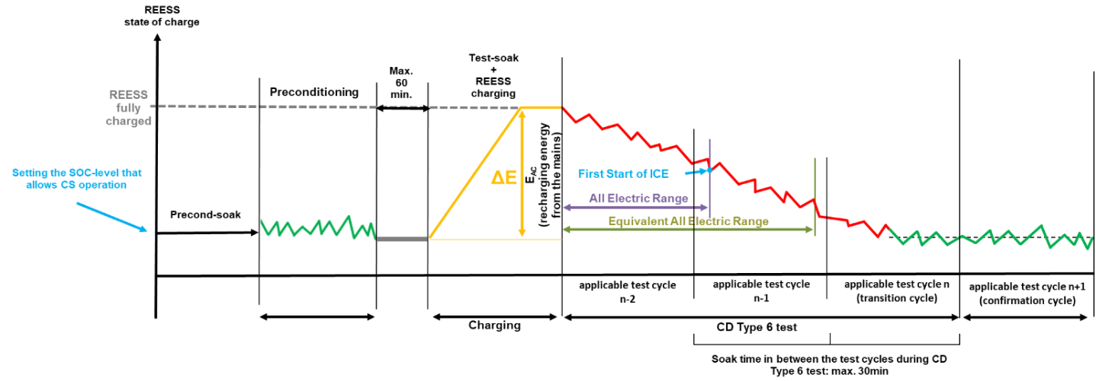
1.2. Test sequence OVC-HEVs according to Option 2
Charge-sustaining Type 6 test with no subsequent charge-depleting Type 6 test (Figure A13.SA1.App1/2).

Figure A13.SA1.App1/2

OVC-HEVs, charge-sustaining Type 6 test
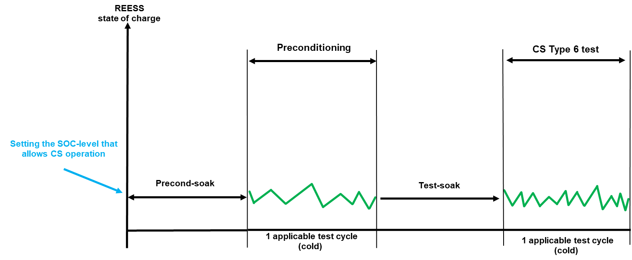
1.3. Test sequence OVC-HEVs according to Option 3
Charge-depleting Type 6 test with subsequent charge-sustaining Type 6 test (Figure A13.SA1.App1/3).

Figure A13.SA1.App1/3

OVC-HEVs, charge-depleting Type 6 test with subsequent charge-sustaining Type 6 test
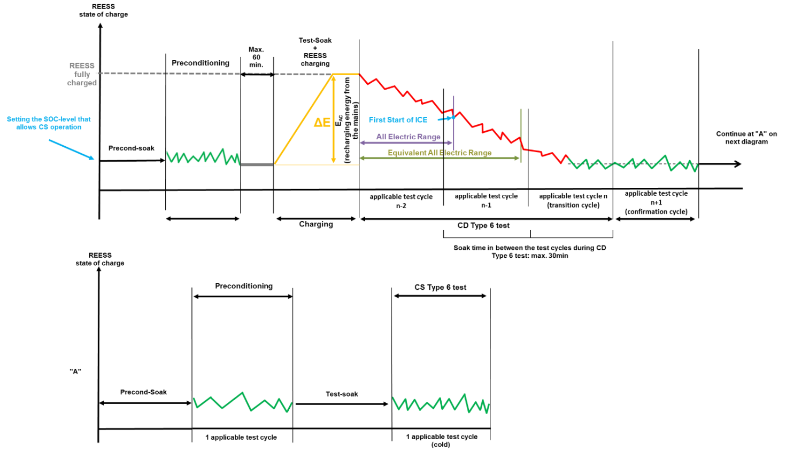
1.4. Test sequence OVC-HEVs according to Option 4
Charge-sustaining Type 6 test with subsequent charge-depleting Type 6 test (Figure A13.SA1.App1/4)
Figure A13.SA1.App1/4
OVC-HEVs, charge-sustaining Type 6 test with subsequent charge-depleting Type 6 test
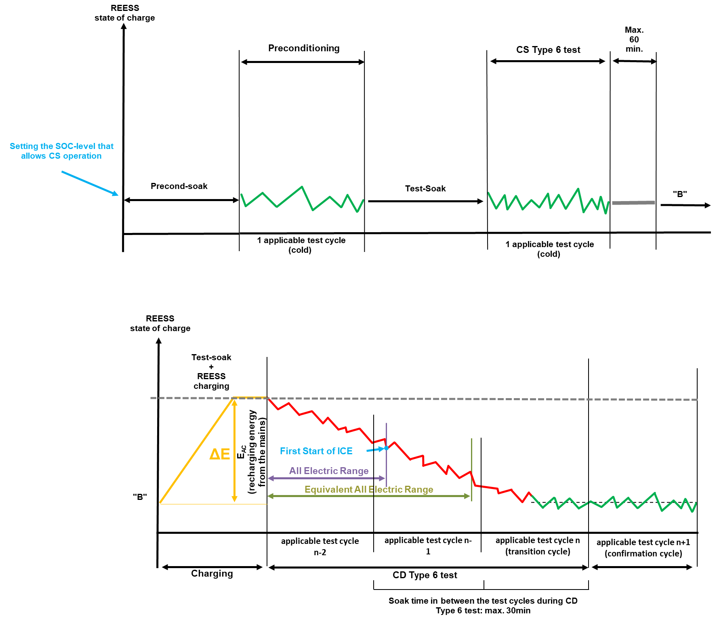

1.5. Test sequence OVC-HEVs according to Option 5
Charge-sustaining Type 6 test with subsequent charge-sustaining test (Figure A13.SA1.App1/5)
Figure A13.SA1.App1/5
OVC-HEVs, charge-sustaining Type 6 test with subsequent charge-sustaining Type 6 test

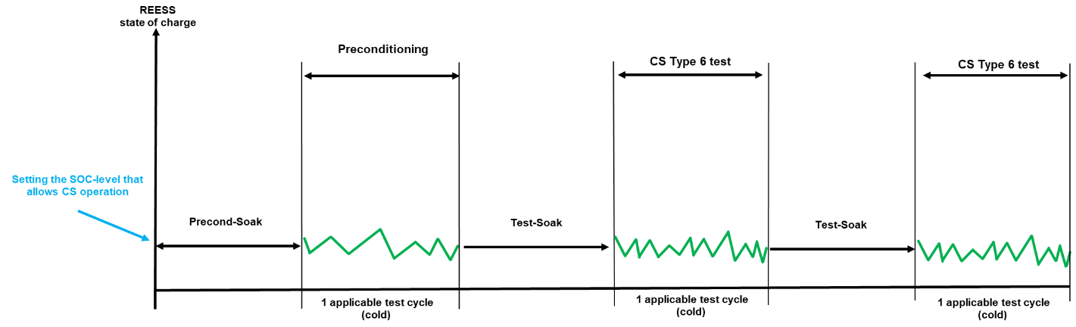

1.6. Test sequence OVC-HEVs according to Option 6
Charge-depleting Type 6 test with subsequent charge-depleting Type 6 test (Figure A13.SA1.App1/6)
Figure A13.SA1.App1/6
OVC-HEVs, charge-depleting Type 6 test with subsequent charge-depleting test
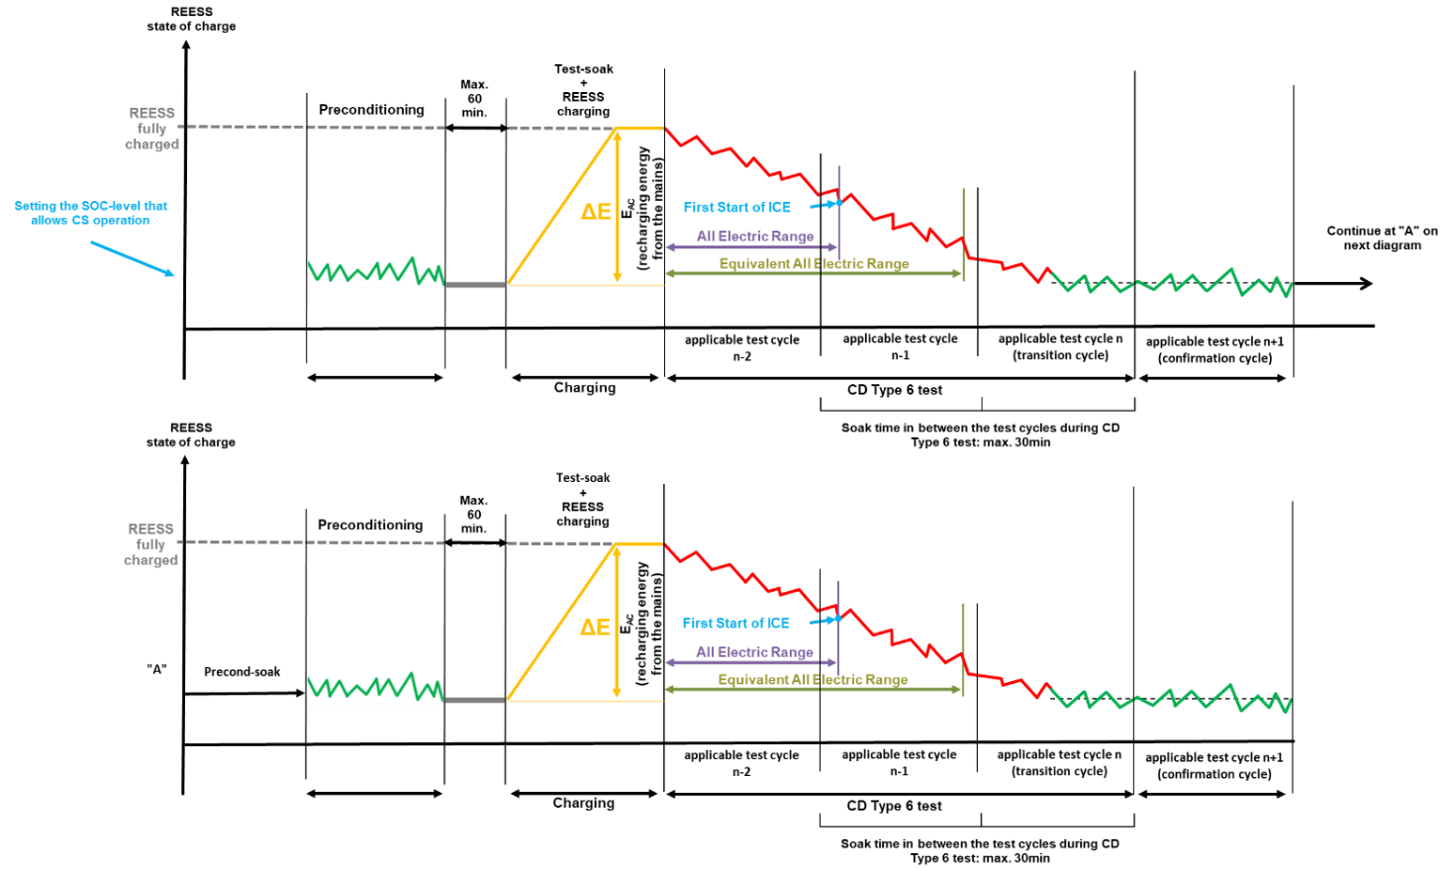
2. Test sequence NOVC-HEVs
Charge-sustaining Type 6 test (Figure A13.SA1.App1/7)

Figure A13.SA1.App1/7

NOVC-HEVs charge-sustaining Type 6 test
3. Test sequences PEV
PEV Type 6 test procedure (Figure A13.SA1.App1/8)

Figure A13.SA1.App1/8
PEV Type 6 test sequence

Sub-Annex 1 - Appendix 2
Vehicle preparation, preconditioning and soaking procedure for Type 6 testing of OVC-HEVs, NOVC-HEVs and PEVs
1. This appendix describes the test procedure for REESS and combustion engine preconditioning in preparation for:
(a) Electric range, charge-depleting and charge-sustaining measurements when testing OVC-HEVs; and
(b) Electric range measurements as well as electric energy consumption measurements when testing PEVs.
(c) Measurements when testing NOVC-HEVs.
2. OVC-HEV preparation, preconditioning and soaking
2.1. Vehicle preparation procedure
The state of charge of the REESS shall be set according to the manufacturer’s recommendation.
The setting of the state of charge of the REESS may be performed at unrestricted conditions.
2.2. Soak before preconditioning (precond-soak)
2.2.1. OVC-HEVs tested under charge-sustaining conditions.
Paragraph 2.6.2.6.1.2.1. of this annex shall be applied.
2.2.2. OVC-HEVs tested under charge-depleting conditions
Vehicles shall be kept in an area with ambient conditions as specified in paragraph 2.6.2.2.3. of this annex for a minimum of 9 hours and a maximum of 36 hours before preconditioning. This time shall be referred as t_{precond-soak-CD} and shall be recorded.
2.2.3. The soak shall be performed without using a cooling fan and with all body parts positioned as intended under normal parking operation.
2.2.4. The REESS shall not be charged during this soak period.
2.2.5. The heating and cooling system shall not be manually activated during the soak period. A thermal comfort preconditioning function, if available, shall not be activated during this soak.
2.3. Transfer from soak to preconditioning
In case that the vehicle is exposed to a temperature higher than -4 °C, the transfer between the soak area and the test cell shall be undertaken as quickly as possible, without any unjustified delay and for no longer than 20 minutes.
2.4. Preconditioning
2.4.1. At the start of the preconditioning test, the test cell shall have a temperature set point of -7 °C and the tolerance of the actual value shall be within ± 3 °C. During preconditioning, the tolerance of the actual value shall be within ± 5 °C.
2.4.2. The vehicle shall be driven over one applicable WLTP test cycle under charge-sustaining operating condition. During this preconditioning cycle, the charging balance of the REESS shall be determined. At the end of preconditioning, the REEC_{i} value defined in paragraph 3.2.4.5.2. of Annex 8 shall be below 0.06. This criteria applies to only discharge side.
2.5. Transfer from preconditioning to soak
Paragraph 2.3. of this appendix shall be applied.
2.6. Soak after preconditioning and before the test (test-soak)
2.6.1. After preconditioning and before testing, the vehicle shall be kept in a soak area with the ambient conditions described in paragraph 2.6.2.2.3. of this annex.
2.6.2. Soaking of the vehicle shall be performed according to paragraph 2.6.2.7.1.5. of this annex.
2.6.2.1. Specific provisions for the charge-sustaining Type 6 test
2.6.2.1.1. The vehicle shall not be connected to the grid.
2.6.2.2. Specific provisions for the charge-depleting Type 6 test
2.6.2.2.1. Forced cooling as described in paragraph 2.6.2.7.1.5. of this annex shall not be applied.
2.6.2.2.2. The vehicle shall be connected to the grid and start REESS charging using the normal charging procedure as defined in paragraph 5 of this appendix within 1 hour after the end of preconditioning.
Soak and charge shall continue until the end-of-charge criterion described in paragraph 5. of this appendix is reached. At the request of the manufacturer, the soak time may be extended to up to 36 hours.
The recharged electric energy shall be measured according to paragraph 6. of this appendix.
2.7. Transfer from soak to Type 6 testing
2.7.1. Transfer when the test procedure starts with a charge-sustaining Type 6 test
Paragraphs 2.6.2.7.1.6. and 2.6.2.7.1.7. of this annex shall be applied.
2.7.2. Transfer when the test procedure starts with a charge-depleting Type 6 test
During the transfer, a stabilized vehicle shall not receive any unjustified exposures to temperatures outside the temperature tolerance -7 °C ± 3 °C. If that is unavoidable, the vehicle shall be stabilised before the start of the test procedure by keeping it at an ambient temperature of -7 °C ± 3 °C for at least six times as long as the vehicle was exposed to temperatures outside the temperature tolerance.
The transfer from the soak area to the test cell shall be undertaken as quickly as possible, without any unjustified delay with a maximum of 1 hour between charge completion end of soak and start of the test procedure.
3. PEV preparation, preconditioning and soaking
3.1. Vehicle preparation procedure
Paragraph 2.1. of this appendix shall be applied.
3.2. Soak before preconditioning (precond-soak)
Provisions described in paragraph 2.2.2. to 2.2.5. of this appendix shall be applied.
3.3. Transfer from soak to preconditioning
Paragraph 2.3. of this appendix shall be applied.
3.4. Preconditioning
3.4.1. Paragraph 2.4.1. of this appendix shall be applied.
3.4.2. The REESS shall be discharged at the constant speed defined in paragraph 3.4.3.3.2. of this sub-annex until the break-off criterion is reached as specified in paragraph 3.4.4.2.3 of Annex 8. Cumulative distance driven should not exceed 50 km before the break-off criterion is reached.
3.5. Transfer from preconditioning to soak
Paragraph 2.3. of this appendix shall be applied.
3.6. Soak after preconditioning and before test (test-soak)
Provisions described in paragraphs 2.6.1., and 2.6.2. of this appendix shall be applied with the exception of 2.6.2.1. which shall not be applied.
This soak time shall be referred as t_{soak-PEV} and shall be recorded.
3.7. Transfer from soak to Type 6 Testing
Paragraph 2.7.2. of this appendix shall be applied.
4. NOVC-HEV preparation, preconditioning and soaking
4.1. Vehicle preparation procedure
Paragraph 2.1. of this appendix shall be applied.
4.2. Soak before preconditioning (precond-soak)
Provisions described in paragraph 2.6.2.6.1.2. of this annex shall be applied.
4.3. Preconditioning
4.3.1. Paragraph 2.4.1. of this appendix shall be applied.
4.3.2. The vehicle shall be driven over one applicable WLTP test cycle under charge-sustaining operating condition.
4.4. Soak after preconditioning and before test (test-soak)
Paragraph 2.6.2.7. of this annex shall be applied.
5. Application of a normal charge
Normal charging is the transfer of electricity to an electrified vehicle with a power of less than or equal to 22 kW.
Where there are several possible methods to perform a normal AC charge (e.g. cable, induction, etc.), the charging procedure via cable shall be used.
Where there are several AC charging power levels available, the highest normal charging power shall be used. An AC charging power lower than the highest normal AC charging power may be selected if recommended by the manufacturer and by approval of the responsible authority.
5.1. The REESS shall be charged at an ambient temperature as specified in paragraph 2.6.2.2.3. of this annex with the on-board charger if fitted.
The vehicle shall be connected to the mains within 60 minutes after the preconditioning. The REESS is fully charged when the end-of-charge criterion, as defined in paragraph 5.2. of this appendix, is reached.
In the following cases, a charger recommended by the manufacturer and using the charging pattern prescribed for normal charging shall be used if:
(a) No on-board charger is fitted, or
(b) The charging time exceeds the maximum soaking time defined in paragraph 2.6.2.7.1.5. of this annex.
The procedures in this paragraph exclude all types of special charges that could be automatically or manually initiated, e.g. equalization charges or servicing charges. The manufacturer shall declare that, during the test, a special charge procedure has not occurred.
5.2. End-of-charge criterion
The end-of-charge criterion is reached when the on-board or external instruments indicate that the REESS is fully charged.
6. Measurement of the recharged electric energy and connection to the grid
The energy measurement equipment, placed between the vehicle charger and the grid, shall measure the recharged electric energy E_{AC} delivered from the grid, as well as the recharge duration.
6.1. If the vehicle has no automatic function for pre-heating the REESS, the electric energy measurement shall be stopped and the vehicle shall be disconnected from the grid when the end-of-charge criterion as defined in paragraph 5.2. of this appendix has been reached.
At the option of the manufacturer, the vehicle may remain connected to the grid. In this case, the electric energy measurement shall continue until the end of the soak.
6.2. If the vehicle has an automatic application which keeps the REESS above a temperature threshold, the vehicle shall remain connected to the grid and the electric energy measurement shall continue until the end of the soak.

