UN/SCETDG/59/INF.22

Committee of Experts on the Transport of Dangerous Goods
and on the Globally Harmonized System of Classification
and Labelling of Chemicals 22 November 2021
Sub-Committee of Experts on the Transport of Dangerous Goods
Fifty-ninth session
Geneva, 29 November-8 December 2021
Item 3 of the provisional agenda
Listing, classification and packing
Proposals for batteries (wet, non-spillable) installed in cargo transport units
Transmitted by the expert from China
Introduction
- At the fifty-sixth session, the Sub-Committee considered the proposals in document ST/SG/AC.10/C.3/2019/48 and informal document INF.41 (56th session) submitted by China on the batteries (wet, non-spillable) installed in cargo transport units (CTUs). Similar to the UN 3536 (LITHIUM BATTERIES INSTALLED IN CARGO TRANSPORT UNIT lithium ion batteries or lithium metal batteries), these batteries as energy storage devices are firmly fixed on the internal structure of the CTU (e.g. fixed on the bracket or cabin, etc.) for transportation as a whole. These CTUs are usually equipped with fixed fire extinguishing system (fire extinguisher, UN 1044) and internal refrigeration system (refrigerator, UN 2857). The current Model Regulations do not specify the transportation requirements for the above batteries (wet, non-spillable) installed in CTUs, with other dangerous goods contained in CTUs for safety or operability purposes (such as firefighting and refrigeration). Therefore, it is not clear how to transport the batteries (wet, non-spillable) installed in CTUs.
- During the discussion at the fifty-sixth session, some experts expressed their support to the proposals in options 2 and 3 of document ST/SG/AC.10/C.3/2019/48, but most experts who spoke believed that these options needed further study before they were adopted by the Sub-Committee. However, other experts believed that there was no need to add an entry for such batteries to make additional provisions, and invited Chinese experts to provide the intended use of the batteries (wet, non-spillable) installed in CTUs (such as providing external power supply for cargo transportation), as well as the differences between the products and those covered by UN 3536, so as to make the content of the proposal clearer.
- China appreciates these comments and suggestions and takes them into consideration in this document, so as to provide the intended use of the batteries (wet, non-spillable) products installed in CTUs (for example, providing external power supply for cargo transportation) as well as the differences between the products and those covered by UN 3536, so as to make the content of the proposal clearer.
Discussion
- The batteries (wet, non-spillable) installed in CTUs, the fixed fire extinguishing system (fire extinguisher, UN 1044) and the internal refrigeration system (refrigerator, UN 2857) installed in CTUs for the purpose of transportation or operation safety and convenience are firmly fixed on the bracket or cabin and other internal structures of the CTU, and integrated with the CTU as a whole, consisting a mobile battery energy storage system. Its function is to supply power for the equipment installed inside CTUs (not dangerous goods itself), or other equipment outside the CTUs. Pictures of the battery system are shown in Annex I.
- Therefore, the structure and function of this kind of battery system is completely similar to the products covered by UN 3536. It is an integrated CTU functioning as mobile energy storage system using large battery as energy storage device, with fixed fire extinguishing system and internal refrigeration system.
- But it seems not appropriate to make batteries (wet, non-spillable) also covered by UN 3536, since the types of batteries used in CTUs are different. The current entry of UN 3536 applies to lithium battery pack, lithium ion battery pack or lithium metal battery pack installed in CTUs. These batteries are all Class 9 dangerous goods, while the batteries (wet, non-spillable) are Class 8 ones. In the event of a fire or spill, emergency response measures taken for these two classes of goods are not exactly the same. For example, when the batteries (wet, non-spillable) leaks, special measures should be taken to prevent corrosion or toxic gases from injuring people. Annex II shows the Emergency Schedules (EmS) codes of UN 3536 and UN 2800 contained in the Dangerous Goods List in IMDG Code as well as the descriptions of the EmS codes on spill emergency measures given in the EmS Guide.
- In reality, due to cost and technical reasons, the production and use of the battery system using batteries (wet, non-spillable) as energy storage device is still very common. This kind of battery system using batteries (wet, non-spillable) as energy storage device is widely used in emergency power supply and other similar applications. Therefore, this kind of products are widely manufactured and transported. Taking the Prefabricated Modular Data Center (PMDC) as an example, this product includes firmly installed the computer equipment of non-dangerous goods used to provide emergency data calculation and data transmission services in the cargo transport unit, together with the power storage batteries (wet, non-spillable) that provides emergency power supply for the equipment, as well as the fire extinguishing system and air conditioning system to ensure the safety of the whole transport unit, working as a whole to provide emergency power supply and other services for emergencies such as earthquake, tsunami and epidemic situation. According to the report of IHS Markit, 2236 containers of PMDC products were consigned for shipment in 2018 (destination and quantity: 846 containers to North America, 944 containers to Europe, Middle East and Africa and 446 containers to Asia). It is expected that, by 2023, the market shipment volume will reach about 6250 containers, and the shipment volume will continue to grow steadily. At the same time, PMDC products are shipped all over the world, including countries such as the United States of America, Canada, Germany, France, the United Kingdom, Ireland and China. However, since the current UN Model Regulations do not specify the transportation requirements of the above batteries (wet, non-spillable) installed in CTU, it is unclear how to mark, label or placard the freight device and how to describe it in the transport document.
- Considering the need to describe the batteries (wet, non-spillable) installed in CTUs in the Model Regulations and the difference between the above batteries and UN 3536 (see paragraph 6. above), China suggests that a new Class 8 entry UN 35XX “BATTERIES, WET, NON-SPILLABLE INSTALLED IN CARGO TRANSPORT UNIT” be added to regulate the transportation of relevant products, as proposed in option 3 of document ST/SG/AC.10/C.3/2019/48 of the 56th session, and that a special provision XXX similar to special provision 389 of UN 3536 should be introduced to describe the requirements for the installed batteries, auxiliary dangerous goods as well as the whole system. The batteries (wet, non-spillable) installed in CTUs shall meet the requirements of special provision 238 (a). And, other dangerous goods necessary for the safety and proper operation of the cargo transport units, such as fire extinguishing system and air conditioning system, shall be firmly fixed or installed in cargo transport components and shall not be otherwise subject to these regulations. The Sub-Committee is invited to consider the following proposals in the light of the above information.
Proposal
- In the Dangerous Goods List in Chapter 3.2, add a new entry as follows:
UN No. | Name and description | Class or division | Subsi-diary hazard | UN packing group | Special provi-sions | Limited and excepted quantities |  | Packagings and IBCs |  | Portable tanks and bulk containers
 |  |  |  |  |  |  |  | Packing instruction | Special packing provisions | Instructions | Special provisions
(1) | (2) | (3) | (4) | (5) | (6) | (7a) | (7b) | (8) | (9) | (10) | (11)
35XX | BATTERIES,WET,NON-SPILLABLE INSTALLED IN CARGO TRANSPORT UNIT | 8 |  |  | XXX | 0 | E0
- In Chapter 3.3, add a new special provision XXX (similar to special provision 389) as follows:
“XXX This entry applies only to batteries (wet, non-spillable) installed in a cargo transport unit and designed only as an energy storage system. Batteries can be considered as non-spillable provided that they are capable of withstanding the vibration and pressure differential tests described in special provision 238 (a), without leakage of battery fluid.
The batteries shall be securely attached to the interior structure of the cargo transport unit (e.g., by means of placement in racks, cabinets, etc.) in such a manner as to prevent short circuits, accidental operation, and significant movement relative to the cargo transport unit under the shocks, loadings and vibrations normally incident to transport. Dangerous goods necessary for the safe and proper operation of the cargo transport unit (e.g. fire extinguishing systems and air conditioning systems), shall be properly secured to or installed in the cargo transport unit and are not otherwise subject to these Regulations. Dangerous goods not necessary for the safe and proper operation of the cargo transport unit shall not be transported within the cargo transport unit.
The batteries inside the cargo transport unit are not subject to marking or labelling requirements. The cargo transport unit shall display the UN number in accordance with 5.3.2.1.2 and be placarded on two opposing sides in accordance with 5.3.1.1.2.
If wet, non-spillable batteries installed in a cargo transport unit meet all the requirements of special provision 238, the cargo transport units are not subject to other provisions of these Regulations.”

Annex I
Overall structure of the CTUs:
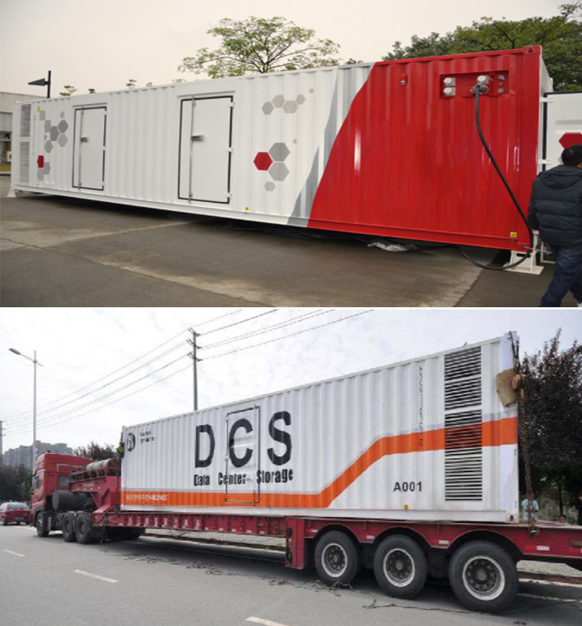
Devices and batteries
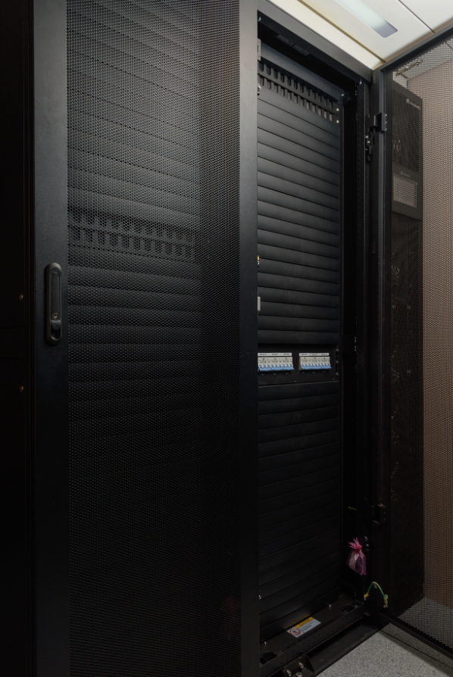
Fire suppression (UN 1044)
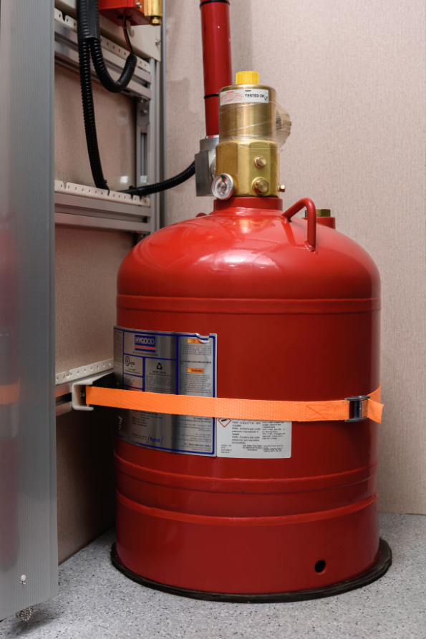
Conditioning systems (UN 2857)
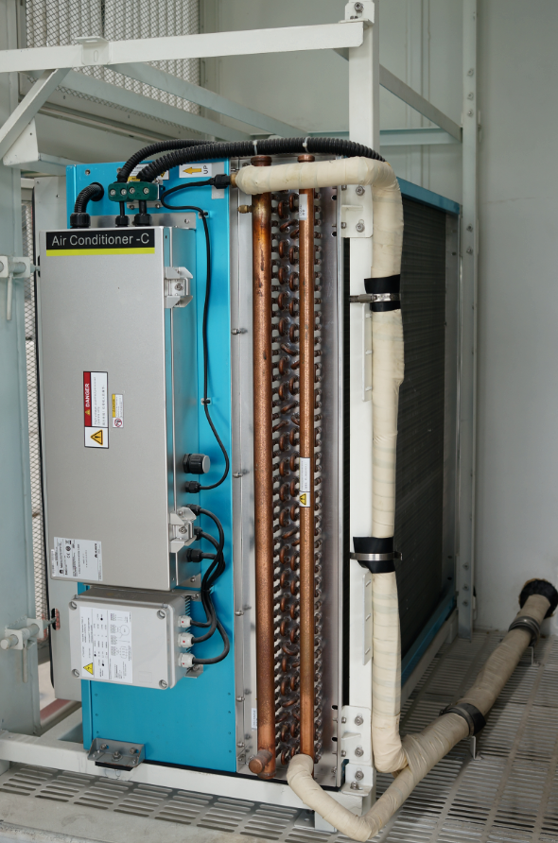

Annex II
EmS codes of UN 3536 and UN 2800 contained in the Dangerous Goods List in IMDG Code

UN  No.  (1) | Proper shipping name(PSN)  (2)  3.1.2 | Class or division  (3)  2.0 | Subsidiary hazard(s)  (4)  2.0 | Packing  Group  (5)  2.0.1.13 | Special provisions  (6)  3.3 | Limited and excepted quantity provisions |  | Packing |  | … | EmS  (15)  5.4.3.2  7.8 | …
 |  |  |  |  |  | Limited quantities  (7a)  3.4 | Excepted quantities  (7b)  3.5 | Instructions  (8)  4.1.4 | Provisions  (9)  4.1.4
2800 | BATTERIES,WET,  NON-SPILLABLE, electric storage | 8 | - | - | 238 | 1L | E0 | P003 | PP16 | … | F-A, S-B | …
3536 | LITHIUM BATTERIES INSTALLED IN CARGO TRANSPORT UNIT lithium ion batteries or lithium metal batteries | 9 | - | - | 389 | 0 | E0 | - | - | … | F-A, S-I | …

Descriptions of the EmS codes on spill emergency measures given in the EmS Guide

