|  |  |  |  |
| --- | --- | --- | --- |
|  | United Nations | ECE/TRANS/WP.29/GRPE/2022/7 | |
| _unlogo | **Economic and Social Council** | | Distr.: General  29 October 2021  Original: English |

**Economic Commission for Europe**

Inland Transport Committee

**World Forum for Harmonization of Vehicle Regulations**

**Working Party on Pollution and Energy**

**Eighty fifth session**

Geneva, 11-14 January 2022

Item 8(b) of the provisional agenda

**Motorcycles and mopeds: Environmental   
and Propulsion Performance Requirements   
(EPPR) for L-category vehicles**

Proposal for a new UN GTR on the measurement procedure for two- or three-wheeled vehicles equipped with a combustion engine with regard to durability of pollution-control devices

Submitted by the Informal Working Group on Environmental and Propulsion Performance Requirements (EPPR)[[1]](#footnote-2)\*

The text reproduced below was prepared by the Informal Working Group (IWG) on Environmental and Propulsion Performance Requirements (EPPR) in line with the authorization to develop the new UN GTR (ECE/TRANS/WP.29/AC.3/58). An informal document on this proposal (GRPE-83-10) was introduced by the IWG on EPPR at the eighty-third session of GRPE (see report ECE/TRANS/WP.29/GRPE/83, para. 42).

Content

*Page[[2]](#footnote-3)\**

I. Statement of technical rationale and justification

A. Introduction

II. Text of the UN GTR

1. General requirements on the durability of pollution-control devices

2. Specific requirements on the durability of pollution-control devices

Annexes

1 The Standard Road Cycle durability test for two- and three-wheeled Vehicles (SRC-LeCV)

2 The USA EPA Approved Mileage Accumulation Cycle (AMA)

3 Bench ageing durability test

4 Standard bench cycle (SBC)

5 Test vehicle requirements test Type V

6 Tests of a replacement pollution-control device

7 Vehicle propulsion family with regard to environmental performance demonstration tests

I.  Statement of technical rationale and justification

A. Introduction

1. In the framework of the 1998 Agreement and under continued work by the informal working group (IWG) on Environmental and Propulsion Performance Requirements of L-category vehicles (EPPR), the objective of this document is to propose a new UN GTR on the measurement procedure for two- or three-wheeled vehicles equipped with a combustion engine with regard to durability of pollution-control devices.

2. The IWG on EPPR also considered alignment with the work done by the IWG on Worldwide harmonized Light Vehicles Test Procedure (WLTP) if deemed advantageous, to ensure harmonization and to avoid any duplication of effort.

3. The authorisation to develop the above GTR was requested at the 62nd session of GRPE in January 2021 with document number GRPE-82-26-Rev.1, which was submitted for adoption to the 184th session of WP.29 in June 2021 as document number ECE/TRANS/WP.29/2021/81.

[To be completed]

**II. Text of the UN GTR**

**1. General requirements on the durability of pollution-control devices**

1.1. Purpose

This Regulation provides a worldwide-harmonized measurement method for the durability of pollution-control devices fitted to two- and three-wheeled vehicles, which is representative for real world vehicle operation.

1.2. General scope

1.2.1. Two- and three-wheeled vehicles equipped with a propulsion unit in accordance with Table 1.

Table 1

**Scope with regard to the propulsion unit and fuel type**

|  | *Vehicle with PI engines (Petrol)* | *Vehicle with CI engines (Diesel)* |
| --- | --- | --- |
|  |  |  |
| Type V Test | Yes | Yes |

1.3. Definitions

The following definitions shall apply in this UN GTR:

1.3.1. ‘Durability’ means the ability of components and systems to last so that the environmental performance can still be met after a mileage set out in paragraph 2.4. and so that vehicle functional safety is ensured, if the vehicle is used under normal or intended circumstances and serviced in accordance with the manufacturer’s recommendations.

1.3.2. ‘Original equipment pollution-control devices’ mean pollution-control devices including oxygen sensors, catalytic converter types or assemblies of catalytic converters, particulate filters covered by the certification and originally delivered for the certifiedvehicle.

1.3.3. ‘Replacement pollution-control devices’ means pollution-control devices including oxygen sensors, catalytic converter types or assemblies of catalytic converters, particulate filters intended to replace an original equipment pollution-control device on a vehicle.

1.4. Nomenclature

1.4.1. Where rounding is required, values ≥ 5 shall be rounded up and values < 5 rounded down.

1.4.2. Throughout this document the decimal sign is a full stop (period) "." and, if used, the thousands separator is a space.

1.5. General requirements test Type V

1.5.1. Manufacturers shall ensure that certification requirements for verifying durability requirements are met. At the choice of the manufacturer one of the following durability test procedures shall be used to provide evidence to the responsible authority that the environmental performance of a certified vehicle is durable:

1.5.1.1. Actual durability testing with full mileage accumulation:

The test vehicles shall physically accumulate the full distance set out in paragraph 2.4. and shall be tested in accordance with the procedure laid down in paragraph 2.3.1. The emission test results up to and including the full distance set out in paragraph 2.4. shall be lower than the emission limits set out in paragraph 7. of Amendment 5 to UN GTR No. 2;

1.5.1.2. Actual durability testing with partial mileage accumulation:

The test vehicles shall physically accumulate a minimum of 50% of the full distance set out in paragraph 2.4. and shall be tested in accordance with the procedure laid down in paragraph 2.3.2. The test results shall be extrapolated up to the full distance set out in paragraph 2.4. Both the test results and the extrapolated results shall be lower than the performance limits set out in paragraph 7. Of UN GTR No.2 Amendment 5;

1.5.1.3. Mathematical durability procedure:

For each emission constituent, the product of the multiplication of the deterioration factor set out in paragraph 2.5 and the environmental test result of a vehicle which has accumulated more than 2500 km for a vehicle with a maximum design vehicle speed of < 130 km/h and 3 500 km for a vehicle with a maximum design vehicle speed of ≥ 130 km/h after it was first started at the end of the production line shall be lower than the environmental limits set out in paragraph 7. of UN GTR No.2 Amendment 5.

1.5.2. The test vehicle(s) to demonstrate durability of the pollution-control devices shall comply with the requirements laid down in Annex 5. The test vehicles’ powertrain and pollution-control device type fitted on the test vehicles shall be documented and listed by the manufacturer. The list shall include at a minimum such items as the specifications of the propulsion type and its powertrain, where applicable, the exhaust oxygen sensor(s), catalytic converter(s) type, particulate filter(s) or other pollution-control devices, intake and exhaust systems and any peripheral device(s) that may have an impact on the environmental performance of the certified vehicle. This documentation shall be added to the test report.

1.5.3. The manufacturer shall provide evidence of the possible impacts on Type V test results of any modification to the emission abatement system configuration, the pollution-control device type specifications or other peripheral device(s) interacting with the pollution-control devices, in production of the vehicle after environmental performance certification. The manufacturer shall provide the responsible authority with this documentation and evidence upon request in order to prove that the durability performance of the vehicle with regard to environmental performance will not be negatively affected by any change in vehicle production, retrospective changes in the vehicle configuration, changes in the specifications of any pollution-control device type, or changes in peripheral devices fitted on the certified vehicle.

1.5.4. The manufacturer shall equip a vehicle in the scope of this GTR with systems, components and separate technical units affecting the environmental performance of a vehicle that is designed, constructed and assembled so as to enable the vehicle in normal use and maintained according to the prescriptions of the manufacturer to comply with the detailed technical requirements and testing procedures of Amendment 5 to UN GTR No. 2 and this GTR on durability requirements of pollution-control devices.

1.5.5. Any hidden strategy that ‘optimises’ the powertrain of the vehicle running the relevant test cycles in an advantageous way, reducing tailpipe emissions and running significantly differently under real-world conditions differently than under emission test laboratory or distance accumulation conditions, is considered a defeat strategy and is prohibited, unless the manufacturer has documented and declared it to the satisfaction of the responsible authority.

1.5.6. An element of design shall not be considered a defeat device if any of the following conditions is met:

1.5.6.1. the need for the device is justified in terms of protecting the engine against damage or accident and ensuring safe operation of the vehicle;

1.5.6.2. the device does not function beyond the requirements of engine starting;

1.5.6.3. the operating conditions are included to a substantial extent in the test procedures for verifying if the vehicle complies with this GTR.

1.6. General requirements applicable for replacement pollution-control devices.

1.6.1. A replacement pollution-control device intended to be fitted to a vehicle certified in compliance with this Regulation shall be tested in accordance with Annex 6.

1.6.2. Original equipment replacement pollution-control devices which are intended to be fitted to a vehicle, do not need to comply with the test requirements of Annex 6.

**1.7. Performance requirements with regard to test Type V**

1.7.1. The performance requirements in terms of emissions limits laid down in paragraph 7. of Amendment 5 to UN GTR No. 2 shall apply as set out under the applicable durability test method set out in paragraph 1.5.

**2.** **Specific requirements on the durability of pollution-control devices**

2.1. Introduction

2.1.1. This section describes the specific procedures for Type V testing to verify the durability of pollution-control devices of two- and three-wheeled vehicles.

2.1.2. The Type V test procedure includes a distance accumulation procedure to age the test vehicles in a defined and repeatable way and also includes the frequency of applied Type I emission verification test procedures conducted before, during and after the distance accumulation of the test vehicles.

2.2. Specific requirements test Type V

2.2.1. In the Type V test procedure, distance shall be accumulated by driving the test vehicles either on a test track, on the road or on a chassis dynamometer. The test track or test road shall be selected at the discretion of the manufacturer.

2.2.1.1. Chassis dynamometer used for distance accumulation

2.2.1.1.1. Chassis dynamometers used to accumulate test Type V durability distance shall enable the durability distance accumulation driving schedule laid down in annexes 1. or 2, as applicable, to be carried out.

2.2.1.1.2. In particular, the dynamometer shall be equipped with systems simulating the same inertia and resistance to progress as those used in the Type I emission laboratory test laid down in Annex 1. of Amendment 5 to UN GTR No. 2. Emission analysis equipment is not required for distance accumulation. The same inertia and flywheel settings and calibration procedures shall be used for the chassis dynamometer referred to in Annex 1 of Amendment 5 to UN GTR No. 2, used to accumulate distance with the test vehicles.

2.2.1.1.3. The test vehicle may be moved to a different bench in order to conduct Type I emission verification tests. The distance accumulated in the Type I emission verification tests may be added to the total accumulated distance.

2.2.2. The Type I emission verification tests before, during and after durability distance accumulation shall be conducted according to the test procedures for emissions after cold start set out in Annex 1. of UN GTR No 2 Amendment 5. All Type I emission verification test results shall be listed and made available to the responsible authority upon request. The results of Type I emission verification tests at the start and the finish of durability distance accumulation shall be included in the test report. At least the first and last Type I emission verification tests shall be conducted or witnessed by the technical service and reported to the responsible authority. The test report shall confirm and state whether the technical service conducted or witnessed the Type I emission verification testing.

2.3. Test Type V, pollution-control device durability test procedure specifications

The specifications of the three alternative durability test procedures are as follows:

2.3.1. Actual durability testing with full distance accumulation

The durability test procedure with full distance accumulation to age the test vehicles shall refer to paragraph 1.5.1.1. Full distance accumulation shall mean full completion of the assigned test distance laid down in paragraph 2.4. by repeating the driving manoeuvres laid down in Annex 1. or, if applicable in Annex 2.

2.3.1.1. The manufacturer shall provide evidence that the emission limits in the applicable Type I emission laboratory test cycle, as set out in paragraph 7. of Amendment 5 to UN GTR No. 2, of the aged test vehicles are not exceeded when starting distance accumulation, during the accumulation phase and after full distance accumulation has been finalised.

2.3.1.2. Multiple Type I emission tests shall be conducted during the full distance accumulation phase with a frequency and amount of Type I test procedures at the choice of the manufacturer and to the satisfaction of the responsible authority. The Type I emission test results shall provide sufficient statistical relevance to identify the deterioration trend, which shall be representative of the vehicle type with regard to environmental performance as placed on the market (see Figure 1).

Figure 1

**Test Type V – Durability test procedure with full distance accumulation**

New vehicle(s) from

(proto-type) production line

Start Type V test: conduct Type I emission tests, degreened vehicle

Multiple Type I emission tests,

partially aged vehicle

Finish Type V test: conduct Type I emission tests, fully aged vehicle

Maximum allowed mileage prior to start of distance accumulation: 100km

Fully distance accumulation durability cycle:

1) SRC-LeCV **or**

2) AMA

**Full mileage accumulation**

2.3.2. Actual durability testing with partial distance accumulation

The durability test procedure for vehicles with partial distance accumulation shall refer to paragraph 1.5.1.2. Partial distance accumulation shall involve completion of a minimum of 50% of the test distance specified in paragraph 2.4. and compliance with the stop criteria in paragraph 2.3.2.3.

2.3.2.1. The manufacturer shall provide evidence that the emission limits in the applicable Type I emission laboratory test cycle, as set out in, paragraph 7. of Amendment 5 to UN GTR No. 2, of the tested aged vehicles are not exceeded at the start of distance accumulation, during the accumulation phase and after the partial accumulation.

2.3.2.2. Multiple Type I emission tests shall be conducted during the partial distance accumulation phase, with the frequency and number of Type I test procedures chosen by the manufacturer. The Type I emission test results shall provide sufficient statistical relevance to identify the deterioration trend, which shall be representative of the vehicle type with regard to the environmental performance placed on the market (see Figure 2).

Figure 2

**Test Type V – Durability test procedure with partial distance accumulation**

New vehicle(s) from

(proto-type) production line

Start Type V test: conduct Type I emission tests, degreened vehicle

Multiple Type I emission tests,

partially aged vehicle

Finish Type V test: conduct Type I emission tests, partially aged vehicle

Maximum allowed mileage prior to start of distance accumulation: 100km

Partial distance accumulation cycle, minimum 50% of assigned distance:

1) SRC-LeCV **or**

2) AMA

**Accelerated durability test procedure, partial mileage accumulation**

2.3.2.3. Stop criteria for the durability test procedure with partial distance accumulation.

Partial distance accumulation may stop if the following criteria are met:

2.3.2.3.1. if a minimum of 50% of the applicable test distance laid down in paragraph 2.4. has been accumulated; and

2.3.2.3.2. if all the Type I emission verification test results are below the emission limits laid down in paragraph 7. of UN GTR No.2 Amendment 5 at all times during the partial distance accumulation phase; or

2.3.2.3.3. if the manufacturer cannot prove that the stop criteria in paragraph 2.3.2.3.1. and 2.3.2.3.2. are met, the distance accumulation shall continue to the point where those criteria are met or to the full durability distance laid down in paragraph 2.4.

2.3.2.4. Data processing and reporting for the durability test procedure with partial distance accumulation

2.3.2.4.1. The manufacturer shall use the arithmetic mean of the Type I emission test results at each test interval, with a minimum of oneemission tests per test interval. All Type I emissions test results shall be plotted per THC, CO, NOx, and if applicable NMHC and PM, emission constituent, against accumulation distance rounded to the nearest kilometre. If more than one test per test interval is performed, then an arithmetic mean shall be used.

2.3.2.4.2. The best fit linear line (trend line: y = ax+b) shall be fitted and drawn through all these data points based on the method of least squares. This best-fit straight trend line shall be extrapolated over the full durability distance laid down in paragraph 2.4. At the request of the manufacturer, the trend line may start as of 20% of the durability distance laid down in paragraph 2.4., in order to take into account possible run-in effects of the pollution-control devices.

2.3.2.4.3. A minimum of four data points shall be used to draw each trend line, with the first at, or before, 20% of the durability distance laid down in paragraph 2.4. and the last one at the end of distance accumulation; at least two other data points shall be equally spaced between the first and final Type I test measurement distances. If more than one test per test interval is performed, then arithmetic means shall be used.

2.3.2.4.4. The applicable emission limits set out paragraph 7. of Amendment 5 to UN GTR No. 2 shall be plotted in the graphs per emission constituent laid down in paragraph 2.3.2.4.2. and 2.3.2.4.3. The plotted trend line shall not exceed these applicable emission limits at any distance data point. The graph per THC, CO, NOx, and if applicable NMHC and PM, emission constituent plotted against accumulation distance shall be added to the test report.

Figure 3

**Theoretical example of the plotted Type I total hydrocarbon (THC) emission test results, the plotted Type I THC Euro 4 test limit (170 mg/km) and the best-fit straight trend line of a Euro 4 motorcycle (vmax > 130 km/h), all versus accumulated distance.**

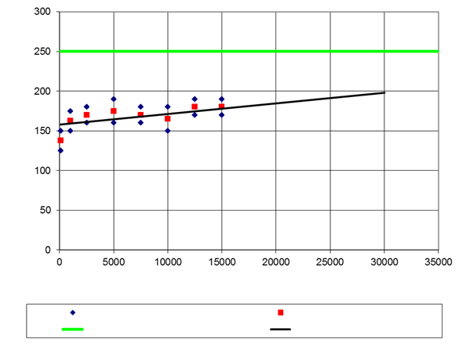

THC (mg/km)

Accumulated distance (km)

THC measured (mg/km)

THC limit (mg/km)

THC average (mg/km)

Linear (THC average (mg/km))

2.3.2.4.5. Trend line parameters a, x and b of the best-fit straight lines and the calculated pollutant value at the end distance according to the vehicle category shall be stated in the test report. The graph for all emission constituents shall be plotted in the test report. In the test report it shall also be stated which measurements were taken or witnessed by the responsible authority and which by the manufacturer.

2.3.3. Mathematical durability procedure

The mathematical durability procedure shall refer to paragraph 1.5.1.3.

2.3.3.1. The emission results of the vehicle that has accumulated more than the distance prescribed in paragraph 1.5.1.3. after it was first started at the end of the production line, the applied deterioration factors set out in paragraph 2.5., and the product of the multiplication of both and the emission limit set out in paragraph 7. of UN GTR No.2 Amendment 5 shall be added to the test report.

2.3.4. Durability distance accumulation driving schedules.

One of the following two durability distance accumulation driving schedules shall be conducted to age the test vehicle until the assigned test distance laid down in paragraph 2.4. is fully completed according to the full distance accumulation test procedure set out in paragraph 2.3.1. or partially completed according to the partial distance accumulation test procedure in paragraph 2.3.2.:

2.3.4.1. The Standard Road Cycle (SRC-LeCV) for two- and three-wheeled vehicles

The Standard Road Cycle (SRC-LeCV) custom tailored for two- and three-wheeled vehicles is the principle durability Type V test cycle composed of a set of four distance accumulation durability cycles. One of these durability distance accumulation cycles shall be used to accumulate distance by the test vehicle(s) according to the technical details laid down in Annex 1.

2.3.4.2. The USA EPA Approved Mileage Accumulation cycle (AMA)

At the choice of the manufacturer, the AMA durability distance accumulation cycle may be conducted as alternative Type V distance accumulation cycle. The AMA durability distance accumulation cycle shall be conducted according to the technical details laid down in Annex 2.

2.3.4.3. Bench ageing durability test.

2.3.4.3.1. At the option of the Contracting Party, as an alternative to paragraph 2.3.1. or 2.3.2., the manufacturer may request to use the bench ageing procedure laid down in Annex 3. The bench ageing durability test, as laid down in Annex 3, shall determine the emissions of an aged vehicle by means of ageing the vehicle catalyst with the standard bench cycle (SBC) to produce the same amount of deterioration experienced by the catalyst due to thermal deactivation over the assigned test distance test laid down in paragraph 2.4.

2.3.4.3.2. The emission results of the vehicle that has accumulated more than 100 km after it was first started at the end of the production line and the deterioration factors as determined using the procedure as set out in Annex 3 shall not exceed the emission limits in the applicable type I emission laboratory test cycle, as set out in paragraph 7. of Amendment 5 to UN GTR No. 2. The emission results of the vehicle that has accumulated more than 100 km after it was first started at the end of the production line, the deterioration factors as determined using the procedure as set out in Annex 3 , the total emissions (calculated with the multiplication or additive equations), and the emission limit set out in paragraph 7. of UN GTR No.2 Amendment 5 shall be added to the test report.

2.3.4.4. At the request of the manufacturer, an additive exhaust emission deterioration factor (D.E.F.) may be calculated and used for the procedure set out in paragraph 2.3.1. and 2.3.2. The deterioration factor shall be calculated for each pollutant as follows:

D. E. F.= Mi2 – Mi1

Where:

Mi1 =mass emission of the pollutant i in g/km after the type 1 test of a vehicle in accordance with the procedure set out in paragraph 2.3.1. and 2.3.2.

Mi2 =mass emission of the pollutant i in g/km after the type 1 test of an aged vehicle in accordance with the procedure set out in paragraph 2.3.1. and 2.3.2.

2.3.5. Test Type V durability verification testing using ‘golden’ pollution-control devices.

2.3.5.1. The pollution-control devices may be removed from the test vehicles after:

2.3.5.1.1. full distance accumulation according to the test procedure in paragraph 2.3.1. is completed, or

2.3.5.1.2. partial distance accumulation according to the test procedure in paragraph 2.3.2. is completed.

2.3.5.2. At the choice of the manufacturer, ‘golden’ pollution-control devices may repeatedly be used for durability performance verification and certification demonstration testing on the same vehicle type with regard to the environmental performance by fitting them on a representative parent vehicle representing the propulsion family set out in Annex 7, later on in vehicle development.

2.3.5.3. The ‘golden’ pollution-control devices shall be permanently marked and the marking number, the associated Type I test results and the specifications shall be made available to the responsible authority upon request.

2.3.5.4. In addition, the manufacturer shall mark and store new, non-aged pollution-control devices with the same specifications as those of the ‘golden’ pollution-control devices and, in the event of a request under paragraph 2.3.5.5., make these available also to the responsible authority, as a reference base.

2.3.5.5. The responsible authority shall be given access at any time during or after the environmental performance certification process both to the ‘golden’ pollution-control devices and new, non-aged pollution-control devices. The responsible authority may request and witness a verification test by the manufacturer or may have the new, non-aged and ‘golden’ pollution-control devices tested by an independent test laboratory in a non-destructive way.

2.4. Minimum distance accumulation requirements

2.4.1. The minimum distance accumulation with regard to test Type V is set out in paragraph 2.4.2.

2.4.2. The minimum distance accumulation

The gaseous pollutant emissions for each class of vehicle set out in paragraph 3. of Amendment 5 to UN GTR No. 2, obtained when tested in accordance with the applicable emission laboratory test cycle specified in Appendix 12 to Annex 4 of Amendment 4 to UN GTR No. 2, shall not exceed the limit values specified in paragraph 7. of Amendment 5 to UN GTR No. 2 when verifying tailpipe emissions during distance accumulation according to Annex 1 or 2. and after having completed the applicable distance set out in Table 2.

Table 2

**Minimum durability distance accumulation (km)**

|  | *Engine displacements  (cc)* | *Max speed  (km/h)* | *Minimum distance accumulation (km)* |
| --- | --- | --- | --- |
|  |  |  |  |
| Two-wheeled  vehicles | ≤50 | ≤25 | 5 500 |
| ≤50 | >25, ≤50 | 11 000 |
| ≤50 | >50, <100 | 20 000 |
| >50, <150 | <100 |
| <150 | ≥100, <115 |
| ≥150 | <115 |
| - | ≥115, <130 |
| - | ≥130, <140 | 35 000 |
| - | ≥140 |
| Three-wheeled vehicles | ≤50 | ≤50 | 11 000 |
| >50 | - | 20 000 |
| - | >50 |

2.5 Deterioration factors for the mathematical durability procedure

2.5.1. At the option of the Contracting Party, as an alternative to paragraph 2.3.1. or 2.3.2, the manufacturer may request to use the mathematical durability procedure laid down in paragraph 2.3.3. The multiplicative deterioration factors for the mathematical durability procedure are set out in Table 4.

Table 4

**Multiplicative deterioration factors for mathematical durability procedure**

| *CO* | *THC* | | *NMHC* | | *NOx* | | *PM* |
| --- | --- | --- | --- | --- | --- | --- | --- |
|  |  | |  | |  | |  |
| PI and CI | PI | CI | PI | CI | PI | CI | CI 1 |
| 1.3 | 1.3 | 1.1 | 1.3 | 1.1 | 1.3 | 1.1 | 1.0 |

Note 1: Only for PI DI and CI engines

Annex 1

The Standard Road Cycle durability test for two- and three-wheeled Vehicles (SRC-LeCV)

**1 Introduction**

1.1. The Standard Road Cycle for two- and three-wheeled Vehicles (SRC-LeCV) is a representative distance accumulation driving schedule to age vehicles and in particular their pollution-control devices in a defined, repeatable and representative way. The test vehicles may run the SRC-LeCV on the road, on a test track or on a distance accumulation chassis dynamometer.

1.2. The SRC-LeCV shall consist of five laps of a 6 km course. The length of the lap may be changed to accommodate the length of the distance accumulation test track or test road. The SRC-LeCV shall include four different vehicle speed profiles.

1.3. The manufacturer may request to be allowed alternatively to perform the next higher numbered test cycle, with the agreement of the responsible authority, if it considers that this better represents the real-world use of the vehicle.

**2. SRC-LeCV distance accumulation test requirements**

2.1. If the SRC-LeCV is performed on a distance accumulation chassis dynamometer:

2.1.1. the chassis dynamometer shall be equipped with systems equivalent to those used in the Type I emission laboratory test set out in Annex 1. of Amendment 5 to UN GTR No. 2, simulating the same inertia and resistance to progress. Emission analysis equipment shall not be required for distance accumulation. The same inertia and flywheel settings and calibration procedures shall be used for the chassis dynamometer used to accumulate distance with the test vehicles set out in Annex 1 of Amendment 5 to UN GTR No. 2;

2.1.2. the test vehicles may be moved to a different chassis dynamometer in order to conduct type I emission verification tests. This dynamometer shall enable the SRC-LeCV to be carried out;

2.1.3. the chassis dynamometer shall be configured to give an indication after each quarter of the 6 km course has been passed that the test driver or robot driver shall proceed with the next set of actions;

2.1.4. a timer displaying seconds shall be made available for execution of the idling periods;

2.1.5. the distance travelled shall be calculated from the number of rotations of the roller and the roller circumference.

2.2. If the SRC-LeCV is not performed on a distance accumulation chassis dynamometer:

2.2.1. the test track or test road shall be selected at the discretion of the manufacturer to the satisfaction of the responsible authority;

2.2.2. the track or road selected shall be shaped so as not to significantly hinder the proper execution of the test instructions;

2.2.3. the route used shall form a loop to allow continuous execution;

2.2.4. track lengths which are multiples, half or quarter of this length shall be permitted. The length of the lap may be changed to accommodate the length of the distance accumulation track or road;

2.2.5. four points shall be marked, or landmarks identified, on the track or road which equate to quarter intervals of the lap;

2.2.6. the distance accumulated shall be calculated from the number of cycles required to complete the test distance. This calculation shall take into account the length of the road or track and chosen lap length. Alternatively, an electronic means of accurately measuring the actual distance travelled may be used. The odometer of the vehicle shall not be used.

2.2.7. Examples of test track configurations

Figure A1/1

**Simplified representation of possible test track configurations**



1/4 Lap

1/2 Lap

3/4 Lap

Start/stop

1/2 Lap

1/4 / 3/4

Lap

Start/stop

1/2 Lap

1/4 or 3/4

Lap

Start/stop

1/4 or 3/4

Lap

Start/stop

2.3. The total distance travelled shall be the applicable durability distance set out in paragraph 2.4. of this GTR, plus one complete SRC-LeCV sub-cycle (30 km).

2.4. No stopping is permitted mid-cycle. Any stops for Type I emission tests, maintenance, soak periods, refuelling, etc. shall be performed at the end of one complete SRC-LeCV sub-cycle, i.e. the culmination of step 47 in Table A1/4. If the vehicle travels to the testing area under its own power, only moderate acceleration and deceleration shall be used and the vehicle shall not be operated at full throttle.

2.5. The four cycles shall be selected on the basis of the maximum design vehicle speed of the vehicle and the engine capacity.

2.6. For the purpose of accumulating distance in the SRC-LeCV, the test vehicles shall be grouped as follows:

Table A1/1

**Two- and three-wheeled vehicles groups for SRC-LeCV**

| *SRC Cycle  classification* | *Engine displacement  (cc)* | *Max. speed (km/h)* |
| --- | --- | --- |
|  |  |  |
| 1 | ≦50 | ＞50, ＜100 |
| ＞50、＜150 | ＜100 |
| 2 | ＜150 | ≧100、＜115 |
| ≧150 | ＜115 |
| - | ≧115，＜130 |
| 3 | - | ≧130，＜140 |
| 4 | - | ≧140 |

2.6.3. If

(a) the acceleration capability of the vehicle is not sufficient to carry out the acceleration phases within the prescribed distances; or

(b) the prescribed maximum vehicle speed in the individual cycles cannot be achieved owing to a lack of propulsion power; or

(c) the maximum design vehicle speed is restricted to a vehicle speed lower than the prescribed SRC-LeCV vehicle speed

the vehicle shall be driven with the accelerator device fully open until the vehicle speed prescribed for the test cycle is reached or until the limited maximum design vehicle speed is reached. Subsequently the test cycle shall be carried out as prescribed for the vehicle category.

Significant or frequent deviations from the prescribed vehicle speed tolerance band and the associated justification shall be reported to the responsible authority and be included in the type V test report.

2.7. SRC-LeCV general driving instructions

2.7.1. Idle instructions:

2.7.1.1. If not already stopped, the vehicle shall decelerate to a full stop and the gear shifted to neutral. The throttle shall be fully released and ignition shall remain on. If a vehicle is equipped with a stop-start system, the combustion engine switches off when the vehicle is stationary; it shall be ensured that the combustion engine continues to idle.

2.7.1.2. The vehicle shall not be prepared for the following action in the test cycle until the full required idle duration has passed.

2.7.2. Acceleration instructions

2.7.2.1. accelerate to the target vehicle speed using the following sub-action methodologies:

2.7.2.1.1. moderate: normal medium part-load acceleration, up to approximately half throttle.

2.7.2.1.2. hard: high part-load acceleration up to full throttle.

2.7.2.2. if moderate acceleration is no longer able to provide a noticeable increase in actual vehicle speed to reach a target vehicle speed, then hard acceleration shall be used and ultimately full throttle.

2.7.3. Deceleration instructions:

2.7.3.1. decelerate from either the previous action or from the maximum vehicle speed attained in the previous action, whichever is lower.

2.7.3.2. if the next action sets the target vehicle speed at 0 km/h, the vehicle shall be stopped before proceeding.

2.7.3.3. moderate deceleration: normal let-off of the throttle; brakes, gears and clutch may be used as required.

2.7.3.4. coast-through deceleration: full let-off of the throttle, clutch engaged and in gear, no foot/hand control actuated, no brakes applied. If the target vehicle speed is 0 km/h (idle) and if the actual vehicle speed is ≤ 5 km/h, the clutch may be disengaged, the gear shifted to neutral and the brakes used in order to prevent engine stall and to entirely stop the vehicle. An upshift is not allowed during a coast-through deceleration. The rider may downshift to increase the braking effect of the engine. During gear changes, extra care shall be afforded to ensure that the gear change is performed promptly, with minimum (i.e. < 2 seconds) coasting in neutral gear, clutch and partial clutch use. The vehicle manufacturer may request to extend this time with the agreement of the responsible authority if absolutely necessary.

2.7.3.5. coast-down deceleration: deceleration shall be initiated by de-clutching (i.e. separating the drive from the wheels) without the use of brakes until the target vehicle speed is reached.

2.7.4. Cruise instruction:

2.7.4.1. if the following action is ‘cruise’, the vehicle may be accelerated to attain the target vehicle speed.

2.7.4.2. the throttle shall continue to be operated as required to attain and remain at the target cruising vehicle speed.

2.7.5. A driving instruction shall be performed in its entirety. Additional idling time, acceleration to above, and deceleration to below, the target vehicle speed is permitted in order to ensure that actions are performed fully.

2.7.6. Gear changes should be carried out according to the guidance laid down in Appendix 13 to Annex 4 of Amendment 5 to UN GTR No. 2. Alternatively, guidance provided by the manufacturer to the consumer may be used if certified by the responsible authority.

2.7.7. Where the test vehicle cannot reach the target vehicle speeds set out in the applicable SRC-LeCV, it shall be operated at wide open throttle and using other available options to attain maximum design vehicle speed.

2.8. SRC-LeCV test steps

The SRC-LeCV test shall consist of the following steps:

2.8.1. the maximum design speed of the vehicle and either the engine capacity shall be obtained;

2.8.2. the required SRC-LeCV shall be selected from Table A1/1 and the required target vehicle speeds and detailed driving instructions from Table A1/3 and Table A1/4.

2.8.3. the column ‘decelerate by’ shall indicate the delta vehicle speed to be subtracted either from the previously attained target vehicle speed or from the maximum design vehicle speed, whichever is lower.

Example lap 1:

Table A1/2

**Example low-speed moped in Europe and high-speed moped in Europe, actual vs. target vehicle speeds**

| *Lap* | *Sub-lap* | *Action* | *Time (s)* | *To/at*  *(Target vehicle speed in km/h)* | *By*  *(Delta vehicle speed in km/h)* | *Vehicle No 1 (Actual vehicle speed in km/h)* | *Vehicle No 2 (Actual vehicle speed in km/h)* |
| --- | --- | --- | --- | --- | --- | --- | --- |
|  |  |  |  |  |  |  |  |
| 1 | 1st 1/4 |  |  |  |  |  |  |
|  |  | Stop & Idle | 10 |  |  |  |  |
|  |  | Accelerate |  | 35 |  | 25 | 35 |
|  |  | Cruise |  | 35 |  | 25 | 35 |
|  | 2nd 1/4 |  |  |  |  |  |  |
|  |  | Decelerate |  |  | 15 | 10 | 20 |
|  |  | Accelerate |  | 35 |  | 25 | 35 |
|  |  | Cruise |  | 35 |  | 25 | 35 |
|  | 3rd 1/4 |  |  |  |  |  |  |
|  |  | Decelerate |  |  | 15 | 10 | 20 |
|  |  | Accelerate |  | 45 |  | 25 | 45 |
|  |  | Cruise |  | 45 |  | 25 | 45 |
|  | 4th 1/4 |  |  |  |  |  |  |
|  |  | Decelerate |  |  | 20 | 5 | 25 |
|  |  | Accelerate |  | 45 |  | 25 | 45 |
|  |  | Cruise |  | 45 |  | 25 | 45 |

Vehicle No 1: Low-speed moped in Europe with maximum design vehicle speed of 25 km/h, subject to SRC-LeCV No 1

Vehicle No 2: High-speed moped in Europewith maximum design vehicle speed of 45 km/h, subject to SRC-LeCV No 1

2.8.4. A table of target vehicle speeds shall be prepared indicating the nominal target vehicle speeds set out in Table A1/3 and Table A1/4 and the attainable target vehicle speeds of the vehicle in a format preferred by the manufacturer to the satisfaction of the responsible authority.

2.8.5. In accordance with paragraph 2.2.5., quarter divisions of the lap length shall be marked or identified on the test track or road, or a system shall be used to indicate the distance being passed on the chassis dynamometer.

2.8.6. After each sub-lap is passed, the required list of actions of Table A1/3 and Table A1/4 shall be performed in order and in accordance with paragraph 2.7. regarding the general driving instructions to or at the next target vehicle speed.

2.8.7. The maximum attained vehicle speed may deviate from the maximum design vehicle speed depending on the type of acceleration required and track conditions. Therefore, during the test the actual attained vehicle speeds shall be monitored to see if the target vehicle speeds are being met as required. Special attention shall be paid to peak vehicle speeds and cruise vehicle speeds close to the maximum design vehicle speed and the subsequent vehicle speed differences in the decelerations.

2.8.8. Where a significant deviation is consistently found when performing multiple sub-cycles, the target vehicle speeds shall be adjusted in the table in paragraph 2.8.4. The adjustment needs to be made only when starting a sub-cycle and not in real time.

2.9. SRC-LeCV detailed test cycle description

2.9.1. Graphical overview of the SRC-LeCV

Figure A1/2

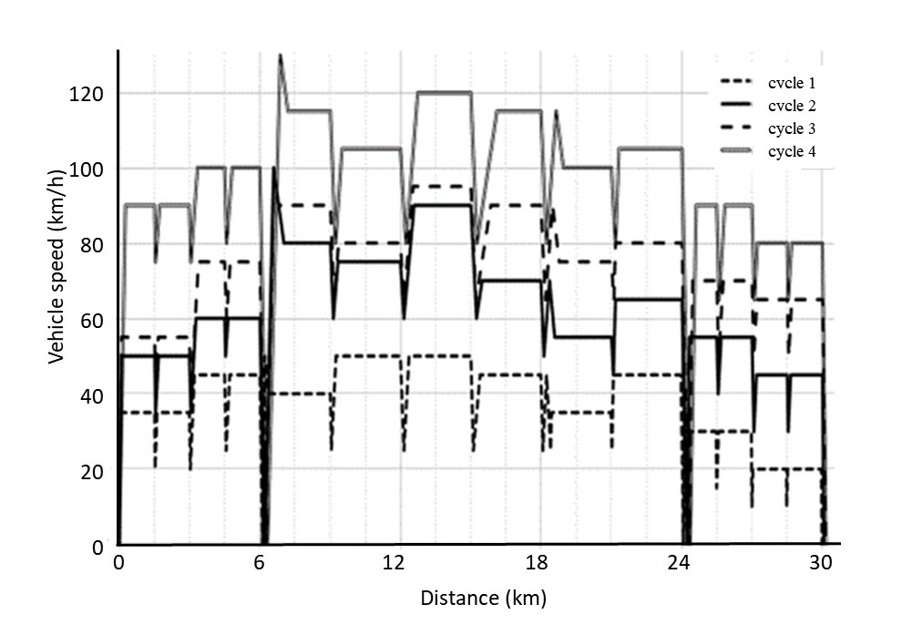**SRC-LeCV, example distance accumulation characteristics for all four cycles**

2.9.2. SRC-LeCV detailed cycle instructions

Table A1/3

**Actions and sub-actions for each cycle and sub-cycle, lap 1, 2 and 3**

| Cycle: | | | | | 1 | | 2 | | 3 | | 4 | |
| --- | --- | --- | --- | --- | --- | --- | --- | --- | --- | --- | --- | --- |
| Lap | Sub-lap | Action | Sub-action | Time (s) | To/at | By | To/at | By | To/at | By | To/at | By |
| 1 | 1st 1/4 |  |  |  | (km/h) | | | | | | | |
|  |  | Stop & Idle |  | 10 |  |  |  |  |  |  |  |  |
|  |  | Accelerate | Hard |  | 35 |  | 50 |  | 55 |  | 90 |  |
|  |  | Cruise |  |  | 35 |  | 50 |  | 55 |  | 90 |  |
|  | 2nd 1/4 |  |  |  |  |  |  |  |  |  |  |  |
|  |  | Decelerate | Moderate |  |  | 15 |  | 15 |  | 15 |  | 15 |
|  |  | Accelerate | Moderate |  | 35 |  | 50 |  | 55 |  | 90 |  |
|  |  | Cruise |  |  | 35 |  | 50 |  | 55 |  | 90 |  |
|  | 3rd 1/4 |  |  |  |  |  |  |  |  |  |  |  |
|  |  | Decelerate | Moderate |  |  | 15 |  | 15 |  | 15 |  | 15 |
|  |  | Accelerate | Moderate |  | 45 |  | 60 |  | 75 |  | 100 |  |
|  |  | Cruise |  |  | 45 |  | 60 |  | 75 |  | 100 |  |
|  | 4th 1/4 |  |  |  |  |  |  |  |  |  |  |  |
|  |  | Decelerate | Moderate |  |  | 20 |  | 10 |  | 15 |  | 20 |
|  |  | Accelerate | Moderate |  | 45 |  | 60 |  | 75 |  | 100 |  |
|  |  | Cruise |  |  | 45 |  | 60 |  | 75 |  | 100 |  |
| 2 | 1st 1/2 |  |  |  |  |  |  |  |  |  |  |  |
|  |  | Decelerate | Coast-through |  | 0 |  | 0 |  | 0 |  | 0 |  |
|  |  | Stop & Idle |  | 10 |  |  |  |  |  |  |  |  |
|  |  | Accelerate | Hard |  | 50 |  | 100 |  | 100 |  | 130 |  |
|  |  | Decelerate | Coast-down |  |  | 10 |  | 20 |  | 10 |  | 15 |
|  |  | Optional accel­eration | Hard |  | 40 |  | 80 |  | 90 |  | 115 |  |
|  |  | Cruise |  |  | 40 |  | 80 |  | 90 |  | 115 |  |
|  | 2nd 1/2 |  |  |  |  |  |  |  |  |  |  |  |
|  |  | Decelerate | Moderate |  |  | 15 |  | 20 |  | 25 |  | 35 |
|  |  | Accelerate | Moderate |  | 50 |  | 75 |  | 80 |  | 105 |  |
|  |  | Cruise |  |  | 50 |  | 75 |  | 80 |  | 105 |  |
| 3 | 1st 1/2 |  |  |  |  |  |  |  |  |  |  |  |
|  |  | Decelerate | Moderate |  |  | 25 |  | 15 |  | 15 |  | 25 |
|  |  | Accelerate | Moderate |  | 50 |  | 90 |  | 95 |  | 120 |  |
|  |  | Cruise |  |  | 50 |  | 90 |  | 95 |  | 120 |  |
|  | 2nd 1/2 |  |  |  |  |  |  |  |  |  |  |  |
|  |  | Decelerate | Moderate |  |  | 25 |  | 10 |  | 30 |  | 40 |
|  |  | Accelerate | Moderate |  | 45 |  | 70 |  | 90 |  | 115 |  |
|  |  | Cruise |  |  | 45 |  | 70 |  | 90 |  | 115 |  |

Table A1/4

**Actions and sub-actions for each cycle and sub-cycle, lap 4 and 5**

| Cycle: | | | | | 1 | | 2 | | 3 | | 4 | |
| --- | --- | --- | --- | --- | --- | --- | --- | --- | --- | --- | --- | --- |
| Lap | Sub-lap | Action | Sub-action | Time (s) | To/at | By | To/at | By | To/at | By | To/at | By |
| 4 | 1st 1/2 |  |  |  | (km/h) | | | | | | | |
|  |  | Decelerate | Moderate |  |  | 20 |  | 20 |  | 25 |  | 35 |
|  |  | Accelerate | Moderate |  | 45 |  | 70 |  | 90 |  | 115 |  |
|  |  | Decelerate | Coast-down |  |  | 20 |  | 15 |  | 15 |  | 15 |
|  |  | Optional accel­ eration | Moderate |  | 35 |  | 55 |  | 75 |  | 100 |  |
|  |  | Cruise |  |  | 35 |  | 55 |  | 75 |  | 100 |  |
|  | 2nd 1/2 |  |  |  |  |  |  |  |  |  |  |  |
|  |  | Decelerate | Moderate |  |  | 10 |  | 10 |  | 10 |  | 20 |
|  |  | Accelerate | Moderate |  | 45 |  | 65 |  | 80 |  | 105 |  |
|  |  | Cruise |  |  | 45 |  | 65 |  | 80 |  | 105 |  |
| 5 | 1st 1/4 |  |  |  |  |  |  |  |  |  |  |  |
|  |  | Decelerate | Coast-through |  | 0 |  | 0 |  | 0 |  | 0 |  |
|  |  | Stop & Idle |  | 45 |  |  |  |  |  |  |  |  |
|  |  | Accelerate | Hard |  | 30 |  | 55 |  | 70 |  | 90 |  |
|  |  | Cruise |  |  | 30 |  | 55 |  | 70 |  | 90 |  |
|  | 2nd 1/4 |  |  |  |  |  |  |  |  |  |  |  |
|  |  | Decelerate | Moderate |  |  | 15 |  | 15 |  | 20 |  | 25 |
|  |  | Accelerate | Moderate |  | 30 |  | 55 |  | 70 |  | 90 |  |
|  |  | Cruise |  |  | 30 |  | 55 |  | 70 |  | 90 |  |
|  | 3rd 1/4 |  |  |  |  |  |  |  |  |  |  |  |
|  |  | Decelerate | Moderate |  |  | 20 |  | 25 |  | 20 |  | 25 |
|  |  | Accelerate | Moderate |  | 20 |  | 45 |  | 65 |  | 80 |  |
|  |  | Cruise |  |  | 20 |  | 45 |  | 65 |  | 80 |  |
|  | 4th 1/4 |  |  |  |  |  |  |  |  |  |  |  |
|  |  | Decelerate | Moderate |  |  | 10 |  | 15 |  | 15 |  | 15 |
|  |  | Accelerate | Moderate |  | 20 |  | 45 |  | 65 |  | 80 |  |
|  |  | Cruise |  |  | 20 |  | 45 |  | 65 |  | 80 |  |
|  |  | Decelerate | Coast-through |  | 0 |  | 0 |  | 0 |  | 0 |  |

2.9.3. Soak procedures in the SRC-LeCV

The SRC-LeCV soak procedure shall consist of the following steps

2.9.3.1. a full SRC-LeCV sub-cycle (approximately 30 km) shall be completed

2.9.3.2. a test Type I emission test may be performed if deemed necessary for statistical relevance;

2.9.3.3. any required maintenance shall be undertaken and the test vehicle may be refuelled;

2.9.3.4. the test vehicle shall be set to idle with the combustion engine running for a minimum of one hour with no user input;

2.9.3.5. the propulsion of the test vehicle shall be turned off

2.9.3.6. the test vehicle shall be cooled down and soaked under ambient conditions for a minimum of six hours (or four hours with a fan and lubrication oil at ambient temperature);

2.9.3.7. the vehicle may be refuelled and distance accumulation shall be resumed as required at lap 1, sub-lap 1 of the SRC-LeCV sub-cycle in Table A1/3.

2.9.3.8. the SRC-LeCV soak procedure shall not replace the regular soak time for Type I emission test laid down in Annex 1 of Amendment 5 to UN GTR No. 2. The SRC-LeCV soak procedure may be coordinated so as to be performed after each maintenance interval or after each emission laboratory test.

2.9.3.9. Test Type V soak procedure for actual durability testing with full distance accumulation

2.9.3.9.1. During the full distance accumulation phase set out in paragraph 2.3.1. of this GTR, the test vehicles shall undergo a minimum number of soak procedures set out in Table A1/5. These procedures shall be evenly distributed over the accumulated distance.

2.9.3.9.2. The number of soak procedures to be conducted during the full distance accumulation phase shall be determined according to the following table:

Table A1/5

**Number of soak procedure depending on the SRC-LeCV in Table A1/1**

| *SRC-LeCV, cycle No* | *Minimum number of test Type V soak procedure* |
| --- | --- |
|  |  |
| 1 & 2 | 3 |
| 3 | 4 |
| 4 | 6 |

2.9.3.10. Test Type V soak procedure for actual durability testing with partial distance accumulation

During the partial mileage accumulation phase set out in paragraph 2.3.2. of this GTR, the test vehicles shall undergo four soak procedures. These procedures shall be evenly distributed over the accumulated mileage.

Annex 2

The USA EPA Approved Mileage Accumulation Cycle (AMA)

1. Introduction

1.1. The Approved Mileage Accumulation cycle (AMA) by the Environmental Protection Agency (EPA) of the United States of America (USA) is a distance accumulation driving schedule used to age test vehicles and their pollution-control devices in a way that is repeatable. The test vehicles may run the driving schedule on the road, on a test track or on a distance accumulation chassis dynamometer.

1.2. The AMA driving schedule shall be completed by repeating the AMA sub-cycle in paragraph 2. until the applicable durability distance in paragraph 2.4. of this GTR has been accumulated.

1.3. The AMA test cycle shall be composed of 11 sub-sub-cycles covering six kilometres each.

2. AMA distance accumulation cycle requirements

2.1. For the purpose of accumulating distance in the AMA test cycle, the vehicles shall be grouped as follows:

Table A2/1

**Grouping of vehicles for the purpose of the AMA durability test**

| *Vehicle Class* | *Engine capacity (cm3)* | *Maximum speed (km/h)* |
| --- | --- | --- |
|  |  |  |
| I | <150 | Not applicable |
| II | ≥150 | <130 |
| III | ≥150 | ≥130 |

2.2. If the AMA test cycle is performed on a kilometre accumulation chassis dynamometer, the distance travelled shall be calculated from the number of rotations of the roller and the roller circumference.

2.3. One AMA test sub-cycle shall be performed as follows:

2.3.1. Driving schedule AMA test sub-sub-cycle

Figure A2/1

**Driving schedule AMA test sub-sub-cycle**

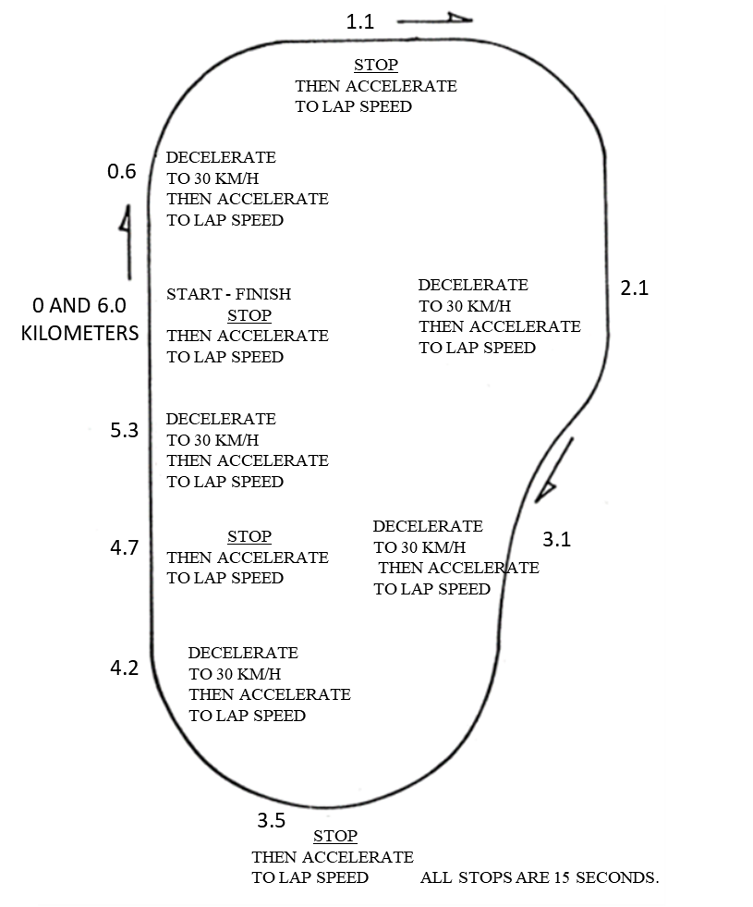

2.3.2. The AMA test cycle consisting of 11 sub-sub-cycles shall be driven at the following sub-sub-cycle vehicle speeds:

Table A2/2

**Maximum vehicle speed in one AMA sub-cycle**

| *Sub-sub-cycle No* | *Class I vehicle*  *(km/h)* | *Class II vehicle*  *(km/h)* | *Class III vehicle*  *Option I*  *(km/h)* | *Class III vehicle*  *Option II*  *(km/h)* |
| --- | --- | --- | --- | --- |
|  |  |  |  |  |
| 1 | 65 | 65 | 65 | 65 |
| 2 | 45 | 45 | 65 | 45 |
| 3 | 65 | 65 | 55 | 65 |
| 4 | 65 | 65 | 45 | 65 |
| 5 | 55 | 55 | 55 | 55 |
| 6 | 45 | 45 | 55 | 45 |
| 7 | 55 | 55 | 70 | 55 |
| 8 | 70 | 70 | 55 | 70 |
| 9 | 55 | 55 | 46 | 55 |
| 10 | 70 | 90 | 90 | 90 |
| 11 | 70 | 90 | 110 | 110 |

2.3.3. Manufacturers may select one of two cycle vehicle speed options for class III vehicles, completing the entire procedure on their selected option.

2.3.4. During the first nine AMA sub-sub-cycles, the test vehicle is stopped four times with the engine idling each time for 15 seconds.

2.3.5. The AMA sub-cycle shall consist of five decelerations in each sub-sub-cycle, dropping from cycle vehicle speed to 30 km/h. The test vehicle shall then gradually be accelerated again until the cycle vehicle speed shown in Table A2/2 is attained.

2.3.6. The 10th sub-sub-cycle shall be carried out at a steady vehicle speed according to the vehicle class as referred in Table A2/1.

2.3.7. The 11th sub-sub-cycle shall begin with a maximum acceleration from stop point up to lap vehicle speed. At halfway, the brakes are applied normally until the test vehicle comes to a stop. This shall be followed by an idle period of 15 seconds and a second maximum acceleration. This completes one AMA sub-cycle.

2.3.8. The schedule shall then be restarted from the beginning of the AMA sub-cycle.

2.3.9. At the manufacturer’s request, and with the agreement of the responsible authority, a vehicle type may be placed in a higher class provided it is capable of complying with all aspects of the procedure for the higher class.

2.3.10. At the manufacturer’s request, and with the agreement of the responsible authority, should the vehicle be unable to attain the specified cycle vehicle speeds for that class, the vehicle type shall be placed in a lower class. If the vehicle is unable to achieve the cycle vehicle speeds required for this lower class, it shall attain the highest possible vehicle speed during the test and full throttle shall be applied if necessary to attain that vehicle speed.

Annex 3

Bench ageing durability test

1. Bench ageing durability test

1.1. The vehicle tested according the procedure laid down in this Annex has driven more than 100 accumulated kilometres after it was first started at the end of the production line.

1.2. The fuel used during the test shall be the one of the specified fuels in Appendix 2. to Annex 4 of Amendment 5 to UN GTR No. 2.

2. Procedure for Vehicles with Positive Ignition Engines

2.1. The following bench ageing procedure shall be applicable for positive-ignition vehicles.

The bench ageing procedure requires the installation of the catalyst-plus-oxygen sensor system on a catalyst ageing bench.

Ageing on the bench shall be conducted by following the standard bench cycle (SBC) for the period of time calculated from the bench ageing time (BAT) equation. The BAT equation requires, as input, catalyst time-at-temperature data measured during the Standard Road Cycle (SRC-LeCV) described in Annex 1. As an alternative, if applicable, the catalyst time-at-temperature data measured during the AMA durability cycle, as described in Annex 2, may be used.

2.2. Standard bench cycle (SBC). Standard catalyst bench ageing shall be conducted following the SBC. The SBC shall be run for the period of time calculated from the BAT equation. The SBC is described in Annex 4.

2.3. Catalyst time-at-temperature data. Catalyst temperature shall be measured during at least two full cycles of the SRC-LeCV cycle as described in Annex 1, or if applicable at least two full cycles of AMA as described in Annex 2.

Catalyst temperature shall be measured at the highest temperature location in the hottest catalyst on the test vehicle. Alternatively, the temperature may be measured at another location providing that it is adjusted to represent the temperature measured at the hottest location using good engineering judgement.

Catalyst temperature shall be measured at a minimum rate of one hertz (one measurement per second).

The measured catalyst temperature results shall be tabulated into a histogram with temperature groups of no larger than 25 °C.

2.4. Bench-ageing time. Bench ageing time shall be calculated using the bench ageing time (BAT) equation as follows:

te for a temperature bin = th\*exp ((R/Tr) – (R/Tv))

Total te = Sum of te over all the temperature groups

bench ageing time = A \*(Total te)

Where:

A = 1.1 This value adjusts the catalyst ageing time to account for deterioration from sources other than thermal ageing of the catalyst.

R = Catalyst thermal reactivity = 18 500

th = The time (in hours) measured within the prescribed temperature bin of the vehicle's catalyst temperature histogram adjusted to a full useful life basis e.g., if the histogram represented 400 km, and useful life is, in accordance with paragraph 2.4. of this GTR, for example for Class 2 vehicle 20 000 km; all histogram time entries would be multiplied by 50 (20 000/400).

Total te = The equivalent time (in hours) to age the catalyst at the temperature of Tr on the catalyst ageing bench using the catalyst ageing cycle to produce the same amount of deterioration experienced by the catalyst due to thermal deactivation over the use for live distance specific for the vehicle class in paragraph 2.4. of this GTR, for example for Class2 vehicle 20 000 km

te for a temperature bin = The equivalent time (in hours) to age the catalyst at the temperature of Tr on the catalyst ageing bench using the catalyst ageing cycle to produce the same amount of deterioration experienced by the catalyst due to thermal deactivation at the temperature bin of Tv over the use for live distance specific for the vehicle class in paragraph 2.4. of this GTR, for example for Class 2 vehicle 20 000 km

Tr = The effective reference temperature (in °K) of the catalyst on the catalyst bench run on the bench ageing cycle. The effective temperature is the constant temperature that would result in the same amount of ageing as the various temperatures experienced during the bench ageing cycle.

Tv = The mid-point temperature (in °K) of the temperature bin of the vehicle on-road catalyst temperature histogram.

2.5. Effective reference temperature on the standard bench cycle (SBC). The effective reference temperature of the SBC shall be determined for the actual catalyst system design and actual ageing bench which will be used using the following procedures:

(a) Measure time-at-temperature data in the catalyst system on the catalyst ageing bench following the SBC. Catalyst temperature shall be measured at the highest temperature location of the hottest catalyst in the system. Alternatively, the temperature may be measured at another location providing that it is adjusted to represent the temperature measured at the hottest location.

Catalyst temperature shall be measured at a minimum rate of one hertz (one measurement per second) during at least 20 minutes of bench ageing. The measured catalyst temperature results shall be tabulated into a histogram with temperature groups of no larger than 10 °C.

(b) The BAT equation shall be used to calculate the effective reference temperature by iterative changes to the reference temperature (Tr) until the calculated ageing time equals or exceeds the actual time represented in the catalyst temperature histogram. The resulting temperature is the effective reference temperature on the SBC for that catalyst system and ageing bench.

2.6. Catalyst ageing bench. The catalyst ageing bench shall follow the SBC and deliver the appropriate exhaust flow and emission level in line with the exhaust flow of engine for which the catalyst is designed, exhaust constituents, and exhaust temperature at the face of the catalyst.

All bench ageing equipment and procedures shall record appropriate information (such as measured A/F ratios and time-at-temperature in the catalyst) to assure that sufficient ageing has actually occurred.

2.7. Required testing. For calculating deterioration factors at least two Type 1 tests before bench ageing of the emission control hardware and at least two Type 1 tests after the bench-aged emission hardware is reinstalled have to be performed on the test vehicle.

Calculation of the deterioration factors has to be done in accordance with the calculation method as specified below.

A multiplicative exhaust emission deterioration factor shall be calculated for each pollutant as follows:

D: E: F:=Mi2/Mi1

Where:

Mi1 =mass emission of the pollutant i in g/km after the type 1 test of a vehicle specified in paragraph 1.1. of this Annex.

Mi2 =mass emission of the pollutant i in g/km after the type test 1 of an aged vehicle according the procedure described in this Annex.

These interpolated values shall be carried out to a minimum of four places to the right of the decimal point before dividing one by the other to determine the deterioration factor. The result shall be rounded to three places to the right of the decimal point.

If a deterioration factor is less than one, it is deemed to be equal to one.

At the request of a manufacturer, an additive exhaust emission deterioration can be used, the factor shall be calculated for each pollutant as follows:

D. E. F. = Mi2 – Mi1

Annex 4

Standard bench cycle (SBC)

1. Introduction

The standard ageing durability procedure consists of ageing a catalyst/oxygen sensor system on an ageing bench which follows the standard bench cycle (SBC) described in this Annex. The SBC requires use of an ageing bench with an engine as the source of feed gas for the catalyst. The SBC is a 60-second cycle which is repeated as necessary on the ageing bench to conduct ageing for the required period of time. The SBC is defined based on the catalyst temperature, engine air/fuel (A/F) ratio, and the amount of secondary air injection which is added in front of the first catalyst.

2. Catalyst temperature control

2.1. Catalyst temperature shall be measured in the catalyst bed at the location where the highest temperature occurs in the hottest catalyst. Alternatively, the feed gas temperature may be measured and converted to catalyst bed temperature using a linear transform calculated from correlation data collected on the catalyst design and ageing bench to be used in the ageing process.

2.2. Control the catalyst temperature at stoichiometric operation (1 to 40 seconds on the cycle) to a minimum of 800 °C (± 10 °C) by selecting the appropriate engine speed, load, and spark timing for the engine. Control the maximum catalyst temperature that occurs during the cycle to 890 °C (± 10 °C) by selecting the appropriate A/F ratio of the engine during the ‘rich’ phase described in the table below.

2.3. If a low control temperature other than 800 °C is utilized, the high control temperature shall be 90 °C higher than the low control temperature.

Table A4/1

**Standard bench cycle (SBC)**

| *Time (seconds)* | *Engine air/fuel ratio* | *Secondary air injection* |
| --- | --- | --- |
|  |  |  |
| 1-40 | Stoichiometric, with load, spark timing, and engine speed controlled to achieve a minimum catalyst temperature of 800 °C | None |
| 41-45 | “Rich” (A/F ratio selected to achieve a maximum catalyst temperature over the entire cycle of 890 °C, or 90° higher than low control temperature) | None |
| 46-55 | “Rich” (A/F ratio selected to achieve a maximum catalyst temperature over the entire cycle of 890 °C, or 90° higher than low control temperature) | 3% (±0.1%) |
| 56-60 | Stoichiometric, same load, spark timing, and engine speed as used in the 1-40 sec period of the cycle | 3% (±0.1%) |

Figure A4/1

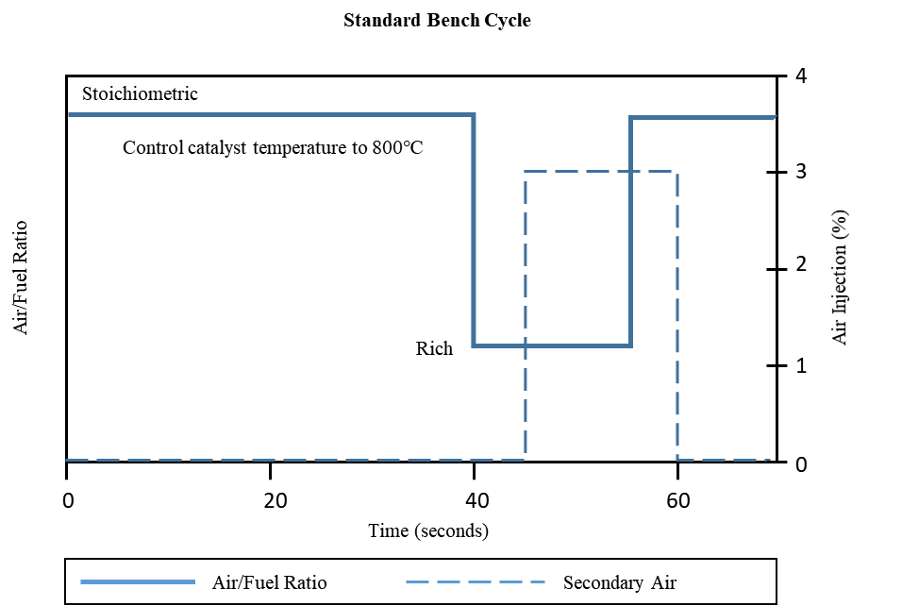**Standard bench cycle (SBC)**

3. Ageing bench equipment and procedures

3.1. Ageing bench configuration. The ageing bench shall provide the appropriate exhaust flow rate, temperature, air-fuel ratio, exhaust constituents and secondary air injection at the inlet face of the catalyst.

The standard ageing bench consists of an engine, engine controller, and engine dynamometer. Other configurations may be acceptable (e.g. whole vehicle on a dynamometer, or a burner that provides the correct exhaust conditions), as long as the catalyst inlet conditions and control features specified in this Annex are met.

A single ageing bench may have the exhaust flow split into several streams providing that each exhaust stream meets the requirements of this Annex. If the bench has more than one exhaust stream, multiple catalyst systems may be aged simultaneously.

3.2. Exhaust system installation. The entire catalyst(s)-plus-oxygen sensor(s) system, together with all exhaust piping which connects these components, will be installed on the bench. For engines with multiple exhaust streams, each bank of the exhaust system will be installed separately on the bench in parallel.

For exhaust systems that contain multiple in-line catalysts, the entire catalyst system including all catalysts, all oxygen sensors and the associated exhaust piping will be installed as a unit for ageing. Alternatively, each individual catalyst may be separately aged for the appropriate period of time.

3.3. Temperature measurement. Catalyst temperature shall be measured using a thermocouple placed in the catalyst bed at the location where the highest temperature occurs in the hottest catalyst. Alternatively, the feed gas temperature just before the catalyst inlet face may be measured and converted to catalyst bed temperature using a linear transform calculated from correlation data collected on the catalyst design and ageing bench to be used in the ageing process. The catalyst temperature shall be stored digitally at the speed of 1 hertz (one measurement per second).

3.4. Air/Fuel measurement. Provisions shall be made for the measurement of the air/fuel (A/F) ratio (such as a wide-range oxygen sensor) as close as possible to the catalyst inlet and outlet flanges. The information from these sensors shall be stored digitally at the speed of 1 hertz (one measurement per second).

3.5. Exhaust flow balance. Provisions shall be made to assure that the proper amount of exhaust (measured in grams/second at stoichiometry, with a tolerance of ± 5 grams/second) flows through each catalyst system that is being aged on the bench.

The proper flow rate is determined based upon the exhaust flow that would occur in the original vehicle's engine at the steady state engine speed and load selected for the bench ageing in paragraph 3.6.

3.6. Setup. The engine speed, load, and spark timing are selected to achieve a catalyst bed temperature of 800 °C (± 10 °C) at steady-state stoichiometric operation.

The air injection system is set to provide the necessary air flow to produce 3.0 % oxygen (± 0.1 %) in the steady-state stoichiometric exhaust stream just in front of the first catalyst. A typical reading at the upstream A/F measurement point (required in paragraph 3.4 of this Annex) is lambda 1.16 (which is approximately 3 % oxygen).

With the air injection on, set the ‘Rich’ A/F ratio to produce a catalyst bed temperature of 890 °C (± 10 °C). A typical A/F value for this step is lambda 0.94 (approximately 2 % CO).

3.7. Ageing cycle. The standard bench ageing procedures use the standard bench cycle (SBC). The SBC is repeated until the amount of ageing calculated from the bench ageing time (BAT) equation is achieved.

3.8. Quality assurance. The temperatures and A/F ratio in paragraph 3.3. and 3.4. shall be reviewed periodically (at least every 50 hours) during ageing. Necessary adjustments shall be made to assure that the SBC is being appropriately followed throughout the ageing process.

After the ageing has been completed, the catalyst time-at-temperature collected during the ageing process shall be tabulated into a histogram with temperature groups of no larger than 10 °C. The BAT equation and the calculated effective reference temperature for the ageing cycle in accordance with paragraph 2.4. of Annex 3 will be used to determine if the appropriate amount of thermal ageing of the catalyst has in fact occurred. Bench ageing will be extended if the thermal effect of the calculated ageing time is not at least 95 % of the target thermal ageing.

3.9. Startup and shutdown. Care should be taken to assure that the maximum catalyst temperature for rapid deterioration (e.g., 1 050 °C) does not occur during startup or shutdown. Special low temperature startup and shutdown procedures may be used to alleviate this concern.

4. Experimentally determining the R-factor for bench ageing durability procedures

4.1. The R-factor is the catalyst thermal reactivity coefficient used in the bench ageing time (BAT) equation. Manufacturers may determine the value of R experimentally using the following procedures.

4.2. Using the applicable bench cycle and ageing bench hardware, age several catalysts (minimum of 3 of the same catalyst design) at different control temperatures between the normal operating temperature and the damage limit temperature. Measure emissions (or catalyst inefficiency (1-catalyst efficiency)) for each exhaust constituent. Assure that the final testing yields data between one- and two-times the emission standard.

4.3. Estimate the value of R and calculate the effective reference temperature (Tr) for the bench ageing cycle for each control temperature in accordance with paragraph 2.4. of Annex 3.

4.4. Plot emissions (or catalyst inefficiency) versus ageing time for each catalyst. Calculate the least-squared best- fit line through the data. For the data set to be useful for this purpose the data should have an approximately common intercept between 0 and 6 400 km (ca. 400mi). See Figure A4/2 for an example.

4.5. Calculate the slope of the best-fit line for each ageing temperature.

4.6. Plot the natural log (ln) of the slope of each best-fit line (determined in paragraph 4.5.) along the vertical axis, versus the inverse of ageing temperature (1/(ageing temperature, deg K)) along the horizontal axis, calculate the least squared best-fit lines through the data. The slope of the line is the R-factor. See Figure A4/3 for an example.

Figure A4/2

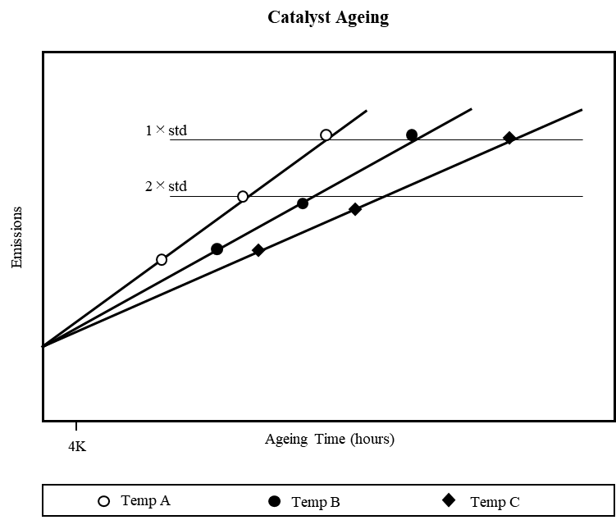**Catalyst Ageing**

4.7. Compare the R-factor to the initial value that was used in accordance with paragraph 4.3. If the calculated R-factor differs from the initial value by more than 5 %, choose a new R-factor that is between the initial and calculated values, and then repeat steps of paragraph 4., to derive a new R-factor. Repeat this process until the calculated R-factor is within 5 % of the initially assumed R-factor.

4.8. Compare the R-factor determined separately for each exhaust constituent. Use the lowest R-factor (worst case) for the BAT equation.

Figure A4/3

**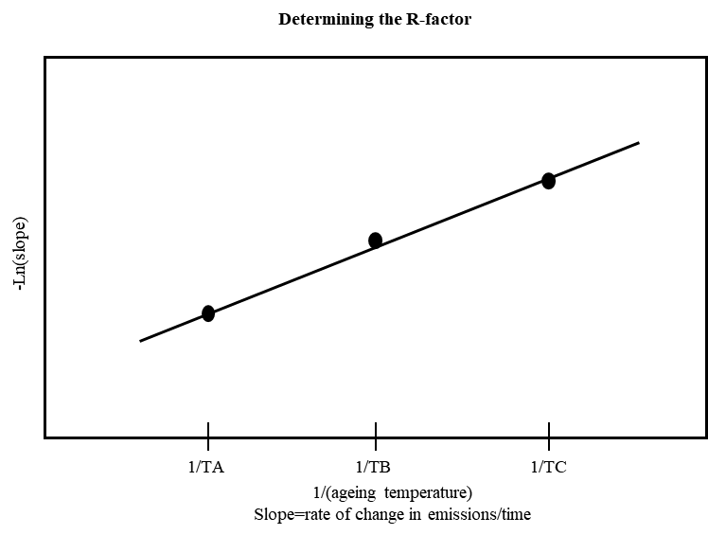Determining the R-factor**

Annex 5

Test vehicle requirements test Type V

1. The test vehicles used for Type V durability testing and in particular the pollution-control and peripheral devices that are relevant for the emission abatement system shall be representative of the vehicle type with regard to environmental performance produced in series and placed on the market.

2. The test vehicles shall be in good mechanical order at the start of distance accumulation and it shall not have more than 100 km accumulated after it was first started at the end of the production line. The propulsion and pollution-control devices shall not have been used since its manufacture, with the exception of quality control tests and accumulation of the first 100 km.

3. Regardless of the durability test procedure selected by the manufacturer, all pollution-control devices and systems, both including hardware, powertrain software and powertrain calibration, fitted on the test vehicles shall be installed and operating for the entire distance accumulation period.

4. The pollution-control devices on the test vehicles shall be permanently marked under surveillance of the responsible authority before the start of distance accumulation and be listed together with the vehicle identification number, powertrain software and powertrain calibration sets. The manufacturer shall make that list available at the request of the responsible authority.

5. Maintenance, adjustments and the use of the controls of the test vehicles shall be as recommended by the manufacturer in the appropriate repair and maintenance information and in the user manual.

6. The durability test shall be conducted with a suitable commercially available fuel at the discretion of the manufacturer. If the test vehicles is/are equipped with a two-stroke engine, lubricating oil shall be used in the proportion and of the grade recommended by the manufacturer in the user manual.

7. The test vehicles’ cooling system shall enable the vehicle to operate at temperatures similar to those obtained during normal road use conditions (oil, coolant, exhaust system, etc.).

8. If the durability test is completed on a test track or road, the reference mass of the test vehicle shall be at least equal to that used for Type I emission tests conducted on a chassis dynamometer.

9. If certified by the responsible authority, the Type V test procedure may be carried out using a test vehicle of which the body style, gear box (automatic or manual) and wheel or tyre size differ from those of the vehicle type for which the environmental performance certification is sought.

Annex 6

Tests of a replacement pollution-control device

1. Scope of the annex

This Annex applies to the pollution-control devices to be fitted as replacement parts on one or more types of vehicle in the scope of this GTR.

2. Requirements

2.1. Requirements regarding pollutant tailpipe emissions

2.1.1. The manufacturer of the replacement pollution-control device shall prepare a vehicle(s) of a type certified in accordance with Amendment 5 to UN GTR No. 2 equipped with a new original equipment pollution-control device. This (these) vehicles shall be selected by the applicant with the agreement of the authority. It (they) shall comply with the requirements of the Type I test set out in Annex 1 of Amendment 5 to UN GTR No. 2.

The vehicle referred to in paragraph 3.2.1., equipped with a replacement pollution-control device is requested, shall undergo the tests laid down in Annex 1 and 2(depending on the certification of the vehicle) of Amendment 5 to UN GTR No. 2 and either Annex 1, Annex 2, Annex 3 or Annex 4 of this GTR.

2.1.1.1. Evaluation of pollutant tailpipe emissions from vehicles equipped with replacement pollution-control devices

Requirements regarding tailpipe are deemed to be complied with if the test vehicle equipped with the replacement pollutant-control device complies with the limit values in Amendment 5 to UN GTR No. 2.

Annex 7

Vehicle propulsion family with regard to environmental performance demonstration tests

1. Introduction

1.1. In order to alleviate the test burden on manufacturers when demonstrating the environmental performance of vehicles these may be grouped as a vehicle propulsion family. One or more parent vehicles shall be selected from this group of vehicles by the manufacturer to the satisfaction of the responsible authority that shall be used to demonstrate environmental performance test types I, and V.

1.2. A two- and three-wheeled vehicle may continue to be regarded as belonging to the same vehicle propulsion family provided that the vehicle variant, version, propulsion, pollution-control system listed in Table A4.App8/1 of Amendment 5 to UN GTR No. 2 are identical or remain within the prescribed and declared tolerances.

2. Vehicle and propulsion family attribution with regard to environmental performance tests

For the environmental test types I and V, a representative parent vehicle shall be selected within the boundaries set by the classification criteria laid down in paragraph 2. of Appendix 8 to Annex 4 of Amendment 5 to UN GTR No. 2.

Table A7/1

**Classification criteria propulsion family with regard to test types I, II, V, VII and VIII**

|  |  |  |  |  |  |  |  |
| --- | --- | --- | --- | --- | --- | --- | --- |
|  | classification criteria description | Test type I | Test type II | Test type V | Test type VII | Test type VIII | |
|  | | | | | | Stage I | Stage II |
| 1. | **Vehicle** | | | | | | |
| 1.1. | category | X | X | X | X | X | X |
| 1.2. | sub-category | X | X | X | X | X | X |
| 1.3. | the inertia of vehicle variant(s) or version(s) within two inertia categories above or below the nominal inertia category: | X |  | X | X | X | X |

1. \* In accordance with the programme of work of the Inland Transport Committee for 2022 as outlined in proposed programme budget for 2022 (A/76/6 (Sect.20), para 20.76), the World Forum will develop, harmonize and update UN Regulations in order to enhance the performance of vehicles. The present document is submitted in conformity with that mandate. [↑](#footnote-ref-2)
2. \* Page numbers will be added at a later stage [↑](#footnote-ref-3)