INF.6
Economic Commission for Europe  Inland Transport Committee  Working Party on the Transport of Perishable Foodstuffs  Seventy-seventh session  Geneva, 26-29 October 2021  Item 5 (b) of the provisional agenda  Proposals of amendments to ATP:  new proposals | 19 October 2021  English

Proposed list of major components
Transmitted by Transfrigoroute International
Summary
Executive summary: Following a proposal from Germany (ECE/TRANS/WP.11/2019/4), it was agreed that drafting a list of components that might affect the cooling capacity of the unit was necessary to clarify the meaning of the expression “no modification to major components” and the representatives of Transfrigoroute International offer to submit a proposal for consideration.
Action to be taken: Annex 1, Appendix 2, Model No. 12
Annex 1, Appendix 2, Model No. 1 A
Related documents: Report of the 75th session of WP11 from 2019.
ECE/TRANS/WP.11/2021/17 (Germany)
Introduction
In the report of the 75th, WP11 session from 2019, it was requested to TI to provide a list of Major components (as detailed below).
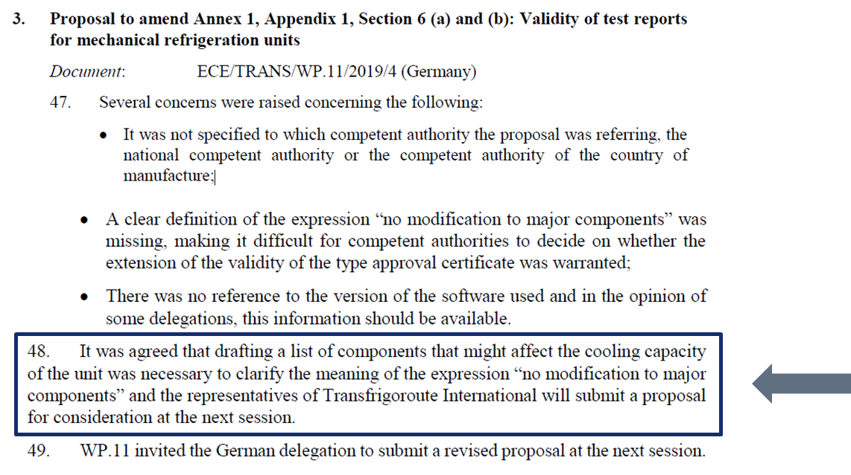
Proposal
The proposal below is mainly based on existing Model 1 A and Model 12 of Annex 1, Appendix 2.
Today if we make a high-level functional analysis of a special equipment for the Transport of Perishable Foodstuffs, we could list different functions as below:
- Power generation/Power source
- Cold/heat production & distribution
- Insulation.
Transfrigoroute International suggest to clearly separate components related to each of above functions.
- List of major components related to Power generation/Power source
(as per Annex 1, Appendix 2, Model No. 12)

Compressor drive
Electrical motor | Type
 | Nominal power | kW
 | Nominal speed | rpm
 | Supply voltage | V
 | Supply frequency | Hz
Internal Combustion Engine | Type
 | Number of cylinders
 | Cubic capacity | cc
 | Nominal power | kW
 | Nominal speed | rpm
 | Fuel
Hydraulic motor | Type
 | Method of drive
Alternator | Type
 | Method of drive
Other mechanical | Nominal speed | rpm
 | Minimum speed | rpm
In regard to the multiple development of alternative power source for vehicles, including electrification, Transfrigoroute International suggest adjusting the list of major components related to Power generation/Power source as follow.
- List of major components related to Power generation/Power source
(Transfrigoroute International proposal Oct. 2021)

Compressor drive
Electrical power source  Electrical motor  Alternator  Inverter/converter  ePTO  Battery  etc | Type
 | Current type (AC/DC)
 | Nominal power | kW
 | Nominal speed (if applicable) | rpm
 | Supply voltage | V
 | Supply frequency | Hz
Internal Combustion Engine | Type
 | Number of cylinders
 | Cubic capacity | cc
 | Nominal power | kW
 | Nominal speed | rpm
 | Fuel | see note below
Hydraulic motor | Type
 | Method of drive
Other mechanical | Nominal speed | rpm
 | Minimum speed | rpm

For Fuel type, please refer to the standards below (several fuel type could be mentiononed
Fuel type | Industry standard
Road + Non-Road Gasoil | EN 590
HVO - XTL | EN 15940
Fatty Acid Methyl Esters (FAME) | EN 14214:2012 + A1:2014
High FAME diesel fuel (B20 and B30) | EN 16709:2015 + A1:2018
High FAME diesel fuel (B20 and B30) | EN 16709:2015 + A1:2019
Natural gas or Biogas (CNG, LNG) | No standards

- List of major components related to Cold/heat production & distribution
(as per Annex 1, Appendix 2, Model No. 12)

Refrigerant | Refrigerant fluid
 | Refrigerant charge | kg
Compressor | Type
 | Number of cylinders
 | Cubic capacity | cc
 | Nominal speed of rotation | rpm
Heat exchangers  Condenser  Evaporator(s) | Type
 | Number of tubes
 | Fan pitch | mm
 | Nature of tube
 | Diameter of tube | mm
 | Exchange surface area | m2
 | Frontal area | m2
Heat exchangers Fans | Number of fans
 | Number of blades per fan
 | Diameter of fan | mm
 | Nominal power | W
 | Total nominal output at defined pressure | (m3/h)
 | Method of drive
Expansion valve | Type

- List of major components related to Insulation
(as per Annex 1, Appendix 2, Model No. 1 A)

Principal dimensions | Total inside surface area Si of body | m²
 | Total outside surface area Se of body | m²
Specifications of the body walls * | Top
 | Bottom
 | Sides
Structural pecularities of body | Number, position and dimensions of doors
 | Number, position and dimensions of vents
 | Number, position and dimensions of ice-loading apertures
Accessories** | Number and type
*: Nature and thickness of materials constituting the body walls
**: Accessories that can have an impact on K coefficient
Justification
Cost: | No cost impact
Feasibility: | The proposal can easily be implemented in ATP.  A transitional period is not needed.
Impact: | Thanks to this proposal, ATP could be easier to apply in case of multiple power source. This case will become more and more frequent, so it is important that ATP get adapted.
Enforceability: | Updated Model 12 could be monitored

