Proposal to revise document ECE/TRANS/WP.29/GRSG/2021/34
Proposal for supplement 1 to 01 Series of amendments to UN Regulation No. 160

Submitted by the Informal Working Group on EDR/DSSAD *
The text reproduced below was prepared by the experts from the Informal Working Group on EDR/DSSAD to revise document ECE/TRANS/WP.29/GRSG/2021/34 to clarify, supplement and correct that document’s text as regards to guidance on Event Data Recorder (EDR) Performance Elements. These revisions are based on continued efforts by the EDR/DSSAD IWG experts to resolve the remaining open issues regarding the EDR provisions in that document especially those that are currently in brackets.
The modifications to document ECE/TRANS/WP.29/GRSG/2021/34 are marked in bold for new or strikethrough for deleted characters.
For additional clarity and context, the entire document with proposed amendments marked up with respect to the original ECE/TRANS/WP.29/2021/058e document has been included as an Appendix.

- Proposal
Paragraph 2. Definitions, amend to add or modify the following definition(s) to be placed in alphabetical order with associated paragraph numbers to be revised accordingly:

2.xx “Adaptive cruise control” is a system which accelerates or decelerates the vehicle to automatically maintain a driver pre-set speed and driver pre-set gap distance from the vehicle in front.
2.xx “Advanced emergency braking system status” means the operating status of a system which can automatically detect an imminent forward collision and activate the vehicle braking system to decelerate the vehicle with the purpose of avoiding or mitigating a collision.

Justification – Incorporation of the above definitions is necessary to support the addition of these data elements.

2.6754. "Vehicle roll rate" means the change in angle over time of the vehicle about its X-axis as determined by the sensing system. The manufacturer will indicate the direction of positive roll rate.
2.6855. "Vehicle yaw rate" means the change in angle over time of the vehicle about its Z-axis as determined by the sensing system. The manufacturer will indicate the direction of positive yaw rate.

Justification – Moves previously added clarification from the definition to a footnote in the data table.

2.21. “Far-side impact centre center air bag deployment, time to deploy" means the deployment time of an air bag between driver and front seat passenger, relative to Time 0.
2.6451. "X-direction" means in the direction of the vehicle’s X-axis, which is parallel to the vehicle's longitudinal “centreline” centerline. The X-direction is positive in the direction of forward vehicle travel.

Justification - Amends the above definitions to correct the spelling of “centre” and “centreline”.

Annex 4. Data elements and format, amend data element tables as follows:

Add footnote to Table 1,“Minimum range” and “Resolution” to clarify system state terms that are functionally interchangeable. Note – Renumbering of footnote for “Accuracy” does have the “#4” struck through , however, it does not show up clearly in the modified text.
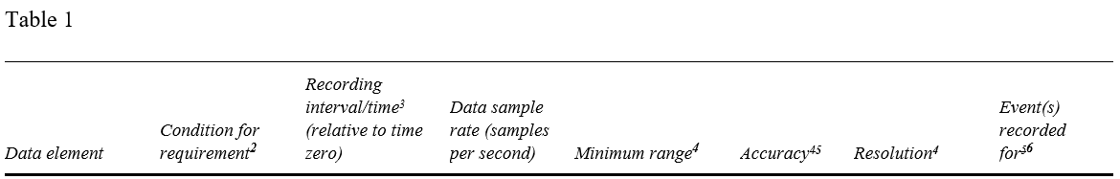
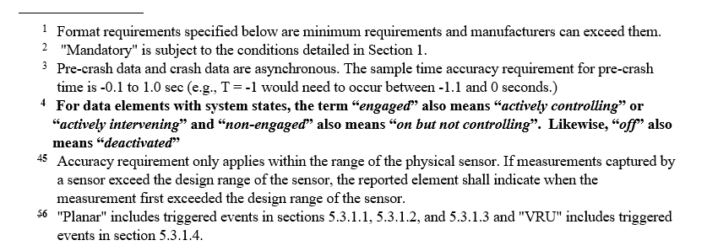

Justification – Clarification is necessary to avoid confusion regarding system state nomenclature.

Amend “recording internal/time” for Table 1 data elements “Lateral acceleration”, “Normal acceleration”, “Vehicle roll angle” and “Vehicle roll rate” and add a footnote indicating that the recording interval for rollover events starts at the time at which the event is determined to have started as defined by the manufacturer.
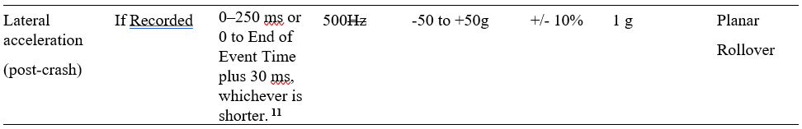
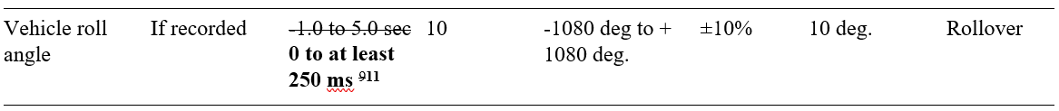
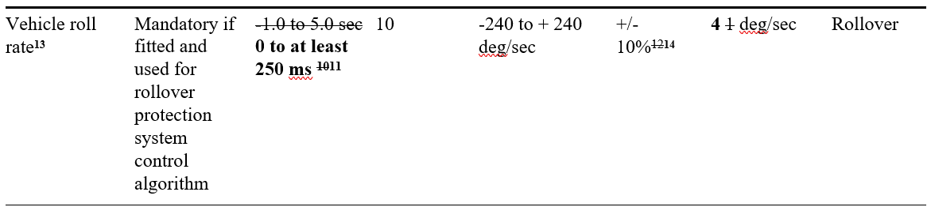
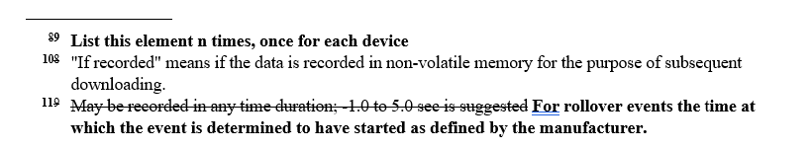
Justification – Amendment makes this requirement more objective by specifying a specific minimum time period. In addition, for rollover events, manufacturers employ a variety of triggering methods and thus the manufacturer needs to define the time at which the event is determined to have started.

Amend “Roll rate” and “Yaw rate” data elements to add a footnote indicating that manufacturer will indicate the direction for positive roll and yaw rates.
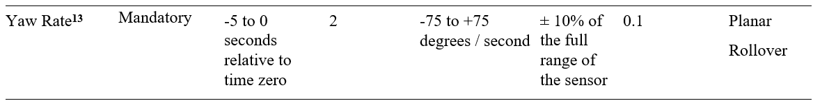

Justification – Amendment is necessary since there are differences in the ISO and SAE coordinate systems such that there is not a harmonized positive direction for roll and yaw directions. As a result, it is necessary to permit vehicle manufacturers to indicate the positive direction for the coordinate system they have implemented.

Amend “Speed, vehicle indicated” data element to add “Rollover” to the event’s recorded column.
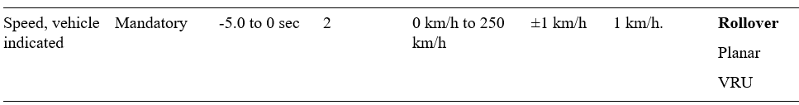
Justification – Corrects an inadvertent omission.

Amend data sample rate units for Lateral acceleration (post-crash), Longitudinal acceleration (post-crash), Normal acceleration (post-crash), Longitudinal acceleration (pre-crash), and Lateral acceleration (pre-crash) by removing “Hz” units to make the table consistent and avoid mixing units of measure.
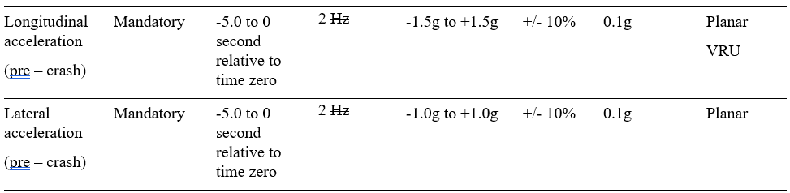

Amend “Complete file recorded” data element to remove “yes, no” since that information is captured in the “Minimum range” and “Resolution” Columns.

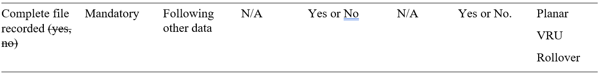

Amend “Cruise Control System” data element title to include “status”.
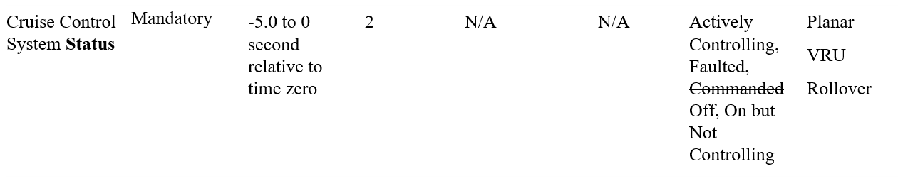

Justification – inclusion of “status” in the data element title is needed to clarify the intent of the date element.

Amend the “Advanced emergency braking system status” system states in the resolution column to use consistent terminology with respect to “engaged”/”non-engaged” (see added footnote #4 above).

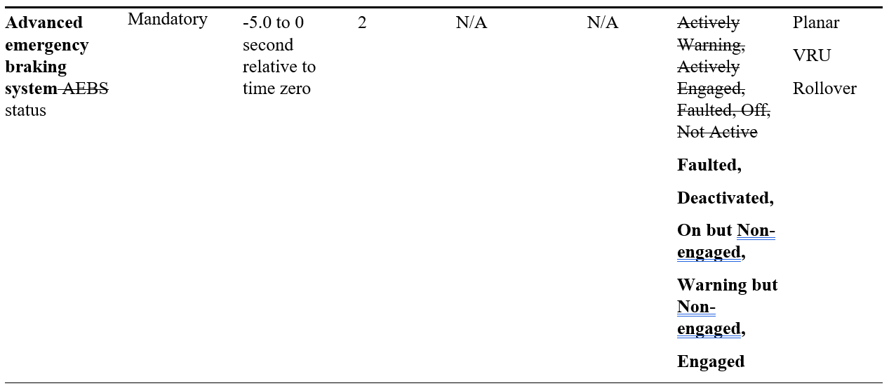

Amend the “Lane departure warning system status” system states in the resolution column to remove the strikethrough thus reverting to the original text (ECE/TRANS/WP.29/2021/58).

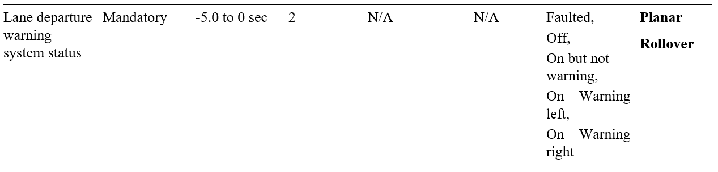

Justification – EDR/DSSAD IWG believes this text best describes the appropriate system states.

Amend the “Corrective steering function status” and “Emergency steering function status” system states in the resolution column to use consistent terminology with respect to “engaged”/”non-engaged” (see added footnote #4 above).

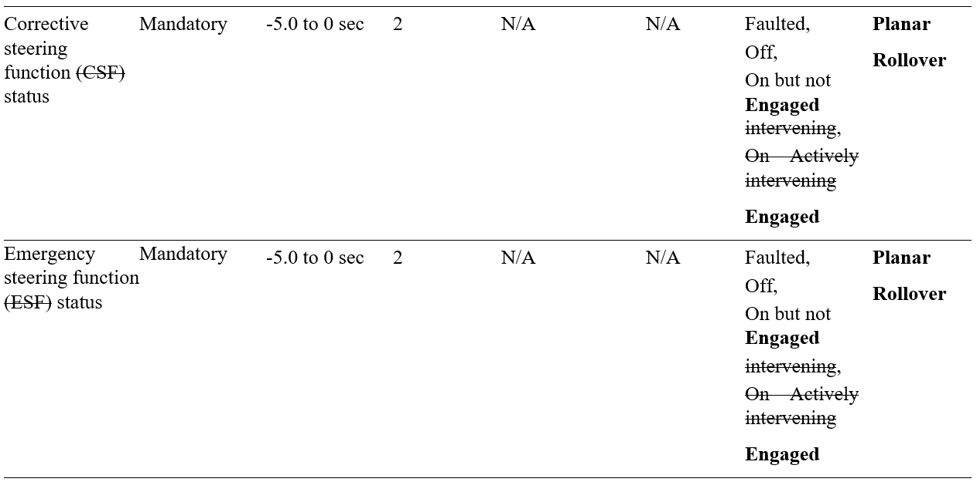

Amend “Cruise control system” and “Adaptive cruise control status” data element system status states to adopt common usage of “Engaged” and “Non-engaged”.

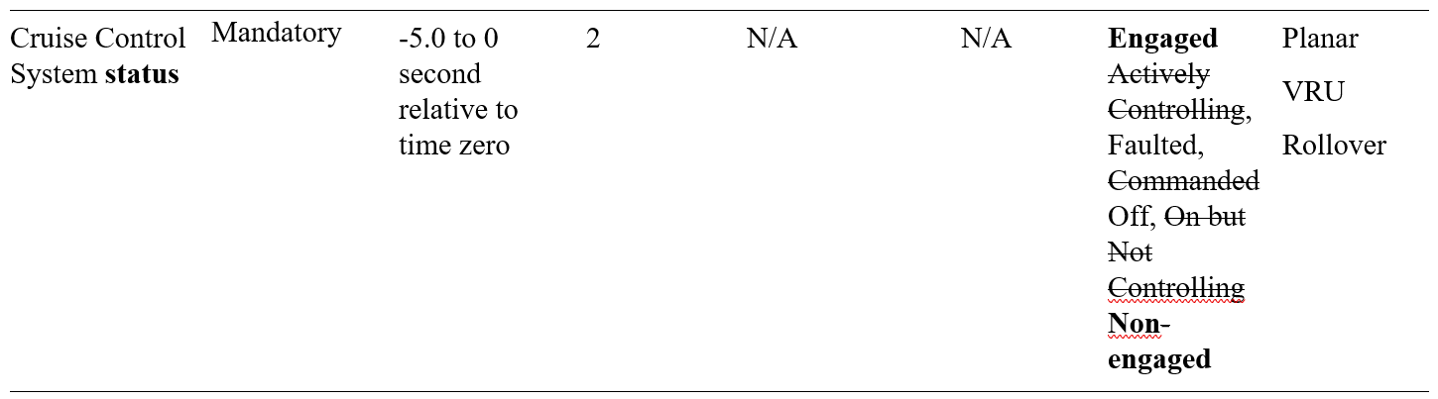
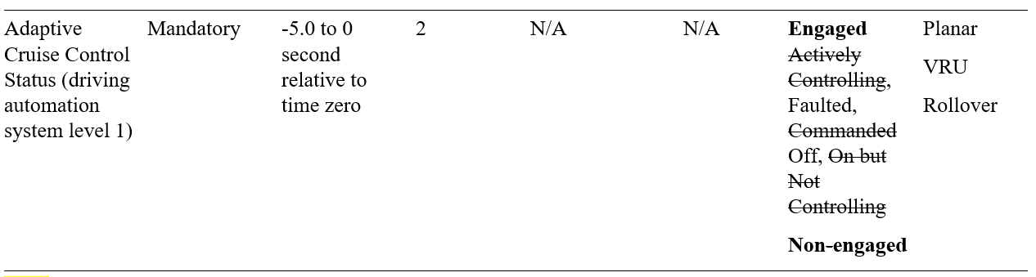

Amend “Far-side impact centre air bag deployment time to deploy” data element title to correct spelling of “centre”.

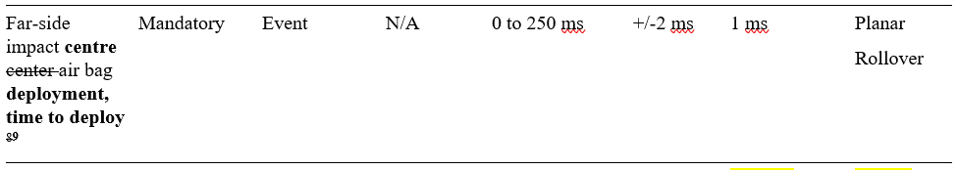
Appendix
Proposed amendments to the Guidance on Event Data Recorder (EDR) Performance Elements Appropriate for Adoption in 1958 and 1998 Agreement Resolutions or Regulations with changes marked in bold for added text and strikethrough for deleted characters.

01 series of amendments for UN Regulation No. 160
UN Regulation on uniform provisions concerning the approval of motor vehicles with regard to the Event Data Recorder
Contents
Page
Regulation
0. Introduction
1. Scope
2. Definitions
3. Application for approval
4. Approval
5. Requirements
6. Modification of vehicle type and extension of approval
7. Conformity of production
8. Penalties for non-conformity of production
9. Production definitively discontinued
10. Names and addresses of Technical Services responsible for conducting approval tests,
and of Type Approval Authorities
11. Transitional Provisions
Annexes
1 Communication
2 Information document on the type approval of a vehicle type with regards to its Event
Data Recorder (EDR)
3 Arrangements of approval marks
4 Data elements and format

0. Introduction
0.1. The intention of this Regulation is to establish uniform provisions concerning the approval of motor vehicles of the Categories M₁ and N₁ with regard to their Event Data Recorders (EDRs).
0.2. The provisions concern the minimum collection, storage and crash survivability of motor vehicle crash event data. It does not include specifications for data retrieval tools and methods as that is subject to national/regional level requirement.
0.3. The purpose of these provisions is to ensure that EDRs record, in a readily usable manner, data valuable for effective crash investigations and for analysis of safety equipment performance (e.g., advanced restraint systems). These data will help provide a better understanding of the circumstances in which crashes and injuries occur and will facilitate the development of safer vehicle designs.
1. Scope
1.1. This Regulation applies to the approval of vehicles of categories M₁ and N₁ with regard to their Event Data Recorder (EDR).
1.2. This Regulation is without prejudice to requirements of national or regional laws related to privacy, data protection and personal data processing.
1.3. The following data elements are excluded from the scope: VIN, associated vehicle details, location/positioning data, information of the driver, and date and time of an event.
1.4. If there is no system or sensor designed to provide the data element to be recorded and stored under section 3, in the format (range, resolution, and sample rate) indicated in Annex 4. "DATA ELEMENTS" or it is not operational at the time of recording, this document requires neither recording of such data nor fitting or making such systems or sensors operational. However, if the vehicle is fitted with an original equipment manufacturer sensor or system designed to provide the data element in the format specified in Annex 4. "DATA ELEMENTS", then it is mandatory to report the data element in the specified format when the sensor or system is operational. In the case the reason for not being operational at the time of recording is a failure of this system or sensor, this failure state shall be recorded by the EDR as defined in the data elements Annex 4. Data elements.
2. Definitions
For the purposes of these performance elements:
2.1. "Anti-lock brake system ABS activity" means the anti-lock brake system is actively controlling the vehicle's brakes.
2.2 "Accident Emergency Call System" means a system that is activated either automatically via in-vehicle sensors or manually, which carries, by means of public mobile wireless communications networks, a set of crash-related data and establishes an emergency audio channel between the occupants of the vehicle and an answering point.
2.xx “Adaptive cruise control” is a system which accelerates or decelerates the vehicle to automatically maintain a driver pre-set speed and driver pre-set gap distance from the vehicle in front.
2.xx “Advanced emergency braking system status” means the operating status of a system which can automatically detect an imminent forward collision and activate the vehicle braking system to decelerate the vehicle with the purpose of avoiding or mitigating a collision.
2.32. "Air bag warning lamp status" means whether the air bag malfunction warning lamp is on or off.
2.4. “Automatically commanded steering function category A” means a function within an electronic control system where actuation of the steering system can result from automatic evaluation of signals initiated on-board the vehicle, possibly in conjunction with passive infrastructure features, to generate control action in order to assist the driver in low speed or parking manoeuvring.
2.5. “Automatically commanded steering function category B1” means a function within an electronic control system where actuation of the steering system can result from automatic evaluation of signals initiated on-board the vehicle, possibly in conjunction with passive infrastructure features, to generate control action in order to assist the driver in keeping the vehicle within the chosen lane by influencing the lateral movement of the vehicle.
2.6. “Automatically commanded steering function category B2” means a function within an electronic control system where actuation of the steering system can result from automatic evaluation of signals initiated on-board the vehicle, possibly in conjunction with passive infrastructure features, to generate control action in order to keep the vehicle within its lane by influencing the lateral movement of the vehicle for extended periods without further driver command/confirmation.
2.7. “Automatically commanded steering function category C” means a function within an electronic control system where actuation of the steering system can result from automatic evaluation of signals initiated on-board the vehicle, possibly in conjunction with passive infrastructure features, to generate control action in order to perform a single lateral manoeuvre (e.g. lane change) when commanded by the driver.
2.8. “Automatically commanded steering function category D” means a function within an electronic control system where actuation of the steering system can result from automatic evaluation of signals initiated on-board the vehicle, possibly in conjunction with passive infrastructure features, to generate control action in order to indicate the possibility of a single lateral manoeuvre (e.g. lane change) but perform that function only following a confirmation by the driver.
2.9. “Automatically commanded steering function category E” means a function within an electronic control system where actuation of the steering system can result from automatic evaluation of signals initiated on-board the vehicle, possibly in conjunction with passive infrastructure features, to generate control action in order to continuously determine the possibility of a manoeuvre (e.g. lane change) and complete these manoeuvres for extended periods without further driver command/confirmation.
2.103. "Capture" means the process of buffering EDR data in a temporary, volatile storage where it is continuously updated at regular time intervals.
2.11. “Corrective steering function” means a control function within an electronic control system whereby, for a limited duration, changes to the steering angle of one or more wheels may result from the automatic evaluation of signals initiated on-board the vehicle, in order to compensate a sudden, unexpected change in the side force of the vehicle, improve the vehicle stability (e.g. side wind, differing adhesion road conditions "µ-split"), or correct lane departure (e.g. to avoid crossing lane markings, leaving the road).
2.124. "Delta-V, lateral" means the cumulative change in velocity, as recorded by the EDR of the vehicle, along the lateral axis.
2.135. "Delta-V, longitudinal" means the cumulative change in velocity, as recorded by the EDR of the vehicle, along the longitudinal axis.
2.146. "Deployment time, frontal air bag" means (for both driver and front passenger) the elapsed time from crash time zero to the deployment command or for multi-staged air bag systems, the deployment command for the first stage.
2.15. “Emergency Steering Function” means a control function which can automatically detect a potential collision and automatically activate the vehicle steering system for a limited duration, to steer the vehicle with the purpose of avoiding or mitigating a collision, with an obstacle obstructing the path of the subject vehicle or when the obstruction of the subject vehicle’s path is deemed imminent.
2.167. "End of event time" means the moment at which the cumulative delta-V within a 20 ms time period becomes 0.8 km/h or less, or the moment at which the crash detection algorithm of the air bag control unit resets.
2.178. "Engine RPM" means:
(a) For vehicles powered by internal combustion engines, the number of revolutions per minute of the main crankshaft of the vehicle's engine, and
(b) For vehicles not entirely powered by internal combustion engines, the number of revolutions per minute of the motor shaft at the point at which it enters the vehicle transmission gearbox, and
(c) For vehicles not powered by internal combustion engines at all, the number of revolutions per minute of the output shaft of the device(s) supplying motive power.
2.189. "Engine throttle, percent full" means the driver-requested acceleration as measured by the throttle position sensor on the accelerator control compared to the fully depressed position.
2.190. "Event" means a crash or other physical occurrence that causes the trigger threshold to be met or exceeded, or any non-reversible deployable restraint to be deployed, whichever occurs first.
2.2011. "Event data recorder" (EDR) means a device or function in a vehicle that records the vehicle's dynamic, time-series data during the time period just prior to an event (e.g., vehicle speed vs. time) or during a crash event (e.g., delta-V vs. time), intended for retrieval after the crash event. For the purposes of this definition, the event data does not include audio and video data.
2.21. “Far-side impact centre center air bag deployment, time to deploy" means the deployment time of an air bag between driver and front seat passenger, relative to Time 0.
2.212. "Frontal air bag" means an inflatable restraint system that requires no action by vehicle occupants and is used to meet the applicable national frontal crash protection requirements.
2.213. "If recorded" means if data is recorded in non-volatile memory for the purpose of subsequent downloading.
2.214. "Ignition cycle, crash" means the number (count) of power mode cycles as determined by the EDR ECU at the time when the crash event occurred since the first use of the EDR.
2.215. "Ignition cycle download" means the number (count) of power mode cycles as determined by the EDR ECU at the time when the data was downloaded since the first use of the EDR.
2.26. “Lane Departure Warning System" means a system to warn the driver of an unintentional drift of the vehicle out of its travel lane.
2.2716. "Lateral acceleration" means the component of the vector acceleration of a point in the vehicle in the y-direction. The lateral acceleration is positive from left to right, from the perspective of the driver when seated in the vehicle facing the direction of forward vehicle travel.
2.2817. "Longitudinal acceleration" means the component of the vector acceleration of a point in the vehicle in the x-direction. The longitudinal acceleration is positive in the direction of forward vehicle travel.
2.2918. "Maximum delta-V, lateral" means the maximum value of the cumulative change in velocity, as recorded by the EDR, of the vehicle along the lateral axis.
2.309. "Maximum delta-V, longitudinal" means the maximum value of the cumulative change in velocity, as recorded by the EDR, of the vehicle along the longitudinal axis.
2.3120. "Maximum delta–V, resultant" means the time-correlated maximum value of the cumulative change in velocity, as reported by the EDR along the vector-added longitudinal and lateral axis.
2.321. "Multi-event crash" means the occurrence of a minimum of 2 events, the first and last of which begin not more than 5 seconds apart.
2.3322. "Non-volatile memory" means the memory reserved for maintaining recorded EDR data in a semi-permanent fashion. Data recorded in non-volatile memory is retained after a loss of power and can be retrieved with EDR data extraction tools and methods.
2.3423. "Normal acceleration" means the component of the vector acceleration of a point in the vehicle in the z-direction. The normal acceleration is positive in a downward direction.
2.3524. "Occupant size classification" means, for front passenger, the classification of an occupant as an adult and not a child, and for the driver, the classification of the driver as not being of small stature as indicated in the data format.
2.3625 "Operational" means that the system or sensor, at the time of the event, is active or can be activated/deactivated by the driver.
2.3726. "Passenger air bag suppression status" means the status of the passenger air bag (suppressed or not suppressed).
2.3827. "Pretensioner" means a device that is activated by a vehicle's crash sensing system and removes slack from a vehicle safety belt system.
2.3928. "Record" means the process of saving captured EDR data into a non-volatile storage for subsequent retrieval.
2.40. “Rollover” means any vehicle rotation of 90 degrees or more about any true longitudinal or lateral axis.
2.4129. "Safety belt status" means the feedback from the safety system that the vehicle’s safety belt is fastened or unfastened.
2.4230. "Seat track position switch, foremost, status" means the status of the switch that is installed to detect whether the seat is moved to a forward position.
2.431. "Service brake, on and off" means the status of the device that is installed in or connected to the brake pedal system to detect whether the pedal was pressed. The device can include the brake pedal switch or other driver-operated service brake control.
2.4432. "Side air bag" means any inflatable occupant restraint device that is mounted to the seat or side structure of the vehicle interior, and that is designed to deploy in a side impact crash to help mitigate occupant injury and/or ejection.
Note - Side air bags can also deploy in other crash modes as determined by the vehicle manufacturer.
2.4533. "Side curtain/tube air bag" means any inflatable occupant restraint device that is mounted to the side structure of the vehicle interior, and that is designed to deploy in a side impact crash or rollover and to help mitigate occupant injury and/or ejection.
Note - Side curtain/tube air bags can also deploy in other crash modes as determined by the manufacturer.
2.4634. "Speed, vehicle indicated" means the vehicle speed indicated by a manufacturer-designated subsystem designed to indicate the vehicle's ground travel speed during vehicle operation.
2.4735. "Stability control" means any device that complies with national, "Electronic stability control systems".
2.4836. "Steering input" means the angular displacement of the steering wheel measured from the straight-ahead position (position corresponding to zero average steer angle of a pair of steered wheels).
2.4937. "Time from event 1 to 2" means the elapsed time from time zero of the first event to time zero of the second event of a multi-event crash.
2.5038. "Time, maximum delta–V, lateral" means the time from crash time zero to the point where the maximum value of the cumulative change in velocity is found, as recorded by the EDR, along the lateral axis.
2.5139. "Time, maximum delta-V, longitudinal" means the time from crash time zero to the point where the maximum value of the cumulative change in velocity is found, as recorded by the EDR, along the longitudinal axis.
2.5240. "Time, maximum delta–V, resultant" means the time from crash time zero to the point where the maximum delta–V resultant occurs, as reported by the EDR.
2.5341. "Time to deploy, pretensioner" means the elapsed time from crash time zero to the deployment command for the safety belt pretensioner (for both driver and front passenger).
2.542. "Time to deploy, side air bag/curtain" means the elapsed time from crash time zero to the deployment command for a side air bag or a side curtain/tube air bag (for both driver and front passenger).
2.5543. "Time to first stage" means the elapsed time between time zero and the time when the first stage of a frontal air bag is commanded to fire.
2.5644. "Time to nth stage" means the elapsed time from crash time zero to the deployment command for the nth stage of a frontal air bag (for both driver and front passenger).
2.5745. "Time zero" is the time reference for the EDR data timestamps of an event.
2.5846. "Trigger threshold" means the appropriate parameter has met the conditions for recording an EDR event.
2.59. "Tyre Pressure Monitoring System" means a system fitted on a vehicle, able to perform a function to evaluate the inflation pressure of the tyres or the variation of this inflation pressure over time and to transmit corresponding information to the user while the vehicle is running.
2.6047. "Vehicle roll angle" means the angle between the vehicle y-axis and the ground plane as determined by the sensing system.
2.6148. "Vehicle type with regard to its Event Data Recorder" means vehicles which do not differ significantly in such essential aspects as:
(a) The manufacturer’s trade name or mark;
(b) Vehicle features which significantly influence the performances of the
EDR; Addition of new trigger(s), new data (elements), or modification in their format, shall not be considered as "significantly influencing the performance of EDR";
(c) The main characteristics and design of the EDR.
2.6249. "Volatile memory" means the memory reserved for buffering of captured EDR data. The memory is not capable of retaining data in a semi-permanent fashion. Data captured in volatile memory is continuously overwritten and is not retained in the event of a power loss or retrievable with EDR data extraction tools.
2.6350. "Vulnerable road user secondary safety system" means a deployable vehicle system outside the occupant compartment designed to mitigate injury consequences to vulnerable road users during a collision.
2.6451. "X-direction" means in the direction of the vehicle’s X-axis, which is parallel to the vehicle's longitudinal “centreline” centerline. The X-direction is positive in the direction of forward vehicle travel.
2.652. "Y-direction" means in the direction of the vehicle’s Y-axis, which is perpendicular to its X-axis and in the same horizontal plane as that axis. The Y-direction is positive from left to right, from the perspective of the driver when seated in the vehicle facing the direction of forward vehicle travel.
2.6653. "Z-direction" means in the direction of the vehicle’s Z-axis, which is perpendicular to the X and Y-axes. The Z-direction is positive in a downward direction.
2.6754. "Vehicle roll rate" means the change in angle over time of the vehicle about its X-axis as determined by the sensing system.
2.6855. "Vehicle yaw rate" means the change in angle over time of the vehicle about its Z-axis as determined by the sensing system.
3. Application for approval
3.1. The application for approval of a vehicle type with regard to its EDR shall be submitted by the vehicle manufacturer or by his authorized representative to the approval authority of the Contracting Party according to the provisions of Schedule 3 of the 1958 Agreement.
3.2. It shall be accompanied by the following documentation (a model of the information document is given in Annex 2):
3.2.1. A description of the vehicle type with regard to the items specified in paragraph 5 below, in particular related to the location of the EDR in the vehicle, the triggering parameters, storing capacity and the resistance to high deceleration and mechanical stress of a severe impact;
3.2.2. The data elements and format stored in the EDR;
3.2.3. Instructions for retrieving data from the EDR.
3.3. A vehicle representative of the vehicle type to be approved shall be submitted to the approval authority or its designated technical service responsible for conducting the approval tests.
4. Approval
4.1. If the vehicle type submitted for approval pursuant to this Regulation meets the requirements of paragraph 5. below, approval of that vehicle type shall be granted.
4.2. An approval number shall be assigned to each type approved. Its first two digits (at present 00 for the Regulation in its original form) shall indicate the series of amendments incorporating the most recent major technical amendments made to the Regulation at the time of issue of the approval. The same Contracting Party shall not assign the same number to another type of vehicle.
4.3. Notice of approval or of extension or of refusal or of withdrawal of approval or of production definitively discontinued of a vehicle type pursuant to this Regulation shall be communicated to the Contracting Parties to the Agreement applying this Regulation by means of a form conforming to the model in Annex 1 to this Regulation and documentation supplied by the applicant being in a format not exceeding A4 (210 × 297mm) and on an appropriate scale or electronic format.
4.4. There shall be affixed, conspicuously and in a readily accessible place specified on the approval form, to every vehicle conforming to a vehicle type approved under this Regulation, an international approval mark conforming to the model described in Annex 3, consisting of either:
4.4.1. A circle surrounding the letter "E" followed by:
(a) The distinguishing number of the country which has granted approval; and
(b) The number of this Regulation, followed by the letter "R", a dash and the approval number to the right of the circle prescribed in this paragraph;
or
4.4.2. An oval surrounding the letters "UI" followed by the Unique Identifier.
4.5. The approval mark shall be clearly legible and be indelible.
4.6. The approval authority shall verify the existence of satisfactory arrangements for ensuring effective checks on conformity of production before type-approval is granted.
5. Requirements
Requirements for vehicles fitted with an EDR include data elements, data format, data capture, and crash test performance and survivability.
5.1. Data elements
5.1.1. Each vehicle fitted with an EDR shall record the data elements specified as mandatory and those required under specified minimum conditions during the interval/time and at the sample rate specified in Annex 4, Table 1.
5.2. Data format
5.2.1. Each data element recorded shall be reported in accordance with the range, accuracy, and resolution specified in Annex 4, Table 1.
5.2.2. Acceleration Time-History data and format: the longitudinal, lateral, and normal acceleration time-history data, as applicable, shall be filtered either during the recording phase or during the data downloading phase to include:
5.2.2.1. The Time Step (TS) that is the inverse of the sampling frequency of the acceleration data and which has units of milliseconds;
5.2.2.2. The number of the first point (NFP), which is an integer that when multiplied by the TS equals the time relative to time zero of the first acceleration data point;
5.2.2.3. The number of the last point (NLP), which is an integer that when multiplied by the TS equals the time relative to time zero of the last acceleration data point; and
5.2.2.4. NLP—NFP + 1 acceleration values sequentially beginning with the acceleration at time NFP * TS and continue sampling the acceleration at TS increments in time until the time NLP * TS is reached.
5.3. Data capture
The EDR shall record the captured data in the vehicle and this data shall remain in the vehicle subject to the provisions of paragraph 5.3.4, at least until they are retrieved in compliance with national or regional legislation or they are overwritten in compliance with paragraph 5.3.4.
The EDR non-volatile memory buffer shall accommodate the data related to at least three different events.
The data elements for every event shall be captured and recorded by the EDR, as specified in paragraph 5.1 in accordance with the following conditions and circumstances:
5.3.1. Conditions for triggering recording of data
An event shall be recorded by the EDR if one of the following threshold values is met or exceeded:
5.3.1.1. Change in longitudinal vehicle velocity more than 8 km/h within a 150 ms or less interval.
5.3.1.2. Change in lateral vehicle velocity more than 8 km/h within a 150 ms or less interval
5.3.1.3. Activation of Non-reversible occupant restraint system.
5.3.1.4. Activation of Vulnerable road user secondary safety system
If a vehicle is not fitted with any Vulnerable Road User (VRU) secondary safety system, this document requires neither recording of data nor fitting of such systems. However, if the vehicle is fitted with such a system, then it is mandatory to record the event data following activation of this system.
5.3.2. Conditions for triggering locking of data
In the circumstances provided below, the memory for the event shall be locked to prevent any future overwriting of the data by subsequent events.
5.3.2.1. In all the cases where a non-reversible occupant restraint system is deployed.
5.3.2.2. In the case of a frontal impact, if the vehicle is not fitted with a non-reversible restraint system for front impact, when the vehicle’s velocity change in x-axis direction exceeds 25 km/h within 150ms or less interval.
5.3.2.3. Activation of Vulnerable road user secondary safety system
5.3.3. Conditions for establishment of time zero
Time zero is established at the time when any of the following first occurs:
5.3.3.1. For systems with "wake-up" air bag control systems, the time at which the occupant restraint control algorithm is activated; or
5.3.3.2. For continuously running algorithms,
5.3.3.2.1. The first point in the interval where a longitudinal, cumulative delta-V of over 0.8 km/h is reached within a 20 ms time period; or
5.3.3.2.2. For vehicles that record "delta-V, lateral," the first point in the interval where a lateral, cumulative delta-V of over 0.8 km/h is reached within a 5 ms time period; or
5.3.3.3. Deployment of a non-reversible deployable restraint or activation of VRU secondary safety protection system.
5.3.4. Overwriting
5.3.4.1 If an EDR non-volatile memory buffer void of previous-event data is not available, the recorded data shall, subject to the provisions of paragraph 5.3.2., be overwritten by the current event data, on a first-in first-out basis, or according to different strategies decided by the manufacturer and made available to the relevant authorities of Contracting Parties.
5.3.4.2 Furthermore, if an EDR non-volatile memory buffer void of previous-event data is not available, data originating from non-reversible restraint system or Vulnerable road user secondary safety system deployment events referred to in paragraph 5.3.2 shall always overwrite any other data that is not locked per 5.3.2.
5.3.5. Power failure
Data recorded in non-volatile memory is retained after loss of power.
5.4. Crash test performance and survivability
5.4.1. Each vehicle subject to the requirements of national or regional frontal crash test regulations, shall conform with the specifications in paragraph 5.4.3.
5.4.2. Each vehicle subject to the requirements of national or regional side impact crash test regulations, shall conform with the specifications of paragraph 5.4.3.
5.4.3. The data elements required by paragraph 5.1, shall be recorded in the format specified by paragraph 5.2, exist at the completion of the crash test and the complete data recorded element shall read "yes" after the test. Elements that are not operating normally in crash tests (e.g., those related to engine operation, braking, etc.) are not required to meet the accuracy or resolution requirements in these crash tests.
The data shall be retrievable even after an impact of a severity level set by UN Regulations Nos. 94, 95 or 137.
5.5. It shall not be possible to deactivate the Event Data Recorder.
6. Modification of vehicle type and extension of approval
6.1. Every modification of the vehicle type as defined in paragraph 2.x of this Regulation shall be notified to the approval authority which approved the vehicle type. The approval authority may then either:
6.1.1. Consider that the modifications made do not have an adverse effect on the conditions of the granting of the approval and grant an extension of approval;
6.1.2. Consider that the modifications made affect the conditions of the granting of the approval and require further tests or additional checks before granting an extension of approval.
6.2. Confirmation or refusal of approval, specifying the alterations, shall be communicated by the procedure specified in paragraph 4.3. above to the Contracting Parties to the Agreement applying this Regulation.
6.3. The approval authority shall inform the other Contracting Parties of the extension by means of the communication form which appears in Annex 1 to this Regulation. It shall assign a serial number to each extension, to be known as the extension number.
7. Conformity of production
7.1. Procedures for the conformity of production shall conform to the general provisions defined in Article 2 and Schedule 1 to the Agreement (E/ECE/TRANS/505/Rev.3) and meet the following requirements:
7.2. A vehicle approved pursuant to this Regulation shall be so manufactured as to conform to the type approved by meeting the requirements of paragraph 5. above;
7.3. The approval authority which has granted the approval may at any time verify the conformity of control methods applicable to each production unit. The normal frequency of such inspections shall be once every two years.
8. Penalties for non-conformity of production
8.1. The approval granted in respect of a vehicle type pursuant to this Regulation may be withdrawn if the requirements laid down in paragraph 7. above are not complied with.
8.2. If a Contracting Party withdraws an approval it had previously granted, it shall forthwith so notify the other Contracting Parties applying this Regulation by sending them a communication form conforming to the model in Annex 1 to this Regulation.
9. Production definitively discontinued
If the holder of the approval completely ceases to manufacture a type of vehicle approved in accordance with this Regulation, he shall so inform the approval authority which granted the approval, which in turn shall forthwith inform the other Contracting Parties to the Agreement applying this Regulation by means of a communication form conforming to the model in Annex 1 to this Regulation.
10. Names and addresses of the Technical Services responsible for conducting approval tests and of Type Approval Authorities
The Contracting Parties to the Agreement applying this Regulation shall communicate to the United Nations Secretariat the names and addresses of the technical services responsible for conducting approval tests and of the approval authorities which grant approval and to which forms certifying approval or extension or refusal or withdrawal of approval are to be sent.
11. Transitional provisions
11.1. As from the official date of entry into force of the 01 series of amendments, no Contracting Party applying this Regulation shall refuse to grant or refuse to accept type approvals under this Regulation as amended by the 01 series of amendments.
11.2. As from 1 July 2024, Contracting Parties applying this Regulation shall not be obliged to accept type approvals to the original version of this Regulation, first issued after 1 July 2024.
11.3. Until 1 July 2026, Contracting Parties applying this Regulation shall accept type approvals to the original version of this Regulation, first issued before 1 July 2024.
11.4. As from 1 July 2026, Contracting Parties applying this Regulation shall not be obliged to accept type approvals issued to the original version of this Regulation.
11.5. Notwithstanding paragraph 11.4., Contracting Parties applying this Regulation shall continue to accept type approvals issued according to the original version of this Regulation, for vehicles which are not affected by the changes introduced by the 01 Series of amendments.
11.6. Contracting Parties applying this Regulation shall not refuse to grant type approvals according to any preceding series of amendments to this Regulation or extensions thereof.

Annex 1
Communication
(Maximum format: A4 (210 x 297 mm)
issued by : (Name of administration)
......................................
......................................
......................................

Concerning: ² Approval granted
Approval extended
Approval refused
Approval withdrawn
Production definitively discontinued
of a vehicle type with regard to its Event Dara Recorder (EDR) pursuant to UN Regulation No. R160.01
Approval No.:
Reason(s) for extension (if applicable):
1. Trade name or mark of the vehicle:
2. Vehicle type:
3. Name and address of manufacturer:
4. If applicable, name and address of manufacturer's representative:
5. Brief description of vehicle:
6. Technical service responsible for conducting the approval tests:
6.1. Date of report issued by that service:
6.2. Number of report issued by that service:
7. Approval granted/refused/extended/withdrawn:²
8. Position of approval mark on the vehicle:
9. Place:
10. Date:
11. Signature:
12. The list of documents deposited with the approval authority which has granted approval is annexed to this communication.

•
Annex 2
Information document on the type approval of a vehicle type with regard to its Event Data Recorder (EDR)
A list of contents shall be included.
Any drawings shall be supplied in appropriate scale and in sufficient detail on size A4 paper or on a folder of A4 format.
Photographs, if any, shall show sufficient detail.
General
1. Trade name or mark of vehicle:
2. Vehicle type:
3. Means of identification of type, if marked on the vehicle:
4. Location of the marking:
5. Location of and method of affixing the approval mark:
6. Category of vehicle:
7. Name and address of manufacturer:
8. Address(es) of assembly plant(s):
9. Photograph(s) and/or drawing(s) of a representative vehicle:
10. EDR
10.1. Make (trade name of manufacturer):
10.2. Type and general commercial description(s):
10.3. Drawing(s) or photographs showing the location and method of attachment of the
EDR in the vehicle:
10.4. Description of the triggering parameter:
10.5. Description of any other relevant parameter (storing capacity, resistance to high
deceleration and mechanical stress of a severe impact, etc.):
10.6. The data elements and data format stored in the EDR:
Data element | Recording interval/time (relative to time zero) | Data sample rate (samples per second) | Minimum range | Accuracy | Resolution
10.7. Instructions for retrieving data from the EDR:

Annex 3
Arrangements of approval marks
(see paragraphs 4.4. to 4.4.2. of this Regulation)

XXXR - 01185
a = 8 mm min
The above approval mark affixed to a vehicle shows that the vehicle type with regard to its EDR concerned has been approved in Germany (E 1) pursuant to UN Regulation No. [XXX]. The first two digits of the approval number (01) indicate that the approval was granted in accordance with the requirements of the 01 series of amendments to UN Regulation No. [XXX].

UI
a/3
270650
a/2
2a/3
a ≥ 8 mm
a

The above Unique Identifier shows that the type concerned has been approved and that the relevant information on that type-approval can be accessed on the UN secure internet database by using 270650 as Unique Identifier. Any leading zeroes in the Unique Identifier may be omitted in the approval marking.
Annex 4
Data elements and format
Table 1
Data element | Condition for requirement | Recording interval/time (relative to time zero) | Data sample rate (samples per second) | Minimum range | Accuracy⁴ | Resolution⁴ | Event(s) recorded for⁵
Delta-V, longitudinal | Mandatory - not required if longitudinal acceleration recorded at ≥500 Hz with sufficient range and resolution to calculate delta-v with required accuracy | 0 to 250 ms or 0 to End of Event Time plus 30 ms, whichever is shorter. | 100 | -100 km/h to + 100 km/h. | ±10% | 1 km/h. | Planar
Maximum delta-V, longitudinal | Mandatory - not required if longitudinal acceleration recorded at ≥500 Hz | 0–300 ms or 0 to End of Event Time plus 30 ms, whichever is shorter. | N/A | -100 km/h to + 100 km/h. | ±10% | 1 km/h. | Planar
Time, maximum delta-V, longitudinal | Mandatory - not required if longitudinal acceleration recorded at ≥500 Hz | 0–300 ms or 0 to End of Event Time plus 30 ms, whichever is shorter. | N/A | 0–300 ms, or 0-End of Event Time plus 30 ms, whichever is shorter. | ±3 ms | 2.5 ms. | Planar
Speed, vehicle indicated | Mandatory | -5.0 to 0 sec | 2 | 0 km/h to 250 km/h | ±1 km/h | 1 km/h. | Rollover  Planar  VRU
Engine throttle, % full (or accelerator pedal, % full) | Mandatory | -5.0 to 0 sec | 2 | 0 to 100% | ±5% | 1% | Planar  Rollover  VRU
Service brake, on/off | Mandatory | -5.0 to 0 sec | 2 | On or Off | N/A | On or Off. | Planar  VRU  Rollover
Ignition cycle, crash | Mandatory | -1.0 sec | N/A | 0 to 60,000 | ±1 cycle | 1 cycle. | Planar  VRU  Rollover
Ignition cycle, download | Mandatory | At time of download⁶ | N/A | 0 to 60,000 | ±1 cycle | 1 cycle. | Planar  VRU  Rollover
Safety belt status, driver | Mandatory | -1.0 sec | N/A | Fastened, not fastened | N/A | Fastened, not fastened | Planar  Rollover
Air bag warning lamp⁷, | Mandatory | -1.0 sec | N/A | On or Off | N/A | On or Off. | Planar  Rollover
Frontal air bag deployment, time to deploy, in the case of a single stage air bag, or time to first stage deployment, in the case of a multi-stage air bag, driver. | Mandatory | Event | N/A | 0 to 250 ms | ±2ms | 1 ms. | Planar
Frontal air bag deployment, time to deploy, in the case of a single stage air bag, or time to first stage deployment, in the case of a multi-stage air bag, front passenger ⁸. | Mandatory | Event | N/A | 0 to 250 ms | ±2 ms | 1 ms. | Planar
Multi-event crash, number of event | If Recorded⁸ | Event | N/A | 1 or more | N/A | 1 or more. | Planar  VRU  Rollover
Time from event 1 to 2 | Mandatory | As needed | N/A | 0 to 5.0 sec | ±0.1 sec | 0.1 sec. | Planar  Rollover
Complete file recorded (yes, no) | Mandatory | Following other data | N/A | Yes or No | N/A | Yes or No. | Planar  VRU  Rollover
Lateral acceleration  (post-crash) | If Recorded | 0–250 ms or 0 to End of Event Time plus 30 ms, whichever is shorter. ¹¹ | 500Hz | -50 to +50g | +/- 10% | 1 g | Planar  Rollover
Longitudinal acceleration  (post-crash) | If Recorded | 0–250 ms or 0 to End of Event Time plus 30 ms, whichever is shorter. | 500Hz | -50 to +50g | +/- 10% | 1 g | Planar
Normal acceleration  (post-crash) | If recorded | -1.0 to 5.0 sec 0 to at least 250 ms⁹ | 10 Hz | -5 g to +5 g | ± 10% | 0.5 g | Rollover
Delta-V, lateral | Mandatory - not required if lateral acceleration recorded at ≥500 Hz and with sufficient range and resolution to calculate delta-v with required accuracy | 0–250 ms or 0 to End of Event Time plus 30 ms, whichever is shorter. | 100 | -100 km/h to + 100 km/h. | ±10% | 1 km/h. | Planar
Maximum delta-V, lateral | Mandatory - not required if lateral acceleration recorded at ≥500 Hz | 0–300 ms or 0 to End of Event Time plus 30 ms, whichever is shorter. | N/A | -100 km/h to + 100 km/h. | ±10% | 1 km/h. | Planar
Time maximum delta-V, lateral | Mandatory - not required if lateral acceleration recorded at ≥500 Hz | 0–300 ms or 0 to End of Event Time plus 30 ms, whichever is shorter. | N/A | 0–300 ms, or 0-End of Event Time plus 30 ms, whichever is shorter. | ±3 ms | 2.5 ms. | Planar
Time for maximum delta-V, resultant. | Mandatory - not required if relevant acceleration recorded at ≥500 Hz | 0–300 ms or 0 to End of Event Time plus 30 ms, whichever is shorter. | N/A | 0–300 ms, or 0-End of Event Time plus 30 ms, whichever is shorter. | ±3 ms | 2.5 ms. | Planar
Engine rpm | Mandatory | -5.0 to 0 sec | 2 | 0 to 10,000 rpm | ±100 rpm¹⁰ | 100 rpm. | Planar  Rollover
Vehicle roll angle | If recorded | -1.0 to 5.0 sec 0 to at least 250 ms ⁹¹¹ | 10 | -1080 deg to + 1080 deg. | ±10% | 10 deg. | Rollover
Vehicle roll rate | Mandatory if fitted and used for rollover protection system control algorithm | -1.0 to 5.0 sec 0 to at least 250 ms ¹⁰¹¹ | 10 | -240 to + 240 deg/sec | +/- 10%¹² | 4 1 deg/sec | Rollover
Anti-lock braking system ABS activity | Mandatory | -5.0 to 0 sec | 2 | Faulted, Non-Engaged, Engaged Active, Intervening¹³ | N/A | Faulted, Non-Engaged, Engaged Active, Intervening¹² | Planar  VRU  Rollover
Stability control | Mandatory | -5.0 to 0 sec | 2 | Faulted, On, Off, Engaged Intervening¹² | N/A | Faulted, On, Off, Engaged Intervening¹² | Planar  VRU  Rollover
Steering input | Mandatory | -5.0 to 0 sec | 2 | -250 deg CW to + 250 deg CCW. | ±5% | ±1%. | Planar  VRU  Rollover
Safety belt status, front passenger ⁸⁹ | Mandatory | -1.0 sec | N/A | Fastened, not fastened | N/A | Fastened, not fastened | Planar  Rollover
Passenger air bag suppression status, front ⁸⁹ | Mandatory | -1.0 sec | N/A | Suppressed or not suppressed | N/A | Suppressed or not suppressed | Planar  Rollover
Frontal air bag deployment, time to nth stage, driver ¹⁵¹⁴. | Mandatory if fitted with a driver’s frontal air bag with a multi-stage inflator. | Event | N/A | 0 to 250 ms | ±2 ms | 1 ms. | Planar
Frontal air bag deployment, time to nth stage, front passenger¹⁴ ⁸⁹. | Mandatory if fitted with a front passenger’s frontal air bag with a multi-stage inflator. | Event | N/A | 0 to 250 ms | ±2 ms | 1 ms. | Planar
Side air bag deployment, time to deploy, driver. | Mandatory | Event | N/A | 0 to 250 ms | ±2 ms | 1 ms. | Planar
Side air bag deployment, time to deploy, front passenger. | Mandatory | Event | N/A | 0 to 250 ms | ±2 ms | 1 ms. | Planar
Side curtain/tube air bag deployment, time to deploy, driver side. | Mandatory | Event | N/A | 0 to 250 ms | ±2 ms | 1 ms. | Planar  Rollover
Side curtain/tube air bag deployment, time to deploy, passenger side. | Mandatory | Event | N/A | 0 to 250 ms | ±2 ms | 1 ms. | Planar  Rollover
Pretensioner deployment, time to fire, driver. | Mandatory | Event | N/A | 0 to 250 ms | ±2 ms | 1 ms. | Planar  Rollover
Pretensioner deployment, time to fire, front passenger ⁸⁹. | Mandatory | Event | N/A | 0 to 250 ms | ±2 ms | 1 ms. | Planar  Rollover
Seat track position switch, foremost, status, driver. | Mandatory if fitted and used for deployment decision | -1.0 sec | N/A | Yes or No | N/A | Yes or No. | Planar  Rollover
Seat track position switch, foremost, status, front passenger ⁸⁹. | Mandatory if fitted and used for deployment decision | -1.0 sec | N/A | Yes or No | N/A | Yes or No. | Planar  Rollover
Occupant size classification, driver | If recorded | -1.0 sec | N/A | 5th percentile female or larger. | N/A | Yes or No. | Planar  Rollover
Occupant size classification, front passenger ⁸⁹ | If recorded | -1.0 sec | N/A | 6yr old HIII US ATD or Q6 ATD or smaller | N/A | Yes or No. | Planar  Rollover
Safety belt status, rear passengers¹⁴ | Mandatory | -1.0 sec | N/A | Fastened, not fastened | N/A | Fastened, not fastened | Planar  Rollover
Tyre Pressure Monitoring System (TPMS) Warning Lamp Status | Mandatory | -1.0 second relative to time zero | N/A | N/A | N/A | On, Off | Planar  Rollover
Longitudinal acceleration  (pre – crash) | Mandatory | -5.0 to 0 second relative to time zero | 2 Hz | -1.5g to +1.5g | +/- 10% | 0.1g | Planar  VRU
Lateral acceleration  (pre – crash) | Mandatory | -5.0 to 0 second relative to time zero | 2 Hz | -1.0g to +1.0g | +/- 10% | 0.1g | Planar
Yaw Rate¹³ | Mandatory | -5 to 0 seconds relative to time zero | 2 | -75 to +75 degrees / second | ± 10% of the full range of the sensor | 0.1 | Planar  Rollover
Traction Control Status | Mandatory if not fitted with Stability control ESC | -5.0 to 0 second relative to time zero | 2 | N/A  Faulted, On, Off, Engaged | N/A | Actively controlling, Faulted, Commanded Off, or On but Not Controlling  Faulted, On, Off, Engaged | Planar  Rollover
Advanced emergency braking system AEBS status | Mandatory | -5.0 to 0 second relative to time zero | 2 | N/A | N/A | Actively Warning, Actively Engaged, Faulted, Off, Not Active  Faulted,  Deactivated,  On but Non-engaged,  Warning but Non-engaged,  Engaged | Planar  VRU  Rollover
Cruise Control System Status | Mandatory | -5.0 to 0 second relative to time zero | 2 | N/A | N/A | Engaged Actively Controlling, Faulted, Commanded Off, On but Not Controlling  Non-engaged | Planar  VRU  Rollover
Adaptive Cruise Control Status (driving automation system level 1) | Mandatory | -5.0 to 0 second relative to time zero | 2 | N/A | N/A | Engaged Actively Controlling, Faulted, Commanded Off, On but Not Controlling  Non-engaged | Planar  VRU  Rollover
VRU Vulnerable road user secondary safety system deployment, time to deploy | Mandatory | Event | N/A | 0 to 250 ms | ± 2 ms | 1 ms | VRU
VRU Vulnerable road user secondary safety system warning indicator status¹⁵ | Mandatory | -1.1 to 0 relative to time zero | N/A | N/A | N/A | On or Off | VRU
Safety belt status mid-position front | Mandatory | -1.0 sec | N/A | Fastened, not fastened | N/A | Fastened, not fastened | Planar  Rollover
Far-side impact centre center air bag deployment, time to deploy ⁸⁹ | Mandatory | Event | N/A | 0 to 250 ms | +/-2 ms | 1 ms | Planar  Rollover
Lane departure warning system status | Mandatory | -5.0 to 0 sec | 2 | N/A | N/A | Faulted,  Off,  On but not warning,  On – Warning left,  On – Warning right | Planar  Rollover
Corrective steering function (CSF) status | Mandatory | -5.0 to 0 sec | 2 | N/A | N/A | Faulted,  Off,  On but not Engaged intervening,  On – Actively intervening  Engaged | Planar  Rollover
Emergency steering function (ESF) status | Mandatory | -5.0 to 0 sec | 2 | N/A | N/A | Faulted,  Off,  On but not Engaged  intervening,  On – Actively intervening  Engaged | Planar  Rollover
Automatically commanded steering function (ACSF) category A status | Mandatory | -5.0 to 0 sec | 2 | N/A | N/A | Faulted,  Off,  On but not controlling,  On – Actively controlling  Stand-By  Active¹⁶ | Planar  Rollover
Automatically commanded steering function (ACSF) category B1 status | Mandatory | -5.0 to 0 sec | 2 | N/A | N/A | Faulted,  Off,  On but not controlling,  On – Actively controlling  Stand-By  Active¹⁶¹⁸ | Planar  Rollover
Automatically commanded steering function (ACSF) category B2 status | Mandatory | -5.0 to 0 sec | 2 | N/A | N/A | Faulted,  Off,  On but not controlling,  On – Actively controlling  Stand-By  Active¹⁶¹⁸ | Planar  Rollover
Automatically commanded steering function (ACSF) category C status | Mandatory | -5.0 to 0 sec | 2 | N/A | N/A | Faulted,  Off,  On but not controlling,  On – Actively controlling  Stand-By  Active¹⁶¹⁸ | Planar  Rollover
Automatically commanded steering function (ACSF) category D status | Mandatory | -5.0 to 0 sec | 2 | N/A | N/A | Faulted,  Off,  On but not controlling,  On – Actively controlling  Stand-By  Active¹⁶¹⁸ | Planar  Rollover
Automatically commanded steering function (ACSF) category E status | Mandatory | -5.0 to 0 sec | 2 | N/A | N/A | Faulted,  Off,  On but not controlling,  On – Actively controlling  Stand-By  Active¹⁶¹⁸ | Planar  Rollover
Accident emergency call system status | Mandatory | Event | N/A | N/A | N/A | Faulted,  On but emergency call not automatically triggered,  On – Emergency call automatically triggered | Planar  VRU  Rollover

* In accordance with the programme of work of the Inland Transport Committee for 2021 as outlined in proposed programme budget for 2021 (A/75/6 (Sect.20), para 20.51), the World Forum will develop, harmonize and update UN Regulations in order to enhance the performance of vehicles. The present document is submitted in conformity with that mandate.
Page numbers will be added at a later stage.
As defined in Section 2 of the Consolidated Resolution on the Construction of Vehicles (R.E.3) (document ECE/TRANS/WP.29/78/Rev.6) – www.unece.org/trans/main/wp29/wp29wgs/wp29gen/wp29resolutions.html.
The distinguishing numbers of the Contracting Parties to the 1958 Agreement are reproduced in Annex 3 to the Consolidated Resolution on the Construction of Vehicles (R.E.3), document ECE/TRANS/WP.29/78/Rev.6 - www.unece.org/trans/main/wp29/wp29wgs/wp29gen/wp29resolutions.html
Through the online platform ("/343 Application") provided by UNECE and dedicated to the exchange of such information: https://www.unece.org/trans/main/wp29/datasharing.html
¹ Distinguishing number of the country which has granted/extended/refused/withdrawn an approval (see approval provisions in this Regulation).
² Strike out what does not apply.
Format requirements specified below are minimum requirements and manufacturers can exceed them.
"Mandatory" is subject to the conditions detailed in Section 1.
Pre-crash data and crash data are asynchronous. The sample time accuracy requirement for pre-crash time is -0.1 to 1.0 sec (e.g., T = -1 would need to occur between -1.1 and 0 seconds.)
For data elements with system states, the term “engaged” also means “actively controlling” or “actively intervening” and “non-engaged” also means “on but not controlling”. Likewise, “off” also means “deactivated”
⁴ Accuracy requirement only applies within the range of the physical sensor. If measurements captured by a sensor exceed the design range of the sensor, the reported element shall indicate when the measurement first exceeded the design range of the sensor.
⁵ "Planar" includes triggered events in sections 5.3.1.1, 5.3.1.2, and 5.3.1.3 and "VRU" includes triggered events in section 5.3.1.4.
⁶ The ignition cycle at the time of download is not required to be recorded at the time of the crash but shall be reported during the download process.
⁷ The frontal air bag warning lamp is the readiness indicator specified in national air bag requirements and may also illuminate to indicate a malfunction in another part of the deployable restraint system.
⁸9 List this element n times, once for each device
1⁰⁸ "If recorded" means if the data is recorded in non-volatile memory for the purpose of subsequent downloading.
⁹ May be recorded in any time duration; -1.0 to 5.0 sec is suggested For rollover events the time at which the event is determined to have started as defined by the manufacturer.
¹⁰ These elements do not need to meet the accuracy and resolution requirements in specified crash tests. ¹¹ “vehicle roll angle” may be recorded in any time duration; -1.0 sec to 5.0 sec is suggested
The manufacturer will indicate the direction of positive roll/yaw rate
¹²¹⁴ Relative to the full range of the sensor ¹³ Manufacturers can include other system states
¹⁴ List this element n - 1 times, once for each stage of a multi-stage air bag system.
List this element n times, once for each device in 2nd, 3rd, row
¹⁵¹⁷ Multiple safety system status indications can be combined into the air bag warning indicator
Faulted = Faulted, Per R79 Off = Off, Standby = ACSF can’t control, Active = ACSF is on but not controlling or ACSF is on and controlling.

