Proposal for amendments to Consolidated Resolution S.R.1

Submitted by the experts of CLCCR

The text reproduced below was prepared by the experts from CLCCR. This proposal amends the definitions in S.R.1 taking into account new technical developments for heavy duty vehicles and battery electric cars.
I. Proposal
Paragraphs 2, amend to read:

“2. "Trailer" means any non-self propelled vehicle, which is designed and constructed to be towed by a power driven vehicle. However, the trailer may be propelled to support the trailer’s motion but shall not apply motive power without being coupled to a towing vehicle;”

II. Justification
- To make the consequences of climate change more manageable for society, it is necessary to significantly reduce CO2 emissions induced by the transport sector worldwide. The transport sector is an important CO2 emitter after the energy sector and other industry branches. Therefore, stringent goals for Heavy Duty Vehicles are defined to limit the CO2 emissions. These ambitious goals will have a major influence on future design of trucks and trailers on roads and it will significantly change the type of propulsion for such vehicle combinations.
E.g., the European directive (EU) 2019/1242 describes the provisions to reduce CO2 emissions for heavy duty vehicles. Despite of the fact that trailers or semi-trailers are currently not regulated, it might be interesting for a closer look on their potential to contribute to the overall CO2 reduction of a vehicle combination.
The trailer or semitrailer itself does not emit CO2 in standstill or driving modes but contribute to the overall CO2 balance of the vehicle combination. CO2 values may be assigned to the trailer due to its rolling resistance, its kerb weight and finally the air drag. Therefore, it is logically to think about measures/technologies for a reduction of these emissions. Based on this development trailer manufacturers are urged to contribute to CO2 reduction by improved trailer design and new technologies now.

- One of these features is a driven axle in a trailer/semi-trailer (e.g., with propulsion and/or recuperation system). Driven axles in trailers have the potential to support the motor vehicle (e.g., the tractor) during start-stop manoeuvres, during accelerating/braking and during transport of heavy loads under ambitious conditions (uphill/downhill) or may convert the kinetic energy of an axle to supply electric systems (e.g. cooling units for reefer). This leads to lower fuel consumption of the motor vehicle respectively cooling units (ergo lower CO2 emissions) and higher agility of the whole vehicle combination.

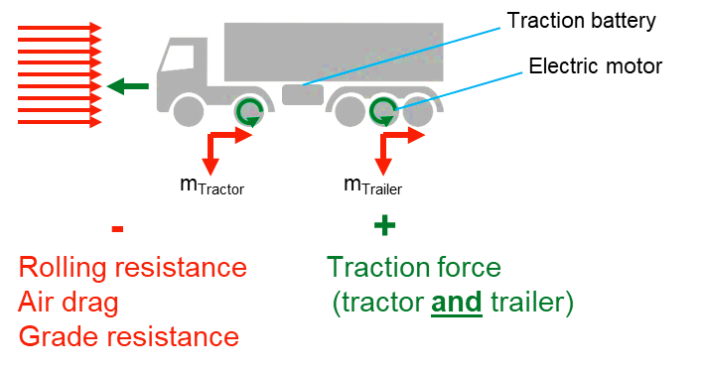
Picture 1: Principle/Example of driven trailer axles

The type of drivetrain may currently be electrical, or hydraulic. The drive train on the trailer/semi-trailer will be controlled to safely follow the towing vehicle. The propelling capacity of any trailer/semi-trailer in a vehicle combination shall be controlled within the vehicle combination in such a way that the longitudinal/lateral stability of the combination is not negatively influenced.
The drive train of the trailer/semi-trailer can operate in the full speed range of the vehicle combination and is not limited to low-speed applications. But the pushing of the towing vehicle by the trailer/semi-trailer is not permitted at speeds higher than 15 km/h.
The trailer shall always remain in the towed condition with tensile forces in the coupling (except for the starting aid and except pushing forces that result from the normal dynamic conditions of the motor vehicle and trailer while driving/braking as it is usual today).
Heavy trailers (category O3 and O4) are predestined to be propelled by an electric or hydraulic engine to reduce the overall CO2 emission of the tractor/lorry. But also propelled light trailers (category O2) have a huge effect on vehicle dynamics. The use of a trailer (e.g., caravan) is mostly not foreseen in combination with battery electric cars or results in a huge reduction of the range due to the limited battery capacity of a car. This may lead to low acceptance of battery electric cars in a growing market of caravan users. But especially an electric propulsion in a trailer of category O2 (e.g., caravan) would allow the use of this trailer in a combination with a battery electric vehicle. The e-trailer would be able to guarantee the normal range of the battery electric car in combination with the trailer without any further emissions.

- The principles of a trailer/semi-trailer for road transport are defined in several regulations. The main definition of a trailer/semi-trailer describes very often the status to be a “towed vehicle” and in some cases to be “non-self-propelled”.
The current definition might lead to misunderstandings in the case that one or more trailer axles may be driven by a type of propulsion integrated into the trailer (e.g., electric engine) in combination with the motor vehicle. A clarification of some definitions in the UNECE regulatory framework would be helpful to avoid different interpretations of type approval authorities worldwide.

Paragraph 2:
“However, the trailer may be propelled to support the trailer’s motion but shall not apply motive power without being coupled to a towing vehicle.” - The trailer shall always be a part of the vehicle combination and shall not be used as a self-driving vehicle. Nevertheless, a trailer/semi-trailer may be a propelled vehicle as long the trailer/semi-trailer is designed to be a towed vehicle under normal driving conditions and propelling forces of the trailer contribute to the overall propelling forces of the towing vehicle during motion. The application of forces to the motion of the trailer depends on the coupling status.

----
Remark:
Paragraph 2: “…constructed to be towed by a power driven vehicle” – The wording “power driven” is not correct for vehicle combinations with more than one trailer e.g. modular vehicle combinations. This wording maybe deleted.

The European Commission is working on a draft regulation to implement trailers into CO2 certification process. The final regulation is to be provided soon.

