Suggestion for an amendment of UN Regulation No. 151
(Blind Spot Information Systems)

The text reproduced below was prepared by the expert from Germany to amend Regulation No. 151 to introduce an alternative test procedure without changing the requirements from the core text.
The modifications to Regulation 151 are marked in bold for new characters and strikethrough for deleted characters.
I Proposal

Paragraph 6.5.7., amend to read:
“6.5.7. Verification of Blind Spot Information signal
Verification of the Blind Spot Information signal can be made by following two methods, at the manufacturer's choosing:
(a) Verify if the Blind Spot Information signal has been activated before the vehicle crosses line C in Figure 1 of Appendix 1 to this Regulation, and if the Blind Spot Information signal has not been activated before the vehicle crosses line D in Figure 1.
(b) The activation of the blind spot information signal may be checked using the test procedure as specified in Annex 4 to this regulation.”

Paragraph 6.5.10., amend to read:
“6.5.10. The test is passed when the Blind Spot Information signal has been activated in all test cases as shown in Table 1 of Appendix 1 to this Regulation before the vehicle has crossed line C (see paragraph 6.5.7. above) or the activation of the blind spot information signal has been verified using the test procedure as specified in Annex 4, and the Blind Spot Information signal has not been activated in any test run when the vehicle passes the traffic sign (see paragraph 6.5.8. above).
[…]”

Insert a new Annex 4, to read:
Annex 4
Alternative Blind Spot Information Dynamic Test
0. Test concept and requirements for use (not legally binding)
This alternative test procedure can be used to verify the conformity of the blind spot information system to paragraph 5.3.1.4 with regard to the activation timing as specified in paragraph 6.5.7. and 6.5.10., provided that the tests are performed with equipment that allows to control the position of both the vehicle under test and the bicycle dummy with an absolute accuracy of ± 0.5 m at all times. This equipment consists of a means to influence the vehicle movement, such as a driving robot system or a driving system that utilizes access to the vehicle’s actuators, a robot-controlled platform for the bicycle dummy, and position measurement systems using a fusion of differential global navigation satellite systems and an inertial measurement unit. Note that the other requirements of paragraph 5.3.1.4., especially false positives and first point of information FPI, still need to be checked with the test procedure as specified in paragraph 6.5 and its subparagraphs.
1. Test procedure
1.1. Verify that the vehicle and the test track are in the condition as required per section 6 and its subparagraphs.
1.2. Equip the vehicle with the following equipment:
1.2.1. A position measurement system, able to measure the vehicle position with an accuracy of [5] cm, such as a differential GNSS and inertial measurement unit fusion system, sampling at no less than 100 Hz.
1.2.2. A driving system that is able to modulate the direction, deceleration and acceleration of the vehicle under test in order to follow recorded trajectories with an accuracy of [50] cm when comparing recorded and replayed trajectory over time.
If the driving system does not allow a sufficient manual control, it may be absent during the recording of the trajectory as defined in paragraph 1.3 below.
1.2.3. A system to detect the information and warning signals after their activation with a time delay of not more than [25] ms.
1.3 Drive manually and record vehicle position over time for all relevant envelopes described in Appendix 1 for the vehicle under test. Modulate the speed as necessary during the turn while staying in the performance requirements as specified in section 5.3.1. (e.g. up to 30 km/h vehicle speed). The initial speed as specified in Appendix 1 should be maintained until passing a line corresponding to x=-30 in the coordinate system as specified in Appendix 1.
The vehicle shall be driven in such a way that the vehicle front is inside the dedicated points given for the respective envelopes in Appendix 1 at all times. This shall be verified with the measured data.
A marking of the positions using markers is permitted but not necessary.
If deemed justified by the technical service, any other trajectories that would be driven with the given vehicle to negotiate 90° turns may be tested as well.
1.4 Drive the tests according to the table in appendix 1, using the driving system and the trajectories as recorded while performing paragraph 1.4 of this annex, ensuring the bicycle dummy robot is synchronized to impact the vehicle under test at the respective impact position (the front right corner (-0, +0.5 m) or a position 6 m (+0, -0.5 m) behind the front right corner of the vehicle) and is travelling on the respective y coordinate.
It may be necessary and shall be allowed to synchronize the dummy robot against a replay of the VUT trajectories (with full driving system control over speed and steering) rather than against the originally recorded trajectory while driving manually.
The dummy speed shall be at the respective speed with a tolerance of +- 2 km/h at all times. The dummy robot starting position should be X=-65m. The acceleration of the dummy shall be such that the dummy shall have reached the speed for the actual test case, as shown in Table 1 in Appendix 1 to this Annex, after a distance of not more than 5.66 m and after the acceleration the dummy shall move within the specified tolerance of +- 2 km/h. The vehicle shall start to move sufficiently before dummy start to allow this dummy starting position.
If the correct collision position for each VUT trajectory has been verified with a test run without a dummy on the carrier platform and repeatability of the test setup has been verified as well, the test may be aborted after detection of the information signal.
1.5. Calculate the stopping distance with respect to passing the bicycle trajectory for each individual trajectory and each available sampling point, taking into account a possible vehicle deceleration of 5 m/s² and a reaction time of 1.4 seconds.
The calculation may be performed in the following manner:
Calculate the required braking distance d_{brake} for each data point on the trajectory, using the following equation:
$d_{brake,total}(t)=\frac{{v(t)}^{2}}{2∙\frac{5m}{s^{2}}}+ 1.4s·v(t)$,
using the momentaneous vehicle speed v(t) in m/s.
The distance of the VUT front right corner on its path to the bicycle line of movement shall be d_{Bicycletrajecrory}(t).
The position of the last point of information then is given by the first time where the following condition applies:
|d_{Bicycletrajecrory}(t). - d_{brake,total}(t) | < [0.35] m
1.6 The test procedure is considered to be passed, and consequently the vehicle is deemed to have fulfilled paragraphs 6.5.6, 6.5.7 and 6.5.10, if the information signal is given at a distance (on the path coordinate of the individual trajectories) greater than the stopping distance (on the path coordinate of the individual trajectories) as calculated in paragraph 1.5 above for all required test runs conducted according to paragraph 1.4 above.
1.7 All measurement data (in the form of plots) and all calculations done in paragraph 1.5 shall be included in a test report with regard to this annex. The test report shall be annexed to the certificate.

Appendix 1
Envelopes and their dedicated points

Envelope 1 (values to be rounded to full dm):
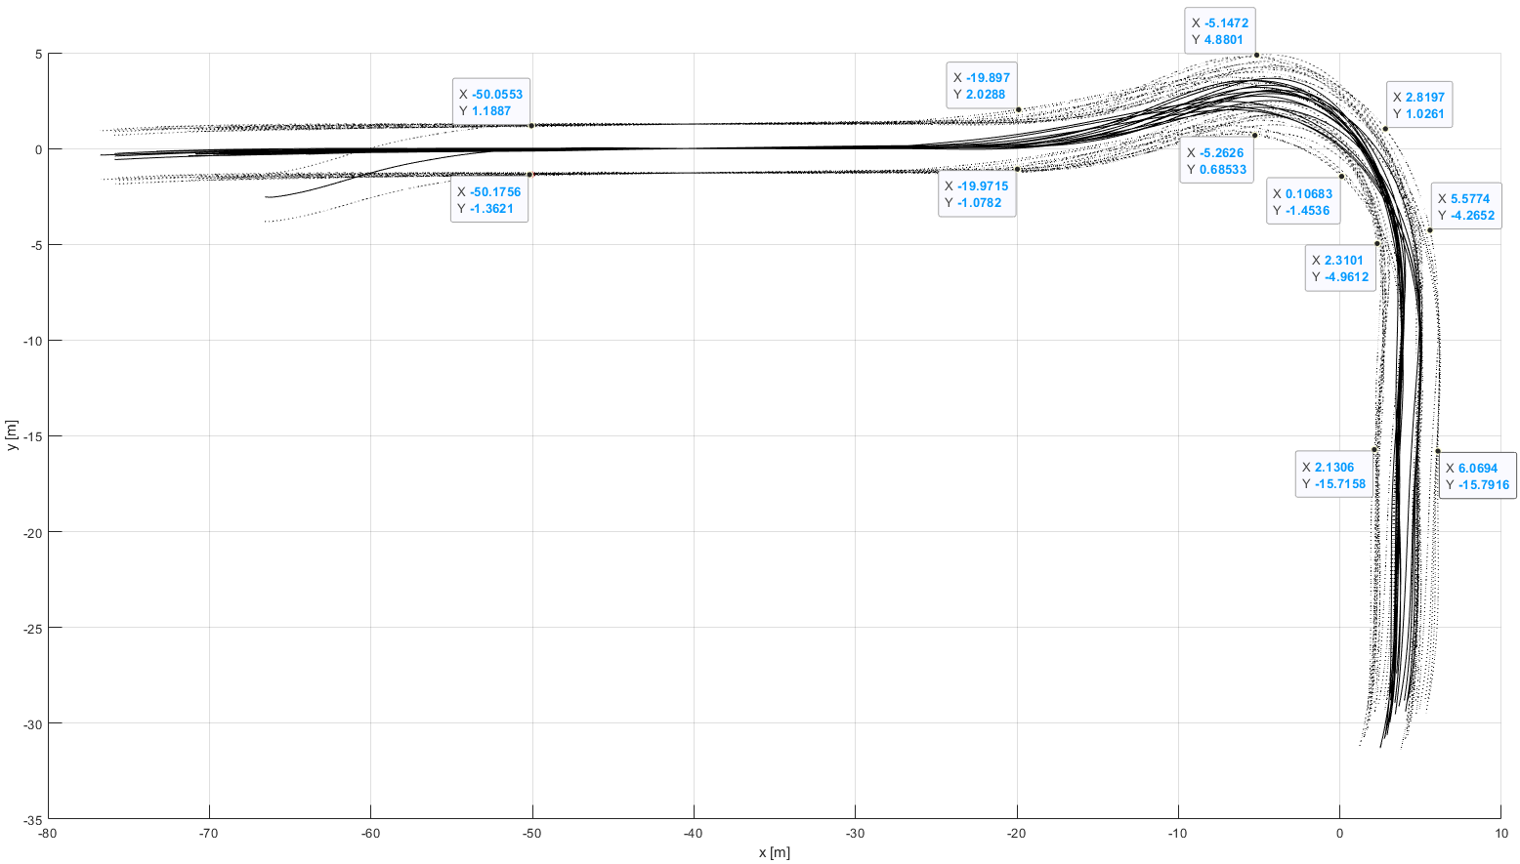
Envelope 2 (not considering the outlier testrun) (values to be rounded to full dm):
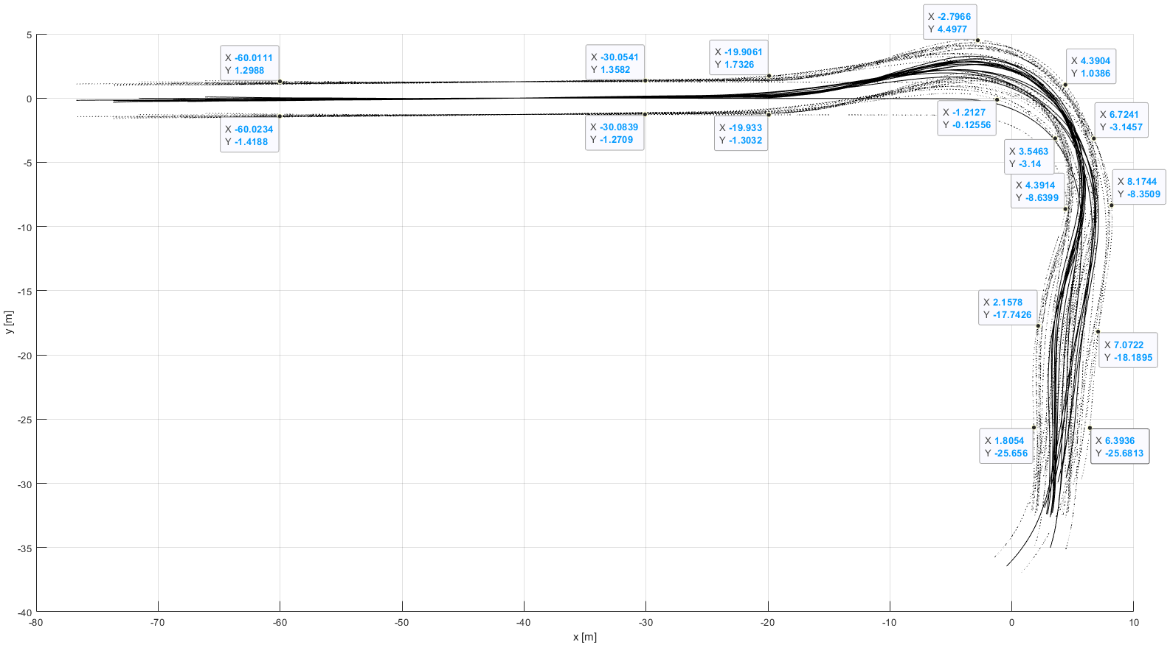
Envelope 3 (values to be rounded to full dm):
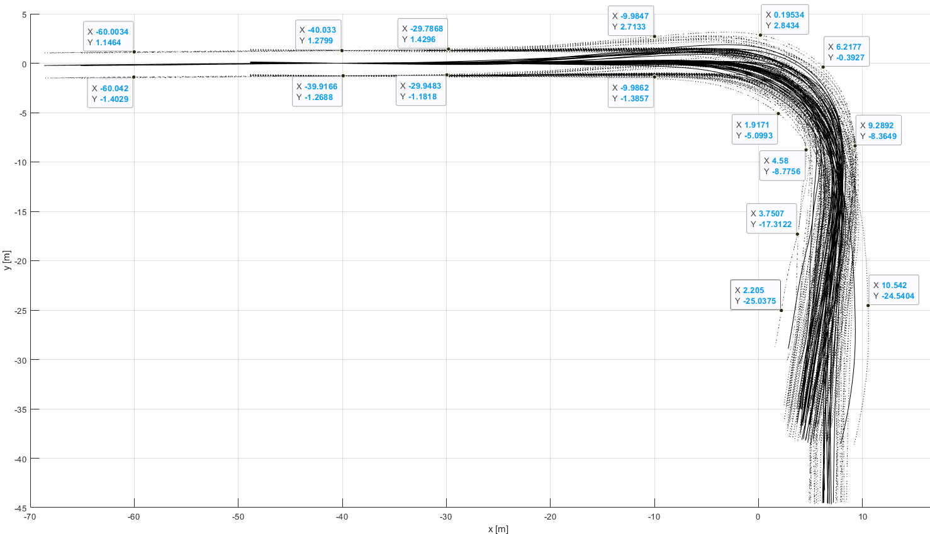

Envelope 4 (values to be rounded to full dm):
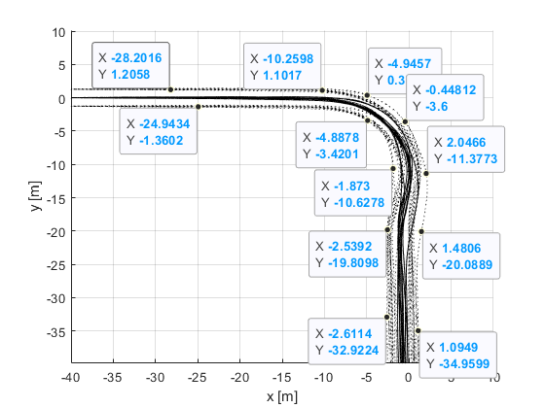
Envelope 5 (values to be rounded to full dm):
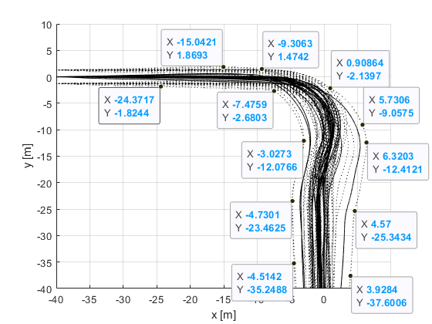
Scenarios (other parameters possible as long as those are within the limits as defined in the core text)

 | Envelope | Lateral bicycle coordinate with respect to dummy center, in the coordinate systems as shown above (tolerance: ± 0.1 m) | Bicycle speed (tolerance:  ± 2 km/h) | Initial vehicle speed (tolerance: ± 2 km/h) | Impact position with tolerance (for two points each)
Single trucks, single tractors | 1,3 | -2.9 m, -5.7 m | 10 km/h, 20 km/h | 10 km/h, 20 km/h | 0m (-0 m, +0.5 m), 6m (-0.5 m, +0 m)
Trucks equipped to tow trailers | 1, 2, 3 | -2.9 m, -5.7 m | 10 km/h, 20 km/h | 10 km/h, 20 km/h | 0m (-0 m, +0.5 m), 6m (-0.5 m, +0 m)
Tractors (equipped to tow semitrailers) | 1, 3 | -2.9 m, -5.7 m | 10 km/h, 20 km/h | 10 km/h, 20 km/h | 0m (-0 m, +0.5 m), 6m (-0.5 m, +0 m)
M3 of Class I | 4, 5 | -2.9 m, -5.7 m | 10 km/h, 20 km/h | 10 km/h, 20 km/h | 0m (-0 m, +0.5 m), 6m (-0.5 m, +0 m)
All other M3 | 5 | -2.9 m, -5.7 m | 10 km/h, 20 km/h | 10 km/h, 20 km/h | 0m (-0 m, +0.5 m), 6m (-0.5 m, +0 m)

Place the relevant speed signs in relation to the vehicle longitudinally within the first 10 m of the trajectory, and with a distance of up to 2 m laterally to the foreseen vehicle path, but not in the vehicle path.

II Justifications

The alternative test procedure allows to give the information signal later than specified in the original version of the regulation, yet still early enough for the driver to come to a comfortable stop after noticing the information signal. There is more flexibility to the system design, with which comes more responsibility for the manufacturer.
The alternative testing annex also paves the way for introducing automated braking functions, since testing those requires test procedures with actual collisions between vehicle and dummy. Therefore it makes Regulation 151 future-proof.
See accompanying presentation GRSG-121-XX.

