Proposal to amend ECE/TRANS/WP.29/GRE/2021/23
Additional amendments to the original proposal are identified in blue characters. Modifications to the existing text of the Regulation are marked in bold for new or strikethrough for deleted characters.
- Proposal
Paragraph 6.6.7., amend to read:
"6.6.7. Other requirements
When the front position lamp is reciprocally incorporated in the front direction indicator lamp, the electrical connection shall be such that the position lamp on the same side as the direction indicator lamp is switched off when the direction indicator lamp is flashing.
6.6.7.1. If a front position lamp is coloured amber and reciprocally incorporated with a direction indicator, the electrical connection of the front position lamp on the relevant side of the vehicle or the reciprocally incorporated part of it shall be such that it is switched OFF during the entire time (both ON and OFF cycle) of operation of the direction indicator lamp.
6.6.7.2. If a front position lamp is coloured white and reciprocally incorporated with a direction indicator, the electrical connection of the front position lamp on the relevant side of the vehicle or the reciprocally incorporated part of it may be such that it is switched OFF during the entire time (both ON and OFF cycle) of operation of the direction indicator lamp."

- Justification
1. This proposal aims to enhance the conspicuity of motorcycles equipped with a front position lamp reciprocally incorporated with a direction indicator, by clarifying the electrical connection requirements in paragraph 6.6.7., as the current text requires the entire front position lamp to be extinguished during the operation of the direction indicator, which may reduce the motorcycle conspicuity (Figure 1).
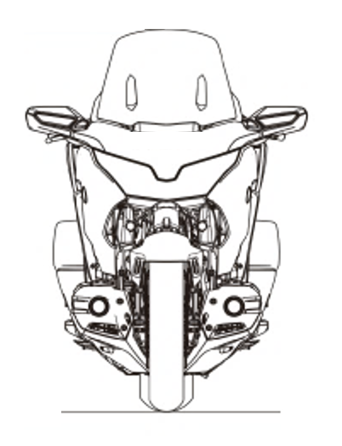
Figure 1
Front position lamp
During ON cycle of
DI operation
During OFF cycle of
DI operation
Illuminated white
Illuminated amber
Extinguished
Outcome of the current wording in paragraph 6.6.7.
2. The amendments to working document GRE/2021/23 aim to guarantee that the motorcycle direction indicator is adequately noticed by other road users, by clarifying the intended behaviour of the reciprocally incorporated part (Figure 2) and preventing other activation possibilities (Figure 3), while streamlining the wording of paragraph 6.6.7.
Illuminated white
Illuminated amber
Extinguished
During ON cycle of
DI operation
During OFF cycle of
DI operation
Figure 2
Proposed solution
.
Illuminated white
Illuminated amber
Extinguished
During ON cycle of
DI operation
During OFF cycle of
DI operation
Figure 3
Prevented behaviour

