Correction of errors in the proposal for the 01 series of amendments to
UN Regulation No. 150 (Retro-reflective devices)

The text reproduced below was prepared by the GRE Informal Working Group on Simplification of Lighting and Light-Signalling Regulations (IWG SLR) with the aim to correct some errors identified in the proposal for the 01 series of amendments to UN Regulation No. 150 (doc. ECE/TRANS/WP.29/GRE/2021/15).

The modifications to text in document ECE/TRANS/WP.29/GRE/2021/15 are marked in bold for new or strikethrough for deleted characters. For prompt reference, all the modifications are highlighted in yellow.

I. Proposal
Title, correct to read:
“UN Regulation No. 149150, amend to read: ”

Contents
Annex 11, amend title to read:
“11 Guidelines for installation of rear marking plates on slow-moving vehicles
(by construction) and their trailers Colour fastness to artificial light – Xenon Arc Test ”

Paragraph 3.3.5.2. (b), amend to read:

“3.3.5.2. In case of retro-reflective marking material of Class C, D, E or F. These markings shall be positioned on the outside at least once:
(a) on strips in a 0.5 m distance,
(b) on areas within 100 mm x 100 mm². ”

Paragraph 5.1.3.1., amend to read:

“5.1.3.1. …
Fourth group: The two samples shall be subjected to the colour-fastness resistance to weathering test (Annex 10 Part 6 of Annex 6). ”

Paragraphs 5.1.4.4.2. and 5.1.4.4.3., delete

Paragraph 5.1.6., amend to read:

“5.1.6. …
This is only applicable to tests described in Part 3 of Annex 4, in Parts 4, and 5 and 6 of Annex 6 and in Annex 10. ”

Table 4, amend to read:
“…
Reference | Tests | Samples
 |  | a | b | c | d | e | f | g | h | i | j
…
Part 2 of Annex 7 | Oils: 5 min.  visual inspection |  |  |  |  |  |  | x  x | x  x
Par. 4.2. | Colorimetry: visual inspection  Trichromatic coordinates in case of doubt |  |  |  |  |  |  | x  x | x  x
Part 1 of Annex 4 | Photometry: limited to 20' and β₁ = β₂ = 0° |  |  |  |  |  |  | x | x
…”

Paragraph 5.2.3.1., amend to read:

“5.2.3.1. Five test samples representing either strips or planes of retro-reflective marking materials have to be submitted to the test laboratory. In the case of strips, at least a length of 3 metres shall be provided; in the case of planes, at least a surface square of 500 mm x 500 mm shall be provided. ”

Paragraph 5.3.2.2., amend to read:
“5.3.2.2. Two samples of the fluorescent or fluorescent retro-reflecting material in which a square of 100 mm x 100 mm² can be inscribed and which are fully representative of the material applied under the same conditions to the same base material as used for the advance warning triangle; ”

Paragraph 5.3.5.2.3., amend to read:

“5.3.5.2.3. The testing of the luminance factor of the fluorescent materials shall be carried out according to the method described in Annex 10 Part 6 of Annex 6.

… ”

Annex 1
Item 10, amend to read:
“10. Position of the approval mark or Unique Identifier (UI)²..................”

Annex 3
Paragraph 6.1., amend to read:

“6.1. One of the retro-reflectors of sample A after the sampling procedure in paragraph 2. shall be tested according to the procedure described in paragraph 1. of Part 2 of Annex 6.2 or, in the case of the Advance Warning Triangle, the sample A shall be tested according to the procedure described in paragraph 2. of Part 2 of Annex 6.2.
…”

Annex 4 – Part 1
Paragraph 2., amend to read:
“2. Definitions
Basic definitions are given in paragraph 2.3. of this Regulation. , but Further definitions and geometry parameters are listed below and are illustrated in Figures A4-I to A4-III.
A Area of the illuminating surface of the retro-reflecting device, usually given in cm²
C Reference centre, e.g. a point on a retro-reflective area which is designated to be the centre of the device for the purpose of specifying its performance and mounting on the goniophoto-meter.
R Reference axis of the retroreflector, e.g. a designated line originating from the reference centre used to describe the angular position of the retro-reflective device.
NOTE 1 The reference axis is fixed in the retro-reflective material and moves with β₁ and β₂.
I Illumination axis, e.g. the line passing through the centre of the light source and the reference centre.
O Observation axis, e.g. the line connecting the reference centre and the centre of the photometer head.
Rr Receiver, observer or measuring device (e.g. photometer head)
Cr Centre of receiver
∅r Diameter of receiver Rr, if circular
Se Source of illumination
Cs Centre of source of illumination
Øs Aperture diameter of illumination source
De Distance from centre Cs to centre C
D’e Distance from centre Cr to centre C
NOTE 2 In general, De and D'e are very nearly the same. Therefore, it may be assumed that De = D'e.
α Observation angle, e.g. the angle between the illumination axis and the observation axis.
NOTE: 3 This angle is sometimes called angle of divergence.
β₁/β₂ Entrance angle, e.g. the angle between the reference axis and the illumination axis. The illumination angle consists of a vertical component (symbol β₁) and a horizontal component (symbol β₂). For any direction the vertical angle is always given first.
NOTE 1: 4 These angles are usually not larger than 90° but, for completeness, the full range is defined as
-90° < β₁ < 90° and
-180° < β₂ < 180°.
NOTE 2: 5 The entrance angle is sometimes as well referred to as illumination angle.
ε Angle of rotation means the angle through which the retro-reflecting device is rotated about its axis of reference starting from a given position. If the retro-reflecting device is marked "TOP" (e.g. the datum mark), the indicated position is taken as the origin.
γ Angular aperture of the measuring device Rr, i.e. the angle subtended by the largest dimension of the receiver as seen from the reference centre (β₁ = β₂ = 0°).
δ Angular aperture of the source Se as seen from the reference centre
η Angular aperture of the retro-reflecting device, e.g. the angle subtended by the largest dimension of the visible area of the illuminating surface, either at the centre of the source of illumination or at the centre of the receiver.
E Illumination of the retro-reflecting device, e.g. the illuminance measured in a plane perpendicular to the incident rays and passing through the reference centre. ”

Annex 4 – Part 1
Paragraph 3.6.., amend to read:
“3.6. The measuring distance shall be chosen in such an order that at least the limits for the angles δ, γ and η given above and illustrated in Figure A4-IVIII are respected, but not lower than 10 m. ”

Figure A5-X, amend the title and replace the figure as follows:
“Figure A5-X
Shape and dimensions of the advance warning triangle of type 2 and of the support Test apparatus for clearance to ground
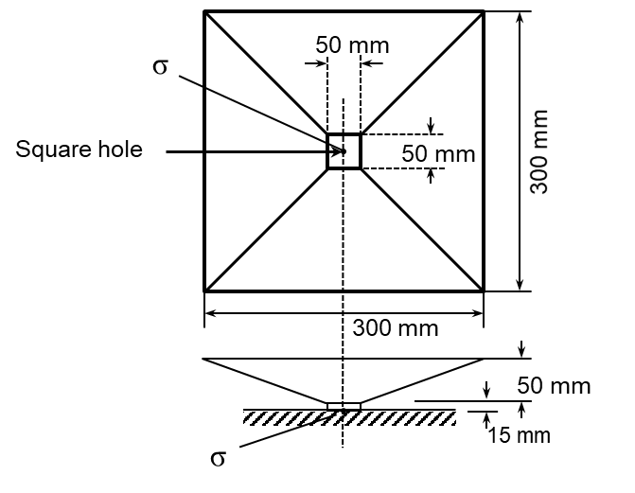…”

Annex 8 – Part 1
Paragraph 2. (b)., amend to read:
“2. …
(b) Water/wash solution temperature 60 °C $\begin{matrix}+ 0 \\ - 5\end{matrix}$ - 5 °C ;
…
…”

Annex 9
Paragraph 5.1., amend the footnote ** to read:
“** FEPA: Federation of European Producers of Abrasives, 20 Avenue Reille, 75014 Paris, France https://fepa-abrasives.org ”

II. Justification
- The title of the Annex 11 in the Contents section has been corrected in order to reflect the correct title in the body of the Regulation further to the restructuring of the Annexes
- For clarity, the unit of measure “mm” has been added to paragraphs 3.3.5.2. (b) and 5.3.2.2. of Annex 8.
- In paragraphs 5.1.3.1., 5.1.6. and 5.3.5.2.3. the reference to Annex 10 has been replaced to read “Part 6 of Annex 6” which is the updated reference after the restructuring of the Annexes
- Paragraphs 5.1.4.4.2. and 5.1.4.4.3. should have been deleted already but, by mistake, this was forgotten.
- In Table 4, the colorimetry test was forgotten for samples “g” and “h”. This proposal reinserts such tests.
- The terminology used to describe the shape of the test samples in paragraphs 5.2.3.1. and 5.3.2.2. has been harmonised.
- The footnote 2 “Strike out what does not apply” in conjunction with item 10 of Annex 1 was wrong since the item refers to the position of the of the approval mark or Unique Identifier and not to their presence.
- In paragraph 6.1. of Annex 3 the reference to Annex 6.2 has been updated to “Part 2 of Annex 6” in order to reflect the restructuring of the Annexes.
- In paragraph 2. of Part 1 of Annex 4, some texts have been improved and some symbols, and their descriptions, have been removed as they were not needed.
- In paragraph 3.6. of Part 1 of Annex 4, the reference to Figure A4-IV was wrong since there is no such a figure. The correct reference is Figure A4-III.
- In Figure A5-X the title has been corrected. The centre of the square hole was indicated by mistake with a “0” (zero) instead of “σ” (sigma). This has now been corrected and aligned with the text of paragraph 1.1.2. of Annex 9.
- For clarity, in paragraph 2. (b) of Part 1 of Annex 8, the upper tolerance of “+ 0” has been added.
- The address of FEPA, indicated in the footnote of paragraph 5.1. of Annex 9, was not up-to-date. This has been replaced with the link to the FEPA website.

