Correction of errors in the proposal for the 01 series of amendments to
UN Regulation No. 149 (Road illumination devices)

The text reproduced below was prepared by the GRE Informal Working Group on Simplification of Lighting and Light-Signalling Regulations (IWG SLR) with the aim to correct some errors identified in the proposal for the 01 series of amendments to UN Regulation No. 149 (doc. ECE/TRANS/WP.29/GRE/2021/14).

The modifications to text in document ECE/TRANS/WP.29/GRE/2021/14 are marked in bold for new or strikethrough for deleted characters. For prompt reference, all the modifications are highlighted in yellow.

I. Proposal
Table 7, Part A, amend to read:
“
 | Element | Angular coordinates in deg. |  | Luminous intensity in cd
 |  | vertical | horizontal | Class C |  | Class V |  | Class E |  | Class W ^{b}
 |  |  |  | min | max | min | max | min | max | min | max
…
Part A | Segment 50 | 0.86°D | 6.84°L to 6.84°R | 2.54∙10³ | - | 1.80∙10³ | - | 2.54∙10³ | - | 2.54∙10³ | -
 | Segment 40LL | 1.07°D | 14°L to 9°L | 8.50∙10² | - | 6.00∙10² | - | 8.50∙10² | - | 8.50∙10² | -
 | 40L | 1.07°D | 9°L14°L | 2.80∙10³ | - | 1.95∙10³ | - | 2.80∙10³ | - | 2.80∙10³ | -
 | Segment 40LL | 1.07°D | 14°L to 9°L | 8.50∙10² | - | 6.00∙10² | - | 8.50∙10² | - | 8.50∙10² | -
 | 40R | 1.07°D | 9°R | 2.80∙10³ | - | 1.95∙10³ | - | 2.80∙10³ | - | 2.80∙10³ | -
… ”

Table 20, amend to read:
“Table 20
Decision Table
 | "Multiple Modes"- Condition  * if more than one mode of the applicable Class exists only the mode which represents the worst condition has to be tested in non-bending mode according to | "Bending Modes" - Condition  if the system uses the same functional units to obtain bending modes for more than one class:
 |  | Yes | No
Class C | Table 21*ª
Category 1 bending mode |  | ** the bending modes shall only be tested in the Class which represents the worst condition  see ^{b} | Table 22
Category 2 bending mode |  | Test category 2 bending mode according to Table 23
Class V  Non-Bending Mode | Table 24*ª
Class V  Category 1 bending mode |  | see **^{b} | Table 25
Class V  Category 2 bending mode |  |  | Table 26
Class W  Non-bending mode | Table 27*ª
Class W  Category 1 bending mode |  | see **^{b} | Table 28
Class W  Category 2 bending mode |  |  | Table 29
Class E | if more than one mode of Class E exists, only the mode Class E which relates to the highest cut-off position has to be tested in non-bending mode according to the corresponding Table 30 to Table 33 | No additional testing of Category 1 and/or Category 2 is necessary
Notes: In the Table 20:
ª If more than one mode of the applicable Class exists, only the mode which represents the worst condition has to be tested in non-bending mode according to Tables 21, 24 or 27.
^{b} the bending modes shall only be tested in the Class which represents the worst condition
...”

Annex 1
Item 10, amend to read:
“10. Position of the approval mark or Unique Identifier (UI)²..................”
Annex 8
Paragraph 1.2.1.1., amend to read:
“1.2.1.1. Ten of these lenses may be replaced by ten samples of material at least 60 mm x 80 mm in size, having a flat or convex outer surface and a substantially flat area (radius of curvature not less than 300 mm) in the middle measuring at least 15 mm x 15 mm ; ”

Annex 8
Paragraph 3.1.2.2., amend to read:

“3.1.2.2. These measurements shall be made after photometric stability (as defined in UN Regulation No. 48) using a standard (étalon) light source and/or LED module(s), or if applicable with a standard gas-discharge with the light source(s) and/or light source module(s), as present in the road illumination device, at the following points:
...”

Annex 8
Paragraph 3.2.1., delete the formula superimposed on the text:
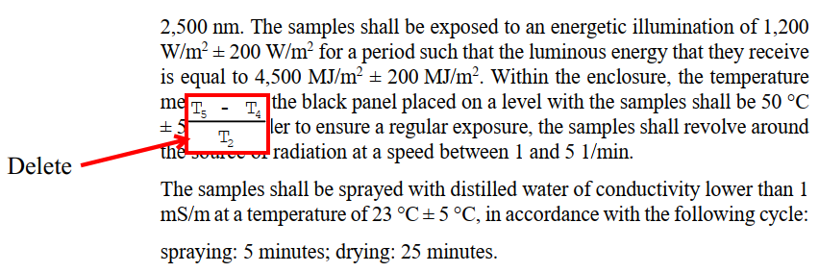

Annex 8
Paragraph 3.2.2.2., amend to read:

“3.2.2.2. Application of the test mixture
Soak a piece of cotton cloth (as per ISO 105) until saturation with the mixture defined in paragraph 3.2.2.1. and, within 10 seconds, apply it for 10 minutes to the outer face of the sample at a pressure of 50 N/cm², corresponding to an effort of 100 N applied on a test surface of 14 mm x 14 mm.
… ”

Annex 8 - Appendix 3
Paragraph 1.1., amend to read:

“1.1. Spray gun
The spray gun used shall be equipped with a nozzle 1.3 mm in diameter allowing a liquid flow rate of 0.24 ± 0.02 l/minute at an operating pressure of 6.0 bars -0/+0.5 bar.
Under these operation conditions the fan pattern obtained shall be 170 mm ± 50 mm in diameter on the surface exposed to deterioration, at a distance of 380 mm ± 10 mm from the nozzle. ”

Annex 12, replace to read:
“Voltage marking
The following marking relates to the requirements of paragraph 3.3.4.6. of this Regulation.

Figure A12

Voltage marking

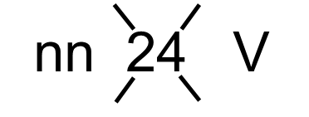

The road illumination device(s) is(are) designed for a rated voltage of nn Volts. ”

II. Justification
- In Table 7, Part A, for the AFS passing-beams it is proposed to use the same format like in Table 6 for the static passing-beams, with identical measurement elements as well as identical luminous intensity requirements for classes C and V passing-beams. The proposal corrects an editorial mistake that was introduced in the development phase of the text for the 01 series of amendments.
- In Table 20, the notes to the table were not indicated properly and had to be moved below the table
- The footnote 2 “Strike out what does not apply” in conjunction with item 10 of Annex 1 was wrong, since the item refers to the position of the approval mark or Unique Identifier and not to their presence.
- For clarity the unit of measure “mm” has been added to paragraphs 1.2.1.1. and 3.2.2.2. of Annex 8.
- Annex 8, Paragraph 3.1.2.2., it is proposed to introduce a technologically neutral text in order to cover all kinds of light sources and light source modules.
- By mistake a formula is displayed superimposed on the text of paragraph 3.2.1. of Annex 8. This formula shall be deleted in order to read properly the text underneath it.
- During the preparation of the official proposal, the sign ± has been inadvertently omitted in two cases in paragraph 1.1. of Annex 8, Appendix 3.
- Annex 12, is proposed to be revised in order to introduce an identical voltage marking for all kinds of AFS, headlamps and front fog lamps, independently on the kind of light sources.

