Transmitted by the experts from IEC | Informal document GRE-85-09  (85th GRE, 26-29 October 2021  Item 4 of the agenda)

Proposal for updating the reference to IEC 60809 in GRE/2021/13 (R148.01) and GRE/2021/14 (R149.01)

This informal document is based on discussion in the IWG SLR, where it was agreed that IEC should prepare a proposal for updating the references to IEC 60809 Edition 4 in the proposals for R148.01 and R149.01.

A Proposal for amending document GRE/2021/13 for UN Regulation No. 148.01 (Light Signalling Devices)

Amend paragraph 3.1.2.5. to read:

“3.1.2.5. In the case of lamps equipped with non-replaceable filament light source(s) or light source module(s) equipped with non-replaceable filament light source(s), a report, acceptable to the Authority responsible for type approval, that demonstrates compliance of these non-replaceable filament light source(s) with the requirements as specified in paragraph 4.11 of IEC 60809, Edition 4.”
Amend paragraph 6.3. to read:

“6.3. In the case where doubt exists in respect to compliance of the non-replaceable filament light source(s) with lifetime requirements and/or, in the case of colour coated filament light sources, with colour endurance requirements, as specified in paragraph 4.11 of IEC 60809, Edition 4, conformity shall be checked as specified in paragraph 4.11 of IEC 60809, Edition 4.”

B. Proposal for amending document GRE/2021/14 for UN Regulation No. 149.01 (Road Illumination Devices)
Amend paragraph 4.5.2.5. to read:

“4.5.2.5. In the case of cornering lamps equipped with non-replaceable filament light source(s) or light source module(s) equipped with non-replaceable filament light source(s), the applicant shall annex to the type approval documentation a report, acceptable to the Authority responsible for type approval, that demonstrates compliance of these non-replaceable filament light source(s) with the requirements as specified in paragraph 4.11 of IEC 60809, Edition 4.”
Amend paragraph 6.1.9.2. to read:

“6.1.9.2. in the case where doubt exists in respect to compliance of the non-replaceable filament light source(s) with lifetime requirements and/or, in the case of colour coated filament light sources, with colour endurance requirements, as specified in paragraph 4.11 of IEC 60809, Edition 4, conformity shall be checked as specified in paragraph 4.11 of IEC 60809, Edition 4.”

II. Justification
Part A:
The IEC standard 60809 was updated in April 2021 from Edition 3 to Edition 4. In Annex 1 and Annex 2 the referenced clause 4.11 (Ed 3 and Ed 4) is shown. The Table 1 in Ed 4 was updated to now refer to both the “old” device regulations and also the “new” Light Sigalling Device Regulation 148 (see blue highlight frame in Annex 2).
It is proposed to refer to the Edition 4 of IEC 60809 in the R148.01.

Part B:
The IEC standard 60809 was updated in April 2021 from Edition 3 to Edition 4. In Annex 1 and Annex 2 the referenced clause 4.11 (Ed 3 and Ed 4) is shown.
The Table 1 in Ed 4 was updated to now refer to both the “old” device regulations and also the “new” Road Illumination Device Regulation 149. In addition, and following the approach of R149.01, where now all functions allow the use of non-replaceable filament light sources, the Table 1 was extended to cover also the “missing” functions such as passing beam and driving beam headlamps (see red highlight frame in Annex 2).
Consequently, it is appropriate to delete the word “cornering” and to refer to the Edition 4 of IEC 60809 in the R149.01.

Annex 1: IEC 60809 Ed3 Clause 4.11
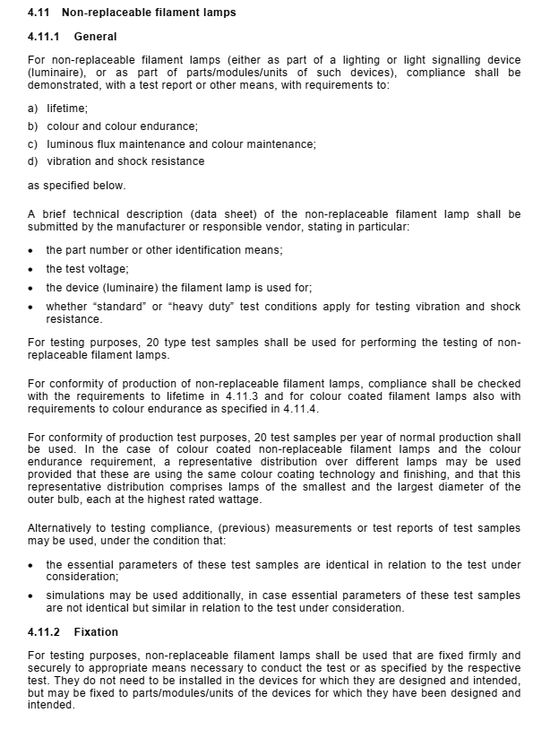 | 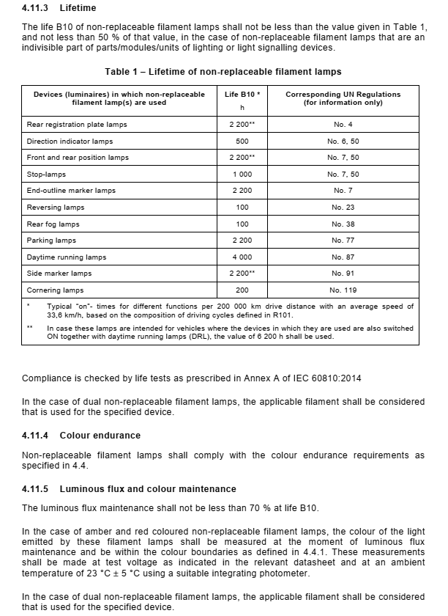

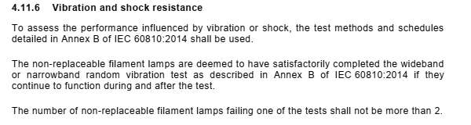

Annex 2: IEC 60809 Ed4 Clause 4.11
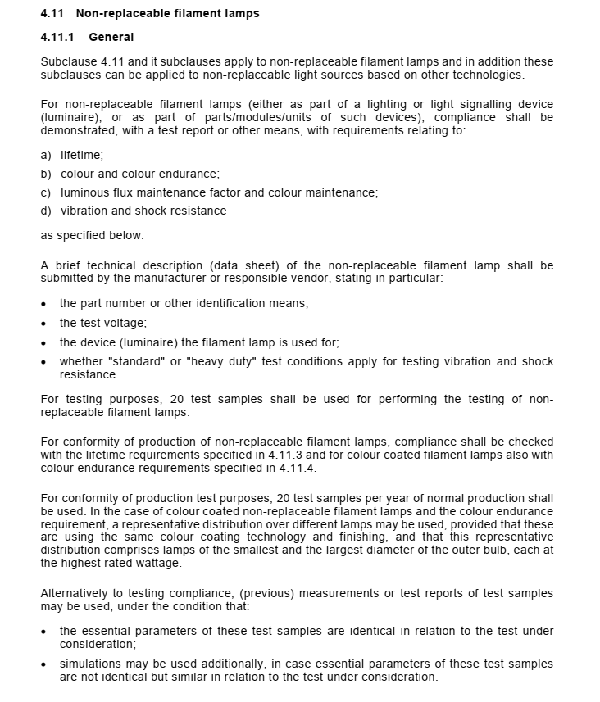 | 