|  |  |  |  |
| --- | --- | --- | --- |
|  | United Nations | ECE/TRANS/WP.29/2021/97 | |
| _unlogo | **Economic and Social Council** | | Distr.: General  2 September 2021  Original: English |

**Economic Commission for Europe**

Inland Transport Committee

**World Forum for Harmonization of Vehicle Regulations**

**185th session**

Geneva, 23-25 November 2021

Item 4.7.1 of the provisional agenda

**1958 Agreement:  
Consideration of draft amendments to existing   
UN Regulations submitted by GRSG**

Proposal for the 04 series of amendments to UN Regulation No. 67 (LPG vehicles)

Submitted by the Working Party on General Safety Provisions [[1]](#footnote-2)\*

The text reproduced below was adopted by the Working Party on General Safety Provisions at its 121st session, held in April 2021 (ECE/TRANS/WP.29/GRSG/100, para. 66). It is based on ECE/TRANS/WP.29/GRSG/2021/8. It is submitted to the World Forum for Harmonization of Vehicle Regulations (WP.29) and the Administrative Committee of the 1958 Agreement (AC.1) for consideration and vote at their November 2021 sessions.

*Paragraph 5.2.,* amend to read:

"5.2. An approval number shall be assigned to each type of equipment approved in accordance with Schedule 4 of the Agreement (E/ECE/TRANS/505/Rev.3)."

*Paragraph 16.2.,* amend to read:

"16.2.An approval number shall be assigned to each type of vehicle approved in accordance with Schedule 4 of the Agreement (E/ECE/TRANS/505/Rev.3)."

*Paragraphs 17.1.8. to 17.1.8.2.,* amend to read:

"17.1.8. Identification of LPG-fuelled vehicles

17.1.8.1. Vehicles of categories M2/N2 and M3/N3 shall be labelled as specified in Annex 17.

17.1.8.2. These labels shall be placed on the front of the vehicle and on the left side as well as on the right side of the vehicle; for the side if available in vicinity of a front door. If there is no front door available, the label has to be placed on the first third of the vehicle length. In addition, for vehicles of category M2 and M3, a label shall be fixed to the rear of the vehicle."

*Insert new paragraphs 22.19. to 22.23.,* to read:

"22.19. As from the official date of entry into force of the 04 series of amendments, no Contracting Party applying this Regulation shall refuse to grant or refuse to accept type approvals under this Regulation as amended by the 03 series of amendments.

22.20. As from 1 September 2023, Contracting Parties applying this Regulation shall not be obliged to accept type approvals to the preceding series of amendments, first issued after 1 September 2023.

22.21. Until 1 September 2025, Contracting Parties applying this Regulation shall accept type approvals to the preceding series of amendments, first issued before 1 September 2023.

22.22. As from 1 September 2025, Contracting Parties applying this Regulation shall not be obliged to accept type approvals issued to the preceding series of amendments to this Regulation.

22.23. Notwithstanding paragraph 22.22. above, Contracting Parties applying the UN Regulation shall continue to accept UN type-approvals issued according to the preceding series of amendments to the UN Regulation, for the vehicles / vehicle systems / vehicle components which are not affected by the changes introduced by the 04 series of amendments."

*Annex 17* amend to read:

**"Annex 17**

**Provisions regarding LPG identification marks for vehicles of categories M2/N2 and M3/N3.**

(Paragraph 17.1.8. of this Regulation)

*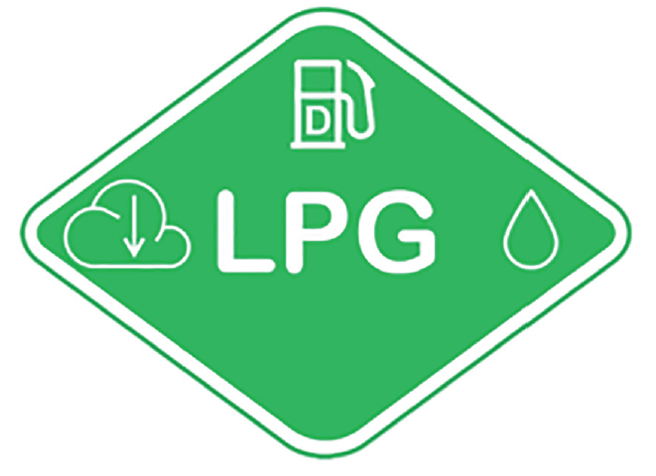*

The label shall be weather resistant.

The centre zone indicates the first energy source.

The upper zone indicates the second energy source.

The left zone indicates the gas behaviour due to density.

The right zone indicates the state of aggregation of stored gaseous fuel.

Layout and symbols shall be in accordance with ISO 17840-4:2018.

The colour and dimensions of the label shall fulfil the following requirements:

Colours:

Background: Green, RGB code 0, 176, 80

Border: white reflecting

Letters and symbols: white reflecting

Dimensions:

Sticker width: > 110 mm

Sticker height: > 80 mm "

1. \* In accordance with the programme of work of the Inland Transport Committee for 2021 as outlined in proposed programme budget for 2021 (A/75/6 (part V sect. 20) para 20.51), the World Forum will develop, harmonize and update UN Regulations in order to enhance the performance of vehicles. The present document is submitted in conformity with that mandate. [↑](#footnote-ref-2)