|  |  |  |  |
| --- | --- | --- | --- |
|  | United Nations | ECE/TRANS/WP.29/GRSP/2021/26 | |
| _unlogo | **Economic and Social Council** | | Distr.: General  21 September 2021  Original: English |

**Economic Commission for Europe**

Inland Transport Committee

**World Forum for Harmonization of Vehicle Regulations**

**Working Party on Passive Safety Provisions**

**Seventieth session**

Geneva, 6–10 December 2021

Item 11 of the provisional agenda

**UN Regulation No. 129 (Enhanced Child Restraint Systems)**

**Proposal for Supplement 7 to the 03 series of amendments to UN Regulation No. 129 (****Enhanced Child Restraint Systems)**

**Submitted by the expert from the European Association of Automotive Suppliers[[1]](#footnote-1)\***

The text reproduced below was prepared by the expert from the European Association of Automotive Suppliers (CLEPA) to amend the existing support leg volume to improve the compatibility between the support leg volume and the Child Restraint Fixtures used for assessing the external dimensions of an Enhanced Child Restraint System (ECRS). The modifications to the current text of the UN Regulation are marked in bold for new or strikethrough for deleted characters.

I. Proposal

*Paragraph 6.3.5.1.,* amend to read:

"6.3.5.1. Support-legand support-leg foot geometricalrequirements

The support leg, including its attachment to the Enhanced child restraint systems and the support-leg foot shall lie completely within the support leg dimension assessment volume (see also figures 1 and 2 of annex 19 of this Regulation), which is defined as follows:

(a) In width by two planes parallel to the X'-Z' plane separated by 200 mm, and centred around the origin; and

(b) In length by two planes parallel to the Z'-Y' plane and positioned at distances of 585 mm and 695 mm forward of the origin along the X' axis; and

(c) In height by a plane parallel to the X'-Y' plane, positioned at a distance of ~~70~~ **185** mm above the origin and measured perpendicular to the X'-Y' plane. Rigid, non-adjustable parts of the support leg shall not extend beyond a plane parallel to the X'-Y' plane, positioned at a distance of 285 mm below the origin and perpendicular to the X'-Y' plane.

The support-leg may protrude the support-leg dimension assessment volume, providing it remains within the volume of the relevant CRF."

*Annex 19., Figure 1*, amend to read:

"Figure 1

**Side view of the support leg dimension assessment volume**

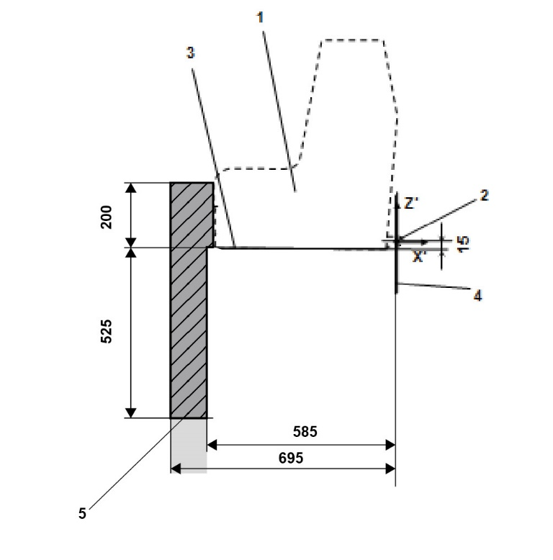

*Key:*

1. Enhanced Child Restraint Fixture (ECRF).

2. ISOFIX low anchorages bar.

3. Plane formed by the bottom surface of the ECRF, which is parallel to and 15 mm below the X'-Y' plane of the coordinate system.

4. Z'-Y' plane of the coordinate system.

5. Upper part of the support-leg dimension assessment volume, which shows the dimensional limitations in X' and Y' direction, the upper height limit in Z' direction, as well as the lower height limitation in Z' direction for rigid, not in Z' direction adjustable support leg components.

*Note*:

1. Drawing not to scale."

*Annex 19., Figure 2*, amend to read:

"Figure 2  
**3D view of the support leg dimension assessment volume**

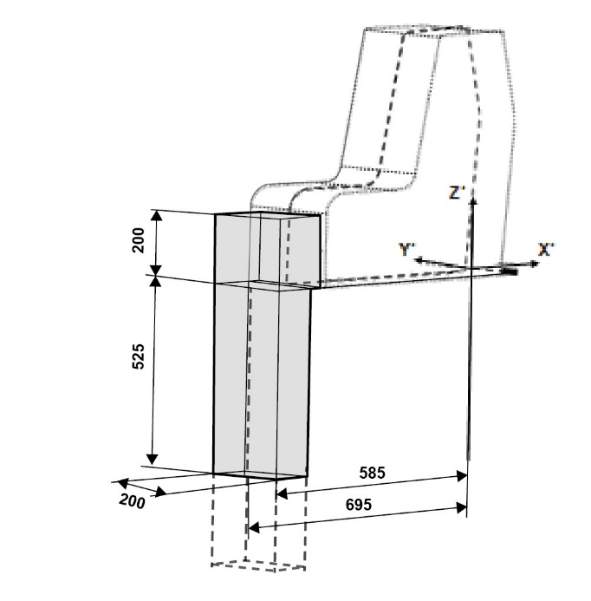

*Note*: Drawing not to scale."

II. Justification

1. UN Regulation No. 16 defines the envelope dimensions of ISO/R2 and ISO/F2X CRF envelopes. The dashed line 2) represents the area where a support leg or similar may protrude. For the ISO/F2X envelope, this is indicated with a height of 200 mm.

Figure 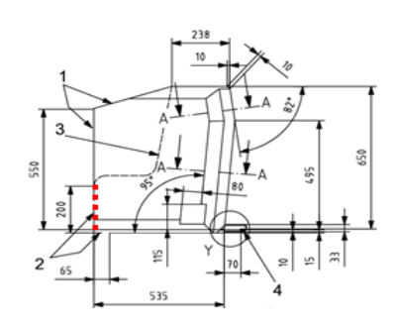

Dimensions in millimeters

**Key**

1. limits in the forward and upward directions.

2. dashed line marks the area where a support leg, or similar may protrude.

2. In our proposal, the top surface of the support leg volume has been raised upwards to match the support leg opening in the ISO/F2X envelope to facilitate more space for support legs. Increasing the height of the support leg volume would improve the compatibility between the support leg volume and the ISO envelopes. This would be particularly useful for large rearward facing CRS designs with support legs.

3. Improving the compatibility between the CRF envelopes and the support leg will have environmental benefits as it will allow improved load paths which will lead to a reduction in materials. This will also mean there is the potential to reduce CRS weight, improving handling for consumers.

Enlarging this volume would also benefit those designs containing electronics for user misuse warnings.

4. The additional support leg volume already overlaps with the ISO/R2 volume and therefore little or no extra space is required (depending on ISOFIX position).

Figure

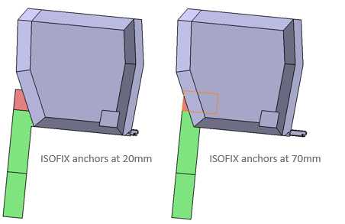

1. \* In accordance with the programme of work of the Inland Transport Committee for 2021 as outlined in proposed programme budget for 2021 (A/75/6 (Sect.20), para 20.51), the World Forum will develop, harmonize and update UN Regulations in order to enhance the performance of vehicles. The present document is submitted in conformity with that mandate. [↑](#footnote-ref-1)