|  |  |  |  |
| --- | --- | --- | --- |
|  | United Nations | ECE/TRANS/WP.29/GRSP/2021/25 | |
| _unlogo | **Economic and Social Council** | | Distr.: General  21 September 2021  Original: English |

**Economic Commission for Europe**

Inland Transport Committee

**World Forum for Harmonization of Vehicle Regulations**

**Working Party on Passive Safety Provisions**

**Seventieth session**

Geneva, 6–10 December 2021

Item 6 of the provisional agenda

**UN Regulation No. 16 (Safety-belts)**

**Proposal for Supplement 4 to the 08 series of amendments to UN Regulation No. 16 (Safety-belts)**

**Submitted by the expert from the European Association of Automotive Suppliers**[[1]](#footnote-1)\*

The text reproduced below was prepared by the expert from the European Association of Automotive Suppliers (CLEPA) and amends the existing support leg volume to improve the compatibility between the support leg volume and the Child Restraint Fixtures used for assessing the external dimensions of an ECRS. The modifications to the current text of the UN Regulation are marked in bold for new or strikethrough for deleted characters.

I. Proposal

*Annex 17, Appendix 2, Figure 9*, amend to read:

"Figure 9

**Side view of the i-Size support leg installation assessment volume for assessing compatibility of the i-Size seating positions with support legs of i-Size child restraint systems**

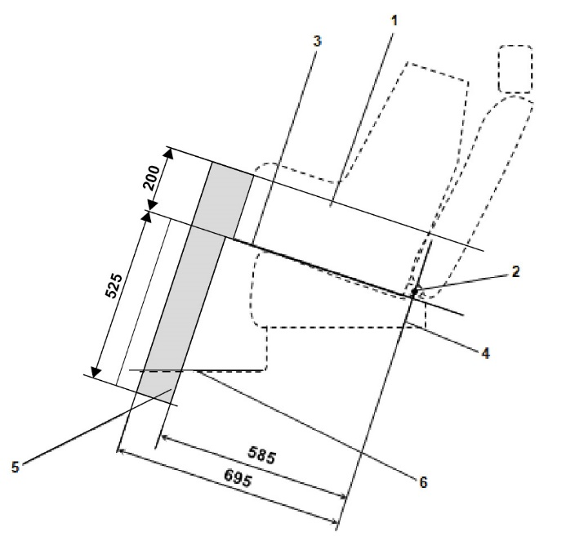

*Key:*

1. Child Restraint Fixture (CRF).

2. ISOFIX low anchorages bar.

3. Plane formed by the bottom surface of the CRF when installed in the designated seating position.

4. Plane passing through the lower anchorage bar and oriented perpendicular to the median longitudinal plane of the CRF and perpendicular to the plane formed by the bottom surface of the CRF when installed in the designated seating position.

5. i-Size support leg installation assessment volume representing the geometrical boundaries for an i-Size ISOFIX child restraint system support leg.

6. Vehicle floor.

*Note:* Drawing not to scale."

*Annex 17, Appendix 2, Figure 10,* amend to read:

# "Figure 10

**3D view of the i-Size support leg installation assessment volume for assessing compatibility of the i-Size seating positions with support legs of i-Size child restraint systems**

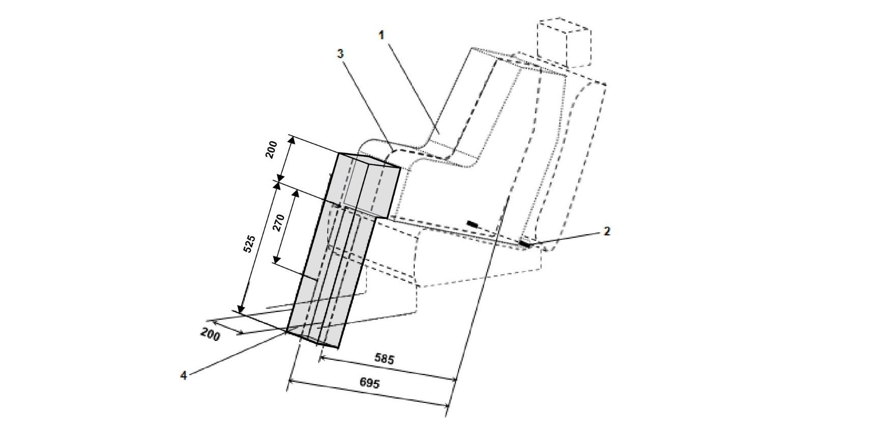

*Key:*

1. Child Restraint Fixture (CRF).

2. ISOFIX low anchorages bar.

3. Median longitudinal plane of the CRF.

4. i-Size support leg installation assessment volume.

*Note:* Drawing not to scale."

II. Justification

1. UN Regulation No. 16 defines the envelope dimensions of ISO/R2 and ISO/F2X CRF envelopes. The dashed line 2) represents the area where a support leg or similar may protrude. For the ISO/F2X envelope, this is indicated with a height of 200 mm.

Figure  
**ISO/…**

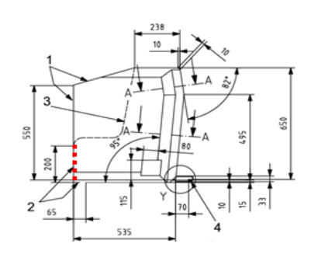

Dimensions in millimeters

**Key**

1. limits in the forward and upward directions.

2. dashed line marks the area where a support leg, or similar may protrude.

2. In our proposal, the top surface of the support leg volume has been raised upwards to match the support leg opening in the ISO/F2X envelope to facilitate more space for support legs. Increasing the height of the support leg volume would improve the compatibility between the support leg volume and the ISO envelopes. This would be particularly useful for large rearward facing CRS designs with support legs.

3. Improving the compatibility between the CRF envelopes and the support leg will have environmental benefits as it will allow improved load paths which will lead to a reduction in materials. This will also mean there is the potential to reduce CRS weight, improving handling for consumers.

4. Enlarging this volume would also benefit those designs containing electronics for user misuse warnings.

5. The additional support leg volume already overlaps with the ISO/R2 volume and therefore little or no extra space is required (depending on ISOFIX position).

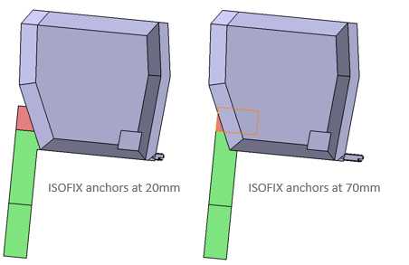

1. \* In accordance with the programme of work of the Inland Transport Committee for 2021 as outlined in proposed programme budget for 2021 (A/75/6 (Sect.20), para 20.51), the World Forum will develop, harmonize and update UN Regulations in order to enhance the performance of vehicles. The present document is submitted in conformity with that mandate. [↑](#footnote-ref-1)